HW2 Solution

On the client computer or vm, you run the following command,

sudo mkdir /mnt/share
`mount -t cifs -o vers=3.0,username=xiaofeng '\\192.168.1.153\shared' /mnt/share`

asdf

we show `mount`, and in the output we can see the following,

//192.168.1.153/shared on /mnt/share type cifs (rw,relatime,vers=3.0,cache=strict,username=xiaofeng,uid=0,noforceuid,gid=0,noforcegid,addr=192.168.1.153,file_mode=0755,dir_mode=0755,soft,nounix,serverino,mapposix,rsize=4194304,wsize=4194304,bsize=1048576,retrans=1,echo_interval=60,actimeo=1,closetimeo=1)

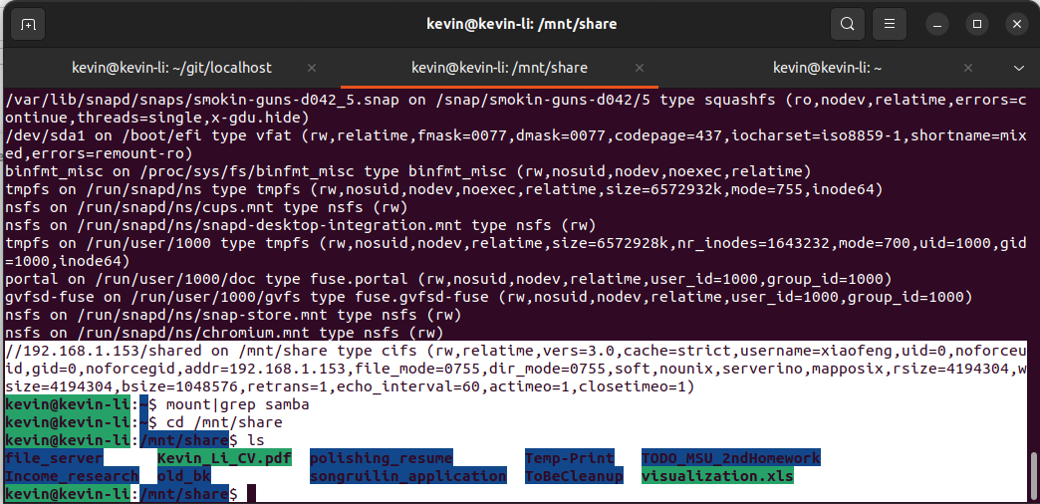
asdf

Then you check if the mounted drive is successful by doing the following commands,

`cd /mnt/share`
`ls`

