

**DOROTHY OLIVE FRANKLIN MEMORIAL TOURNAMENT**

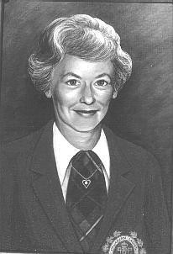

This annual Provincial Tournament is to commemorate Dorothy's contribution to golf at the Club, Provincial and National Levels. Proceeds are used to send promising junior golfers to out-of-province and international competitions. This tournament is held at the club level in the month of June and is open to any female golfer with an established handicap factor (maximum 40.4). Please include this event on your Fixture Sheet.



FORMAT: FEE:



PRIZES: TIES:



Low Net Handicap Differential – can be combined with any stroke play competition.

$2.00 per participant.



One prize will be awarded to each Zone Low Net Differential winner. Each Zone will forward the Zone winner's score card to the Zone 4 Treasurer to determine the overall Provincial winner and an award will be presented at the Captains’ Fall Meeting.

To be broken by using the formula below.



**SUBMIT RESULTS, ENTRY FEES AND ATTESTED SCORE CARD TO ADDRESS BELOW DUE DATE JULY 31st**



**Make Cheque Payable to: BCG Zone 4 Women’s Committee**

**Send To Zone 4 Treasurer, SHERRY WORK @ 409 – 2211 WALL STREET, VANCOUVER, BC V5L 1G4**

**OR e-Transfer TO:** [**zone4womenscommittee@gmail.com**](mailto:zone4womenscommittee@gmail.com)

Club: Tees: Course Rating: Slope Rating: No. Participants: Amount Collected:



Winner: Factor:

Score



Less  **Your** Course Rating



= Differential



Differential x 113



÷  **Your** Slope Rating



Less Handicap Factor



***NET HANDICAP DIFFERENTIAL***



Revised Novermber 2018

