**POSTING SCORES**

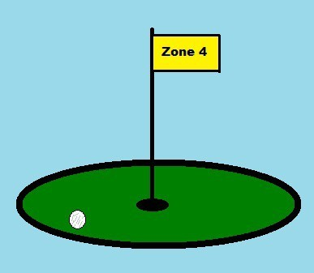

The basic premise of the Golf Canada Handicap System is that every player will try to make the best score on every hole, in every round regardless of where the round was played, and that the player will post every acceptable round.

You should post the following scores for handicap purposes:

• Post all 9 and 18 hole scores played in

accordance with the principles of The Rules of

Golf

• 13 or more holes played you must post an 18- hole score

**GOLF CANADA HANDICAP**

The Handicap System enables all golfers of different skill levels to compete on an equitable basis.

• 7 – 12 holes played you must post a 9-hole

score

• Post all scores made in an area observing its

Active Season

• Post scores played under the Local Rule of

“preferred lies”

• Scores from all forms of competition such as match play, stroke play, and team competition

The following are unacceptable scores for posting:

• Scores of fewer than 7 holes

• Scores made on a golf course in an area during its Inactive Season

• Scores made not under the principles of the

Rules of Golf

• Scores from courses under 3,000 yards for 18 holes or less than 1,500 yards for 9 holes

• Scores made in competitions stipulating the use of less than 14 clubs

• Scores made on golf courses without valid

Course and Slope Ratings

• Scores made on courses that are not a member of Golf Canada/Provincial Golf Association

**HANDICAP FACTOR**

A Handicap Factor is a numeric measurement used to indicate a player's potential ability on a course of average difficulty in Canada.

A Handicap Factor is calculated using your best 10 scores of your last 20 rounds. It is expressed as a number taken to one decimal place, for example 11.4.

A Handicap Factor must be current and updated after each round. We use our Handicap Factor to convert it into a Course Handicap for the set of tees played. A Handicap Factor is portable from course to course as well as from one set of tees to another on the same golf course.

**ACTIVE SEASON**

An “*active season*” is the period during which scores are acceptable for handicap purposes.

British Columbia – March 1 to November 15

All scores made in an area observing an Active Season must be posted such as when you travel south for the Winter. Post scores from California, Arizona, Florida, Hawaii, and even Mexico if it has a valid Course and Slope Rating.