ORCA · SUSTech-BIO · Healthy Living Class Workbook
Healthy Living
for Older Adults
V2.1 · Health Basics + Personal Notes + Interest Workshops
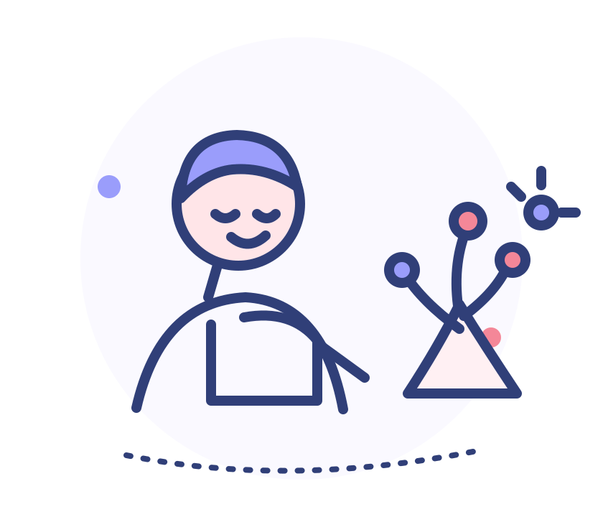
How to use this workbook Start with the page that matters to you today. Read a few points and write down your questions. This is not a book to memorize; it is a practical guide for everyday life.
Less dense text, more ideas you can see and use.

Page guide
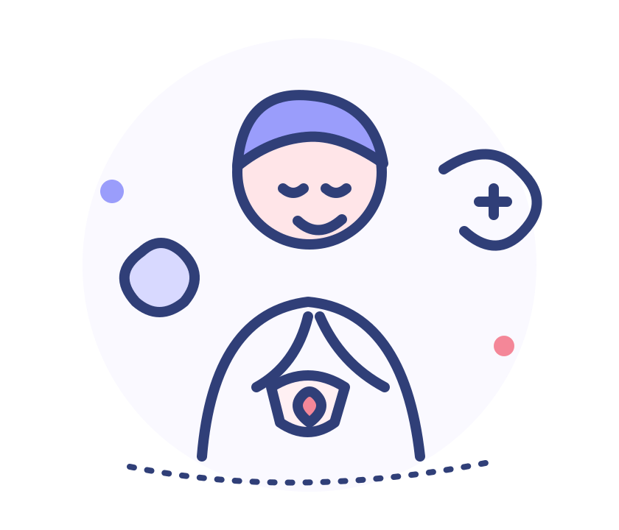Start with what matters most to you
Health toolkit Body changes p.3 | Chronic conditions p.5–7 | Medicines p.8–10 | Food p.11–12 | Movement p.13–14 | Home safety and emergencies p.15–17 | Mood and memory p.18–19 | Checkups and appointments p.20–21
Interest workshops Phone photography and photo editing p.23–24 | Flower arranging p.25–26 | AI and checking information p.27–28 | Container gardening p.29–30 | Hand lettering and cards p.31–32 | Music and memories p.33–34
A simple rhythm for each class
01 Look at the illustration
Find the small picture that shows the topic.
02 Choose one useful idea
You do not need to remember everything. Write your questions on a notes page.
03 Try one small change at home
Share it with a friend, classmate, instructor, or someone you trust. See whether it works for you.
Emergency signs Sudden chest pain, severe shortness of breath, facial drooping, weakness on one side, trouble speaking, or confusion? Call your local emergency number right away.

Chapter 1 / Understanding your body
Changes with age do not always mean illness
Some changes happen gradually, such as needing more light to read, lighter sleep, or slower walking. Forgetting a name and remembering it later does not by itself mean illness. Notice whether changes are becoming more frequent or affecting everyday activities.
Things you can observe Occasional tiredness, a brief memory lapse, or gradual changes in vision or hearing. Note when it happens, how long it lasts, and what you were doing.
Consider making an appointment Memory, mood, walking, appetite, or daily tasks are getting harder over time; weight keeps dropping; or sleep problems affect daytime life.
Seek urgent help for sudden changes Sudden chest pain, severe shortness of breath, facial drooping, one-sided weakness, trouble speaking, or confusion. Call your local emergency number. Do not wait for symptoms to pass.
Tell your clinician what has changed
Instead of saying only “I have not felt well,” try: “Twice this month I had to stop and rest on a short walk. It is happening more often than before.” Specific examples can help a clinician understand what is going on.

Notes / quick reminders
My body changes: a note to bring to an appointment
Write down the one change that concerns you most. A few notes can make it easier to explain what has been happening.
The change I noticed: ______________________________
About when it started: ______________________________
How often / how long it lasts: ______________________________
A daily activity it affects: ______________________________
A question I want to ask: ______________________________
Example “Twice last week I felt short of breath near the end of a short walk. Rest helped, but it is happening more often.” This is more useful than saying only “I do not feel well.”
If you notice the emergency signs on the previous page, call your local emergency number instead of stopping to fill in this page.

Chapter 2 / Living with common conditions
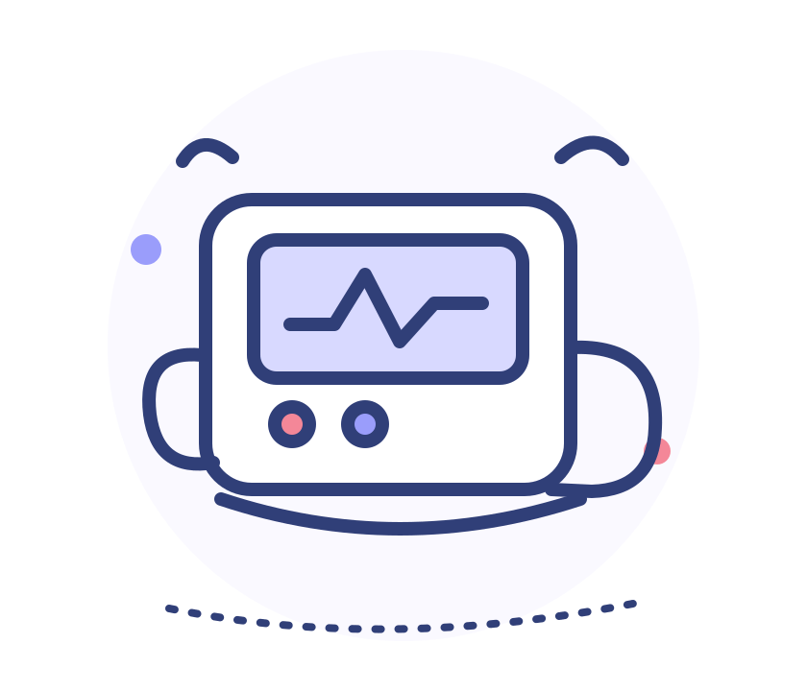Managing a long-term condition: look for patterns
High blood pressure and diabetes may not cause obvious symptoms. Do not judge control by how you feel today, and do not change a dose based on one reading.
Checking blood pressure at home
01 Sit quietly for about 5 minutes
Support your back, keep both feet flat, and stay quiet during the measurement.
02 Place the cuff on your bare upper arm
Support your arm at about heart level. Follow the device instructions.
03 Repeat and record
Wait about 1 minute between readings. Record the date, time, and numbers, and bring them to your appointment.
For blood sugar, record when you tested Fasting, after a meal, and bedtime readings are not directly comparable. Note the time and its relation to meals; follow your care plan for how often to test.
Targets are personal A clinician can set goals based on your health, age, risk of low blood sugar, and other conditions. Do not copy someone else’s target.

Chronic conditions / Recognizing emergencies
Two emergencies to recognize
Persistent chest pressure or pain If it comes with sweating, nausea, or shortness of breath, call your local emergency number immediately. Do not drive yourself or wait for your next appointment.
Remember FAST for possible stroke
F Face
Ask the person to smile. Does one side of the face droop?
A Arms
Ask the person to raise both arms. Does one arm drift down or feel weak?
S Speech
Ask the person to repeat a simple sentence. Is speech slurred or hard to understand?
T Time: call for help
Note when symptoms began. Do not give food, drink, or medicine unless emergency professionals tell you to.
Watch for low blood sugar Shaking, sweating, a fast heartbeat, or weakness may be warning signs. Follow the personal plan made with your clinician. If someone is unconscious or cannot swallow, do not put food or drink in their mouth; call for emergency help.

Chronic conditions / Bone and joint health
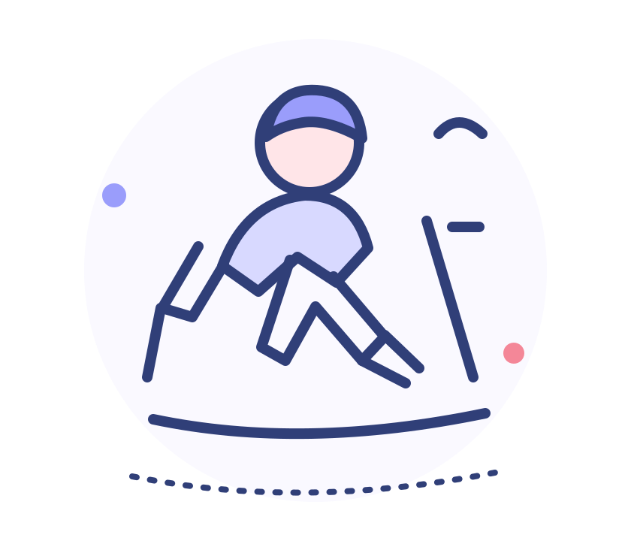Bone and joint pain deserves attention
Osteoporosis can weaken bones without early symptoms. Height loss, a new stoop, or ongoing back pain are reasons to ask a clinician whether a bone-density test is appropriate. A fall can cause a fracture, so take it seriously.
Protecting your bones Foods such as dairy or fortified alternatives, beans, tofu, and leafy greens can provide calcium. Activity and safe time outdoors may also help. Ask a clinician before taking calcium or vitamin D, especially if you have kidney disease or kidney stones.
Notice how joint pain changes
• Note when it hurts
Tell your clinician whether stiffness is worse in the morning, pain increases with activity, or rest helps.
• Move gently; do not push through pain
Gentle movement or warmth may feel helpful for some people. Seek medical advice for a hot, swollen joint or sudden severe pain.
Pain medicines need care Some pain medicines can affect the stomach, kidneys, or blood pressure. Ask a clinician or pharmacist about options for ongoing pain.

Chapter 3 / Using medicines safely
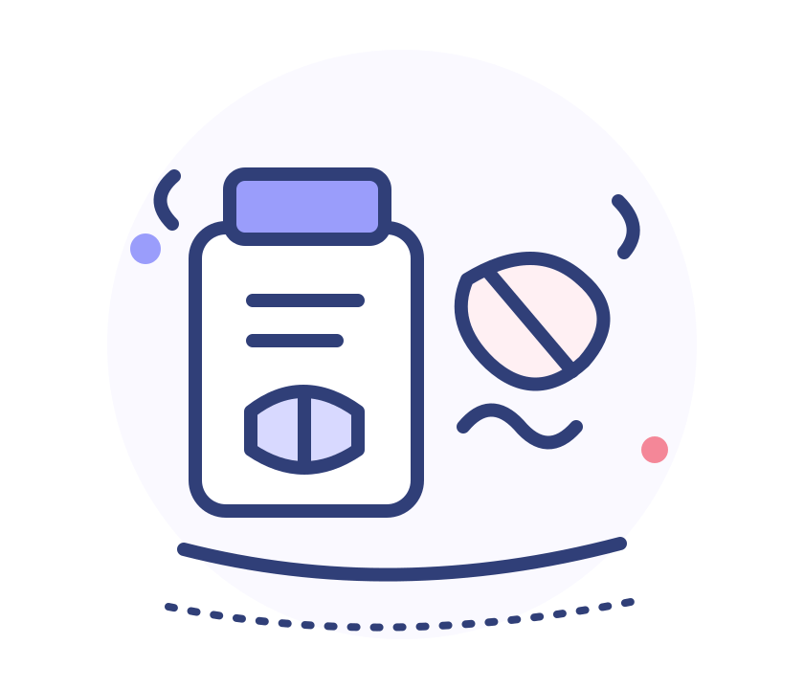Before taking a medicine, check the label
Many people use prescription and nonprescription medicines, vitamins, supplements, or traditional remedies at the same time. Different packaging does not always mean different ingredients. Bring an up-to-date list to appointments.
01 Check the person’s name and the medicine name
Do not identify a pill by its color or shape alone. Ask a pharmacist if the label is unclear.
02 Check the dose, timing, and instructions
Instructions may differ for before meals, after meals, or bedtime. If unsure, ask rather than guess.
03 Do not double a dose after a missed dose
What to do depends on the medicine. Check its instructions or ask a clinician or pharmacist.
04 Note any new symptoms
Report a rash, significant dizziness, weakness, a fall, or a change in alertness. Breathing trouble or a severe allergic reaction needs urgent help.
Do not stop, increase, or switch a medicine on your own Even if you feel better, discuss changes with the prescriber.

Notes / quick reminders
My medication list
List prescription and nonprescription medicines, vitamins, supplements, and traditional remedies. Update the list whenever something changes.
Medicine 1
Name / what it is for: ______________________________
How much and when: ______________________________
Medicine 2
Name / what it is for: ______________________________
How much and when: ______________________________
Medicine 3
Name / what it is for: ______________________________
How much and when: ______________________________
Questions for my clinician or pharmacist
Could any ingredients be duplicated or interact? __________________________
What should I do if I miss a dose? ______________________________
Can this tablet be split, crushed, or changed to another form? ______________
Storing medicines Follow the label and keep the instructions. Do not split or crush special-release tablets unless a pharmacist or clinician says it is safe.

Medicine safety / Avoiding scams
Supplements are not a substitute for treatment
Supplements cannot replace prescribed treatment for conditions such as high blood pressure or diabetes. Whether calcium, fish oil, or vitamins are suitable depends on your diet, health, and other medicines.
Pause when you hear claims like “Cures everything,” “You do not need a clinician,” “Buy today or lose your chance,” or “Stop your current medicine.” These are not reliable medical advice.
1 Do not send money or share one-time codes
If a stranger asks you to transfer money or install unfamiliar software, end the call and verify independently.
2 Write down the product name
Check it with a trusted person, clinician, or pharmacist before buying.
3 Use an official source
Check medicines and supplements through a recognized regulator or public health agency; do not rely on a seller’s verbal promise.
My plan for handling a health-related sales pitch
When I am unsure, I will ask: ______________________________
Someone I can check with: ______________________________

Chapter 4 / Eating well
Make room for variety at meals
You do not need a “miracle food.” Choose a variety of staple foods, vegetables and fruit, and protein foods that fit your culture, budget, appetite, and health needs. Notice changes in appetite, weight, chewing, or swallowing.
Staple foods Rice, bread, oats, corn, potatoes, or other grains and starchy foods
Choose portions that fit your appetite and health needs.
Protein foods Beans, lentils, fish, eggs, dairy or fortified alternatives, tofu, or lean meat
Choose different options across the week. If chewing is difficult, ask about softer textures.
Vegetables and fruit Choose different colors and types when available
The right amount and preparation can depend on your health and care plan.
If you have a health condition, avoid one-size-fits-all diets Food needs can differ with high blood pressure, diabetes, kidney disease, and other conditions. Avoid extreme diets, cutting out whole food groups, or taking large amounts of supplements without advice.
Fluid needs are individual Drinking smaller amounts through the day may be comfortable. If a clinician has asked you to limit fluids because of a heart or kidney condition, follow that plan.

Notes / quick reminders
What did I eat today?
No need to count calories. Recall the kinds of foods you ate and choose one small change to try tomorrow.
Staple food today: ______________________________
Vegetables / fruit today: ______________________________
Beans, fish, eggs, dairy, tofu, or meat today: ____________________________
Something I noticed
Any change in appetite, chewing, or swallowing? ___________________________
A question for my clinician or dietitian: ______________________________
Tell a clinician promptly Frequent coughing while eating, trouble swallowing, a major drop in appetite, ongoing weight loss, repeated vomiting, or a sudden change in bowel habits should not be addressed only by changing your diet.
One small change I might try tomorrow: ______________________________

Chapter 5 / Moving safely
Movement and recovery: safety first, then routine
Choose activity that fits your strength, balance, pain, and health conditions. Exercise does not need to leave you exhausted. After surgery, illness, or a recent fall, ask a health professional what is suitable.
Walking A stroll, walking indoors, or gentle dancing
Start at a comfortable pace for a short time and build a routine you can maintain.
Strength Try sit-to-stand movements beside a stable support
Move steadily and keep breathing. Stop and ask for advice if knee or back pain increases.
Balance Shift your weight while holding a sturdy chair
Clear the area. Do not close your eyes or practice on a slippery surface.
Stop if you notice Chest pain, severe shortness of breath, dizziness, a racing heartbeat, or a sudden increase in pain. Seek help if symptoms are severe or do not settle with rest.

Notes / quick reminders
My weekly movement log
A short note is enough: what you did, for how long, and how you felt. Set goals with a health professional if needed.
Monday Activity: __________________ About how long: ______ How I felt: __________
Tuesday Activity: __________________ About how long: ______ How I felt: __________
Wednesday Activity: _______________ About how long: ______ How I felt: __________
Thursday Activity: _________________ About how long: ______ How I felt: __________
Friday Activity: ___________________ About how long: ______ How I felt: __________
Saturday Activity: _________________ About how long: ______ How I felt: __________
Sunday Activity: ___________________ About how long: ______ How I felt: __________
Three ways to reduce fall risks Clear clutter from walkways; turn on a light when getting up at night; use a non-slip bath mat and check that grab bars are secure. Wear well-fitting shoes with good grip.
One place at home I can make safer: ______________________________

Chapter 6 / Everyday safety
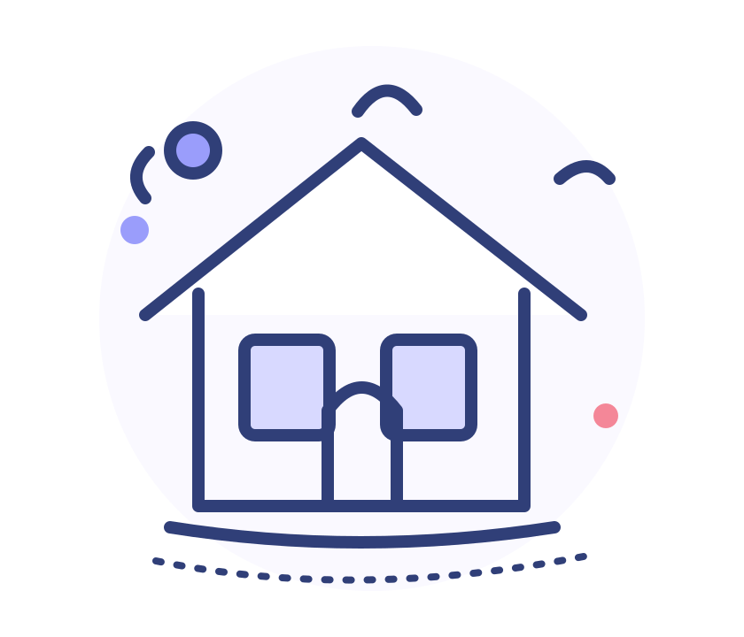A quick home safety check
Start with the route you use most. You do not have to change the whole home at once. Ask someone you trust to walk through with you if vision, hearing, or balance has changed.
□ Walkways Could cords, curled rugs, or clutter cause a trip?
□ At night Are slippers within reach? Is the path to the bathroom well lit?
□ Bathroom Is the floor slippery? Are grab bars and non-slip mats secure?
□ High shelves Can everyday items be moved within easy reach?
□ Kitchen Is it easy to forget a stove, appliance, or kettle is on?
One change to make today Tell someone you trust about the spot that feels least safe, and start there together.

Emergencies / Staying safe when out
If something happens: call for help first
If there is an emergency Check that the area is safe. Call your local emergency number and give the location, symptoms, start time, and a call-back number. Follow the dispatcher’s instructions. Do not move or give medicine unless instructed.
Possible stroke
Remember FAST: check the face, ask the person to raise both arms, listen to their speech, and call your local emergency number if you notice a sudden problem.
Do not give food, drink, or medicine. Note when the symptoms began.
Phone and online safety
• A caller asks you to transfer money
Hang up. Call the organization using a number you already trust, or ask someone you trust to help verify.
• Someone asks for a code or bank details
Do not share them, open unfamiliar links, or install software at the caller’s request.
• If you live alone
Arrange a regular check-in with someone you trust. Make sure they know whom to contact in an emergency.

Notes / quick reminders
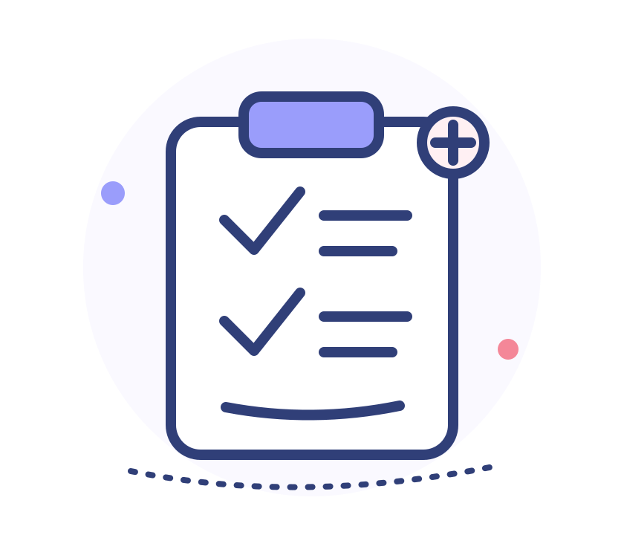My emergency and contact information
Keep this page somewhere you and a trusted person can find it. Review it together from time to time.
Emergency contact name / phone: ______________________________
My address (to give the emergency dispatcher): ___________________________
Health conditions / allergies responders should know: ____________________
Where I keep my current medicine list: ______________________________
When calling for emergency help, share
1 Your exact location, including building, room, and a nearby landmark.
2 What happened, when it began, and whether the person is awake and breathing normally.
3 A call-back number. If possible, ask someone to meet responders at the entrance.
In an emergency, call your local emergency number. Online searches are not a substitute for urgent care.

Chapter 7 / Mood, memory, and connection
Mood, sleep, and memory deserve care
Retirement, health changes, grief, or a change in surroundings can affect mood. Feeling sad sometimes does not automatically mean illness. Ongoing low mood, loss of interest, or major changes in sleep or appetite are reasons to talk with someone and seek professional support.
When to seek support If low mood or anxiety lasts for about two weeks and affects sleep, eating, interests, or daily life, contact a primary care clinician or mental health professional.
Sudden confusion needs prompt medical attention A rapid change in awareness, behavior, or speech—especially with fever, a fall, or a new medicine—should not simply be blamed on age.
Keep a few familiar routines
• Stay in touch
Choose a day to call a friend or take a walk together.
• Keep doing things you enjoy
Singing, gardening, reading, games, and learning a song can be adapted to your energy.
• Keep important things easy to find
Use a regular place for keys, a calendar for appointments, and an up-to-date medicine list.
Memory practice is not a guarantee Reading, social connection, and activities can support engagement, but no single exercise can guarantee prevention of dementia.

Notes / quick reminders
My mood and connection menu
Write down someone you might contact and one small thing that helps you feel comfortable. Leave out private details if you prefer.
Someone I would like to contact: ______________________________
Call / meet / do something together: ______________________________
One small thing that helps me relax: ______________________________
An activity I might try this week: ______________________________
Talking with someone about support
Start with what matters to you “What worries me most is…” “I would like to keep doing this myself…” “I would like someone I trust to come with me…”
How someone can help Listen first, then decide together how to handle appointments, medicine reminders, or household tasks. Avoid criticism or taking over every decision.
If you think about harming yourself, tell someone you trust or a health professional right away. You do not have to handle it alone.

Chapter 8 / Checkups and appointments
A checkup is not better just because it has more tests
Screening depends on age, health history, family history, and previous results. Ask the clinic whether to fast and what to do with regular medicines. Do not stop a medicine unless a clinician tells you to.
• Before the visit
Bring your health records, previous results, and current medicine list. Bring identification or insurance details if they are used where you live.
• During the visit
Mention past conditions, operations, allergies, and recent changes in how you feel.
• Reviewing results
An out-of-range mark is not a diagnosis by itself. Ask how it fits with your symptoms and earlier results.
• Follow-up
Add follow-up dates to a calendar. Seek care for ongoing symptoms even if a previous checkup was normal.
Preventive care after age 65 Ask your local primary care clinic or public health service which checkups and preventive services are recommended for you. Guidance varies by country and personal health.

Notes / quick reminders
My appointment notes
Write the three most important things first. If time is short, start with the problem that concerns you most.
The main thing I want help with today: ______________________________
When it started and how it has changed: ______________________________
Medicines / supplements I use: ______________________________
Three questions I want to ask
1. ______________________________ ______________________
2. ______________________________ ______________________
3. ______________________________ ______________________
Before I leave, check
□ I know how to take my medicine. □ I know when to follow up. □ I know what symptoms need earlier help.
Coverage and referrals Insurance coverage, referrals, and clinic services vary by location and plan. Check with your local health service or insurer.

Part 2 / Interests and everyday skills
Learn something new.
Make room for more joy.
The goal of these workshops You do not have to master something in one class. Take one photo, arrange one flower, or check one piece of information. That counts.
Phone photography · Flower arranging · AI and information checking · Container gardening · Hand lettering · Music

INTEREST WORKSHOP 01
Phone photography: make the subject clear
Start by getting a clear photo; editing can come later. Choose something you enjoy: a flower, a cup of tea, a portrait, or the light outside your window.
1 Clean the lens and hold steady
Use both hands. Rest your elbows lightly against a table or your body if that helps.
2 Look at the light and background
Light from the front or side can help. If the background feels busy, take a step or move closer.
3 Choose one main subject
You do not need to include everything. Place the subject near the center or a little to one side.
4 Check the photo
Make sure it is clear and the subject is not blocked. Retake it if you like.
Try this Take three photos of one flower: a wider view, a close-up, and one from a different angle. Choose the one you like best.

INTEREST WORKSHOP 01 / CONTINUED
Photo editing: make small changes and keep the original
Photoshop or a phone photo editor works in a similar way. Make one small change at a time, compare before and after, and undo anything you do not like.
• Crop
Remove distracting edges, but keep a person’s head and the main part of a flower in the frame.
• Brighten
If a photo is dark, raise the brightness a little. Keep details visible.
• Adjust color
Make small changes to warmth or saturation so flowers and food still look natural.
• Save a copy
Keep the original photo. Ask before sharing a photo of someone else.
My photo notes
What I photographed: ______________________________
What I like about this photo: ______________________________
An angle or light I want to try next time: ______________________________

INTEREST WORKSHOP 02
Flower arranging: choose a focal flower, then look at the whole
Flowers do not need to be expensive. Choose a stable vase, colors you like, and some open space. Notice the direction of the stems and make small adjustments.
01 Choose a stable vase
Add water and check that the vase will not tip easily.
02 Place the focal flowers
Choose one to three flowers and decide how tall and which way the arrangement should face.
03 Add supporting flowers and leaves
Look from different sides. If it feels crowded, remove one stem and compare.
04 Trim and care for the arrangement
Remove leaves below the waterline. Check the water and change it as needed for the flowers.
Comfort and safety Point scissors away from yourself. Ask for help trimming stems if your hands are uncomfortable. If fragrance or pollen bothers you, choose low-scent flowers or focus on color and shape.

Notes / quick reminders
My flower-arranging plan
Think it through before you begin. Your notes do not need to look like a drawing.
Flowers / leaves I would like to use: ______________________________
Where I might place the focal flower: left / center / right ________________
Colors I would like to use: ______________________________
The shape of my vase: ______________________________
Sketch a simple arrangement
○ ○ ○ ○ ○ ○ ○
○ ○ ○ ○ ○ ○ ○
○ ○ ○ ○ ○ ○ ○
○ ○ ○ ○ ○ ○ ○
○ ○ ○ ○ ○ ○ ○
After arranging Is the vase steady? Can you see the focal flower? Do you like the colors? Write down one thing you are happy with.

INTEREST WORKSHOP 03
Radio, websites, and AI: check before you act
Radio, websites, and AI can explain ideas or help organize questions, but they cannot examine you. Check advice about symptoms, medicines, or treatment with a clinician or pharmacist.
• Check the source
Who published it: a recognized health service, a medical organization, or someone selling a product?
• Check the date
When was it posted? Has it been updated?
• Check the purpose
Is it explaining health information, or urging you to buy, transfer money, or install an app?
• Take questions to a trusted source
Save the claim and where you found it. Ask a clinician, pharmacist, or public health service.
A prompt you can try “Explain this health topic in plain language. Tell me what needs a clinician’s judgment. Do not diagnose me or tell me to stop or change a medicine.”
Protect your privacy Do not upload identity documents, bank details, passwords, one-time codes, or an unedited medical record. Check an AI service’s privacy settings before use.

Notes / quick reminders
Checking a health claim
Write down one piece of advice you heard, then find a reliable source to check it.
The advice I heard or read: ______________________________
Who shared it / where I found it: ______________________________
Date: ______________________________
Who I can ask to verify it: ______________________________
What I learned / what is still unclear: ______________________________
A quick reminder If the source is unclear, pause. If the information is old, check for an update. If someone urges you to buy or stop a medicine, ask a health professional.

INTEREST WORKSHOP 04
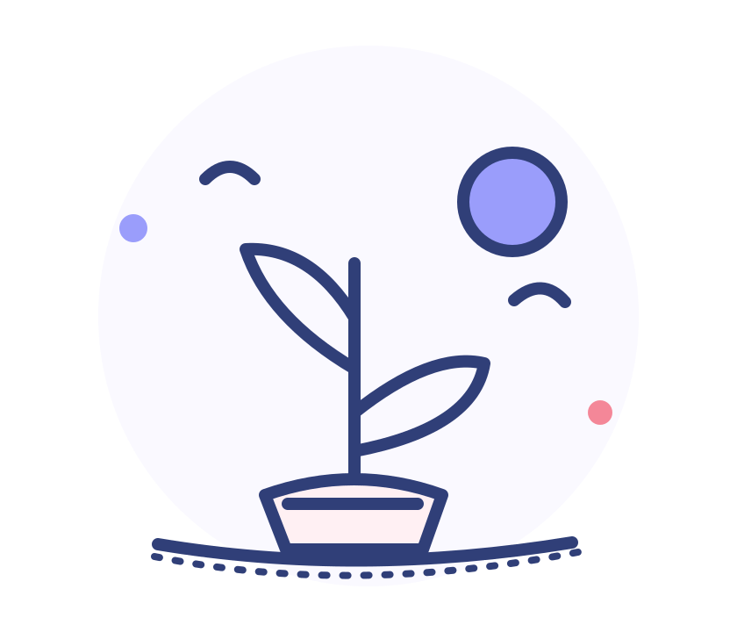Container gardening: begin with one easy-care plant
You do not need many tools. Notice the light, airflow, and space where you live, then choose a plant that fits. You might start with a familiar herb such as mint, basil, or scallions.
1 Choose a spot
Notice how much sun it gets and whether it gets wet in the rain. Keep the pot stable and out of walkways.
2 Choose one manageable plant
Ask a garden-center worker or instructor what suits your light. Start with one small plant.
3 Check the soil and leaves
Feel whether the soil is dry and follow the plant label for watering. Use a pot that drains well; do not let water sit in the tray.
4 Observe once a week
Look for new leaves, color changes, and soil moisture. Note when you watered and find a routine that works.
A safety note Do not eat an unfamiliar plant or use an ornamental plant as medicine. Keep soil, fertilizer, and pruning tools away from children and pets.

Notes / quick reminders
My plant observation card
One note a week is enough. A small change is worth noticing.
Plant name (ask an instructor if unsure): ______________________________
Where I keep it: ______________________________
Light / weather today: ______________________________
The last time I watered it: ______________________________
A change in the leaves or new growth: ______________________________
Sketch one leaf you noticed today
______________________________
______________________________
______________________________
______________________________
Next week I will look for Has a new leaf grown? Does the soil dry quickly? Observe before changing how you care for the plant.

INTEREST WORKSHOP 05
Hand lettering: make a small card of your own
You do not need perfect handwriting. Choose a pen that feels comfortable, sit with relaxed shoulders, and write slowly. Copy a short message to make a greeting card or bookmark.
1 Choose a short message
For example, “Wishing you a peaceful day” or a kind note for someone you care about.
2 Write it large first
Try it once on scrap paper with a thicker pen. Leave some space between letters and words.
3 Add one small drawing
Try a flower, a leaf, or a few stars. Keep it simple; the card does not need to be full.
4 Share it or keep it
Add the date and your name. Give it to someone or keep it in your notebook.
Keep your hand comfortable Take short breaks or use a thicker pen if your fingers or wrist tire easily. Stop if writing hurts.

Notes / quick reminders
My greeting-card draft
Try a few words here first. You choose who it is for and what you want to say.
Who I might give it to: ______________________________
One thing I would like to say: ______________________________
Colors I might choose: ______________________________
Write or sketch below
______________________________
______________________________
______________________________
______________________________
______________________________
______________________________
______________________________
One thing I like about it ______________________________

INTEREST WORKSHOP 06
Music and memories: listen and note how it feels
Choose a familiar song, local music, a faith or community program, or a radio show. Listen at a comfortable volume. A familiar sound can be a pleasant part of the day and a way to start a conversation.
1 Choose a familiar sound
It could be a song you have enjoyed for years, local folk music, or a favorite radio program.
2 Set a comfortable volume
It should be easy to hear. If you need the volume very high, check the device or headphones.
3 Notice one detail
Write down a lyric, a melody, or a place or person it brings to mind.
4 Share it if you like
Tell a classmate, friend, or family member when you first heard it and what you remember.
Protect your hearing Avoid listening through headphones at high volume for long periods. Ask a clinician about ongoing ringing in the ears or difficulty hearing conversations.

Notes / quick reminders
A sound I remember
You do not need to write a full story. A few words are enough.
Song / program I heard today: ______________________________
A sound detail I liked: ______________________________
A time or place it brings to mind: ______________________________
Someone I might share it with: ______________________________
Draw a small mark for this sound
______________________________
______________________________
______________________________
______________________________
______________________________
If you would like Ask someone to listen to a familiar song with you and share what each of you remembers.

Notes / quick reminders
A four-week plan: change one small thing at a time
Keep the goal small enough to begin. Review it later and decide whether it suits you.
My goal (for example, take a short walk twice a week): ___________________
The day I plan to begin: ______________________________
Something that might get in the way: ______________________________
Someone who could join or remind me: ______________________________
What I would like to review after four weeks: ____________________________
One note each week
Week 1: ______________________________
Week 2: ______________________________
Week 3: ______________________________
Week 4: ______________________________
No need to blame yourself If it did not happen, see whether the goal was too difficult or the timing was not right. Make it smaller and try again.

Notes / quick reminders
Class notes
Write down a question for the instructor or one idea you would like to remember.
01 ______________________________
02 ______________________________
03 ______________________________
04 ______________________________
05 ______________________________
06 ______________________________
07 ______________________________
08 ______________________________
09 ______________________________
One thing for next time ______________________________

A page of reliable sources
Sources and how to use this workbook
This workbook shares general health information, not a personal diagnosis or treatment plan. Guidance and services vary by location and may change. For questions about medicines, symptoms, food, fluids, or activity, ask a health professional who knows your situation.
World Health Organization (WHO): Ageing and health · Open source
WHO: Healthy diet · Open source
WHO: Physical activity for older adults · Open source
WHO: Mental health of older adults · Open source
National Institute on Aging: Taking medicines safely as you age · Open source
CDC: Heart attack signs and symptoms · Open source
CDC: Stroke signs and symptoms · Open source
Emergency reminder Sudden chest pain, severe shortness of breath, facial drooping, one-sided weakness, trouble speaking, or confusion? Call your local emergency number. Do not wait for an online reply.
May this workbook be a small helper in daily life: easy to find when you need it, with space to write questions and try something new.

