Simulation on Multiple Adaptive Filter Algorithms

Ali Rahman, Yingzhi Hao, Kevin Lin

Department of Electrical Engineering, The Cooper Union, New York City

rahman5@cooper.edu

hao2@cooper.edu

lin12@cooper.edu

***Abstract***— **We simulated signal communication with several signal modulation methods using MATLAB. With no ISI, we matched AWGN performance for 4 and 16 QAM. With moderate ISI, we utilized adaptive equalizer to achieve BER lower than 10^-4 at 12 dB SNR with BPSK modulation.**

1. Introduction

Using MATLAB, we simulated signal communication with several signal modulation methods. In section II, we discuss how we match AWGN performance for 4 and 16 QAM. In section III, we describe our experiment of implementing different type of adaptive equalizer, such as LMS, RLS and DEP, to reduce BER to lower than 10^-4 at 12 dB SNR with BPSK modulation given a moderate ISI channel. Section IV contains the results of our implementations.

1. MATCH PERFORMANCE FOR 4/16 QAM

The skeleton script was modified to work with 4 and 16 QAM modulation. Under the condition of no ISI, we were able to properly scale the noise and let our generated BER match the theoretical curve.

1. REDUCE BER UNDER MODERATE ISI

The skeleton script was modified to work with BPSK modulation. When moderate ISI exists in the communication channel, the BER is almost flex over 0-14 dB SNR. To reduce BER, during each transmission, a training signal was sent before the actual message was sent. The received signal was passed to an equalizer to reverse signal distortion.

Several different equalization algorithms were tried. This includes using lease mean square (LMS), recursive least square (RLS) algorithm with both linear equalizer and decision feedback equalizer (DFE). When implementing each algorithm, we also tried different iterations and different length of training bits. The iteration was varied between 1 to 10, and the length of training bits was varied between 0 to 100.

1. RESULT

Figure 1 and 2 show that, under QAM 4 and QAM 16 modulation, we were able to scale the noise and let our generated BER match the theoretical curve.

Figure 3 shows the result of using LMS and RLS with linear equalizer. The equalizer does reduce some BER. LMS with step size 0.01 and RLS with forgetting factor 1 have BER less than 10^-4 at 12 dB SNR.

Figure 4 shows the result of using LMS with decision feedback equalizer with different step size. The BER, with step size 0.01, is close to the theoretical curve and is less than 10^-4 at 12 dB SNR.

Figure 5 shows our trials of using different length of training bits with LMS and DFE on BPSK.

V. APPENDIX

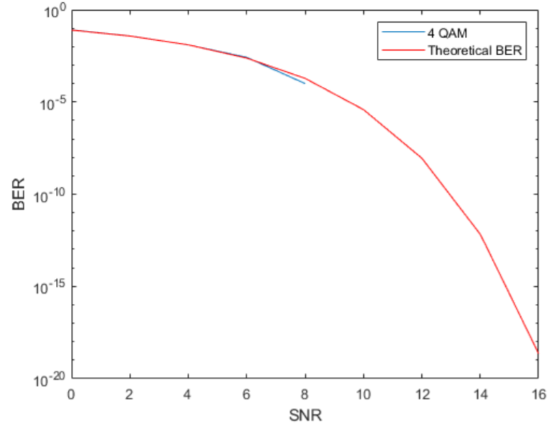

*Figure 1 BER vs SNR with QAM 4 Modulation*

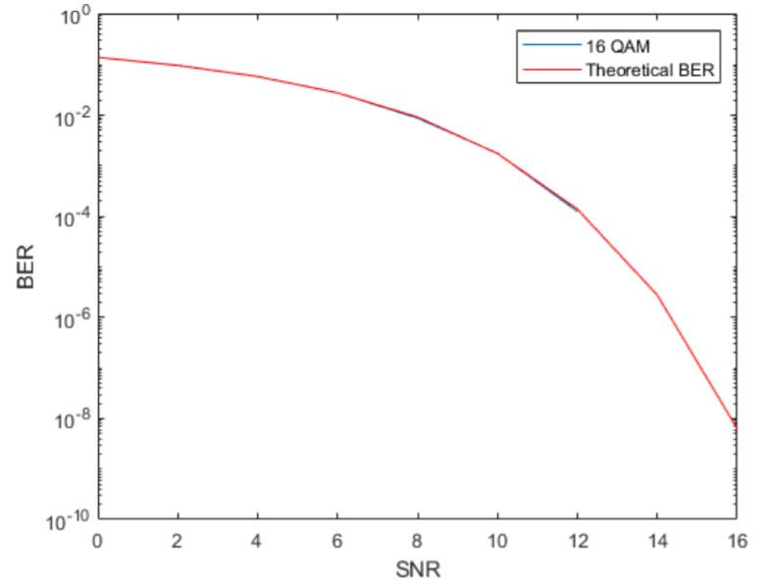

*Figure 2 BER vs SNR with QAM 16 Modulation*

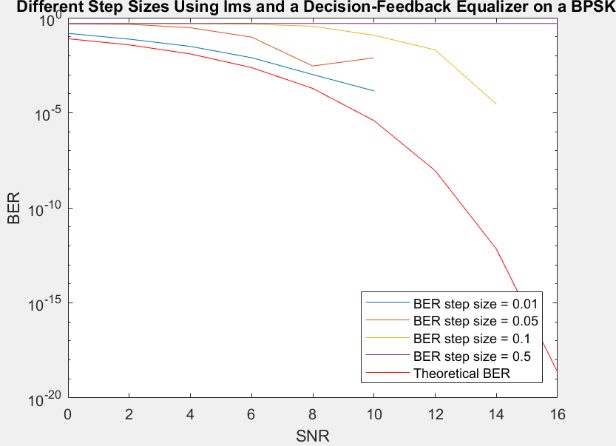

*Figure 4 BER vs SNR of Linear Equalizer with RSL and LMS Algorithm on BPSK Modulation*

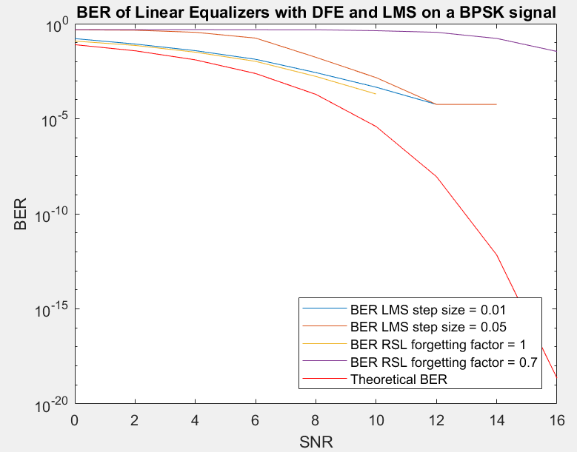

*Figure 3 BER vs SNR of Linear Equalizer with RSL and LMS Algorithm on BPSK Modulation*

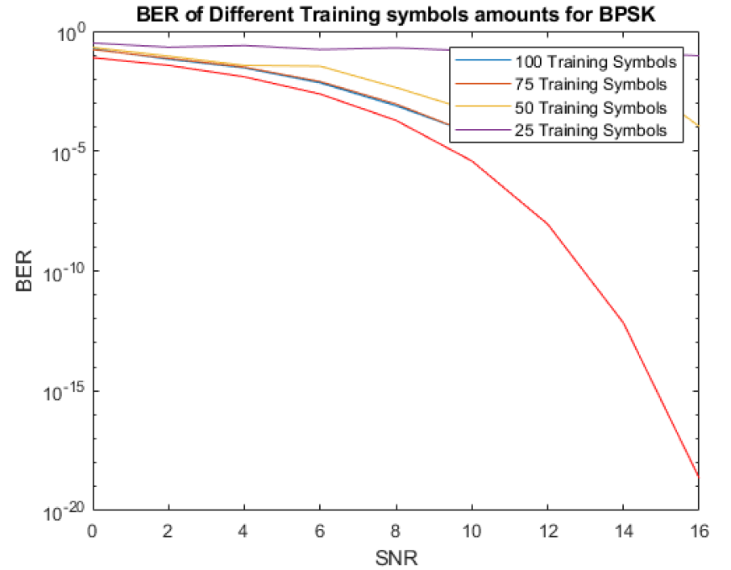

*Figure 5 BER with LMS and DFE on a BPSK*