Performance Testing Steps:

1. Press F12 to access the dev tools
2. For data to put under REST/API’s column:
   1. Look under NETWORK tab
   2. Copy data under Name column and Time column
   3. Paste data under specified column on document
3. For UI time look for
   1. Icon showing when UI is first painted (meaning when page visibly renders):
   2. 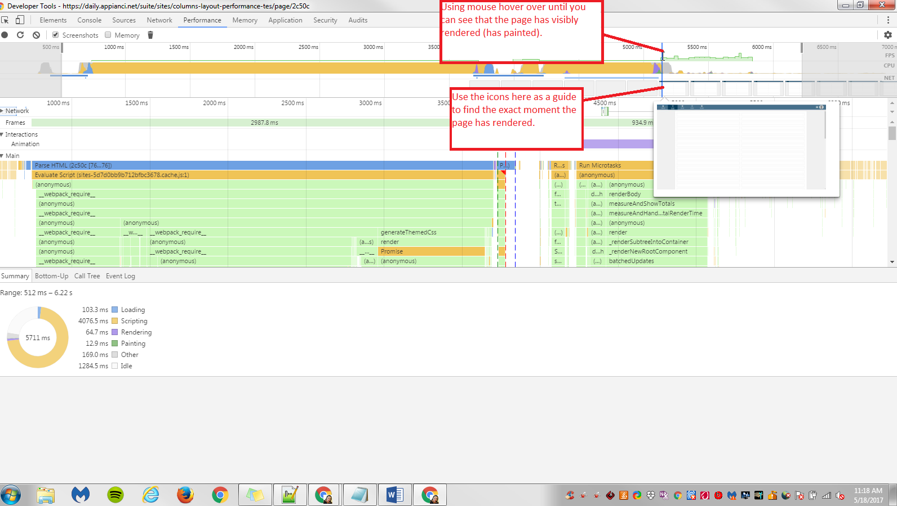
   3. Scroll over to that moment as shown in image below:
   4. 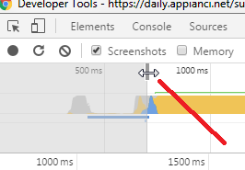
   5. 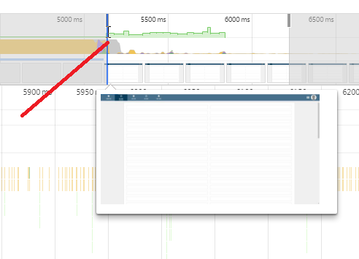
   6. Use the other scroll bar to align with the end of green data
   7. 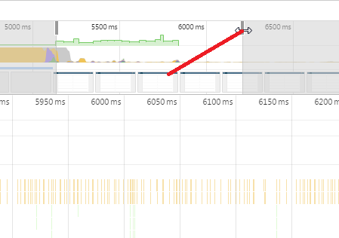
   8. 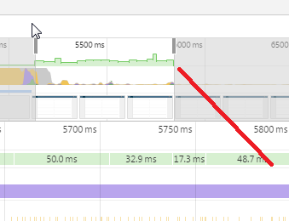
   9. Now look for the pie chart at the bottom left of screen- This is the information needed to record.
   10. 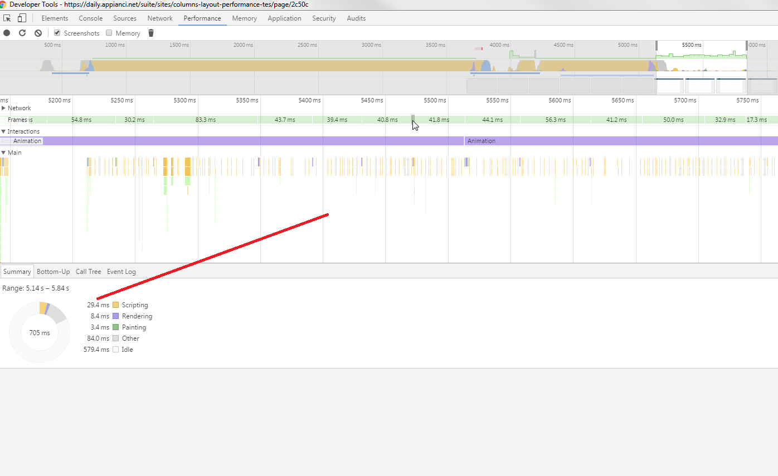
4. For Entire Browser Timeframe:
   1. Use the scroll bar pictured below- scroll to far right of screen
   2. 
   3. Look at pie chart at bottom left of screen. Where it says range, use final number.
   4. 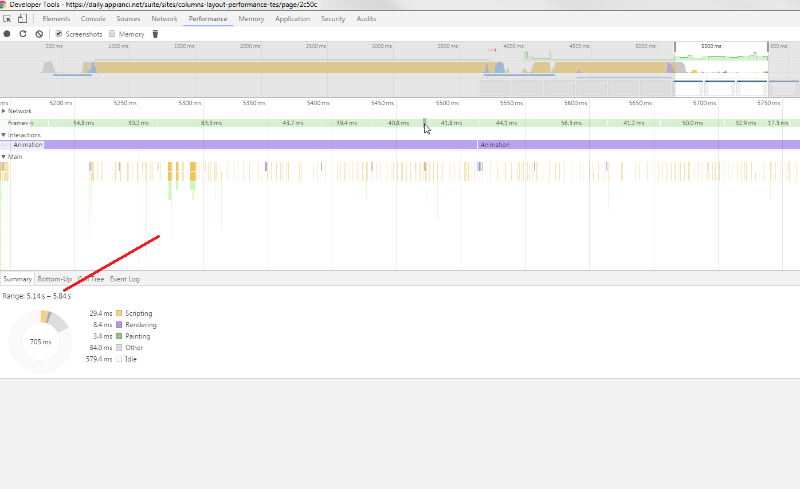
5. For REST Timeframe- look under NETWORK tab at FINISH (bottom of screen)
   1. 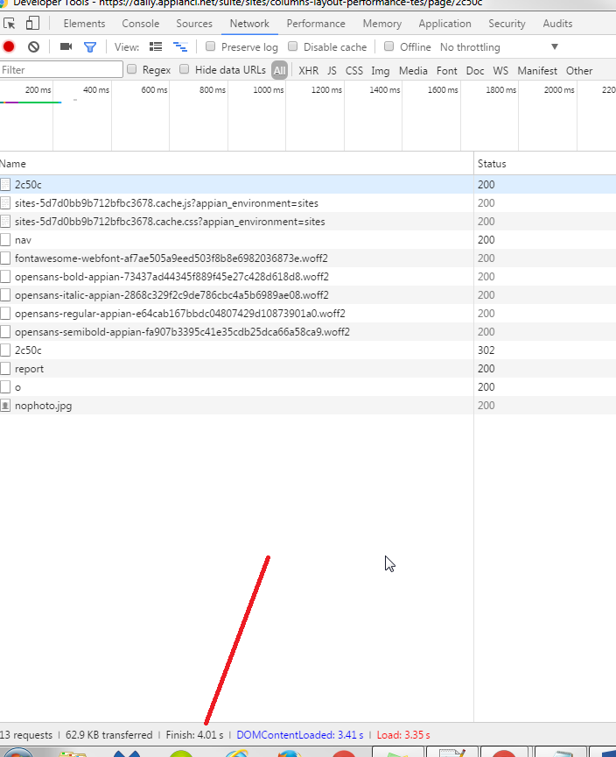
6. For UI Main Rendering-
   1. Using the steps from # 3 (UI Time) view the pie chart.
   2. The start number is the first number in the range.
   3. The end number is the last number in the range.
   4. 
7. Total UI Rendering will auto populate. It is the difference between range number of # 6.
8. Remember between each test case to cancel within the NETWORK and PERFORMANCE tab before you refresh so that the data is accurate.
   1. 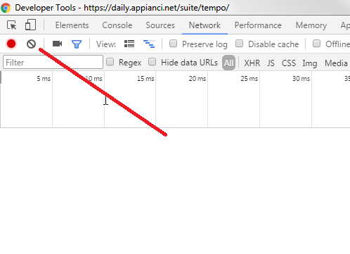
   2. 