**Demo 07**

**Content Creation for Eco-Friendly Reusable Water Bottles Marketing Using *Write For Me* GPT**



**Objective:** To create engaging and relevant marketing content for an eco-friendly reusable water bottle using **Write For Me** GPT, aiming to connect authentically with environmentally conscious consumers

**Tools required:** Write For Me

**Prerequisites:** ChatGPT - 4

**Steps to be followed:**

1. Log in to ChatGPT
2. Navigate to ExploreGPTs and search for 'Write For Me' GPT
3. Copy the scenario and prompt provided below, and paste it into *Write For Me* GPT
4. Observe the response

**Step 1: Log in to ChatGPT**

To proceed with your tasks, visit the official website and either sign up for a new account or log in to your existing ChatGPT account.

[**https://chat.openai.com/**](https://chat.openai.com/)

**Step 2: After logging in to ChatGPT-4, navigate to ExploreGPTs and search for 'Write For Me' GPT**

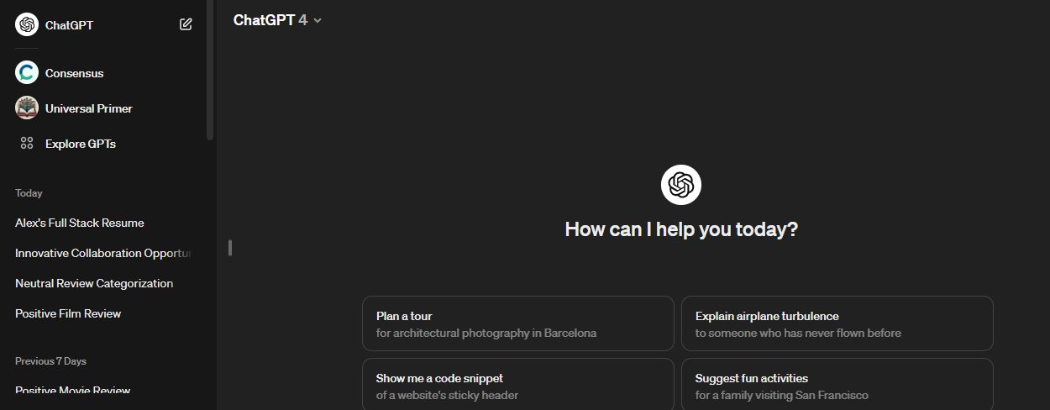

**Step 3: Copy the scenario and prompt provided below, and paste it into *Write For Me* GPT**

**Scenario:**

You're preparing to launch an eco-friendly reusable water bottle made from sustainable materials. Your target audience is environmentally conscious individuals who are active and health-conscious. You aim to highlight the benefits of your product over single-use plastic bottles, emphasizing sustainability, health benefits, and your commitment to reducing plastic waste. Your goal is to connect with potential customers who value eco-friendly alternatives to everyday products.

**Prompt:**

Create a compelling blog post for our new eco-friendly reusable water bottle product. The blog post should introduce the product and its unique features, discuss the importance of reducing single-use plastic in our daily lives, and highlight the health and environmental benefits of choosing our sustainable water bottle.

The tone should be informative, engaging, and persuasive, aiming to connect with health-conscious and environmentally aware individuals.

**Step 4: Observe the response**

