Audible Product Sales Data

- Project Overview: -
- This project is on data visualization aids on providing key insights for the sales trend on audible product sales based on relevant parameters
- This project analyses sales data using Excel and Power BI to find trends and improve business decisions.

2. Tools Used
- Microsoft Excel
- Power BI

- Dataset
- Source: [Audible_Uncleaned]
- Data contains: [Duration, Price, Ratings, Author Name, Narrator Name, etc.]

4. Steps Followed –
- Cleaned data in Excel (Removed blanks, formatted columns)
- Used Excel formulas and Pivot Tables for basic analysis
- Imported cleaned data into Power BI - Built dashboards using charts, slicers, and KPIs

5. Key Insights
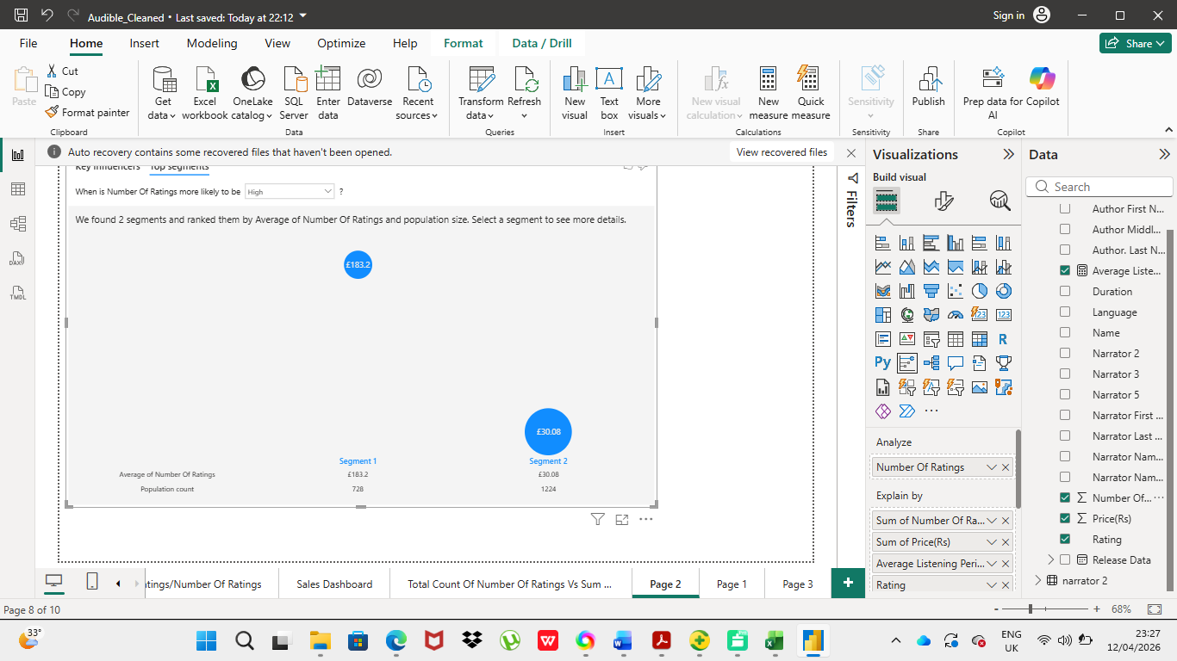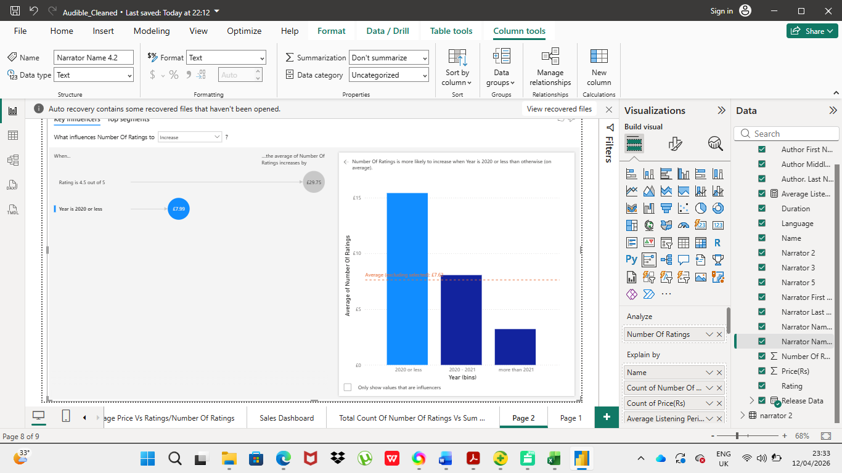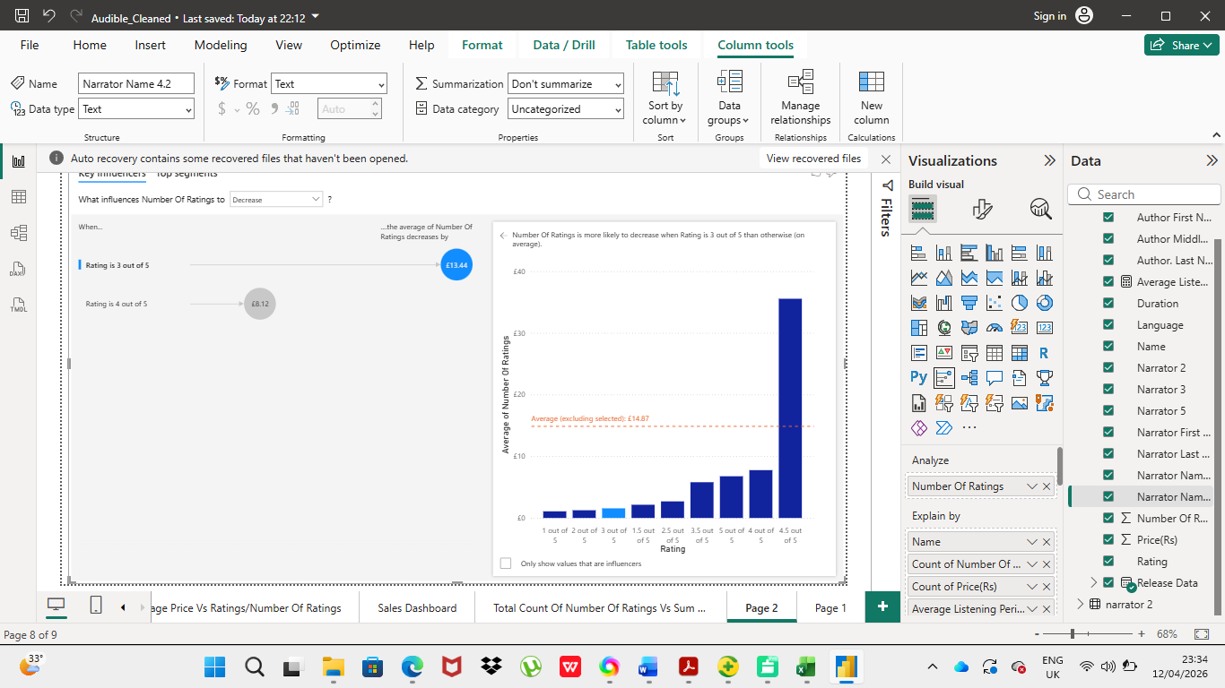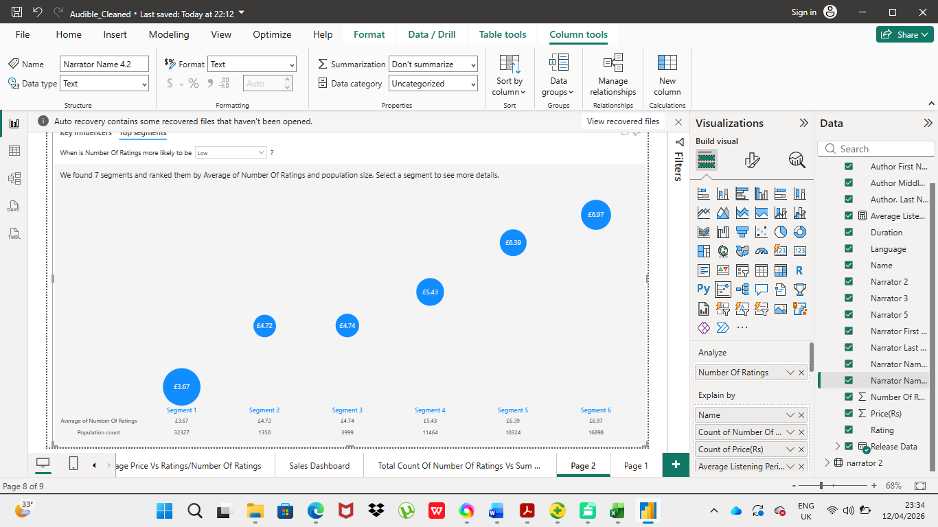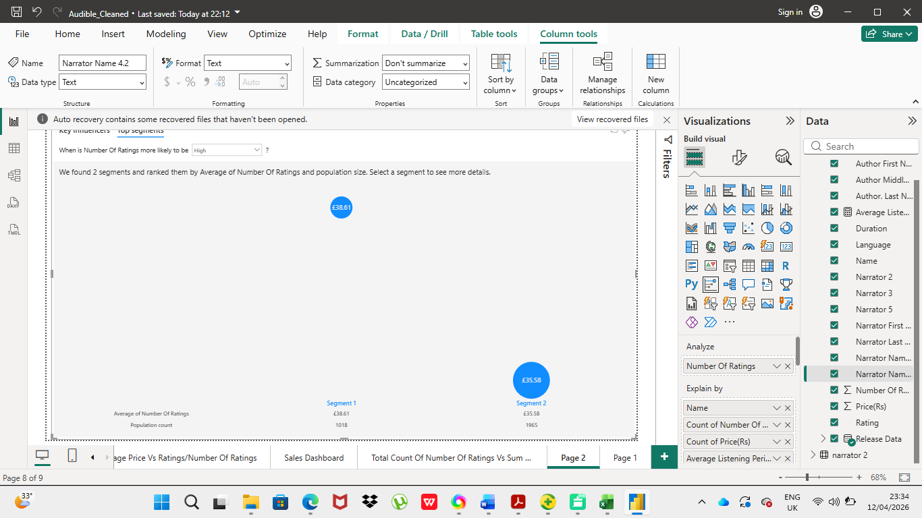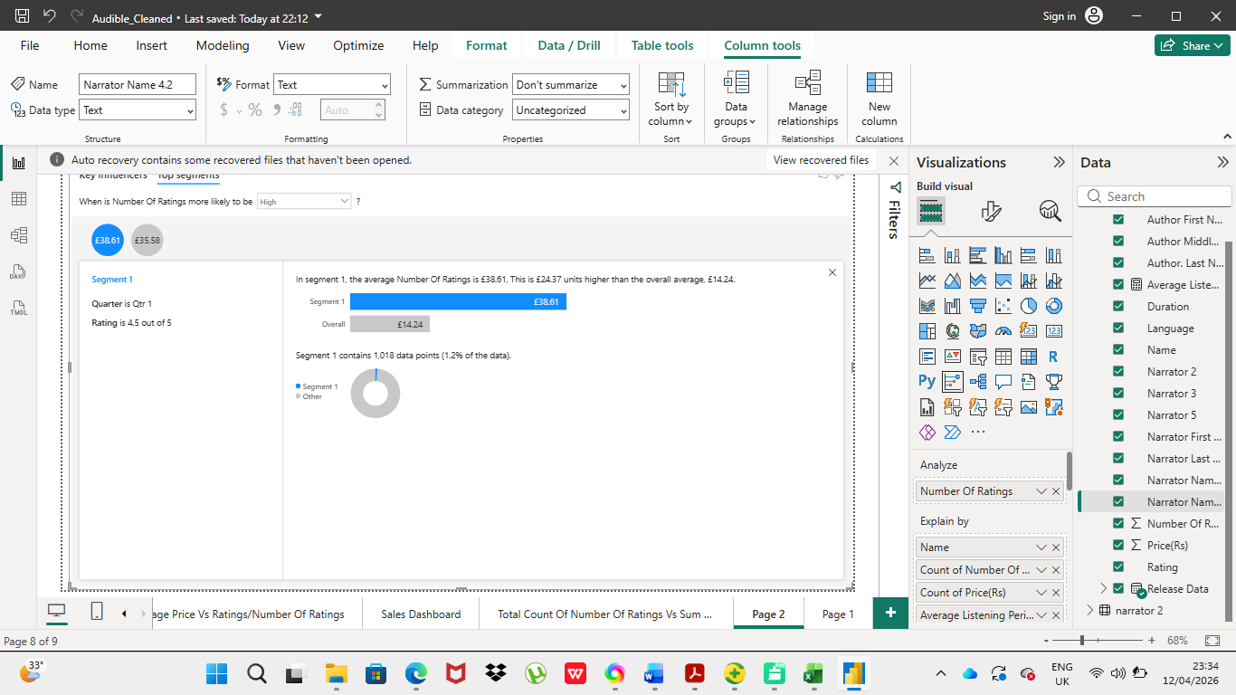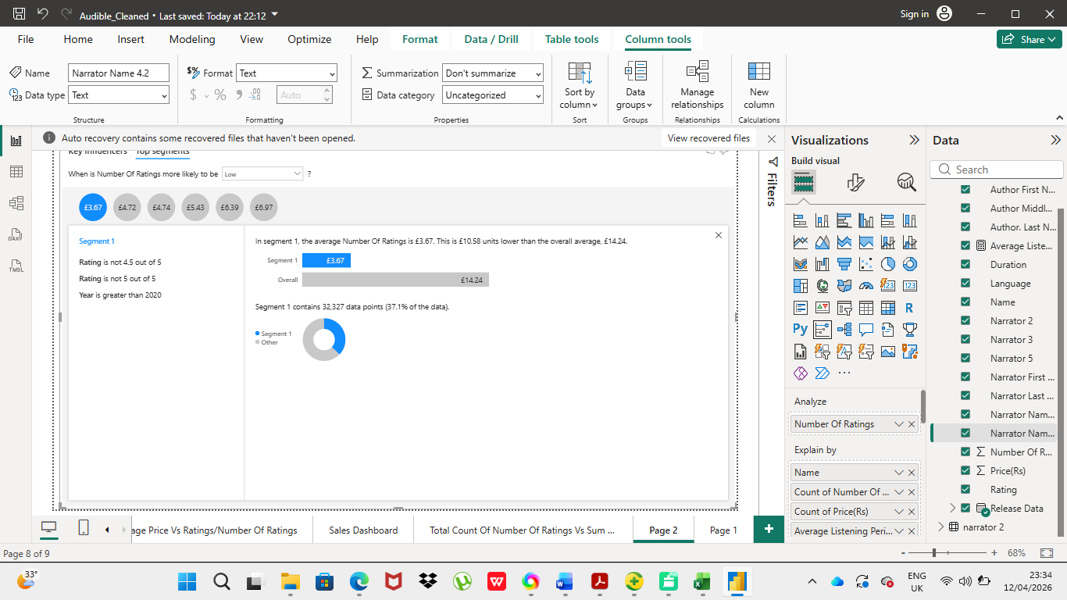

6. Dashboard Screenshots:
Pasted below are the overall dashboard screenshot for convenient reference
Via Power Bi
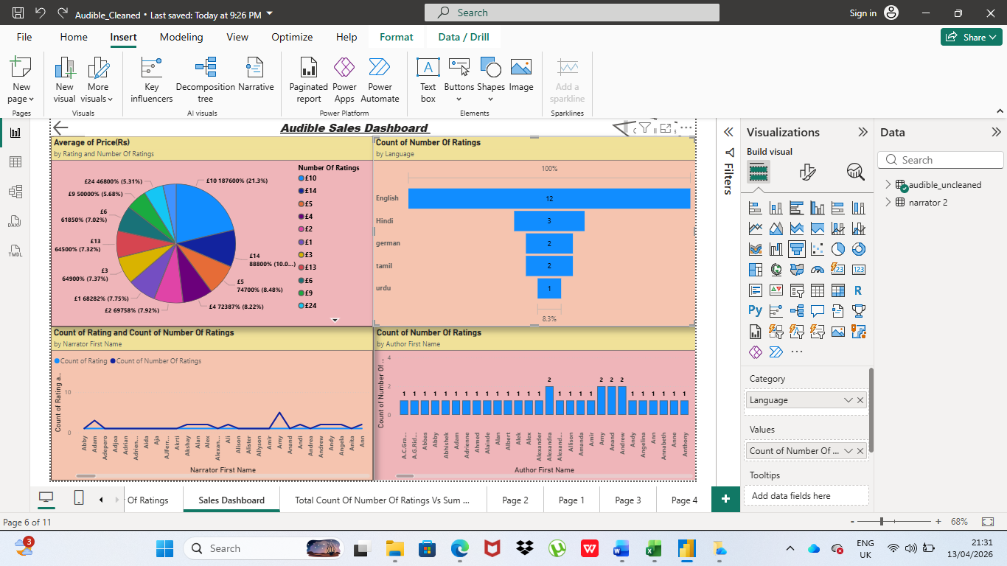

Via Excel
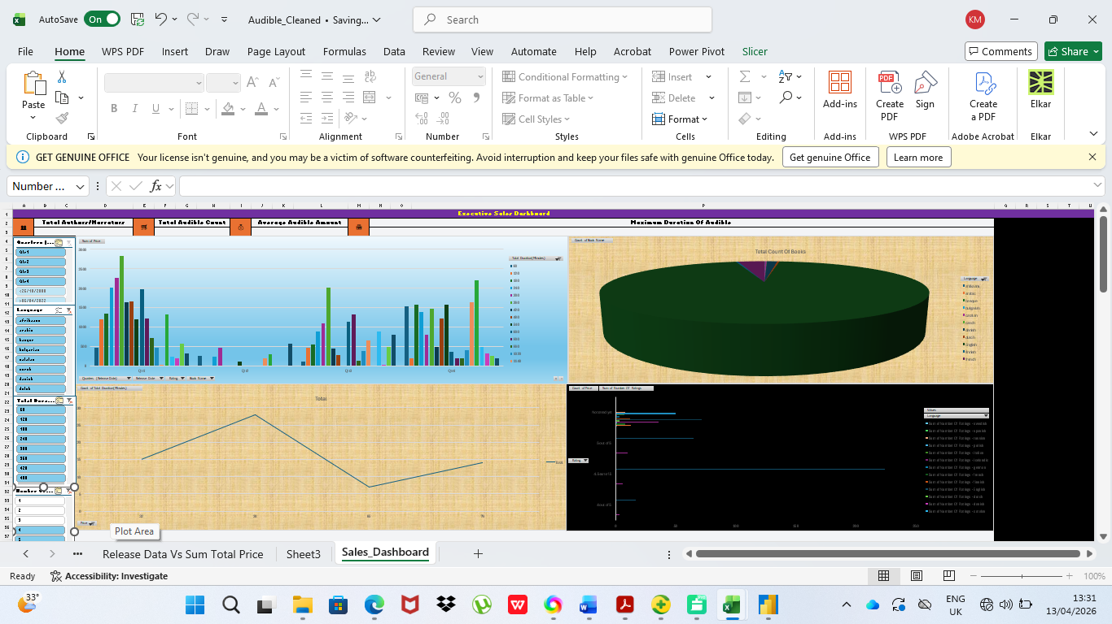

7. Files Included –
- Audible_Uncleaned.xlsx
- Cleaned data and basic analysis - Audible_Cleaned.pbix
- Power BI dashboard
- Project description

8. How to Use –
- Open Audible_Cleaned.pbix to view the cleaned data
- Open Audible_Cleaned.pbix in Power BI Desktop to explore the visuals.
- Please zoom out for better viewing in certain graphical representations
- Slicers can be selected for required data selection

