COS 314: Artificial Intelligence
Project 3: Neural Networks
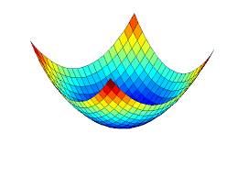
Dr. Katherine Malan
Student: Kevin Mc Inerney
ID: U15402569

[28/05/2015]

Contents
Abstract 4
Data Set 5
Splitting the data 6
Feature Extraction 6
Wrangling 7
Neural Network Architecture 8
Optimizing Parameters 10
Learning Rate & Momentum 10
Convergence Rates 11
Conclusion 13

"Entities should not be multiplied unnecessarily."

-William of Ockham-

Abstract
A neural network was implemented by the author using the powerful backpropagation algorithm. The neural network was trained and optimized to function as an efficient and accurate English-Afrikaans language classifier. The final model demonstrates accuracy levels of approximately 99% and relies on a simple architecture. The current paper outlines some of the important steps that were undertaken to build and optimize this classifier. Ultimately, the author concludes that neural networks are best implemented with architectures that are as simple as possible. Simpler architectures using fewer features alleviate over-fitting and also reduce the search space of possible parameters – this is because the size of a hidden layer is generally less than the number of features. Future improvements are discussed in the conclusion.

Data Set
A corpus of English and Afrikaans text was created using a diverse range of sources such as the University of Pretoria website, online newspapers, and children’s stories. The sentences are also relatively diverse in their length showing a large standard deviation, but with an average length that corresponds well to most average sentences. The table below (Table 1) shows some basic descriptive statistics – lengths are shown in terms of the number of characters per sentence.
Table 1
 | Number of Characters
Average Sentence Length | 221.14
Standard Deviation | 98.55
Max Sentence Length | 610
Min Sentence Length | 64

The difference in sentence length between both languages is show in Table 2. The table indicates that English sentences were longer on average. Although both sentences are sufficiently long to make classification possible, it would be safer to create a more balanced dataset. This is a potential improvement that could be made.
Table 2
 | English | Afrikaans
Average Sentence Length | 230.37 | 212.35
Standard Deviation | 111.58 | 84.16
Max Sentence Length | 610 | 429
Min Sentence Length | 93 | 64

Splitting the data
To split the data into training and test sets, a modified version of the Fisher-Yates algorithm was implemented. This algorithm generates an array of unique random values within a specified range of 0.. n.

To shuffle an array a of n elements (indices 0..n-1):
for i from n − 1 downto 1 do
j ← random integer such that 0 ≤ j ≤ i
exchange a[j] and a[i]

These random values are then used to shuffle the dataset. The algorithm was modified such that random swapping could only occur between sets of numbers that were either both even, or both odd. Because the data originally alternated form one class (English) to the next (Afrikaans) with each line, this modification ensured that the classes still alternated between classes on every line even after they had been shuffled. Alternating classes during training appeared to greatly improve the accuracy and convergence rate of the neural network, although further analysis is needed to confirm this.

Feature Extraction
Thirty two features were engineered for the training of the neural network, but only three of these were used in the final model. These features are summarized below.
Table 3
Feature | Description | Example
 | Letters of the Alphabet | A,B,C,D….Z
1 - 26 | Common Afrikaans Letters | 3 of the most commonly used letters G,D,K
27 | Common English Letters | 3 of the most commonly used letters C,T,H
28 | Common English Words | 22 words such as (the, it, be etc….)
29 | Common Afrikaans Words | 24 words such as (om, op, dat, die..)
30 | Special Afrikaans Characters | 9 Afrikaans special characters, such as (Ô û ü..)
31 | Double vowels | Two double vowels (‘aa and ‘oo’)
32 | Bias Unit | -1
Each feature was obtained by simply counting the number of occurrences of that feature in each sentence as they were read in from a tab-delimited text file line by line. Once the counts were tallied, they were scaled and added to a two dimensional vector array – each row represents a training example, and each column a specific feature. Features were scaled to values between minus (1/sqrt(3)) and positive (1/sqrt(3)). Letters were scaled per sentence for convenience, but they could also have been scaled across all sentences. For the six booster features, information about the frequency of letter usage in different languages was found at this website: http://www.sttmedia.com/characterfrequency-afrikaans. Furthermore, information on the most frequently used words can be found here: http://www.1000mostcommonwords.com/. To explore these features the backpropogation algorithm takes in a parameter that determines how many letters from the alphabet are used as features. Furthermore, six additional booster features can be added through a Boolean parameter (true/false). All of the preprocessing described above is carried out at runtime in the TextProcessor.java class. This class is invoked in the constructor of the neural network when it is called all text related functions reside there.

Wrangling

Once the neural network has finished training/testing there is still a huge amount of data to process. Each data point had to be averaged from 30 trials and there were over 6000 rows as a result. Another class called Wrangle.java was implemented which did the job of reading in these results and returning an average result for each blocks of thirty trials. Accuracy was measured as the average accuracy taken from the last accuracy score in each row before the stopping condition was met. This was met when training accuracy reached 100%. This is not ideal as the best test score doesn’t always coincide with the best training score, especially when over fitting occurs. However, an assumption was made by the author that over-fitting would be rare due the very minimal architecture of the neural network.

Neural Network Architecture
It is advantageous to determine the number of features to use before optimizing other parameters, because the size of the hidden layer is informally constrained by how many features there are. A general rule of thumb used by many, is that the hidden layer should be approximately 2/3rds the size of the input layer or perhaps halfway between the input layer and the output layer. For this reason, an experiment was conducted to determine the optimal number of features. A neural network was run for each letter in the alphabet - with the feature set growing by a single letter of the alphabet each time. For example, in the first iteration the only feature was the letter ‘a’, in the second it was (‘a’,’b’) and so on up to (‘a’……’z’). Surprisingly, the data showed signs of over-fitting once more than just three letters were used as features. In Figure 1, the hidden layer sizes were 2 and 3, respectively, but the results were also replicated for larger hidden layer sizes of 12 in Figure 2. In the 27th iteration all six booster features are added in one go. Each data point is averaged from 30 trials.
Figure 1.
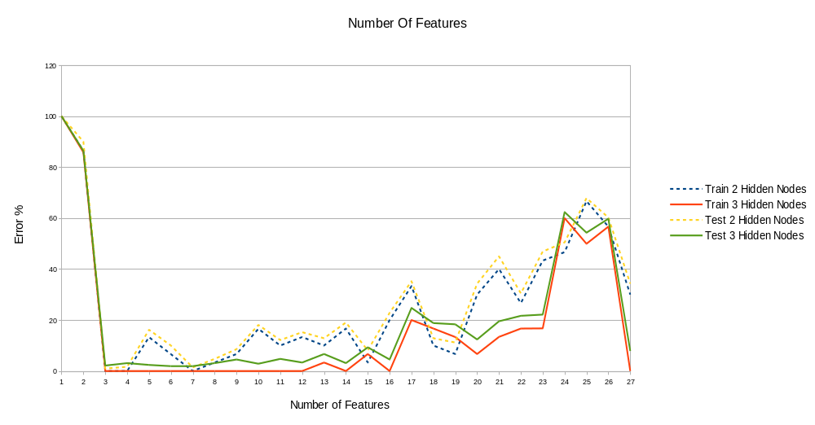

Figure 2.
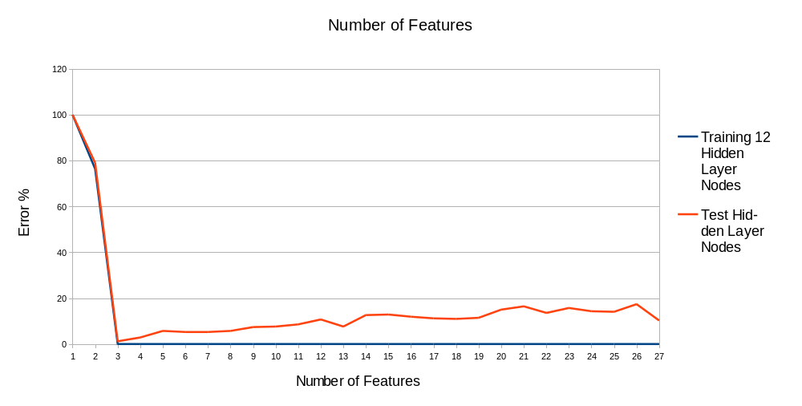
Based on these results it was decided that the features (a,b,c) would be sufficient for training. Therefore, the number of hidden layers would be either 2 or 3. A future improvement would be to sort the alphabet letters according to their discriminative strength between the two languages. For example, if the first three letters were (c,g,k) then the number of features used could potentially be made even smaller. Reducing the number of features early on also reduces the search space for optimizing our other parameters because our hidden layer size will now be at most 3 in size.

Optimizing Parameters

Learning Rate & Momentum
The following graph (Figure 3.) displays the effect of the parameters learning rate and momentum on the error rate of the neural network. Again, each data point is averaged from 30 trials and there are two set sets of lines – one for a hidden layer size of two, and one for a size of three. The average scores come from the last accuracy score taken before the stopping condition was reached (100% training accuracy).The learning rate and momentum were both measured at 10 values in the range 0.1 to 0.95 incrementing in values of 0.95. In the graph below, the learning rate increased at every10th even interval of the entire width of the graph. Momentum is increased in every 10th even interval of the larger learning rate intervals. No obvious periodicity is evident, but the error rate is consistently low. In contrast, earlier attempts to find good parameters resulted in larger error rates and more obvious effects of both momentum and learning rate (Figure 4)
Figure 3.
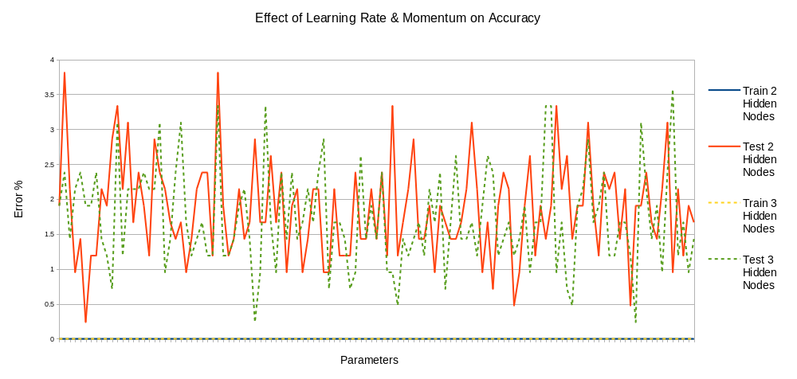

Figure 4.
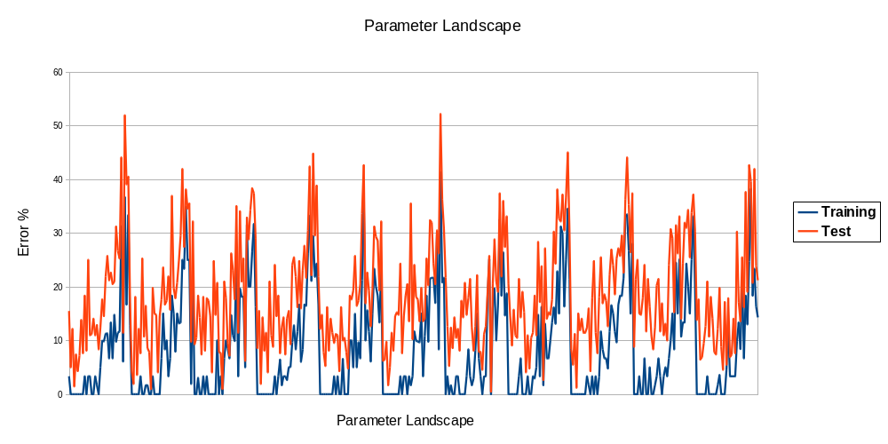

Convergence Rates
Figure 3 shows that while good accuracy is obtained it is not wildly affected by any combination of learning rate and momentum. Figure 4 shows that this isn’t always the true, however. Considering the good accuracy scores across the board, we should optimize these two parameters based on other criteria. The convergence rate of the algorithm may be affected by these parameters too and a high convergence rate might be able to increase the efficiency and speed of the neural network without any drop in accuracy. To investigate this, the same experiment was run as in Figure 3. This time, we measured the number of epochs taken to converge instead of the accuracy. Figure 5 clearly shows that higher learning rates and momentums have the effect of dramatically reducing the number of epochs required for training.

Figure 5.
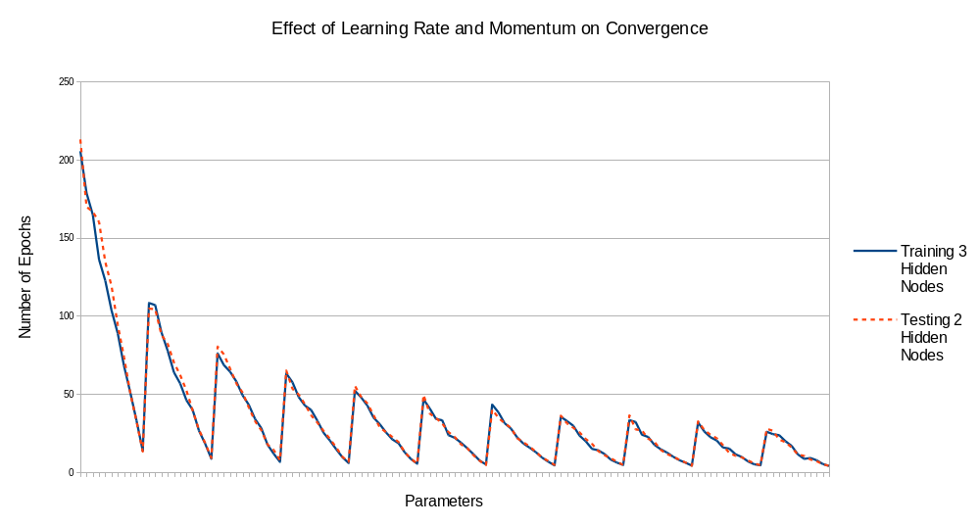
Based on all the experiments it seems that there is no good reason to use a hidden layer size of 3, rather than 2, as both appear to perform similarly. Both achieve similar accuracy, and Figure 5 above demonstrates that they converge at similar rates for a given set of parameters.

Conclusion
After conducting several experiments the optimal neural network arrived at had the following characteristics:

Table 2.
Parameter | Description
Number of Features | 3 (not including the bias unit) (a,b,c)
Number of Hidden Nodes | 2 (not including the bias unit)
Learning Rate | 0.9
Momentum | 0.9

The final set of parameters came as a surprise to author who had done much exploratory analysis using larger hidden layers sizes and high numbers of features. The biggest lesson I’ve learned is that neural networks are very powerful and prone to over-fitting when given too much information – less is more. I’ve also learned that pre-processing the data is at least equally as important to the success of the classifier as the implementation of the algorithm. I discovered that alternating training examples much improved the training speed and accuracy. Other steps such as scaling and were also clearly vital to the success of the classifier. Had the problem been more difficult, feature extraction would have played more of an important role. However, this wasn’t the case here and the booster features were ultimately discarded.
Improvements could be made by sorting the alphabet-letter features by their discriminatory power. This could reduce the number of features down from three. The code itself could be made more readable and extensible. Initially it was planned that the code would allow neural networks to be created with different numbers of hidden layers. However, this idea was abandoned for convenience and but the code still remains over complicated in places as a result.

