LOCKSMITH INSTANT QUOTE & LEAD CAPTURE PLATFORM
SaaS Multi-Tenant Operations & Customer Lead Acquisition Manual

Prepared for: Atypikal Locksmiths & Location Operators
Author: Lead Systems Engineering Team
Date: July 2026
Version: 1.0.0
Table of Contents
Below is the hierarchical map of the contents documented in this operational manual:
- 1. System Overview & Architecture — Explains the SaaS components, tech stack, and landing page interface.
- 2. Embeddable Instant Quote Wizard — Highlights the user flow, service forms, postcode check, pricing matrix, and notifications.
- 3. Administrative Management Dashboard — Details lead metrics, leads table, quotes log, and Kanban workspace.
- 4. Tenant Settings & Branding Setup — Guides tenant profiles, business details, notifications customizers, and branding.
- 5. Technical Installation & Deployment — Walks engineers through database seeding, env config, and running the build locally.
1. System Overview & Architecture
The Locksmith Instant Quote & Lead Capture Platform is a comprehensive multi-tenant software system designed for the modern locksmith enterprise. The application acts as a customer capture gateway, dynamically generating pricing estimates based on various factors, geolocating enquiries, and supplying local operators with lead monitoring capabilities.
Tech Stack Foundation
The system is engineered on top of the following production-grade tech stack:
- Framework: Next.js 15 (utilizing React 19 and Turbopack compiler engines for speed).
- Database and ORM: Drizzle ORM interacting with PostgreSQL (with auto-fallback to local in-memory store in mock mode).
- Styling: Vanilla Tailwind CSS v4, supporting dynamic CSS glassmorphism, responsive viewports, and modern animations.
- Integrations: Resend API (Email notifications) and Twilio (SMS technician dispatching).
The SaaS Landing Page
The landing page presents a dark-themed, glowing landing portal displaying the software-as-a-service features. It highlights how businesses can embed the quote widget on any platform (WordPress, Wix, Elementor, Custom HTML) and manage their operations from the back-office dashboard.
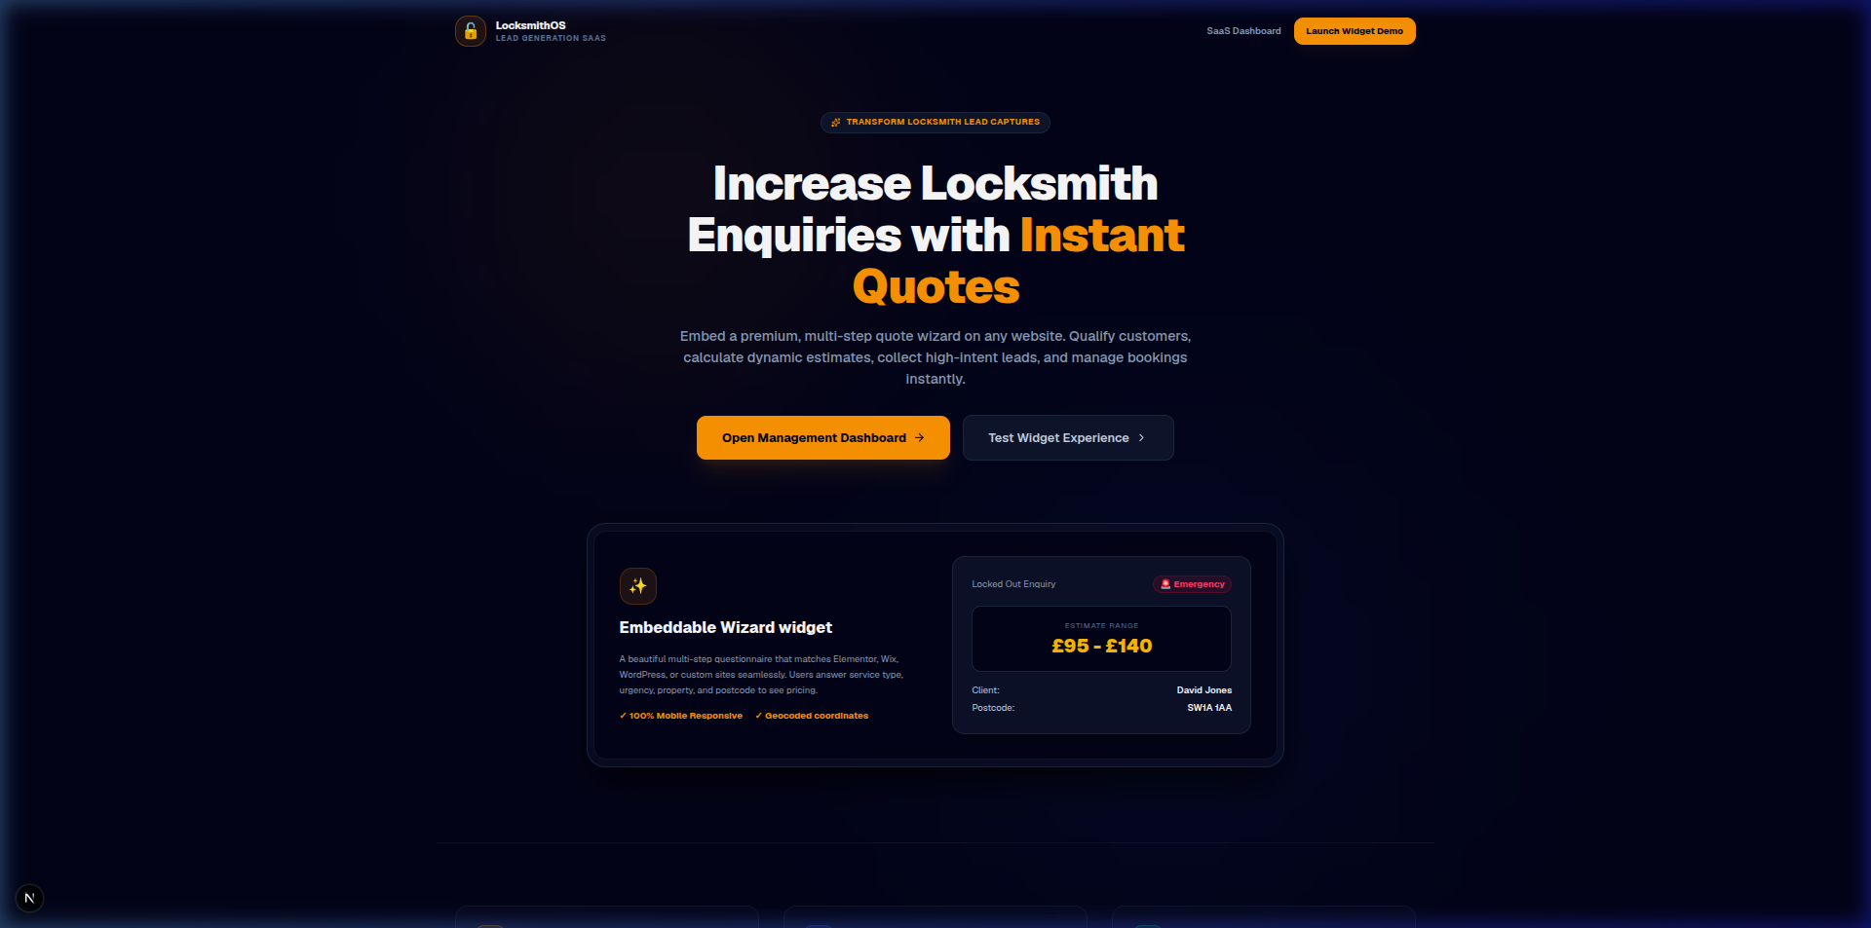
Figure: The SaaS Landing Page showing widgets integration benefits
2. Embeddable Instant Quote Wizard
The frontend customer wizard is a 6-step multi-stage questionnaire designed to eliminate friction and qualify high-intent emergency or scheduled lock enquiries.
Customer Booking Steps
- Step 1: Service Type Selection — Offers 8 lock service types, including Locked Out (Emergency), Lost Keys, Broken Key, Lock Replacement, Lock Repair, UPVC Door Lock, Security Upgrade, and Commercial Locksmith.
- Step 2: Property Type — Distinguishes between Residential and Commercial lock types to adjust parts pricing and dispatch criteria.
- Step 3: Urgency Level — Sets dispatcher priority: Emergency (immediate dispatch), Same Day, or Booked in Advance.
- Step 4: Postcode Verification — Validates customer location (e.g. SW1A 1AA) to compute geographical travel distances.
- Step 5: Contact Credentials — Gathers name, telephone, email address, and records marketing/SMS consent.
- Step 6: Dynamic Pricing Display — Instantly shows the customer a calculated estimate range.
Pricing Matrix Logic
The system computes prices using the formula:
Estimate = (Base Service Rate + Urgency Premium) * Property Multiplier + Distance Surcharge
The table below shows the base rates for key services:
Locksmith Service | Base Rate | Property Multiplier | Average Time
Locked Out (Emergency) | £80.00 | Residential (1.0x) / Commercial (1.3x) | 30 - 45 mins
Lost Keys & Lock Rekey | £90.00 | Residential (1.0x) / Commercial (1.3x) | 45 - 60 mins
UPVC Door Mechanism Fix | £110.00 | Residential (1.0x) / Commercial (1.4x) | 60 - 90 mins
Commercial Master Keying | £150.00 | Commercial (1.0x) | 90+ mins
Instant Notifications & Technician Dispatch
Immediately when the client clicks 'Generate Instant Quote', two background communications are fired:
- SMS Dispatch (Twilio): A message is dispatched to the technician's mobile with client name, service type, urgency, phone, and estimate range.
- Email Summary (Resend): A complete email summary is sent to the tenant inbox containing geocoded travel routing, postcode, and full enquiry answers.
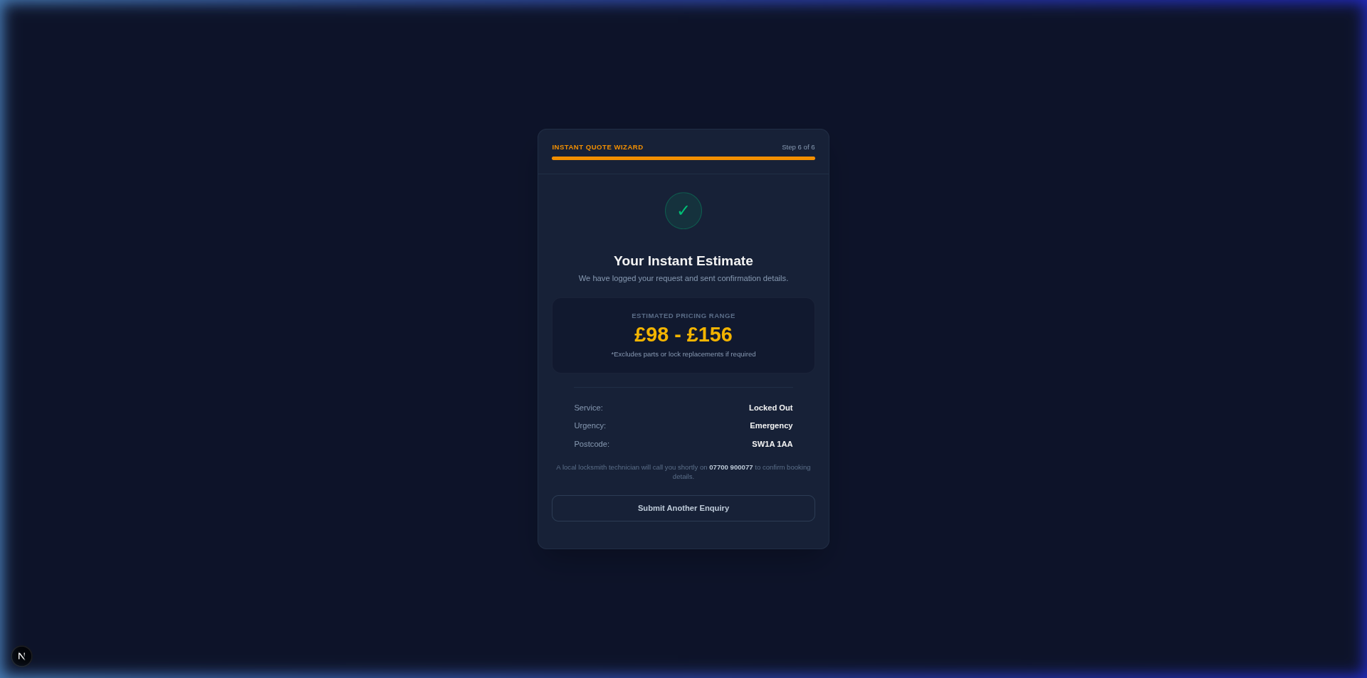
Figure: Quote Wizard step 6 displaying the dynamically computed locksmith pricing estimate
3. Administrative Management Dashboard
The admin dashboard is a secure control center allowing locksmith businesses to view, update, and manage leads as they progress through the system.
Key KPI Analytics Counters
The top of the dashboard displays 4 real-time business counters:
- Total Leads: Total count of leads captured in the database.
- Quotes Generated: Total number of calculated locksmith estimates.
- Conversion Rate: Percentage of leads that transitioned to Booked or Completed status (target is >80%).
- Average Quote Value: The average pound-sterling (£) value computed across all quote history.
Lead Pipeline (Kanban Board)
To simplify customer management, the dashboard implements a visual Kanban board divided into six columns:
- 1. New Lead: Fresh enquiries directly populated by the Quote Wizard.
- 2. Contacted: Leads who have been called or messaged for initial scheduling verification.
- 3. Quoted: Customers who have received a finalized formal quote/booking contract.
- 4. Booked: Confirmed jobs scheduled in the dispatch calendar.
- 5. Completed: Successful locksmith site visits where jobs were finalized and resolved.
- 6. Lost: Declined leads, unresponsive clients, or out-of-coverage postcode requests.
Technicians can drag and drop cards from one column to another. The card position update instantly triggers a REST PATCH request to the API, changing the database state in real-time.
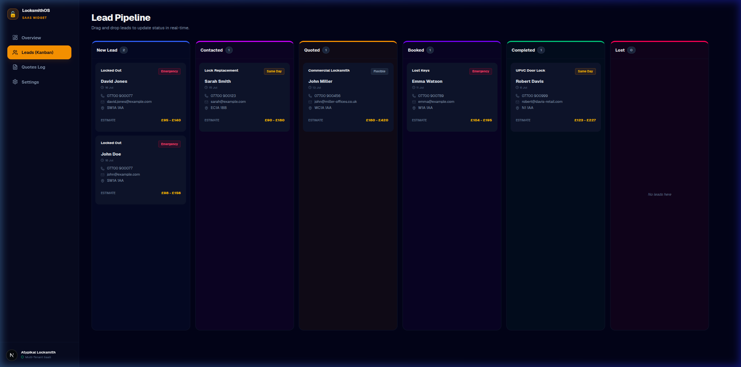
Figure: Lead Pipeline Kanban workspace with custom status columns and detail cards
4. Tenant Settings & Branding Setup
Because the system is built with a multi-tenant structure, each locksmith brand can fully customize the widget styling and dispatch behavior.
Customizable Variables
Through the dashboard settings page, tenants can configure:
- Profile Details: Business name, phone line, address, support email, and brand logo upload.
- Notification Dispatch: On/off toggles for SMS alerts and email client receipts.
- Custom Notification Templates: Templates are customized using placeholder variables that parse real-time database details:
- - {clientName}: Parses the full name of the customer.
- - {serviceType}: The type of service selected in step 1.
- - {estimate}: The dynamically generated price range.
- - {phone}: The customer's contact telephone.
- - {postcode}: The customer's geographic postcode location.

