Site Indicator Species for Predicting the Productivity of Teak Plantations in Phrae Province, Thailand

Narinthorn JUMWONG¹, Chongrak WACHRINRAT^{2,*}, Sarawood SUNGKAEW³
and Atchara TEERAWATANANON⁴

¹Faculty of Forestry, Kasetsart University, Thailand, ffornrt@ku.ac.th
²Department of Silviculture, Faculty of Forestry, Kasetsart University, Thailand, fforcrw@ku.ac.th
³Department of Forest Biology, Faculty of Forestry, Kasetsart University, Thailand, sungkaes@tcd.ie
⁴Natural History Museum, Pathum Thani, Thailand, teerawaa@tcd.ie
*Corresponding Author

Keywords: Productivity, Site Indicator Species, Site Quality, Teak Plantation, Thailand

INTRODUCTION
In Thailand, teak plantations have been managed for last 112 years for the timber industry. Site quality assessments of the teak plantations are based on site index method and soil survey. The site index method, however, need the record of teak growth in each site, and it is difficult to evaluate the site quality and productivity of teak at the site lacking teak growth record and when we establish a new teak plantation. This research aimed to evaluated site quality for teak plantation by using plant indicators species.

Materials and methods
The study was conducted in teak plantations belonging to the Forest Industry Organization (FIO) in Phrae province, Northern Thailand included the Wang Chin (WC), Khun Mae Kham Mee (KM), and Mae Sa-Roy (MS) plantations (Figure 1). These plantations cover a wide range of growth rates and the trees in them cab be distributed into 6 classes based on their age, i.e., 6-10, 11-15, 16-20, 21-25, 26-30, and >30 years. Twenty four temporary sample plots were randomized using a dominant height growth covering 5 site index classes, established by the Forestry Research Center (1997). Setting a temporary sampling plot of 40x40 m in size, dominant height of 16 trees was measured using a haga altimeter. The DBH of all trees was measured by a diameter tape. 5 Sub-quadrates, of 4x4 m in size, were set up at the corners and in the middle of the plots, there number were 5 per plot (Figure 1). The frequency and density of every plant species were estimated.
The site index for teak at base age 30 years was determined using the anamorphic site index method (Prasomsin 1991). The under story characteristics were included the scientific name, family, and life form (Smitinan 2014). The site indicator species was analyzed by Indicator Species Analysis (ISA) and Two Way Indicator Species Analysis or TWINSPAN available in PC-ORD version 6.08, developed for windows (McCune & Mefford 2011).

RESULTS AND DISCUSSION
Results

Site index of teak
Site index of teak was divided into 3 site classes as 24, 21, and 18, indicating good, moderate, and poor site qualities, respectively (Figure 2).

Under story characteristics
In this study, we included all the plants that grew under the teak stand as an under story. A total of 110 species from 38 families were classified by their habit into 12 types, Bamboo (B), Climber (C), Climbing Fern (CF), Exotic herb (ExH), Exotic shrub (ExS), Grass (G), Herb (H), Shrub (S), Shrub/Shrubby tree (S/ST), Shrub/Tree (S/T), Tree (T), and Terrestrial Fern (TerF). Most of the under story comprised of trees (55 species). The dominant family of the under story was Fabaceae with a total of 24 species.

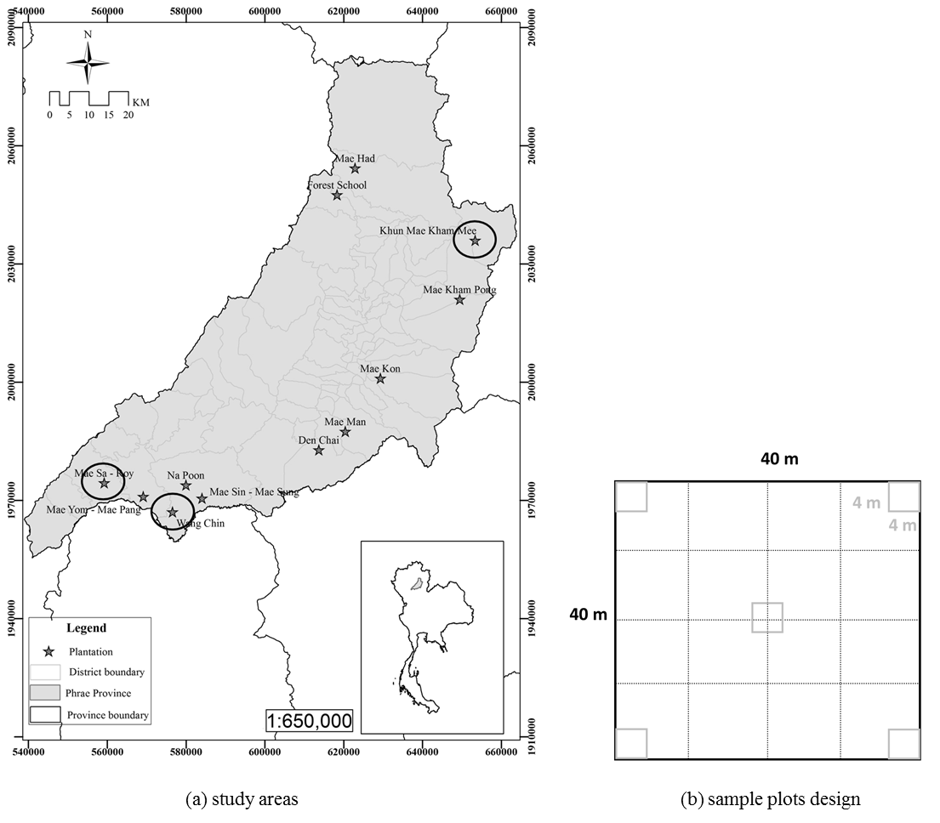

Figure 1. The location of the three study areas, Khun Mae Kham Mee plantation, Wang Chin plantation, and Mae Sa-Roy plantation (a) and the sample plots design (b).

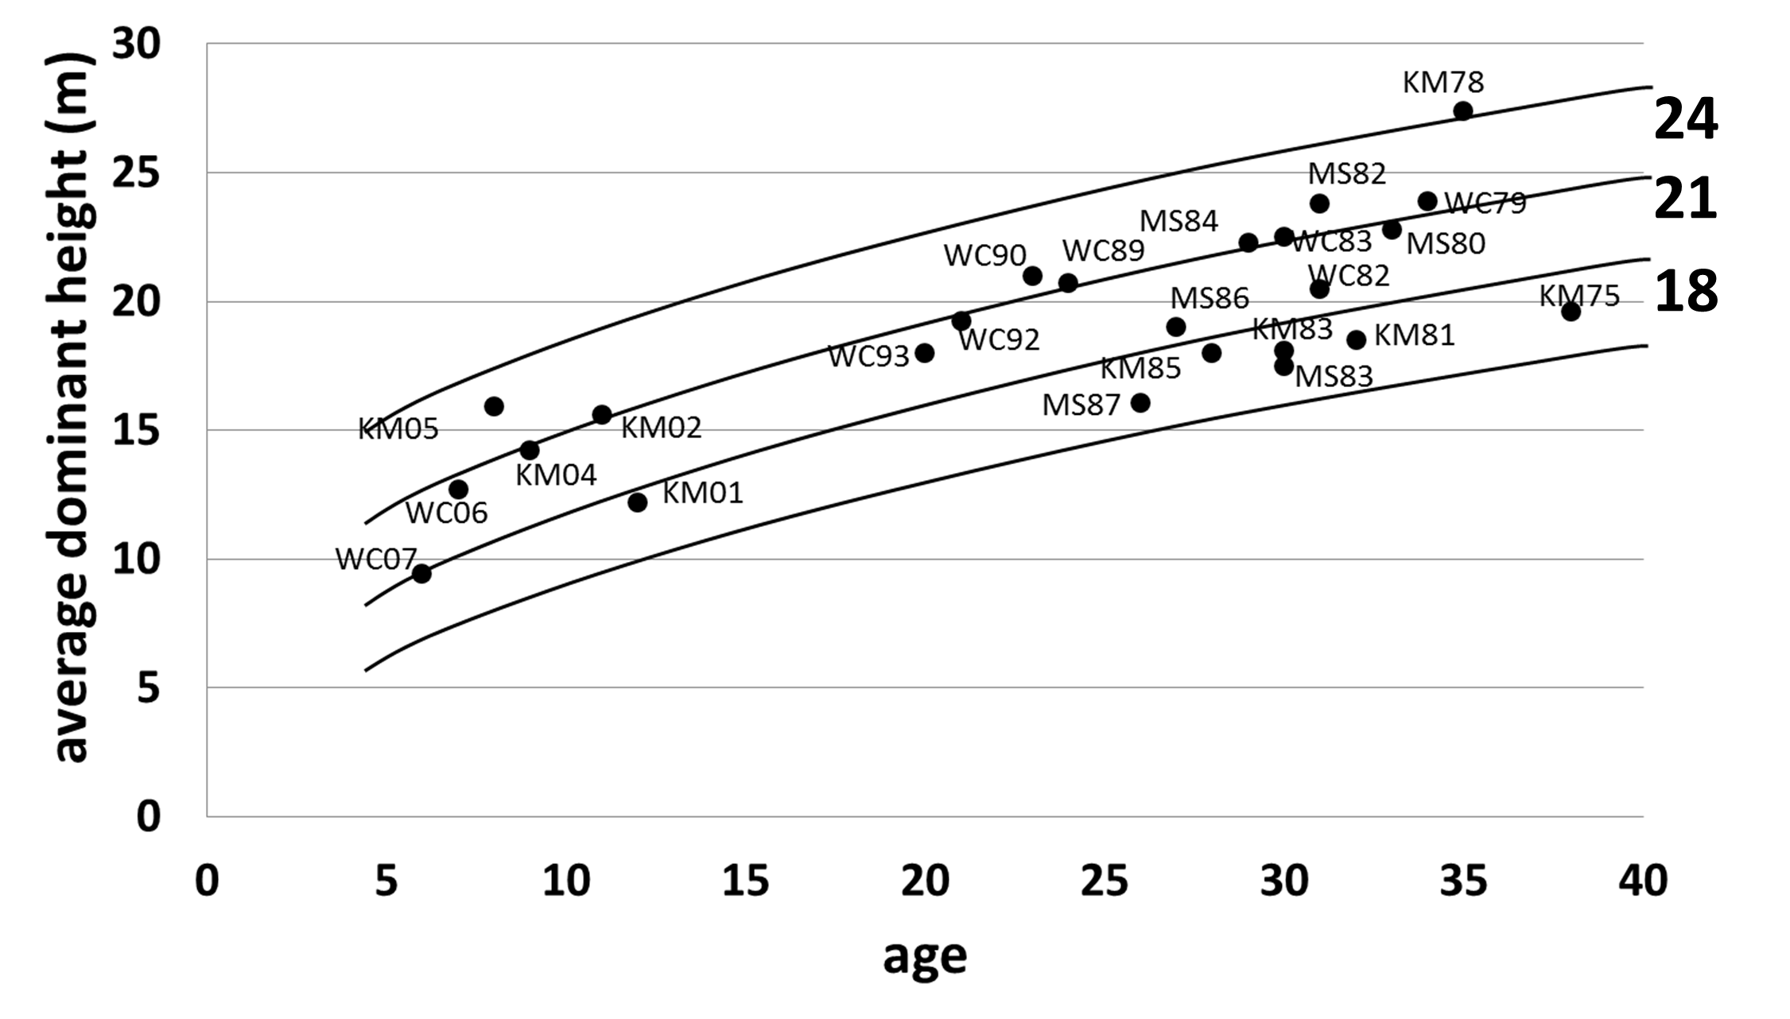

Figure 2. Site index classes for teak in the various plantations located in the Phrae province, Thailand

Plant indicator species
The results of Indicator Species Analysis (ISA) showed the significantly indicator species of the good site, moderate site and poor site, respectively from the highest to the lowest significant value (Table 1).

Table 1. Plant indicator species derived from ISA
Site Class | Indicator SPP. | P Value | Significance level
Site Class | Indicator SPP. | P Value | Bonferoni  correction | Sequential  bonferoni | FDR
3 plantations
good site | Streblus ilicifolius | 0.0194 | 0.00075 | 0.00075 | 0.00075
good site | Lagerstroemia floribunda | 0.0200 | 0.00075 | 0.00076 | 0.00149
good site | Dalbergia cana | 0.0254 | 0.00075 | 0.00077 | 0.00224
poor site | Dalbergia nigrescens | 0.0444 | 0.00075 | 0.00078 | 0.00299
moderate site | Mimosa pudica | 0.0472 | 0.00075 | 0.00079 | 0.00373
Khun Mae Kham Mee Plantation (KM)
good site | Lagerstroemia calyculata | 0.0160 | 0.000658 | 0.00066 | 0.00066
good site | Dalbergia cana | 0.0160 | 0.000658 | 0.00067 | 0.00132
Wang Chin Plantation (WC)
good site | Streblus ilicifolius | 0.0080 | 0.000133 | 0.00083 | 0.00083
Mae Sa-Roy Plantation (MS); |  | No indicator species

The results from TWINSPAN revealed the under story species were clearly grouped by area. The under story in MS and WC were clustered in the negative group (group 0). Therefore, the under story in KM were found to lie in the positive group (group 1). In sites with moderate and poor suitability, the indicator value did not point to the species indicator. On the other hand, species indicators for a good site quality class in KM and WC were Dalbergia cultrate and Croton stellatopilosus, respectively (Figure 2).

Discussion
An ecosystem is the product of a complex interaction of biological environment (Green and Klinka, 1994). As a result, different areas contain different environmental factors that determine the presence or absence of various plant species. Plant indicator species analysis should be defined in a contiguous area and coverage over the entire area. More sample plots will increase more reliability of the results.
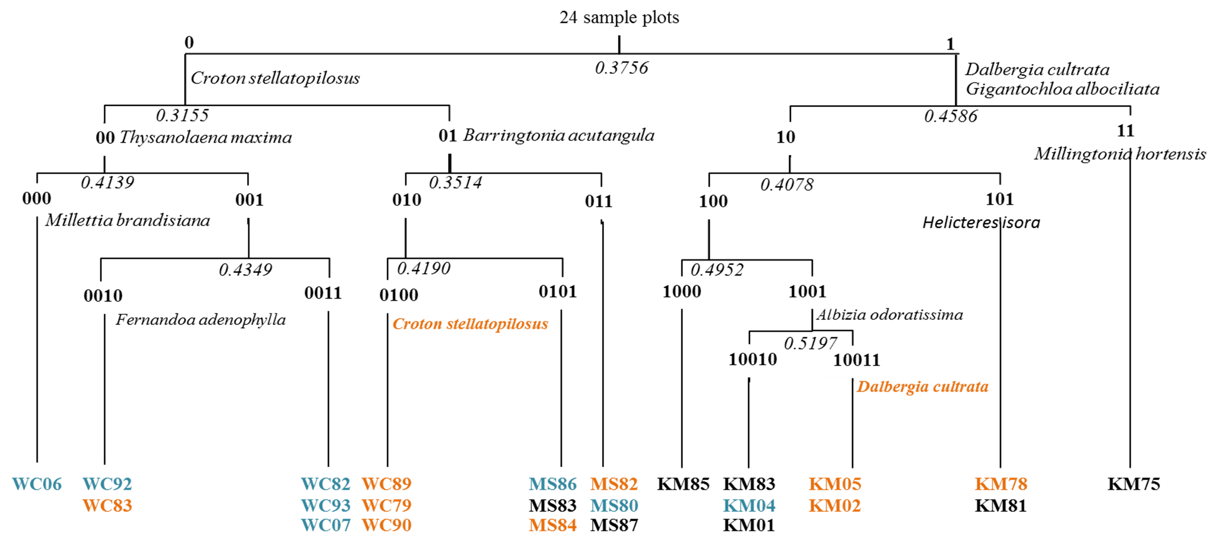

Figure 2. Vegetation types determined by TWINSPAN. Eigenvalues and indicator species for each division are shown.
Remark: For the sample plot; orange alphabets are good site, blue are moderate site and black are poor site

REFERENCES
Forestry Research Center. 1997. Surveying and evaluation of yield in FIO plantation: Forestry Research Center, Faculty of Forestry, Kasetsart University. (In Thai)
Prasomsin P. 1991. Forest mathematics manual: Faculty of Forestry, Kasetsart University. (In Thai)
Smitinan T. 2014. Thai Plant Names: Forest Herbarium of the Royal Forest Department. (In Thai)
Mccune B & Mefford MJ. 2011. PC-ORD: Multivariate Analysis of Ecological Data, Version 6.0 for Windows. Gleneden Beach, Oregon.
Green RN & Klinka KA. 1994. Filed Guide to Site Identification and Interpretation for the Vancouver Forest Region: Ministry of Forest Research Program of British Columbia.

