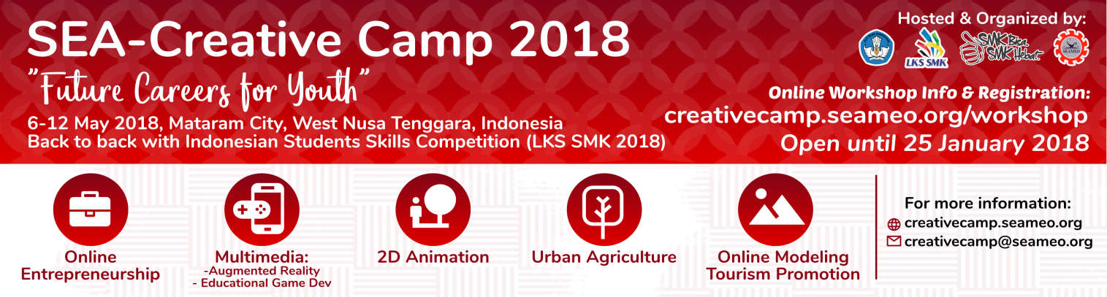

Indonesian National Education Day’s Celebration and

National Student Skills Competition

7-11 May 2018 I Lombok City Center, Mataram City, Lombok, Indonesia

**PARTICIPATION FORM**

**(Judging Member)**

To confirm the participation of this event, please fill out this form and return it to SEAMEO **by or before Wednesday 2 May 2018** by email: [creativecamp@seameo.org](mailto:creativecamp@seameo.org); [piyapa@seameo.org](mailto:piyapa@seameo.org)**;** [alfan@seamolec.org](mailto:alfan@seamolec.org); agustaufiq.id@gmail.com

|  |  |  |  |
| --- | --- | --- | --- |
| 1. **Resource Person’s Profile** | | | |
| Name: Riana Hartati | | | |
| Position: Lab Research Staff | | | |
| Organisation: SEAMEO BIOTROP | | | |
| Address: Jl. Raya Tajur Km. 6 | | | |
| City: Bogor | Postcode: 16134 | | Country: Indonesia |
| Tel: + 62 [(251) 8323848](https://www.google.com/search?q=alamat+biotrop&ie=utf-8&oe=utf-8&client=firefox-b-ab) | | Fax: + 62 [(251) 8323848](https://www.google.com/search?q=alamat+biotrop&ie=utf-8&oe=utf-8&client=firefox-b-ab) | |
| Email Address: riana@biotrop.org | | Mobile Number: 085694465604 | |
| 1. **Topic of your presentation at sharing session (30 minutes)** | | | |
| Presentation Topic: Mini-HUBS (Mini Hydroponics from Used Bottles)  Duration of Presentation: 30 minutes | | | |
| 1. **Hotel Reservation** | | | |
| The hotel will be supported by MOEC from 6 to 12 May 2018. Please suggest your arrival and departure date:  **Arriving Lombok:** Check in date: 6 May 2018 **Departing Lombok:** Check out date: 12 May 2018 | | | |
| 1. **Flight Schedule** | | | |
| |  |  |  |  | | --- | --- | --- | --- | | Arrive Lombok, Indonesia | Date:  6 May 2018 | Flight Number:  ID 6950 | Arrival Time:  11:05 | | Depart Lombok, Indonesia | Date:  12 May 2018 | Flight Number:  ID 6957 | Departure Time:  14:15 | | | | |