CALCIUM UPTAKE OF *Pleurotus djamor* ON CALCIUM-ENRICHED RICE STRAW BASED FORMULATION

**DIVINE GRACE S. BATENGA, RENATO G. REYES**

Department of Biological Sciences, College of Arts and Sciences, Central Luzon State University, Science City of Muñoz, C-3120, Nueva Ecija, Philippines, dgdsalvador23@gmail.com

**Keywords:** Agricultural lime, Calcium uptake, Eggshell, Oyster shell *Pleurotus djamor*

# INTRODUCTION

Mushrooms have been traditionally used as foods and medicines in many parts of the world. They have become attractive as functional foods and as a source of physiologically beneficial compounds (Lee et al., 2009; Ferreira et al., 2007). Among the different mushrooms which are commercially grown, genus *Pleurotus* has more cultivated species than any other mushrooms because of its flexible temperature and environmental requirements (Zadrazil & Dube, 1992).

Calcium (Ca) is one of the three minerals required in the diet in relatively large quantities. Calcium is needed for our heart, muscles and nerves to function properly. Many published studies show that low calcium intake is associated with low bone mass and high fracture rates (NIH, 2015).

The growing interest in the cultivation of mushrooms can help in solving many problems of global importance such as protein and mineral shortage (Masamba & Kazombe-Mwale, 2010). Studies confirmed that *Pleurotus* species have an adaptive capability to uptake minerals such as selenium and calcium (Choi et al., 2011; Bhatia et al., 2014). The effective absorption of calcium by *Pleurotus djamor* grown in rice straw-based formulation enriched separately with various concentrations of agricultural lime (AGL), eggshell powder (ESP) and oyster shell powder (OSP) is the aim of this study. The influence of calcium supplementation in the mineral values and yield potential were assessed.

# Materials and methods

**Collection of Ca sources and preparation of powder**

Pulverized agricultural lime was brought in the market. Eggshell and oyster shell powders were collected and prepared following the procedures of Faruruwa and Danladi (2013); Choi et al., (2011) with some modifications. The samples were sun-dried for 48 hours and placed in an oven for 30 minutes. Dried eggshells and oyster shells were powdered using a blender and sifted using a metal sieve. 100 grams of each sample was subjected to elemental analysis to determine their mineral contents.

**Cultivation and fruiting of *P. djamor* on calcium-enriched rice straw based formulation**

Pure culture of *P. djamor* was revived using previously prepared potato dextrose agar. Grain spawn made from unmilled rice grains were prepared to inoculate the previously sterilized rice straw –based formulation consisting of 7 parts composted rice straw, 3 parts of sawdust and one part rice bran (v/v) supplemented separately with different concentrations (0% control, 2%, 4%, 6%, 8% and 10%) of Ca sources contained in a heat resistant 6x12 inches polypropylene bags (i.e. 500 g of formulated substrates per bag, replicated 3 times). After a month of incubation, the fruiting bags of *P. djamor* were transferred to the mushroom growing house to allow the emergence of fruiting bodies. Fruiting bodies with appropriate size were harvested, weighed and air-dried until the 3rd flush. Yield and biological efficiency (BE) of freshly harvested fruiting bodies for each treatment was recorded for every flushing. BE was calculated using the following formula: BE= 100 × (fresh weight of harvested mushrooms/ initial weight of the substrate)

**Determination of Ca in fruiting bodies**

Dried fruiting bodies of *P. djamor* were grounded. 100 g of ground dried mushroom of each treatment was submitted at the Integrated of Soils Division, Regional Soils Laboratory, Department of Agriculture, City of San Fernando, Pampanga, Philippines for elemental analysis using Atomic Absorption Spectrophotometer (AAS).

**RESULTS AND DISCUSSION**

**Weight of fruiting bodies and BE**

The weight of fruiting bodies of *P. djamor* in every flush, total yield and BE are presented in Table 1. Mushroom grown in substrate with 2% AGL produces the highest yield with 119.44 g while the highest amount of lime (10%) in the substrates resulted to a poor yield. Supplementation of varying concentrations of ESP and OSP in the substrates did not increase nor decrease the yield of the mushroom. Similarly, the BE in ESP and OSP- enriched mushrooms were analogous to each other. Meanwhile, the highest BE in AGL-supplemented mushroom was recorded in 2% and 4% with 23.89% and 23.06% while the lowest was 13.47% in 10% AGL.

## Table 1. Influence of varying concentrations of Ca sources on the yield and BE of *P. djamor*.

|  |  |  |  |  |  |
| --- | --- | --- | --- | --- | --- |
| Calcium | Weight of fruiting bodies (g) in | | | Total yield (g) | BE  (%) |
| Sources | 1st Flush | 2nd Flush | 3rd Flush |
| 0% AGL | 56.11±15.30ab | 29.22±3.96a | 20.89±6.19a | 106.22±18.41abc | 21.24±3.68abc |
| 2% AGL | 71.44±12.29a | 27.89±3.95a | 20.11±5.56a | 119.44±13.21a | 23.89±2.64a |
| 4% AGL | 70.90±15.70a | 25.60±3.31ab | 18.80±4.44a | 115.30±16.97ab | 23.06±3.39ab |
| 6% AGL | 52.30±19.15b | 26.00±1.70ab | 17.40±5.04ab | 95.70±19.24c | 19.14±3.85c |
| 8% AGL | 53.17±9.87b | 30.33±8.21a | 16.17±4.71ab | 99.67±9.33bc | 19.93±1.87bc |
| 10% AGL | 32.67±8.33c | 21.83±7.88b | 12.83±4.07b | 67.33±3.56d | 13.47±0.71d |
| 0% ESP | 56.11±15.30ab | 29.22±3.96a | 20.89±6.19ab | 106.22±18.41a | 21.24±3.68a |
| 2% ESP | 60.00±12.29ab | 24.90±1.37b | 19.70±1.89b | 104.60±21.98a | 20.92±4.39a |
| 4% ESP | 70.83±15.70a | 24.17±3.71b | 19.33±3.27b | 114.33±10.88a | 22.87±2.17a |
| 6% ESP | 67.29±19.15ab | 29.43±6.78a | 24.71±6.02a | 121.43±12.53a | 24.28±2.50a |
| 8% ESP | 51.44±9.87b | 32.78±1.86a | 19.00±2.74b | 103.22±16.35a | 20.64±3.27a |
| 10% ESP | 54.78±8.33ab | 30.11±2.03a | 19.78±2.91b | 104.67±13.09a | 20.93±2.62a |
| 0% OSP | 56.11±15.30a | 29.22±3.96a | 20.89±6.19a | 106.22±18.41a | 21.24±3.68a |
| 2% OSP | 62.14±12.29a | 27.14±11.92a | 20.14±4.74a | 109.43±11.39a | 21.89±2.28a |
| 4% OSP | 65.00±15.70a | 25.75±4.98a | 20.63±4.66a | 111.38±10.32a | 22.27±2.06a |
| 6% OSP | 61.43±19.15b | 24.29±7.04a | 18.29±4.39a | 104.38±21.32a | 20.80±4.26a |
| 8% OSP | 59.33±9.87a | 25.17±7.96a | 19.67±4.97a | 104.17±13.26a | 20.83±2.65a |
| 10% OSP | 56.50±8.33a | 21.83±4.58a | 16.00±3.29a | 94.33±8.50a | 18.87±1.70a |

Values presented are means ± SD. Treatment means in each Ca source with the same letter of superscript in each column are not significantly different from each other at 5% level of significance using LSD.

## Determination of Ca in fruiting bodies

Figure 1 shows the calcium content present from the sources used in this study in (mg/100g dried sample). Agricultural lime contains the highest amount of calcium with 343.7 mg followed by OSP with 319.75 mg, while ESP contains the lowest amount of concentrations.

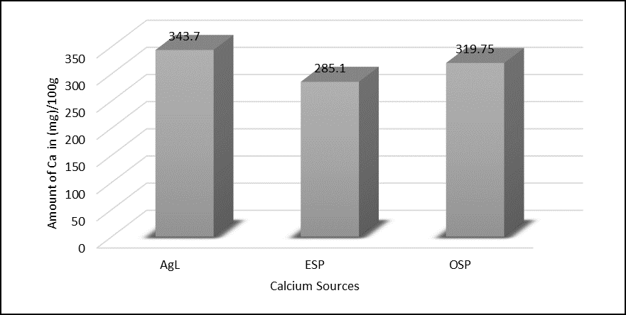

Figure 1. Amount of calcium (mg/100 g) present in AGL, ESP and OSP

## The calcium absorption efficacy of *P. djamor* is presented in figure 2, the highest Ca contents were recorded in 10% AGL and 6% ESP with 80 mg/100 g and 78.33 mg/100 g, respectively. The lowest absorption was noted in 4% ESP with only 26 mg/100 g Ca content. Equal amount of Ca in all levels of concentration was observed in OSP- enriched mushrooms. According to the National Institute of Health (2016), the recommended calcium daily intake for adults is 1000 mg to avoid bone problems and osteoporosis.

## In conclusion, ESP and OSP produces good yield mushrooms with increased Ca content, while AGL provides high calcium content mushrooms but with very poor yield. The results demonstrate the great potential of AGL, ESP and OSP in the production of Ca-enriched mushrooms and show the ability of this fungus to absorb and bio magnify Ca.

## 

Figure 2. Average content of Ca absorbed by *P. djamor* in every concentration of different Ca sources

REFERENCES

Article within a journal

Bhatia P, Prakash R, Prakash NT. 2014. Enhanced antioxidant properties as a function of selenium uptake by edible mushrooms cultivated on selenium-accumulated waste post-harvest wheat and paddy residues. International Journal of Recycling of Organic Waste in Agriculture, 3: 127-132.

Choi UK, Lee OK, Kim YC. 2011. Effect of calcinated oyster shell powder on growth, yield, spawn run, and primordial formation of king oyster mushroom (Pleurotus eryngii). Molecules, 16: 2313-2322.

Faruruwa, D, Danladi C. 2013. Quantification of calcium and calcium carbonate in eggshell obtained from local, improved chickens and ducks of Gombe (Northern Nigeria). Topclass Global Journals of Agricultural Research, 1(1): 8-10.

Ferreira ICFR, Baptista P, Vilas-Boas M, Barros L. 2007. Free radical scavenging capacity and reducing power of wild edible mushrooms from northeast Portugal: Individual cap and stipe activity. Food Chemistry 100: 1511-1516.

Lee CY, Park JE, Kim BB, Ro HS. 2009. Determination of mineral components in the cultivation substrates of edible mushrooms and their uptake in fruiting bodies. Mycobiology, 37(2): 109-113.

Masamba KG, Kazombo-Malawe. 2010. Determination and comparison of nutrient and mineral contents between cultivated and indigenous edible mushrooms in Central Malawi. African Journal of Food Science, 4(4): 176-179.

Zadrazil F, Dube HC.1992. The oyster mushroom: importance and prospects. Mushroom Research, 1: 25-32.

*Webpage*

National Institute of Health [Internet]. 2015. Calcium and Vitamin D: Important at every age; [updated 2015 May 01; cited 2017 Jan 25]. Available from https://www.bones.nih.gov/health-info/bone/bone-health/nutrition/calcium-and-vitamin-d-important-every-age

National Institute of Health [Internet]. 2016. Calcium: Dietary supplement fact sheet; [updated 2016 Mar 02; cited 2017 Jan 25]. Available from: https://ods.od.nih.gov/factsheets/Calcium-HealthProfessional/

ACKNOWLEDGEMENT

1. Center for Tropical Mushroom Research and Development, Department of Biological Sciences, College of

Arts and Sciences, Central Luzon State University, Science City of Muñoz, Nueva Ecija, Philippines

2. Department of Science and Technology- Science Education Institute (DOST-SEI) and Accelerated Science

and Technology Human Resource Development Program- National Science Consortium (ASTHRDP- NSC)