MODELLING HABITAT SUITABILITY OF *JALAK* BALI

(*Leucopsar rotschildii*)

**SUTOMO1 AND EDDIE VAN ETTEN2**

1Bali Botanical Garden – Indonesian Institute of Sciences (LIPI), Candikuning, Baturiti, Tabanan, Bali 82191 Indonesia; email: sutomo.uwa@gmail.com

2Centre for Ecosystem Management, Edith Cowan University, Joondalup Drive, Joondalup, Perth, Western Australia; email : e.van_etten@ecu.edu.au

**Keywords**: Bali Barat, BCCVL, habitat, *Leucopsar rotschildii* species distribution modelling**.**

# INTRODUCTION

The critically endangered Bali starling (*Leucopsar rothschildi*) is the only endemic bird found in Bali (van der Zon 1980). Habitat destruction and capturing for the pet trade brought the species to the verge of extinction (Dirgayusa *et al.* 2000). Species with limited distribution or rapidly decreasing range margins are particularly sensitive to processes of global change (Ariefiandy *et al.* 2015; Davis *et al.* 2016). Given the high extinction risk facing such species, conservation program are likely to require multidisciplinary approaches that address both aspects; from the species itself but also from their habitats. Regrettably, for many species, their habitat ecology moreover in light of climate change, remains inadequately understood.

Species distribution model (SDM) has the capability to assess current distribution and simulate climate-induced range shifts under different global change scenarios at the single-species and community levels (Elith and Leathwick 2009). This study will elaborate our efforts to map remaining habitat and its vegetation types for jalak Bali in Bali Barat National Park (BBNP) and also conduct species distribution modeling across Indonesia to highlight other locations where jalak Bali could be potentially introduce for ex-situ conservation program.

# Materials and methods

Remote sensing and statistical modeling technique were used to achieve these goals. For mapping jalak bali habitat in BBNP, LANDSAT images (LANDSAT 4, 7 and 8) analysis results using supervised classification algorithm was overlaid with known location of Bali Starling distribution in BBNP. This information obtained from literature study and also personal communication with BBNP rangers and managers (Wiryawan 2014). Fieldworks involve vegetation sampling in several locations of known jalak Bali locations and also for conducting ground-truthing (accuracy test) of the remote sensing results. We also uses Generalized Linear Model (GLM) feature in Biodiversity and Climate Change Virtual Laboratory/BCCVL (http://www.bccvl.org.au/) to develop a species distribution model/SDM (habitat suitability) of *Leucopsar rotschildii* based upon its naturalized distribution to project the potential distribution of this species throughout Indonesia under current climate conditions.

**RESULTS AND DISCUSSION**

Remote sensing analysis categorized the distribution into three periods namely the 1984 distribution, 1994 and the 2010 distributions. The 1984 consists of locations such as Cekik, Gilimanuk (lampu merah), Tegal bunder and Prapat Agung. Whereas the 1994 distribution namely Teluk lumpur, Sumber Batok, Teluk Kelor. The recent distribution in 2010 was at Sumber Batok Klampok, Brumbun, Kotal, Teluk Terima and Tanjung Kotal. Bali Starling was mostly found in adjacent areas, whether it was the border between savanna-forest, savanna-cropland, savanna-shrubland, settlement-cropland, and forest-shrubland (Figure 1). Bali Starling was also found in forest only area, or in mangrove. In Bali Barat National Park, forest is the dominant land cover, comprising > 75% of the national park area.

We discovered as many as 22 species belongs to 14 families of plants in the two known locations of jalak Bali namely Cekik and Brumbun. Less variation in Cekik areas with only 10 species and eight families, compared to Brumbun with 20 species and 12 families. There was eight species that were presence in both savannas; where almost all (except *Borassus flabellifer* and *Schleicera oleosa*) the species in Cekik (*Chromolaena odorata, Lantana camara, Desmodium sp., Grewia koodersii, Bridelia sp., Cynodon dactylon, Deyeuxia australis, Zizypus rotundifolia*) were also presence in Brumbun, but not the opposite.

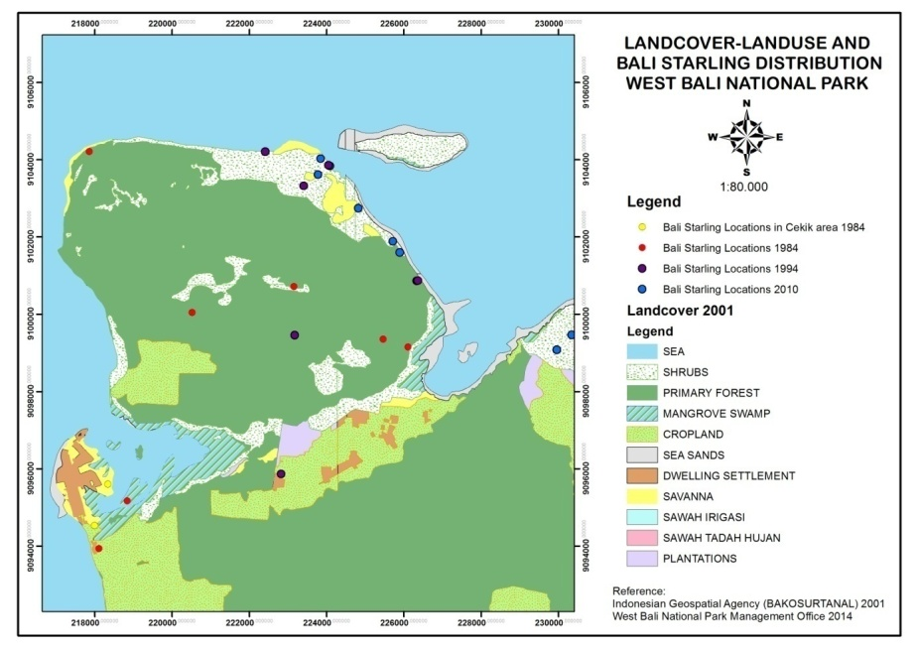

Figure 1. Overlay analysis Bali Starling distribution with 2001 Land Use map of Bali Barat National Park

In terms of modeling, optimal number of occurence records is important. For some common species, such as the wedgetailed eagle, one might find datasets with tens of thousands records. But for conservation purposes we might be interested in a rare species with much less records such as the jalak Bali. The optimal number of occurrence records is related to the geographic range of the species(Huijbers *et al.* 2016). In general, models tend to be less accurate for species that have a broad geographic range and that are tolerant to a range of environmental conditions compared to species with smaller geographic ranges and limited environmental tolerances. So even if or species is rare and we only have a few occurrence records, if its geographical range is small, it is likely that the suitable environmental conditions for it are accurately sampled with fewer points compared to a species with a larger range.

Our SDM results highlight several places that have similar Habitat Suitability Index with the original habitat of Bali Starling in Bali Barat National Park. This result is close to the real situation. We learnt that Bali Starling prefer lowland areas, preferably occur in less dense forest, secondary forest, monsoon/dry forest and with adjacent savanna or grasslands/more open vegetation. The SDM result map (Figure 2) shows that it is suitable at Baluran, Banyuwangi, Alas Purwo, the whole Bali including Nusa Penida Island except Bedugul, Batur and Agung Mountain areas (highland) and south west of Lombok Island except north of Lombok near the Rinjani Mountain (highland). This has implication for selecting potential sites for future ex-situ conservation and breeding program extension to save this endemic bird from its extinction (van Balen and Gepak 1994).

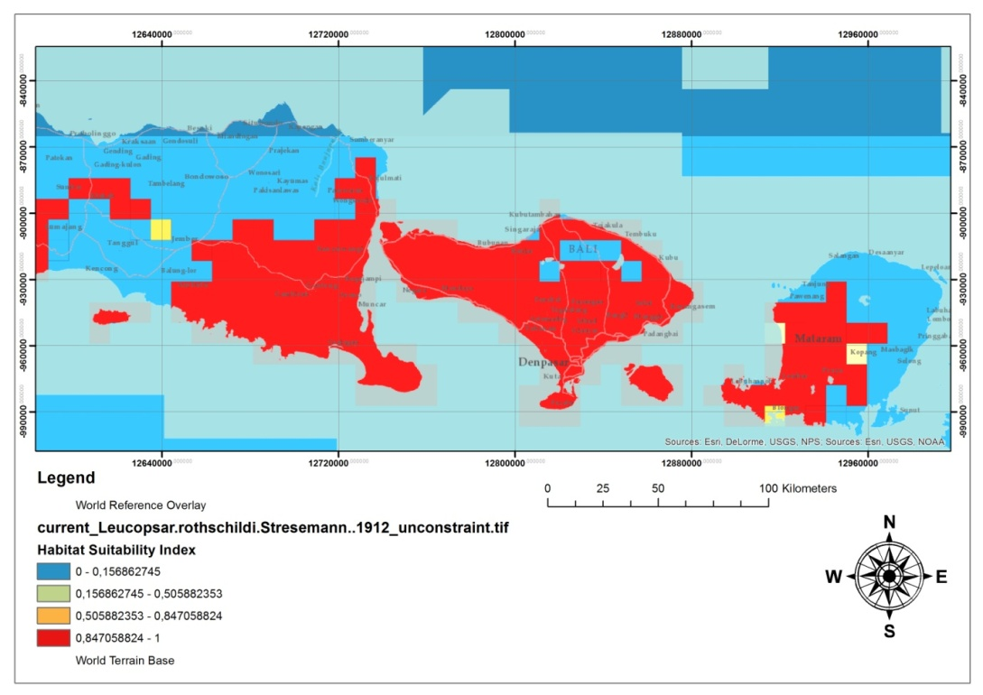

Figure 2. Result of SDM analysis. Habitat suitability distribution map for jalak Bali

REFERENCES

Ariefiandy A., Purwandana D., Natali C., Imansyah M. J., Surahman M., Jessop T. S. & Ciofi C. (2015) Conservation of Komodo dragons Varanus komodoensis in the Wae Wuul nature reserve, Flores, Indonesia: a multidisciplinary approach. *International Zoo Yearbook* **49**, 67-80.

Davis R. A., Doherty T. S., van Etten E. J. B., Radford J. Q., Holmes F., Knuckey C. & Davis B. J. (2016) Conserving long unburnt vegetation is important for bird species, guilds and diversity. *Biodiversity and Conservation*, 1-14.

Dirgayusa I., Adi Putra I. & Prins H. H. T. (2000) Status and distribution of the endemic Bali starling Leucopsar rothschildi. *Oryx* **34**, 188-97.

Elith J. & Leathwick J. R. (2009) Species distribution models: ecological explanation and prediction across space and time. *Annual review of ecology, evolution, and systematics* **40**, 677-97.

Huijbers C., Richmond S., Low-Choy S. J., Laffan S., Hallgren W. & Holewa H. (2016) Online open course Biodiversity and Climate Change Virtual Laboratory.

van Balen B. & Gepak V. H. (1994) The captive breeding and conservation programme of the Bali starling (Leucopsar rothschildi). In: *Creative Conservation* pp. 420-30. Springer.

van der Zon A. P. M. (1980) Bali's Endangered White Starling. *Oryx* **15**, 345-9.

Wiryawan. (2014) Distribution of Bali Starling in Bali Barat National Park. Gilimanuk.