ANALYSIS OF ECOLOGICAL ZONE AND IDENTIFICATION OF GEOMORPHOLOGY GEO-AREA CILETUH LANDSCAPE IN SUKABUMI REGENCY

**AISYAH SABILLA PH1, AFRA DN MAKALEW2 ARIS MUNANDAR3**

1Landscape Architecture Study Program, Graduate School, Bogor Agricultural Institute. Email: aisyahsabilla@gmail.com

2Department of Landscape Architecture, Faculty of Agriculture, Bogor Agricultural Institute. Email: amakalew@yahoo.com

3Department of Landscape Architecture, Faculty of Agriculture, Bogor Agricultural Institute. Email: amunandaripb@yahoo.com

**Keywords:** Ecological zone, geopark, geomorphology, and morphometry.

# INTRODUCTION

# West Java has one of the districts with promising potential for tourism progress, namely Sukabumi Regency located in the south. There is a tourist place called Geopark Nasional Ciletuh located in Geo-area Ciletuh which is currently heavily promoted and is being pursued to gain recognition from UNESCO as Global Geopark Network (GGN) in 2016 (Dasiharjo et al., 2016). With the main natural attractions, this area is based on conservation, education with geological, biological and cultural diversity.Geological specialty of Geo-area Ciletuh is the oldest type of rock in Java Island in the formation of Sekis Pasir Luhur which is pre-Tertiary rock consisting of metamorphic rocks with rock type ie sekis, amphibolite, filit, kwarsit, gabro which is related to peridotite (Sukamto 1975). The uniqueness and beauty of natural resources owned by Geo-area Ciletuh get negative impact that is crosser deliberately run over Batu Batik or Batu Naga which is estimated 55 million year old as play area (Alamsyah S and Gandapurnama B. 2017).

# Materials and methods

The research was conducted in Geo-area Ciletuh, Sukabumi District, West Java. Geo-area Ciletuh includes three districts of Ciemas District, Ciracap Subdistrict, and Surade District with an area of about 58,373 Ha or 583.73 Km2. The equipment to be used in this research includes digital cameras, a set of computers, and various software such as ArcMap 10.4, Erdas Imagine version 9.1, Microsoft Word 2016, and Microsoft Excel 2016. ]. Landscape ecological zone mapping analysis was conducted in accordance with directives from the Ministry of Agriculture (1980), while geomorphological is viewed from the morphometric aspect and rock type (Van Zuidam 1979).

**RESULTS AND DISCUSSION**

1. Mapping of landscape ecological zones

The landscape ecological zone mapping is derived from overlay of landscape sensitivity maps and land cover that will result in ecological condition of the area divided into three, namely high ecological zones, medium ecological zones, and low ecological zones. Ecological zone of Geo-area Ciletuh area is moderate, that is 72.03% of total area with land use such as agriculture, plantation, and rice field. Although the built space, this zone should still be protected by not exploiting the existing natural resources and not building the structure above it except for the sake of protection (Figure 1).

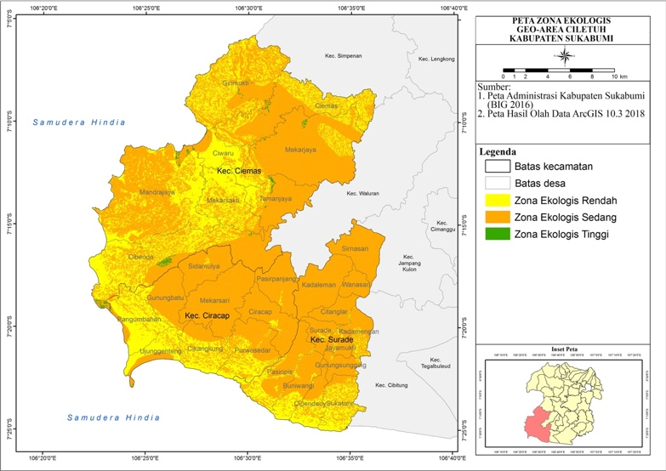

Figure 1. Map of the ecological zone of Geoarea Ciletuh area

2. Identification and geomorphological description

The relief condition is dominated by a weak corrugation of 35.36% or quite steep at 37.08%. The pattern of river flow that formed got four types of dendritic, parallel, trellis, and rektangular. The main types of rocks contained (sorted by strength of structure) are Batu Breksi Tufa (37.09%), Sandstone Kwarsa (13.80%), Sand Stone Gamping (6.89%), Tufa Sand Stone (15.53%), Clay (22.62% , and Coastal Alluvial Deposition (4.07%) (Figure 2). Areas with ecological zones are being dominated by frozen rocks and morphometrically are steep and very steep, so this area is only allowed for the utilization of the built space. While areas with low ecological zones are dominated by soft rocks and morfometri ramps and sloping, so that in this area is allowed for the utilization of built space for the benefit of tourism and protection, but must follow the zonation of existing protected areas.

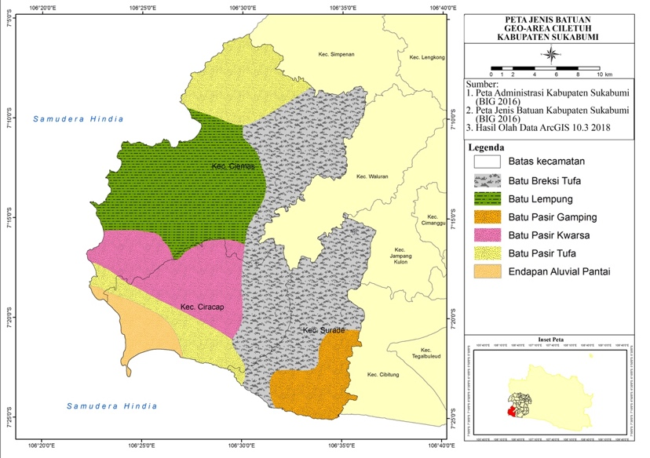

Figure 2. Map Type Geoarea Ciletuh rocks

REFERENCES

Alamsyah S, Gandapurnama B. 2017. The charm of Millions of Years Stone in Caperuh Geopark is Crossed Crosser. [https://news.detik.com/berita-jawa-barat/d- 3580295/pesona-batu-jutaan- tahun-di-geopark-ciletuh-yang-dilindas-crosser]. July 31, 2017, September 14, 2017.

Dasiharjo, Supriatna U, Saputra IM. 2016. Development of Geopark Ciletuh Based on Community Participation as Geowisata Area in Sukabumi Regency. Journal of Resort and Leisure Management, Vol. 13 No.1, 55-60.

Sukamto, Wed. 1975. Geology Sheet Jampang and Balekambang Java. Center for Geological Research and Development Directorate General Mining Department of Mining and Energy, Bandung, Indonesia.

Decree of the Minister of Agriculture No. 837 / Kpts / Um / 11/1980 dated November 24, 1980 on Criteria and Procedures for the Establishment of Protection Forest.

Zuidam, R.A Van. 1979. Guide to Morphology Areal Topographic Interpretation and Mapping.

ITC Textbook of photo interpretation vol VII, International Institute for Aerial Surveys.