BACTERIAL COMMUNITY OF LABORATORY SCALE ANAEROBIC DIGESTION OF KITCHEN WASTES FOR BIOGAS PRODUCTION

**RENCE MARRION M. PINEDA1, SOFRONIO P. KALAW1,2, RENATO G. REYES1,3**

**AND JERWIN R. UNDAN1,4**

1Department of Biology, College of Arts and Sciences, Central Luzon State University, Science City of Muñoz, Nueva Ecija, Philippines 2012, rencepineda28@gmail.com

2Center for Tropical Mushroom Research and Development, Central Luzon State University, Science City of Muñoz, Nueva Ecija, Philippines 2012,

3Flora and Fauna Analytical and Diagnostic Laboratory, Central Luzon State University, Science City of Muñoz, Nueva Ecija, Philippines 2012, renato.reyes@clsu.edu.ph  
4Biotechnology and Analytical Laboratory, Central Luzon State University, Science City of Munoz, Nueva Ecija, Philippines 2012, jerwinundan@clsu.edu.ph

**Keywords:** 16S rRNA gene, anaerobic digestion, biogas, mcrA gene

# INTRODUCTION

An attractive option for both energy generation as well as waste disposal is to utilize important microorganisms for anaerobic digestion (Nguyena et al., 2007). It has been suggested as an alternative method of treating high concentration of organic waste. Biogas from this process can be used to generate heat and electricity. Anaerobic digestion as a source of renewable energy has the potential to improve energy supply security and help in reducing greenhouse gas emissions.

Consequently, through the interactions of the microbes, a lot of diversity exists in the biogas system just as in the digestive system of ruminant animals (Amani et al., 2010). This study aimed to isolate and identify bacteria associated with laboratory scale anaerobic digestion of kitchen wastes.

# Materials and methods

Two laboratory scale anaerobic digesters were constructed and fed with kitchen wastes collected from different establishments at Old Market of Central Luzon State University. The anaerobic digestion process of each digesters were described by determining the degradation rates, retention times and biogas production rates (Schnurer & Jarvis, 2010). Sampling of the slurry was made every three days along with measurement of pH, temperature and biogas production. Slurry samples were serially diluted and inoculated to Nutrient Agar and MacConkey Agar to obtain pure cultures of microorganisms. Thioglycollate broth test was conducted to evaluate the oxygen requirements of the pure cultures. The bacterial isolates were molecularly identified using 16SrRNA (16S ribosomal RNA) and mcrA (methyl coenzyme-M reductase) gene sequencing.

**RESULTS AND DISCUSSION**

Eighteen (18) species of bacteria belong to four classes (Bacilli, Alphaproteobacteria, Betaproteobacteria, Gammaproteobacteria), five orders (Bacillales, Rhizobiales, Burkholderiales, Enterobacteriales, Pseudomonadales), eight families (Bacillaceae, Paenibacillaceae, Bradyrhizobiaceae, Burkholderiaceae, Comamonadaceae Enterobacteriaceae, Morganellaceae, Moaxellaceae) and fourteen genera (*Lysinibacyllus, Bacillus, Paenibacillus, Bradyrhizobium, Burkholderia, Comamonas, Citrobacter, Morganella, Escherichia, Klebsiella, Kosakonia, Shimwellia, Proteus, Acinetobacter*) were identified in this study. There were highest percentages of identified species in class Gammaproteobacteria (66.67%), order Enterobacterales (61.11%), family Enterobacteriaceae (50%) and genus *Citrobacter* (22.22%) (Figure 1).

The 18 identified microorganisms were *Bradyrhizobium* sp.*, Lysinibacillus* sp.*, Morganella morganii, Comamonas testosteroni, Burkholderia multivorans, Paenibacillus peoriae,* *Bacillus flexus*, *Proteus mirabilis, Shimwellia blattae, Citrobacter* sp*., Citrobacter freundii, Escherichia coli, Kosakonia sacchari, Citrobacter koseri, Klebsiella variicola, Acinetobacter pittii,* and *Citrobacter* sp. Seven were isolated from reactor A (Table 1) and eleven were from reactor B (Table 2).

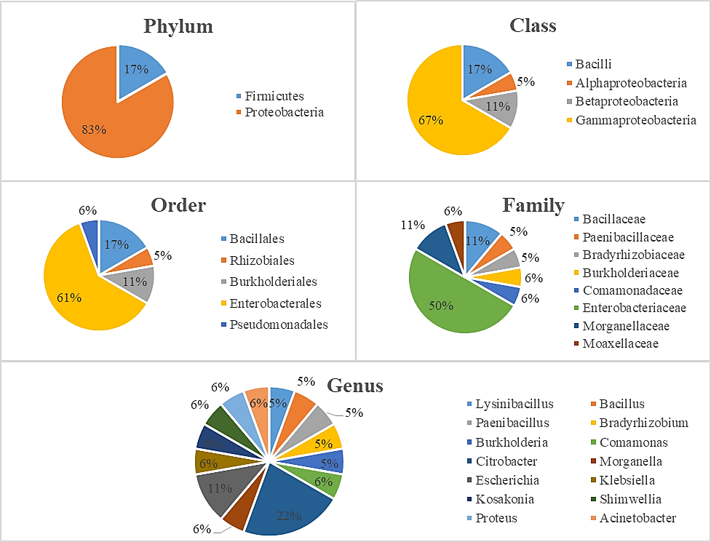

Figure 1. Percentage charts of Phylum, Class, Order, Family and Genus of Bacteria isolated and identified in this study

Table 1. Identities and Accession numbers of the isolated microorganisms from reactor A.

|  |  |  |  |  |  |
| --- | --- | --- | --- | --- | --- |
| Query (bp) | % Identity | Organism | Accession No. | Oxygen Requirement | Lactose Fermentation |
| 284 | 77 | *Bradyrhizobium* sp. | KT239675.2 | Facultative anaerobe | na* |
| 305 | 94 | *Lysinibacillus* sp. | KX343997.1 | Facultative anaerobe | na* |
| 916 | 100 | *Morganella morganii* | KY120325.1 | Facultative anaerobe | Non-lactose fermenter |
| 913 | 100 | *Comamonas testosterone* | LT899938.1 | Facultative anaerobe | Non-lactose fermenter |
| 525 | 99 | *Burkholderia multivorans* | CP020397.1 | Obligate aerobe | Lactose fermenter |
| 920 | 100 | *Paenibacillus peoriae* | KX058498.1 | Aerotolerant | na* |
| 164 | 93 | *Bacillus flexus* | KY773224.1 | Obligate aerobe | na* |

* not available

Table 2. Identities and Accession numbers of the isolated microorganisms from reactor B.

|  |  |  |  |  |  |
| --- | --- | --- | --- | --- | --- |
| Query (Bp) | % Identity | Organism | Accession No. | Oxygen Requirement | Lactose Fermentation |
| 752 | 100 | *Proteus mirabilis* | CP028522.1 | Facultative anaerobe | na* |
| 759 | 100 | *Shimwellia blattae* | CP001560.1 | Obligate aerobe | Non-lactose fermenter |
| 912 | 99 | *Citrobacter* sp. | AF530068.2 | Facultative anaerobe | Lactose fermenter |
| 912 | 100 | *Citrobacter freundii* | MF288078.1 | Facultative anaerobe | Lactose fermenter |
| 912 | 100 | *Escherichia coli* | MF104544.1 | Facultative anaerobe | Lactose fermenter |
| 908 | 100 | *Kosakonia sacchari* | CP016337.1 | Aerotolerant | Lactose fermenter |
| 915 | 100 | *Citrobacter koseri* | CP026709.1 | Facultative anaerobe | na* |
| 914 | 99 | *Klebsiella variicola* | MH111590.1 | Obligate aerobe | na* |
| 914 | 100 | *Escherichia coli* | MF104544.1 | Facultative anaerobe | Lactose fermenter |
| 932 | 99 | *Acinetobacter pittii* | MH211315.1 | Obligate aerobe | Lactose fermenter |
| 625 | 97 | *Citrobacter* sp. | CP014030.2 | Facultative anaerobe | na* |

* not available

REFERENCES

Amani, T., Nosrati, M., Sreekrishnan, T. R. 2010. Anaerobic digestion from the viewpoint of microbiological, chemical, and operational aspects — a review. Environmental Reviews, 18: 255–278.

Nguyena, P. H. L., Kuruparana, P., Visvanathan, C. 2007. Anaerobic digestion of municipal solid waste as a treatment prior to landfill. Bioresource Technology, 98, 380–7.

Schnurer, A. Jarvis, A. 2010. Microbiological handbook for biogas plants. Swedish Waste Management : 1–74.