SITE INDEX OF SIAMESE ROSEWOOD (*Dalbergia cochinchinensis* Pierre) IN PLANTATION OF THAILAND

**TAENGMOO PHUNCHAISRI1, CHONGRAK WACHRINRAT2, PONTHEP MEUNPONG3, SUWAN TANGMITCHAROEN4 AND NAWAPHONG KUASAKUN5**

1 Department of Silviculture Faculty of Forestry Kasetsart University,

50 Ngam Wong Wan Rd, Lat Yao Chatuchak Bangkok 10900,Thailand, taengmoo.p@ku.th

2 Department of Silviculture Faculty of Forestry Kasetsart University,

50 Ngam Wong Wan Rd, Lat Yao Chatuchak Bangkok 10900,Thailand, fforcrw@ku.ac.th

3 Department of Silviculture Faculty of Forestry Kasetsart University,

50 Ngam Wong Wan Rd, Lat Yao Chatuchak Bangkok 10900,Thailand, fforptm@ku.ac.th

4 Forest Research and Development Bureau, Royal Forest Department,

61 Phaholyothin Rd, Chatuchak,Bangkok 10900,Thailand, suwantang@hotmail.com

5 Department of Silviculture Faculty of Forestry Kasetsart University,

50 Ngam Wong Wan Rd, Lat Yao Chatuchak Bangkok 10900,Thailand, nawaphong007@gmail.com

**Keywords:** Siamese Rosewood, Site Index

# INTRODUCTION

Siamese rosewood (*Dalbergia cochinchinensis* Pierre) was accepted as a beautiful and high value. However, illegal logging is a major problem and the a cause of decrease in natural forest. Thus plantation is an excellent choice for Siamese rosewood. Site Index is one of the main measures of forest productivity used throughout the world. For even-age plantations Site Index is defined as the height of dominant trees at a given reference age. Site index estimate growth and yield led to forest plantation management.

# Materials and methods

All information of plantation received from The Royal Forest Department of Thailand(RFD) and The Forest Industry Organization(FIO), 26 sites were collected and selected 3 replication (78 temporary simple plots). Measurement by diameter breast height at 1.30 meter and total height. Dominant trees in each simple plot were selected for structure site index.

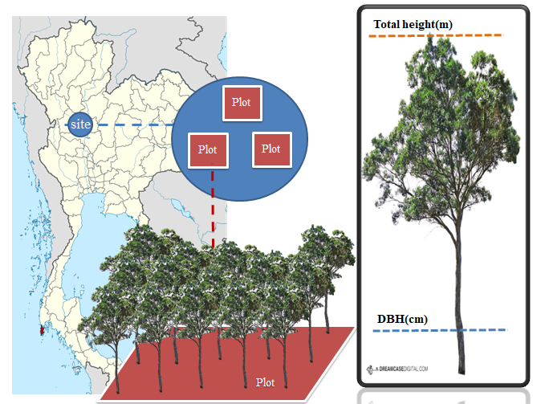

**Figure 1** Temporary simple plots and Measurement

However, the current study only had access to temporary plot data and consequently, the guide curve method was applied (Alder,1980) The model followed this form:

Ln(Hdo) = b0+b1A-1

where Hdo is dominant height

b0 and b1 is coefficient

A is stand age.

**RESULTS AND DISCUSSION**

The results of growth and mean annual increment of Siamese rosewood data from 26 sites shown in table 1.

**Table 1** Growth and Mean Annual Increment of *Dalbergia cochinchinensis* Pierre

|  |  |  |  |  |  |  |
| --- | --- | --- | --- | --- | --- | --- |
| Site | Age(yr) | DBH(cm)+SD | H(m)+SD | HDo(m)1+SD | MAIDBH(m) | MAIH(cm) |
| ST | 28 | 19.18±7.67 | 19.83±4.34 | 24.40±1.27 | 0.68 | 0.71 |
| PL | 27 | 13.28±5.36 | 17.93±5.46 | 24.84±1.30 | 0.49 | 0.66 |
| RBL | 22 | 23.42±7.48 | 14.06±3.30 | 14.53±2.98 | 1.06 | 0.64 |
| KKP1 | 23 | 19.62±6.90 | 19.60±5.09 | 24.13±2.19 | 0.85 | 0.90 |
| KPP2 | 23 | 19.39±9.17 | 17.54±6.65 | 24.27±1.89 | 0.84 | 0.76 |
| KKP3 | 23 | 18.43±7.30 | 16.72±3.92 | 20.60±1.87 | 0.80 | 0.73 |
| ITK | 20 | 15.85±6.87 | 17.30±5.30 | 23.79±2.94 | 0.79 | 0.86 |
| PK1 | 21 | 16.99±7.68 | 15.19±5.01 | 20.78±1.58 | 0.81 | 0.72 |
| PK2 | 18 | 17.85±7.13 | 15.69±4.66 | 20.76±1.87 | 0.99 | 0.87 |
| TPP | 27 | 25.55±11.14 | 20.01±5.32 | 24.40±1.54 | 0.95 | 0.74 |
| HR | 30 | 20.30±7.91 | 20.34±7.02 | 28.55±3.55 | 0.68 | 0.68 |
| TK22 | 36 | 25.34±9.17 | 18.90±6.55 | 26.70±2.46 | 0.70 | 0.52 |
| TK23 | 35 | 22.11±8.69 | 19.82±6.74 | 27.63±2.22 | 0.63 | 0.57 |
| TK26 | 32 | 24.86±10.38 | 21.86±7.83 | 29.14±3.36 | 0.78 | 0.68 |
| MS02 | 28 | 20.32±6.24 | 16.74±3.21 | 20.09±1.32 | 0.73 | 0.60 |
| MS03 | 28 | 14.25±5.95 | 13.98±4.56 | 20.53±2.27 | 0.51 | 0.50 |
| NK | 25 | 13.91±5.74 | 11.55±4.01 | 15.90±2.27 | 0.56 | 0.46 |
| HR2P | 25 | 17.95±6.21 | 14.58±3.61 | 17.42±1.68 | 0.72 | 0.58 |
| HRMix | 25 | 20.26±8.15 | 16.64±4.21 | 17.49±3.14 | 0.81 | 0.67 |
| Loei | 55 | 16.79±5.56 | 17.40±4.76 | 22.24±2.61 | 0.31 | 0.32 |
| PNK | 54 | 31.59±7.34 | 22.64±4.77 | 22.86±4.64 | 0.59 | 0.42 |
| KRS | 42 | 33.05±9.33 | 23.34±5.21 | 24.23±5.17 | 0.79 | 0.56 |
| DL | 16 | 16.73±5.73 | 16.10±3.43 | 19.79±2.00 | 1.05 | 1.01 |
| Ud | 20 | 14.15±5.66 | 13.82±4.96 | 17.27±4.30 | 0.71 | 0.69 |
| TT | 13 | 6.99±3.89 | 6.18±3.42 | 7.66±3.27 | 0.54 | 0.48 |
| PT | 26 | 20.33±8.15 | 18.26±5.43 | 21.63±2.20 | 0.78 | 0.70 |

The proportional curve method was adopted to construct site index and applies base age at 30 years. Site class distributes for five classes as Very good, Good, Moderate, Poor and Very poor.

**Figure 2** Site index of *Dalbergia cochinchinensis* Pierre.

**ACKNOWLEDGEMENT**

This research is supported in part by the Graduate Program Scholarship from Graduate School, Kasetsart University.

REFERENCES

Alder, D. 1980. **Forest Volume Estimation and Yield Prediction.** Vol. 2. Food and

Agriculture Organization of United Nation, Rome.