Viper Result Replication Guide

Runtimes

viper runtimes are generally relatively short. Without look/lookfast selected, the code takes ~5 minutes for initial template creation and ~10 minutes in the second phase for actual RV calculation.

Reproduction of Results

As we run viper via the GUI rather than a script, here is a step-by-step guide to replicate our results with the data provided in the folder “CD35_1D_both_nods”.

1.) In the viper installation folder, launch GUI via the command “python GUI_viper.py”

2.) Set data files to the provided data folder, and match the options seen here:
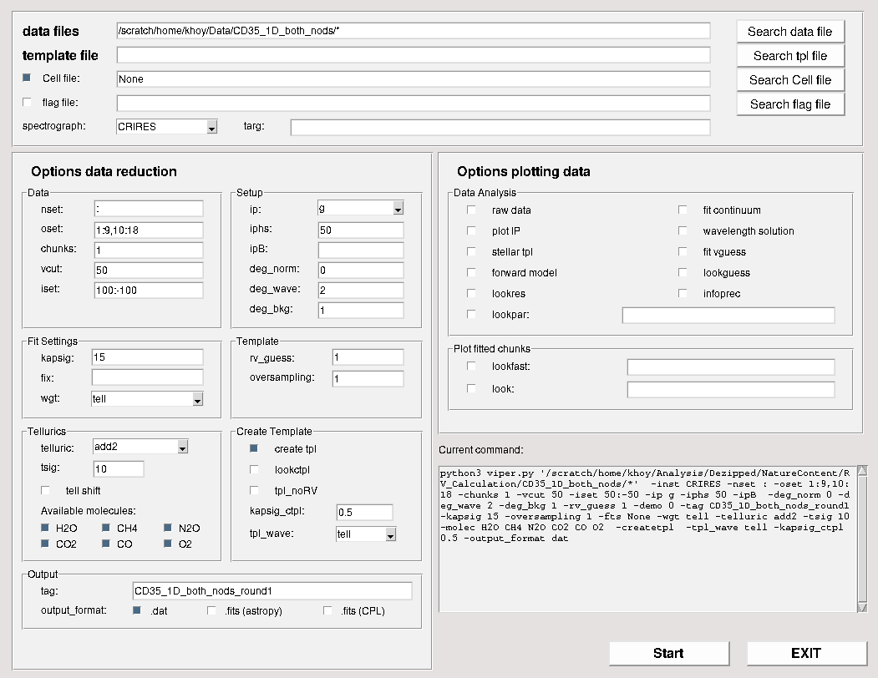

These are the parameters used to create the initial template. The “oset” parameter controls the orders included in the run. Each order is treated separately, but we have to skip order 9 because there are so few telluric lines that the recalibrated wavelength solution can decrease, causing the code to crash. This is also why we crop each order to 100:-100, as the edge pixels can cause similar issues. This poor recalibration makes the order useless for RV calculation in any case. To see the code working to correct tellurics and make the template, one can check the “lookfast” option in the “Plot fitted chunks” box on the right, and/or the “lookctpl” option under “Create Template.” This significantly increases the runtime, but is useful in understanding the procedure of the code and examining the data.

Once the settings match those shown above, press “Start” in the lower right. Without “lookfast” or “lookctpl”, this step takes only a few minutes. You will know that a run is successful when a file ending in “_tpl.fits” is created in the same directory as the GUI script.

NOTE: If you cannot see the output box, try maximizing the window, the GUI has some issues handling different screen sizes, but this has worked for some.

3.) Once an initial template is made, change the settings to:
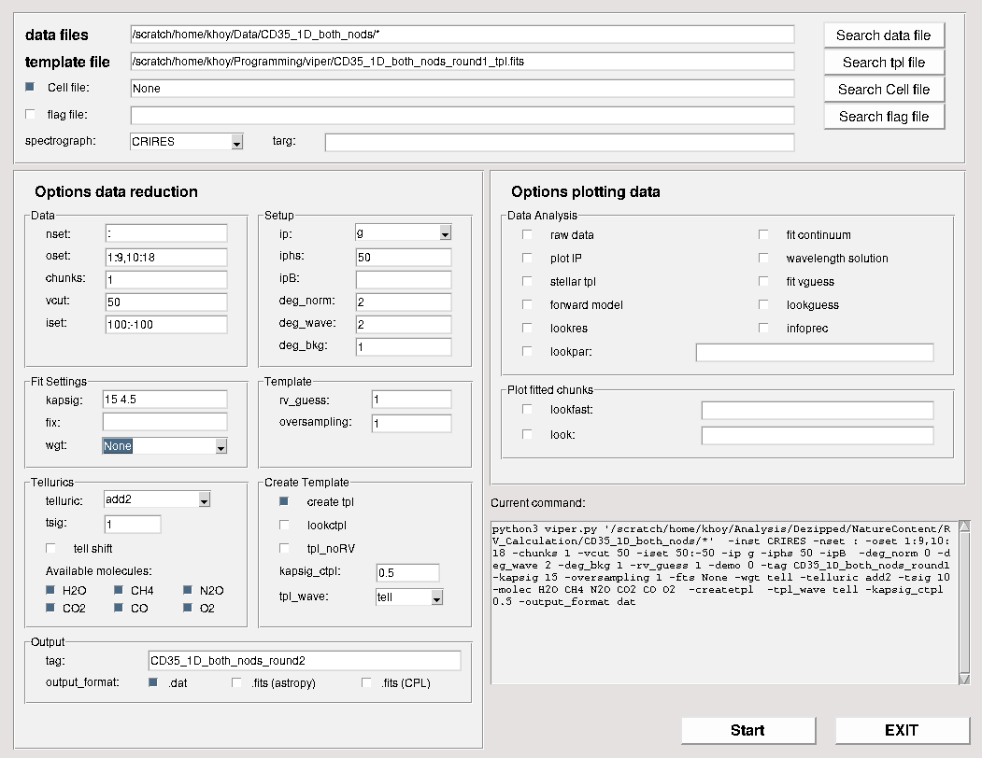

Note that the path to the “template file” should be changed for the user’s file path, and the “tag” option should be changed so this run does not overwrite the previous template (hence “round1”, “round2”, etc). The main changes are additional sigma clipping, no longer weighting by tellurics, and adding normalization. We heavily weight tellurics during the initial template creation because they are the only component of the model at that time. Now that we have a model composed of the template and the tellurics, we don’t want to weigh one more heavily than the other. Having the model also helps with the normalization, which is why it is employed at this stage.

The following parameters should be modified from the previous step:
template file: add the template created in step 2
kapsig: 15 → 15 4.5
wgt: tell → None
tsig: 10 → 1
deg_norm: 0 → 2
tag: just change the name so the previous output is not overwritten (I increment the round number)

Once the settings match those above, press “Start” in the lower right. This step takes a bit longer than the previous, something like upwards of 10 minutes.

4.) The result of this run is what is used in our work, as subsequent runs did not show significant changes in the RVs. To do further iterations, no options need to be changed except for the template file and output file name.

5.) Close this GUI to switch to the order selection GUI. It is launched with “python GUI_vpr.py”. This GUI allows the user to inspect the RVs on a per-order basis in order to exclude highly unstable orders.

6.) Open the CD35_both_nods_round2.rvo.dat file by inputting the path into “rvo file 1” and select the “cen RVs to zero median” and “ocen rvo 1” options below, likeso:
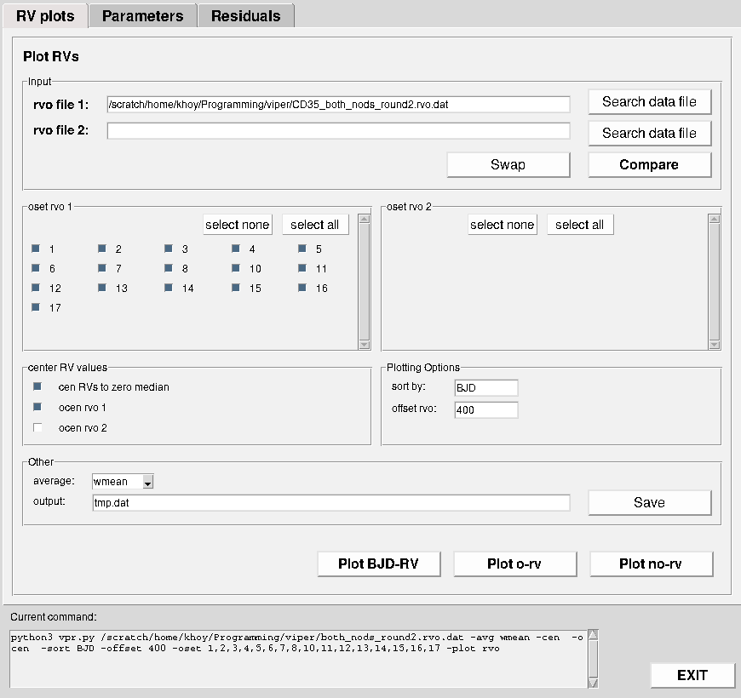

The “ocen rvo 1” option centers all order RVs over time, so if one order has a systematic offset in RV, that is subtracted to avoid biasing the RV. This ensures an accurate relative RV measurement over time, across all orders.

Note: The different plot buttons at the bottom right may only appear as short white rectangles on some screens. Please use the above image as a guide to know which button corresponds to which plot.

7.) Now, clicking the “Plot o-rv” button, one should see a plot like this:
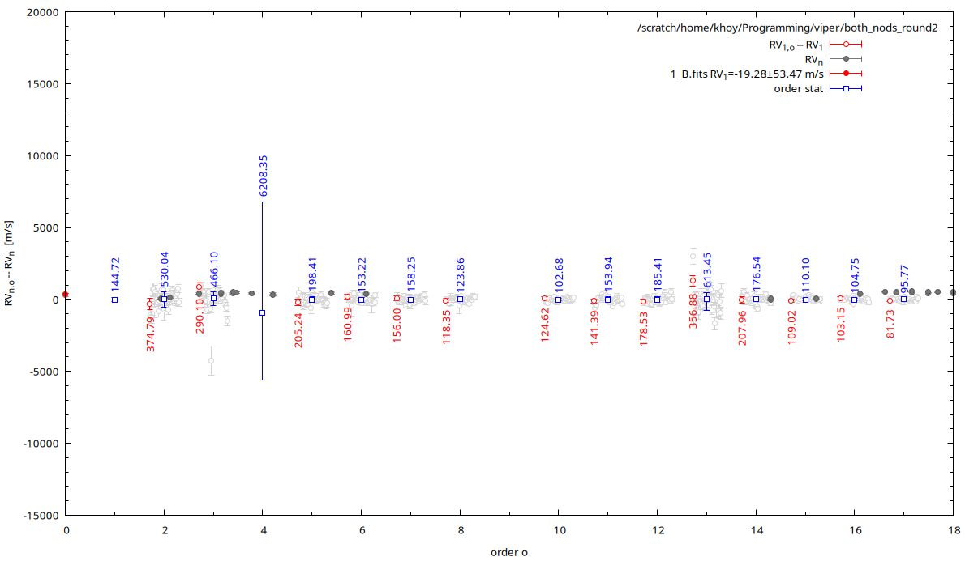

This plot shows the measured RV deviation of each order of each order from the overall mean. Looking at order 4, we see a huge dispersion in the order stat, indicating a high degree of variance from the mean (in this case, a lack of tellurics makes for poor wavelength calibration). We then de-select this order in the “oset rvo 1” box of the main GUI. The plot should now look like this:
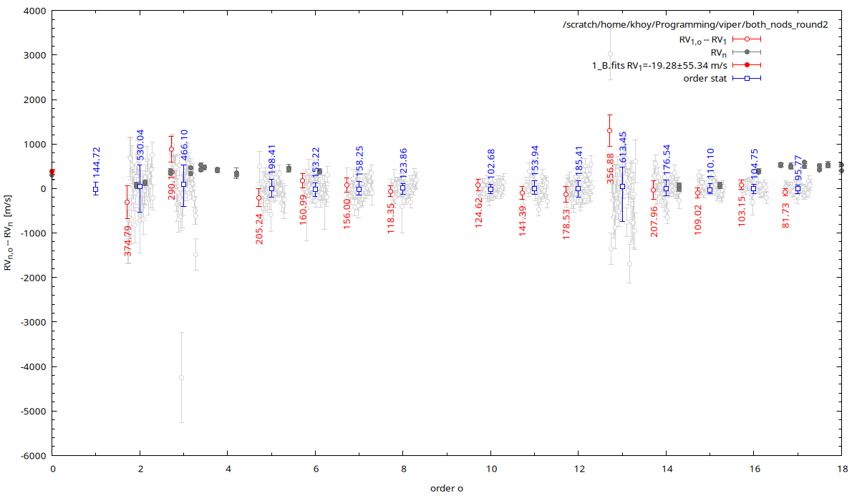

Here we can now see some relatively strong dispersion in orders 3 and 13. These will be the last orders excluded from our final RV points. This iterative process is the general procedure for deciding which orders to exclude. Deselecting orders 3 and 13 then shows some dispersion in order 2, but it’s not sufficiently elevated to justify its exclusion, and we always favor including as many orders as possible.

8.) The RV points should now be:
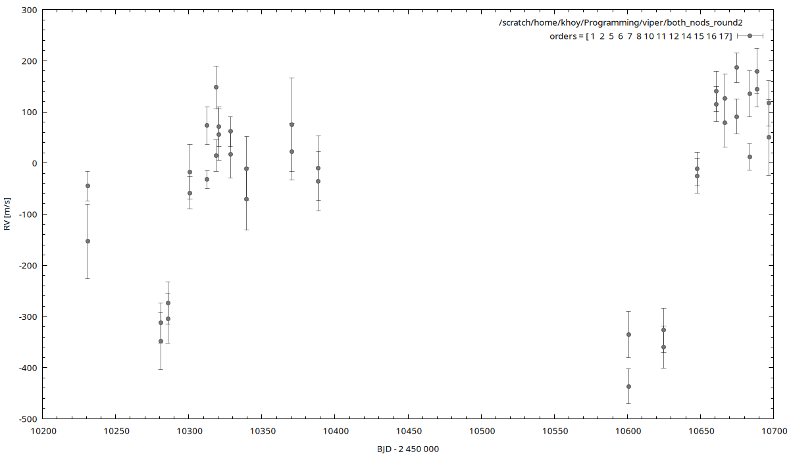

These values can be exported to a text file using the options in the “Other” box of the GUI.

9.) Run the script “combine_nodding_rvs.py” included here. This bins the RV points from each night with a weighted average and the associated error propagation. This produces the final RV data used in the work, which will be fed to EMPEROR, as described in the other folder.

