DXCore ClassCleaner Plugin

What is needed:
- Visual Studio 2005
- DXCore 2.0.1 or later (note that DXCore is installed with CodeRush)
- Knowledge of how to code a class in C#

The ClassCleaner plugin features the ability to:
- Organize a class and create regions
- Organize a class without creating regions
- Remove whitespace (removes excessive line breaks)
- Remove regions (rids the class of regions)

Setup:
  - You can either use the assembly supplied or compile the source to produce the ClassCleaner assembly.
  - Once you have the ClassCleaner assembly copy it to “C:\Program Files\Developer Express Inc\DXCore for Visual Studio .NET\2.0\Bin\Plugins”.
  - Start Visual Studio and select “DevExpress->Options” from the top menu strip.
  - Configure commands with shortcuts. Navigate to “IDE/ShortCuts” with the DevExpress “Options” dialog.
  - First I recommend creating a folder under “Code” called “ClassCleaner”. The commands that need shortcuts are:
- OrganizeWithRegions
    - OrganizeWORegions
    - RemoveWhitespace
    - RemoveRegions
    - SelectCurrentMember
    - CutCurrentMember

  - 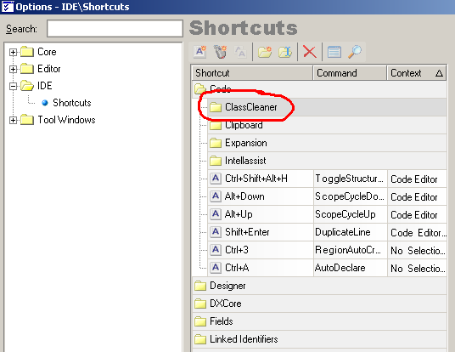
Add a shortcut for each command. The keystrokes I use are:
    - RemoveRegions: ctrl+shift+alt+I
    - RemoveWhitespace: ctrl+shift+alt+K
    - OrganizeWithRegions: ctrl+shift+alt+L
    - OrganizeWORegions: ctrl+shift+alt+O
    - SelectCurrentMember ctrl+P
    - CutCurrentMember ctrl+shift+P
  - For each shortcut make sure “Use” is set to “InClass” which is located at “Editor/Code/InClass”.
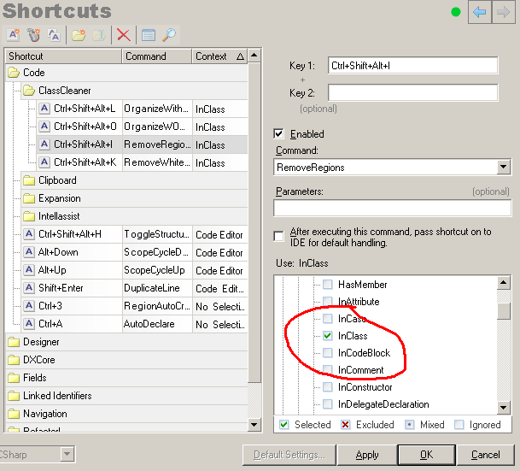

Using ClassCleaner:

The next step is to open a class file, put your cursor inside the class, and press ctrl+shift+alt+L or ctrl+shift+alt+O to organize the file. To test out “RemoveWhitespace”: open a class file, inside the class hit “Enter” five times, and then press ctrl+shift+alt+L. To test out “RemoveRegions”: open a class file that contains regions, place the cursor inside the class, and press ctrl+shift+alt+I.

NOTE: As stated above your cursor must be inside the class.

What and which order ClassCleaner organizes a class is configurable. Navigate to “DevExpress->Options” on the top menu strip. Next go to “Editor/ClassCleaner” to view the configuration.
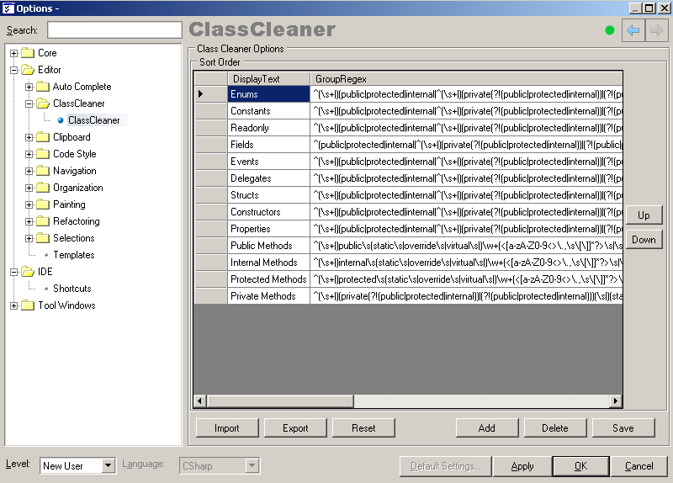

Notice the above grid contains DisplayText and a GroupRegEx. The GroupRegEx is a regular expression that defines what will be in the group. Matches for the regular expression are done on the code block only, not including the comments. Below shows a highlighted code section that would match the “Properties” regular expression and would be organized into that code group. Each method, property, field, etcetera is matched individually against regular expressions but excluding comments.

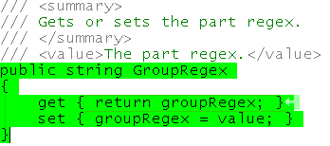

The ClassCleaner configuration allows users to add code groups, delete code groups, and change the order of how code blocks will be organized. Another useful feature is the ability to import and export code group configuration settings. This allows the settings to be distributed around the team or even have different ClassCleaner configuration files for different projects. The “Reset” button does just that it resets to the original default settings.

