Upgrade Instructions

Upgrading to a newer version of the ClassCleaner plugin is very easy.

- You can either use the assembly supplied or compile the source to produce the ClassCleaner assembly.
- Once you have the ClassCleaner assembly copy it to “C:\Program Files\Developer Express Inc\DXCore for Visual Studio .NET\2.0\Bin\Plugins”.
- Navigate to “DevExpress->Options” on the top menu strip. Next go to “Editor/ClassCleaner” to view the configuration.
- To load the new default Regular Expressions Click the Reset button then Save and close out of the DevExpress configuration.

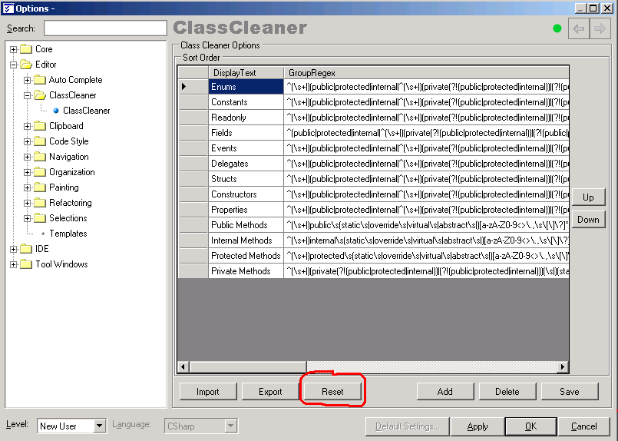

The upgrade is complete!

NOTE: You may get messages of your configuration is out of date. Please be persistent and click through the dialogs and then click reset.

