Ford Furagasin – Engagement Retention & User Analytics Intelligence Report
Prepared By: Kevin Monama
Role: Data Analyst
Company: Ford Furgasin
This business intelligence report investigates user engagement behaviour, retention trends, conversion performance, and platform activity metrics for Ford Furgasin.
The analysis transforms dashboard metrics into executive-level storytelling to uncover operational weaknesses, growth opportunities, and strategic recommendations.
The report focuses on:
• Daily Active Users (DAU)
• Monthly Active Users (MAU)
• Click Through Rate (CTR)
• Conversion Rate
• Average Daily Users
• Average Monthly Users
• Session Duration
• Page Retention
• Engagement Forecasting

Executive Summary
Ford Furagasin is experiencing a period of measurable user growth combined with unstable engagement quality.
The analytics dashboards reveal a platform attracting increasing traffic, but behavioural signals suggest declining interaction depth and inconsistent user retention.
The business currently demonstrates:
• Strong DAU expansion
• Declining average session duration
• Weak engagement consistency
• Volatile user retention behaviour
• Risk of long-term churn escalation
The core challenge is not visibility or acquisition, but maintaining meaningful interaction quality after users enter the platform.
This analysis evaluates how engagement metrics influence long-term platform sustainability and profitability.

Business Problem Statement
Ford Furagasin faces several strategic business problems impacting engagement retention and conversion efficiency.
Problem 1: Declining Session Quality
Although users continue returning to the platform, average engagement duration is decreasing. Users are spending less time consuming content or interacting deeply with platform features.
Problem 2: Weak Retention Stability
Retention patterns fluctuate heavily across different engagement periods, indicating users are not consistently forming long-term behavioural habits.
Problem 3: Navigation Drop-Off
Page retention metrics reveal declining engagement as users navigate deeper into the ecosystem. This suggests content discovery inefficiencies or weak user journey optimization.
Problem 4: Conversion Funnel Leakage
Traffic acquisition may be outperforming conversion efficiency. Users enter the platform but do not consistently complete target actions.
Problem 5: Forecasted Engagement Risk
Trend forecasting reveals possible future engagement decline if personalization and retention systems are not strengthened.

Key KPIs Analysed
1. Daily Active Users (DAU)
Measures how many users actively engage with the platform daily.
2. Monthly Active Users (MAU)
Tracks the scale and sustainability of monthly engagement.
3. Average Daily Users
Measures consistency in daily interaction behaviour.
4. Average Monthly Users
Measures long-term engagement ecosystem health.
5. Click Through Rate (CTR)
Evaluates how effectively users interact with content and calls-to-action.
6. Conversion Rate
Measures successful completion of business objectives including sign-ups, purchases, or interactions.
7. Session Duration
Tracks engagement depth and user attention quality.
8. Page Retention
Measures how successfully users continue navigating through the platform.
9. Engagement Forecasting
Projects future engagement scenarios based on current behavioural patterns.

Data Storytelling & Dashboard Interpretation
The engagement dashboards reveal a platform growing in visibility but struggling with behavioural depth.
The first dashboard focusing on DAU and session duration demonstrates a critical behavioural contradiction. Daily Active Users increased significantly between January and February, moving from approximately 2,200 active users toward nearly 3,900 users.
This indicates:
• Strong acquisition campaigns
• Improved market visibility
• Increased user awareness
• Effective traffic generation
However, average session duration declined during the same period from roughly 920 minutes toward 845 minutes.
This behavioural contradiction suggests:
• Users are entering the platform but not staying engaged
• Content relevance may be declining
• User experience friction could exist
• Personalization systems may be weak
• Platform value perception may not be increasing with traffic
The forecasting model further highlights three possible business futures.
Optimistic Growth Scenario:
Engagement rises toward 45+ average engagement points. This scenario would likely emerge if Ford Furagasin improves personalization, recommendation systems, and behavioural targeting.
Stable Scenario:
Engagement stabilizes around 30 points. Growth remains operationally sustainable but strategically stagnant.
Decline Scenario:
Engagement falls below 20 points, indicating serious churn risk, weakened loyalty, and reduced platform stickiness.
The second visualization analysing page retention reveals inconsistent behavioural navigation. Users demonstrate stronger interaction on certain page levels while rapidly dropping engagement across deeper navigation layers.
This indicates:
• Uneven content quality
• Navigation inefficiencies
• User journey confusion
• Weak content prioritization
• Reduced behavioural continuity
The downward trendline confirms that user engagement probability decreases as navigation complexity increases.
The final dashboard focusing on average daily active users demonstrates short-term engagement volatility. Peak activity occurred around January 18 before declining sharply toward January 20.
This suggests:
• Campaign-driven spikes
• Behavioural inconsistency
• Weak retention loops
• User fatigue after acquisition
• Limited habit formation
Collectively, the dashboards reveal that Ford Furagasin has successfully improved acquisition visibility but has not yet fully optimized behavioural retention systems.

Engagement Retention Analysis
Retention is one of the most important indicators of digital platform health because it determines whether users derive sustainable value from the ecosystem.
CTR Performance:
CTR performance likely reflects strong curiosity-based acquisition but weaker post-click satisfaction. Users appear willing to engage initially but may not consistently find meaningful value afterward.
DAU vs MAU Relationship:
The DAU and MAU relationship suggests healthy platform exposure but inconsistent recurring engagement behaviour. Sustainable platforms typically maintain strong ratios between active daily users and active monthly users.
Average User Behaviour:
Average daily users fluctuate significantly, suggesting behavioural instability rather than habitual engagement patterns.
Conversion Efficiency:
The conversion funnel may contain friction points causing users to abandon actions before completion.
Page Retention:
Users appear increasingly likely to disengage as they progress through navigation layers. This highlights the importance of simplifying information architecture and improving recommendation systems.
Session Duration:
Session duration decline is one of the strongest warning indicators within the analysis because it reflects weakening interaction quality.

Strategic Insights
Insight 1: Acquisition Is Outperforming Retention
The Company successfully attracts users but struggles maintaining behavioural depth.
Insight 2: Session Quality Is Declining
Lower session duration indicates weaker emotional connection or platform utility.
Insight 3: Navigation Complexity Reduces Engagement
Users disengage more frequently when progressing deeper into content pathways.
Insight 4: Forecasting Reveals Churn Risk
If engagement quality continues weakening, future retention rates may decline significantly.
Insight 5: Behavioural Loyalty Has Not Fully Matured
Engagement volatility suggests users are not yet forming platform dependency or routine usage behaviour.

Recommendations
1. Improve Personalization Systems
Deploy AI-driven recommendation systems tailored to user behaviour patterns.
2. Simplify Navigation Architecture
Reduce friction by streamlining user journeys and improving content accessibility.
3. Introduce Behavioural Engagement Loops
Implement rewards, streak systems, achievement tracking, and gamification strategies.
4. Strengthen Conversion Funnel Monitoring
Track behavioural drop-off points more aggressively through funnel analytics.
5. Enhance Onboarding Experience
Educate users faster about platform value during first-time interaction.
6. Introduce Predictive Retention Analytics
Use forecasting models to identify users likely to churn before disengagement occurs.
7. Optimize CTR Campaigns
Focus on attracting users with higher behavioural quality instead of purely maximizing clicks.
8. Deploy Cohort Analysis
Analyse engagement by user cohorts to identify long-term retention patterns.
9. Expand Executive Dashboards
Provide leadership teams with real-time behavioural intelligence monitoring.
10. Conduct A/B Testing
Continuously test page structures, CTA positioning, layouts, onboarding, and recommendation systems.

Business Impact
If Ford Furagasin successfully improves retention quality and engagement depth, the company could achieve:
• Increased customer lifetime value
• Lower churn rates
• Improved monetization performance
• Higher conversion efficiency
• Better advertising returns
• Stronger customer loyalty
• Improved user satisfaction
• Greater long-term scalability
• Stronger investor confidence
Retention optimization has direct financial implications because retained users generate substantially more long-term value than short-term acquisition spikes.

Caveats & Analytical Limitations
Several analytical limitations should be acknowledged.
• The dashboards represent a limited observation period.
• Forecasting assumptions may shift with market conditions.
• Seasonal trends may influence engagement metrics.
• External campaigns may temporarily distort DAU activity.
• Demographic segmentation data was unavailable.
• Device-level analytics were not integrated.
• Revenue attribution data was limited.
Future analysis should include:
• Cohort retention analysis
• Device segmentation
• Geographic segmentation
• Sentiment analysis
• Revenue contribution modelling
• Funnel attribution tracking

Conclusion
Ford Furagasin demonstrates strong acquisition capability supported by increasing Daily Active Users and rising platform visibility.
However, the analytics reveal that long-term engagement sustainability depends heavily on improving retention quality, personalization systems, and behavioural consistency.
The company has reached a strategic phase where growth alone is no longer sufficient. Sustainable success will depend on increasing interaction depth, emotional engagement, and platform loyalty.
By improving user experience architecture, predictive analytics, onboarding systems, and behavioural personalization, Ford Furagasin can transform traffic growth into long-term ecosystem expansion.
This project demonstrates the importance of business intelligence in converting engagement metrics into strategic decision-making frameworks.

Dashboard Visualizations & Insights
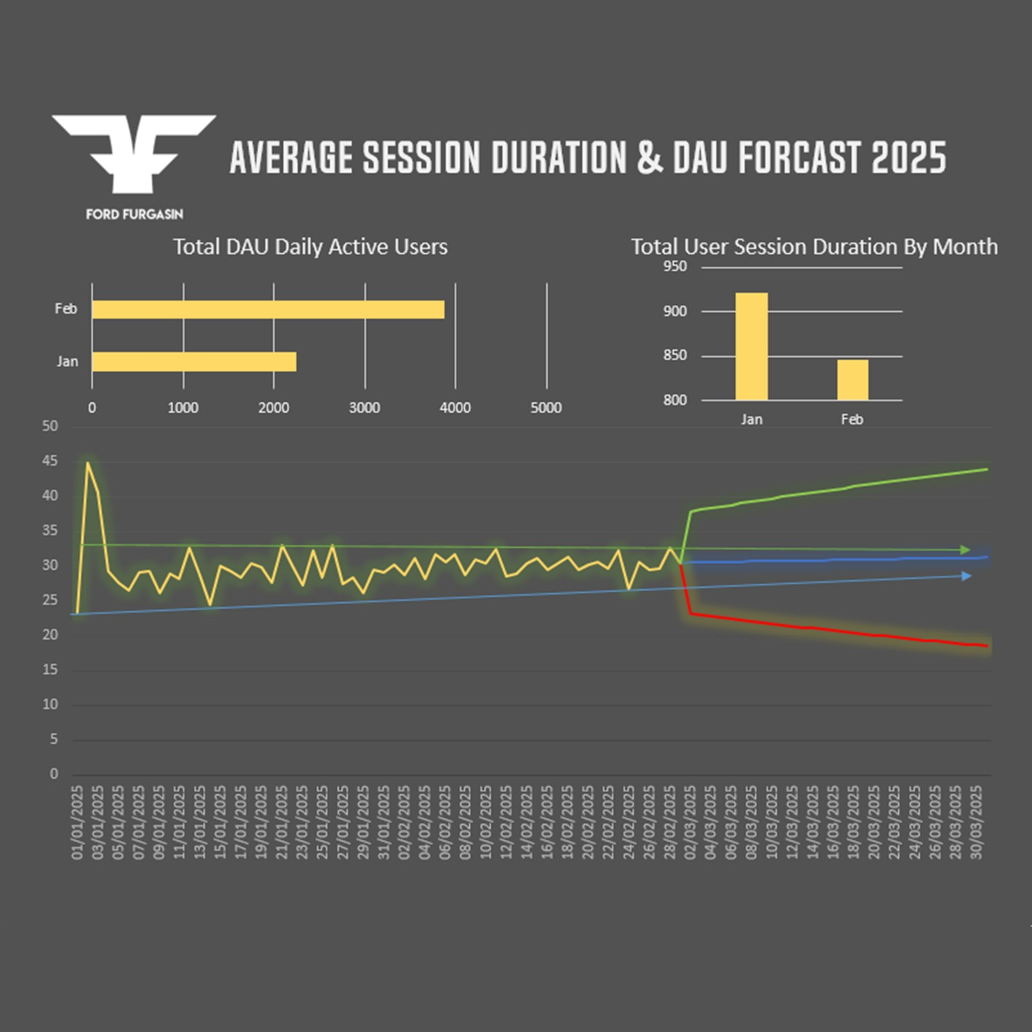
DAU growth versus declining session duration forecasting model.
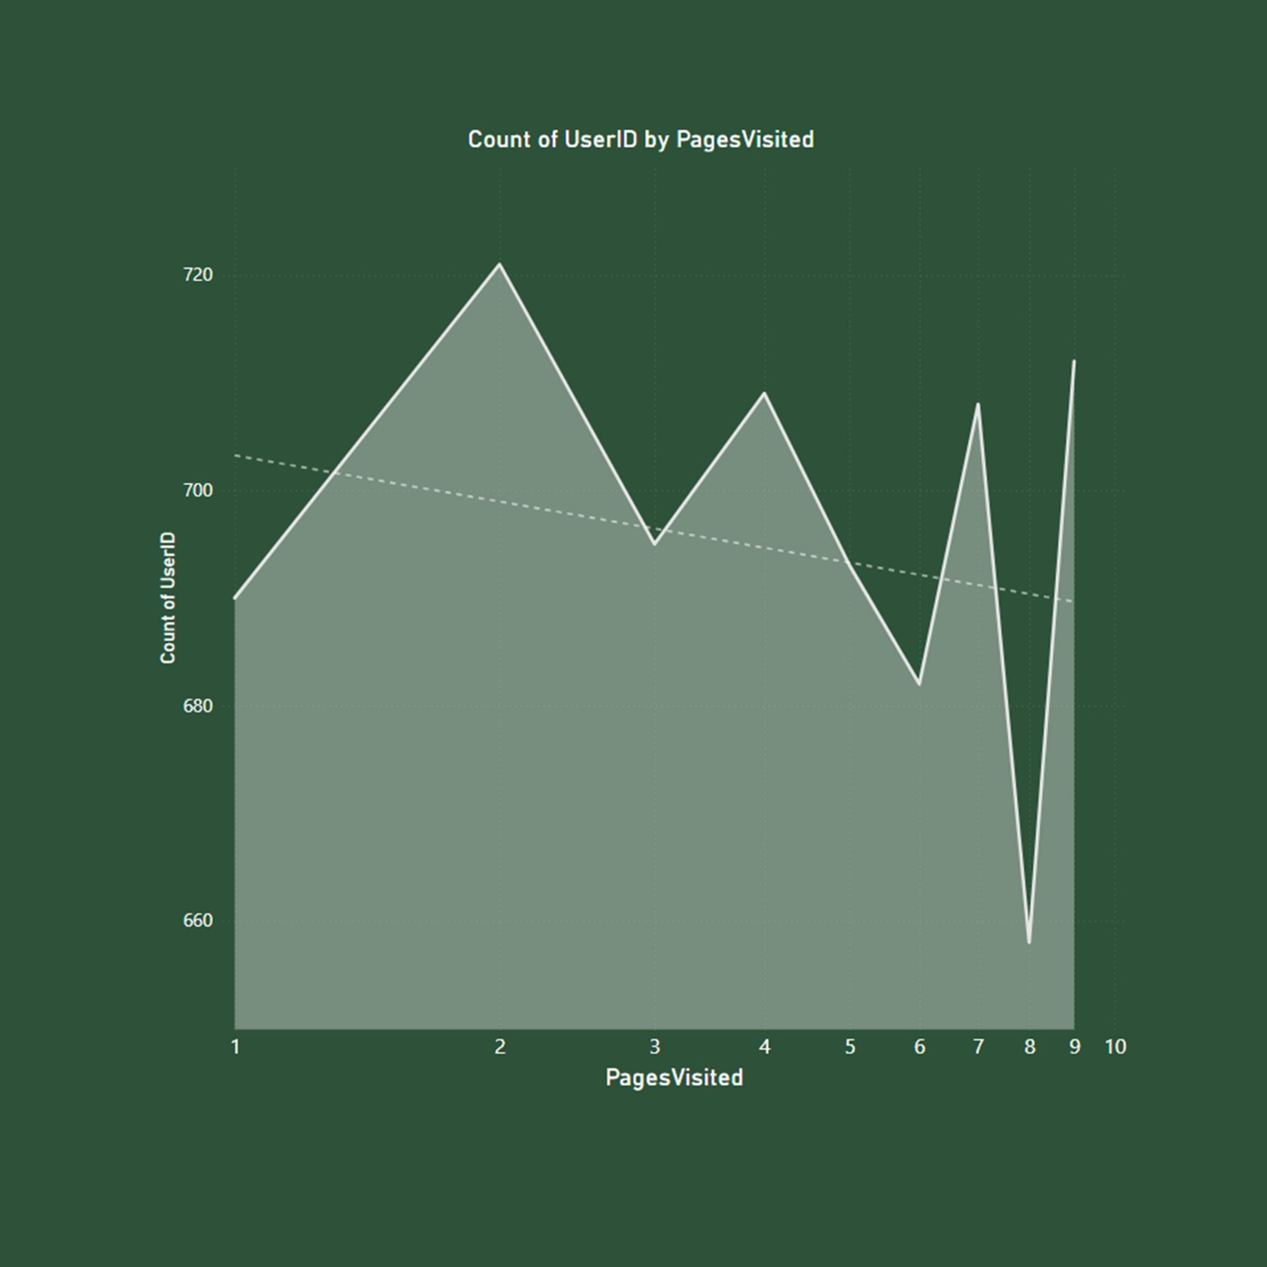
Page retention behaviour and navigation engagement analysis.
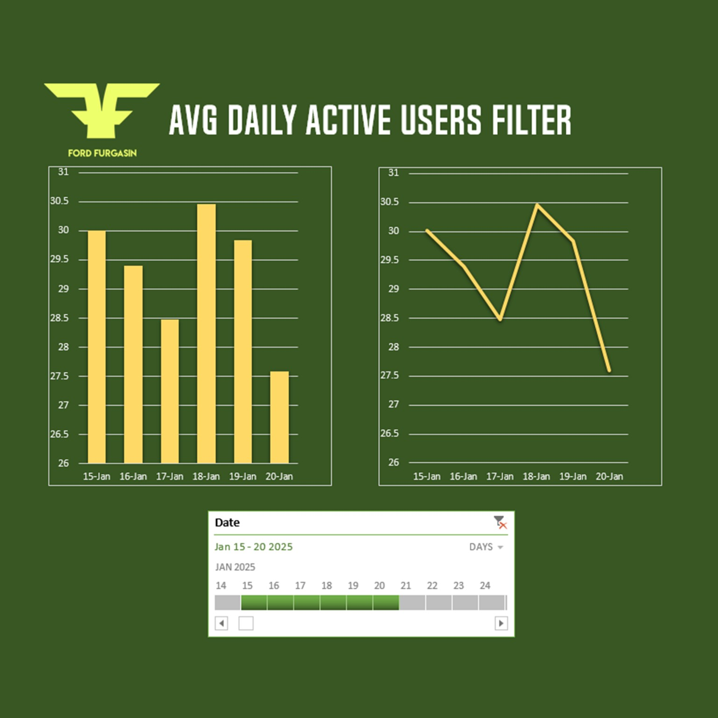
Average daily active user fluctuations and short-term engagement trends.

README.md Portfolio Version
# Ford Furagasin Engagement Retention Analytics
## Overview
This project investigates user engagement, retention performance, session behaviour, and forecasting analytics for Ford Furagasin.
## Business Objective
The objective was to uncover behavioural trends affecting retention, conversion efficiency, and long-term engagement sustainability.
## KPIs Analysed
- Daily Active Users (DAU)
- Monthly Active Users (MAU)
- Average Daily Users
- Average Monthly Users
- Click Through Rate (CTR)
- Conversion Rate
- Session Duration
- Page Retention
- Engagement Forecasting
## Key Findings
- DAU increased significantly.
- Session duration declined.
- Behavioural retention instability exists.
- Navigation complexity reduced engagement.
- Forecasting revealed future churn risk.
## Strategic Recommendations
- Improve personalization systems.
- Strengthen onboarding experiences.
- Optimize recommendation engines.
- Introduce predictive analytics.
- Enhance behavioural retention systems.
## Skills Demonstrated
- Data Analytics
- Business Intelligence
- Dashboard Interpretation
- KPI Analysis
- Data Storytelling
- Retention Analytics
- Forecasting
- Strategic Recommendations
## Business Value
The project demonstrates how behavioural analytics can transform engagement metrics into executive-level strategic decisions.

