Moodflow Marketing Campaign Effectiveness Analysis
Prepared by: Kevin Monama | Data Analyst
README.md STYLE EXECUTIVE REPORT
This report evaluates the effectiveness of Mood Flow’s digital marketing campaigns through quantitative analysis and business storytelling. The objective is to identify performance gaps, uncover operational inefficiencies, evaluate return on investment (ROI), and provide strategic recommendations that can improve future campaign outcomes.

1. Business Problem
- Mood Flow invested heavily in multiple digital marketing channels (Instagram Ads, Google Ads, Facebook Ads, and Email Campaigns), but leadership lacked visibility into which campaigns generated the highest business value.
- The organization needed to answer critical business questions:
• Which campaign generated the strongest ROI?
• Which channels produced the highest engagement and conversion efficiency?
• Were marketing budgets being allocated effectively?
• Which campaigns showed scalability potential?
• Which campaigns consumed resources without proportional revenue growth?
- Executive Concern: Marketing spend was increasing faster than measurable business growth. Without proper attribution and performance analysis, the company risked overspending on low-performing campaigns.

2. Key Performance Indicators (KPIs)
- Revenue: Measures total income generated from each campaign.
- Clicks: Indicates customer interest and campaign engagement.
- Impressions: Measures campaign visibility and audience reach.
- CTR (Click Through Rate): Measures effectiveness of ad creatives and targeting.
- Conversions: Tracks successful customer actions.
- Conversion Rate: Measures efficiency in converting traffic into outcomes.
- Cost: Tracks marketing spend allocation.
- ROI: Determines profitability and strategic effectiveness.
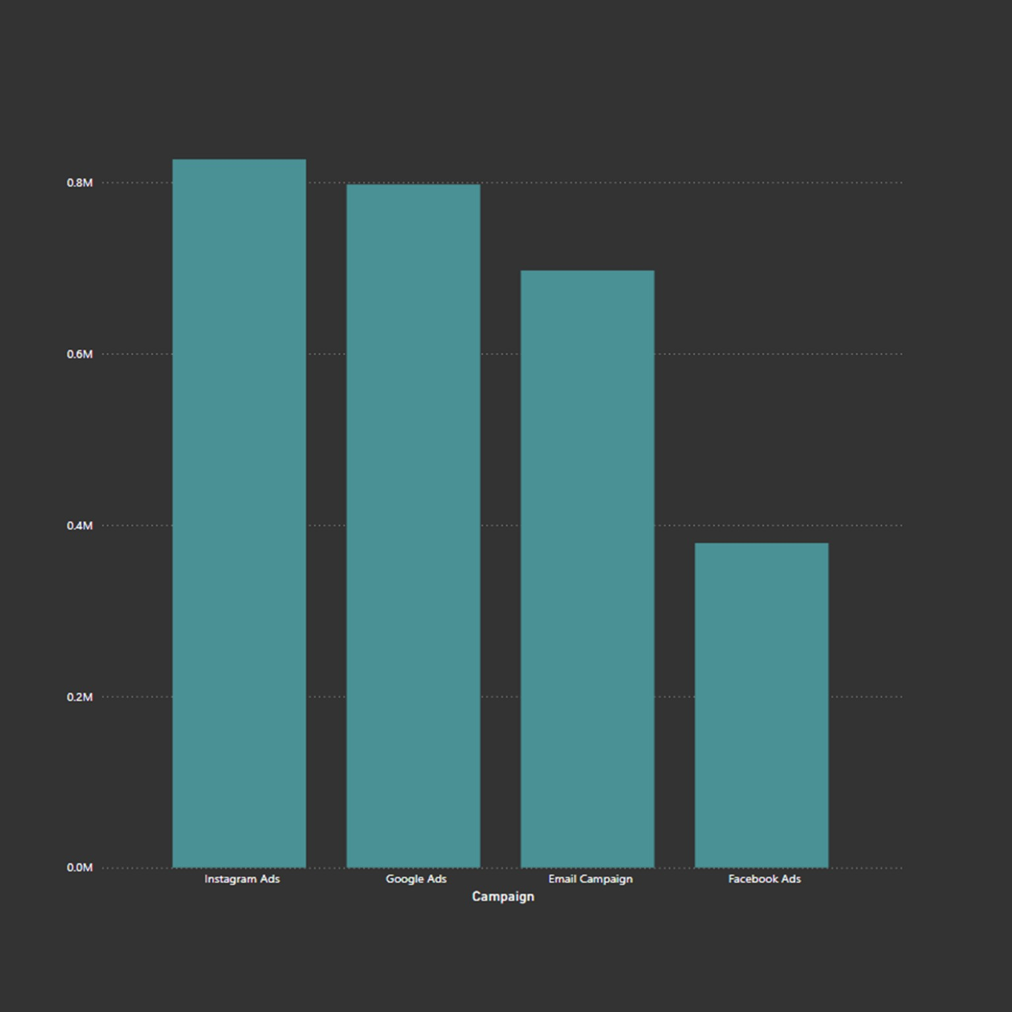
Figure 1: Revenue Comparison Across Campaigns
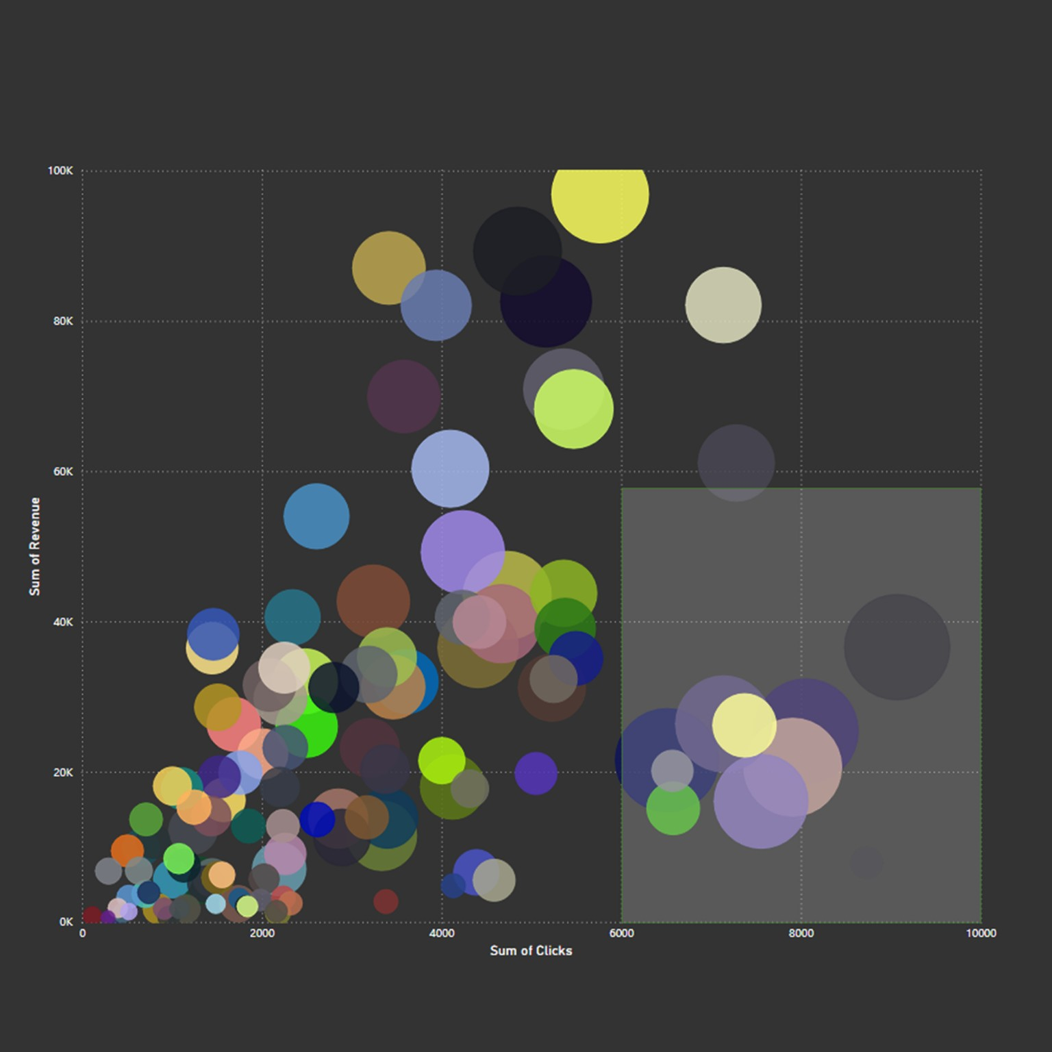
Figure 2: Revenue vs Click Performance
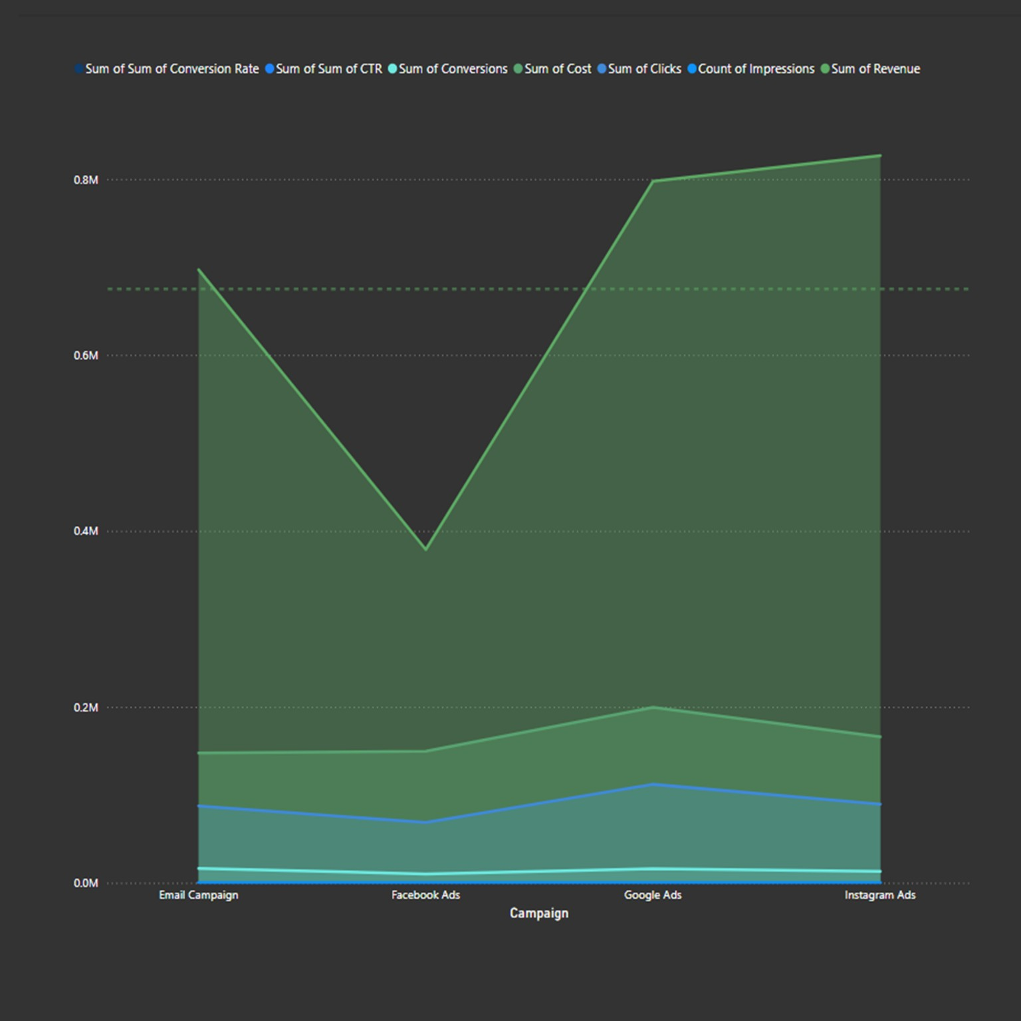
Figure 3: Campaign KPI Trend Overview

3. Analytical Insights & Storytelling
Mood Flow’s marketing ecosystem reveals a clear imbalance between visibility, engagement,
and actual profitability. Although all campaigns generated measurable audience interaction,
their financial efficiency differed significantly.
Instagram Ads emerged as the strongest revenue-generating campaign, surpassing all other
channels with approximately 0.82M in revenue. This indicates strong audience resonance,
effective visual storytelling, and potentially superior audience targeting. The campaign
demonstrated that emotionally engaging social-first content can directly influence customer
purchase behavior.
Google Ads closely followed with roughly 0.80M in revenue. While slightly below Instagram,
Google Ads displayed remarkable stability and scalability. Search-driven intent likely
contributed to stronger conversion quality because users interacting with search campaigns
often possess higher purchasing intent compared to passive social media users.
Email Campaigns generated approximately 0.70M in revenue despite lower visibility compared
to paid advertising channels. This suggests that owned audiences remain valuable and cost-efficient.
Email marketing continues to provide strong retention and remarketing opportunities,
especially when personalized customer journeys are implemented.
Facebook Ads produced the weakest performance at approximately 0.38M revenue. The data suggests
that although Facebook generated traffic, its audience engagement quality may have been lower.
This raises concerns around targeting efficiency, audience fatigue, or declining platform responsiveness.
The bubble chart further reveals an important behavioral trend:
higher click volume does not automatically translate into higher revenue.
Several campaigns accumulated substantial clicks while generating limited revenue output,
indicating weak conversion quality or ineffective landing page experiences.
The highlighted cluster in the upper-right region demonstrates campaigns with high click volume
but inconsistent revenue generation. This pattern may indicate:
• Poor post-click customer experiences
• Weak product-market alignment
• Audience mismatch
• Conversion funnel friction
• Excessive dependence on vanity metrics instead of business outcomes
Meanwhile, mid-volume campaigns generated disproportionately higher revenue,
suggesting that campaign quality outweighed pure traffic quantity.
The KPI trend chart reveals another important operational insight:
Instagram and Google Ads consistently maintained stronger overall KPI performance,
while Facebook Ads underperformed across almost every major business metric.
From a strategic perspective, Mood Flow’s challenge is not audience acquisition alone.
The company must optimize acquisition quality, conversion efficiency, and budget allocation.

4. ROI Performance Evaluation
The campaign portfolio demonstrates uneven ROI distribution.
Instagram Ads delivered the highest commercial impact due to its combination of:
• High visibility
• Strong engagement
• Strong revenue generation
• Brand amplification potential
Google Ads demonstrated the strongest intent-driven traffic behavior,
making it highly scalable for long-term customer acquisition.
Email Campaigns likely achieved the highest cost-efficiency ratio despite lower absolute revenue.
Because email marketing generally operates at lower acquisition costs,
its profitability potential remains extremely valuable.
Facebook Ads delivered weaker returns relative to campaign exposure and clicks.
This suggests inefficient spending and lower customer acquisition quality.
Key conclusion:
Not all traffic is equal.
The campaigns generating the most attention were not always the campaigns generating
the strongest business value.

5. Strategic Recommendations
- Reallocate more budget toward Instagram and Google Ads due to their stronger revenue performance.
- Reduce inefficient Facebook spending until audience targeting and creative strategies are optimized.
- Strengthen conversion funnel optimization using landing page A/B testing.
- Implement advanced customer segmentation to improve personalization.
- Introduce predictive analytics to forecast campaign profitability.
- Track Customer Lifetime Value (CLV) rather than focusing only on clicks and impressions.
- Improve attribution modeling to understand multi-touch customer journeys.
- Enhance email automation workflows to maximize retention and repeat purchases.
- Use behavioral analytics to identify friction points causing drop-offs after clicks.
- Shift executive reporting away from vanity metrics toward profitability-focused KPIs.

6. Caveats & Limitations
Although the analysis provides valuable business insights, several limitations must be acknowledged:
• The dataset appears aggregated, limiting granular customer-level behavioral analysis.
• Seasonal trends and external market conditions were not included.
• Attribution overlap may exist between campaigns.
• Customer demographics and geographic segmentation were unavailable.
• Long-term customer retention metrics were not included.
• ROI calculations may differ if operational overhead costs are incorporated.
• Correlation does not always imply causation.
These limitations highlight the importance of continuous data collection,
data governance, and deeper analytical maturity.

7. Why This Analysis Matters
This project demonstrates practical business intelligence capabilities required in modern data analytics roles.
Core competencies demonstrated:
• Business storytelling
• Marketing analytics
• KPI interpretation
• ROI evaluation
• Data visualization analysis
• Strategic recommendation development
• Executive-level reporting
• Quantitative reasoning
• Data-driven decision-making
The project reflects how data analysts translate raw campaign metrics into strategic business actions.
Rather than simply reporting numbers, the analysis focuses on uncovering operational inefficiencies,
customer behavior patterns, and commercial growth opportunities.
Prepared for portfolio and recruiter review.
Author: Kevin Monama

