COSC 205 Lab 1

Team: Arrested Developers: Kevin Ngkaion, Tuscun McFarlan, Tzu Ai Shen, Dake Wang

Jan 17, 2023

**Burndown Chart**

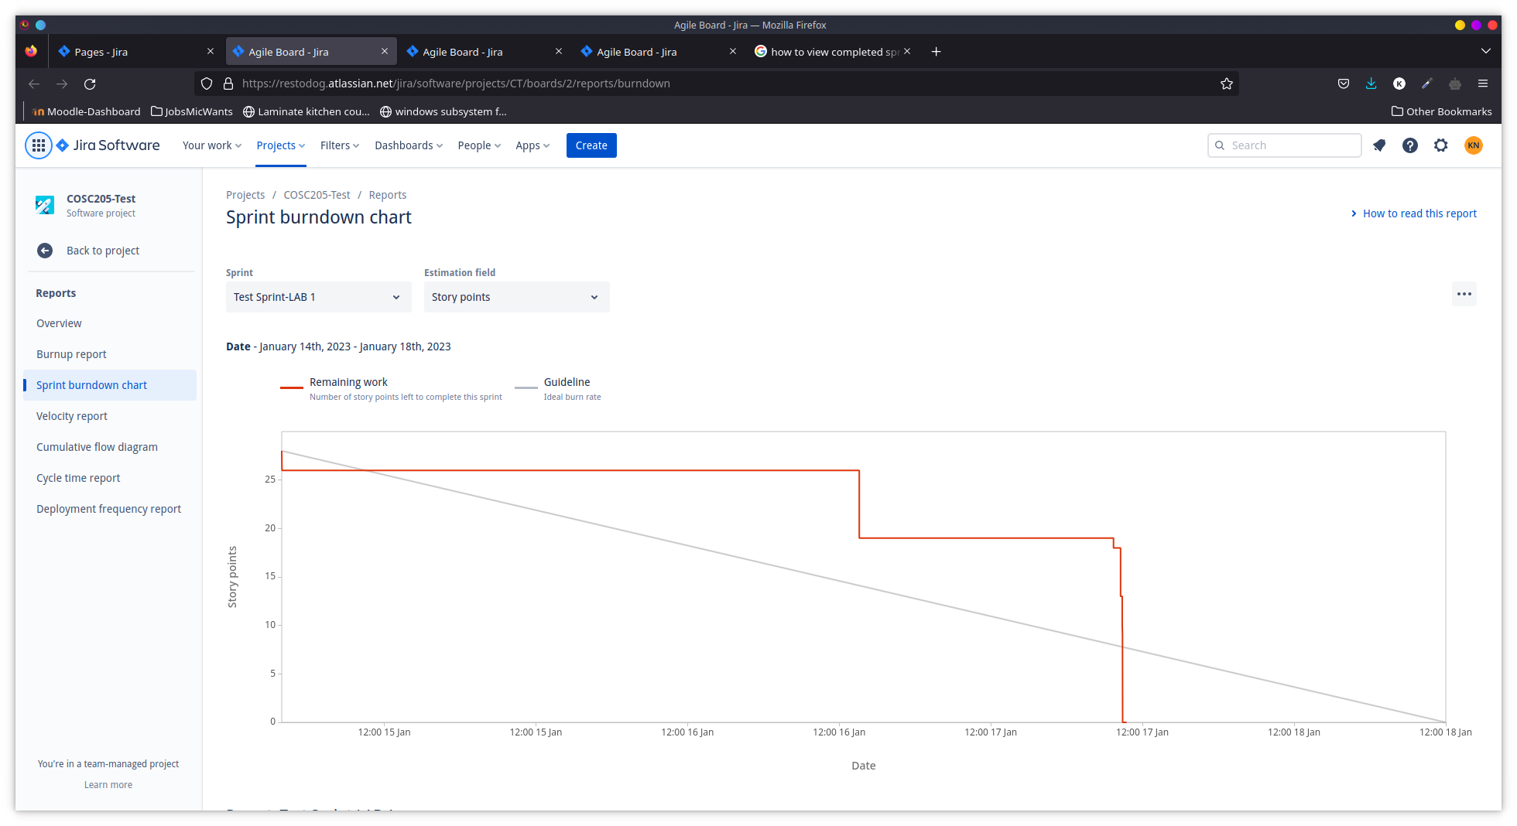

There is a sharp drop in the remaining work chart because we completed all the tasks in one day.

**Velocity Chart**

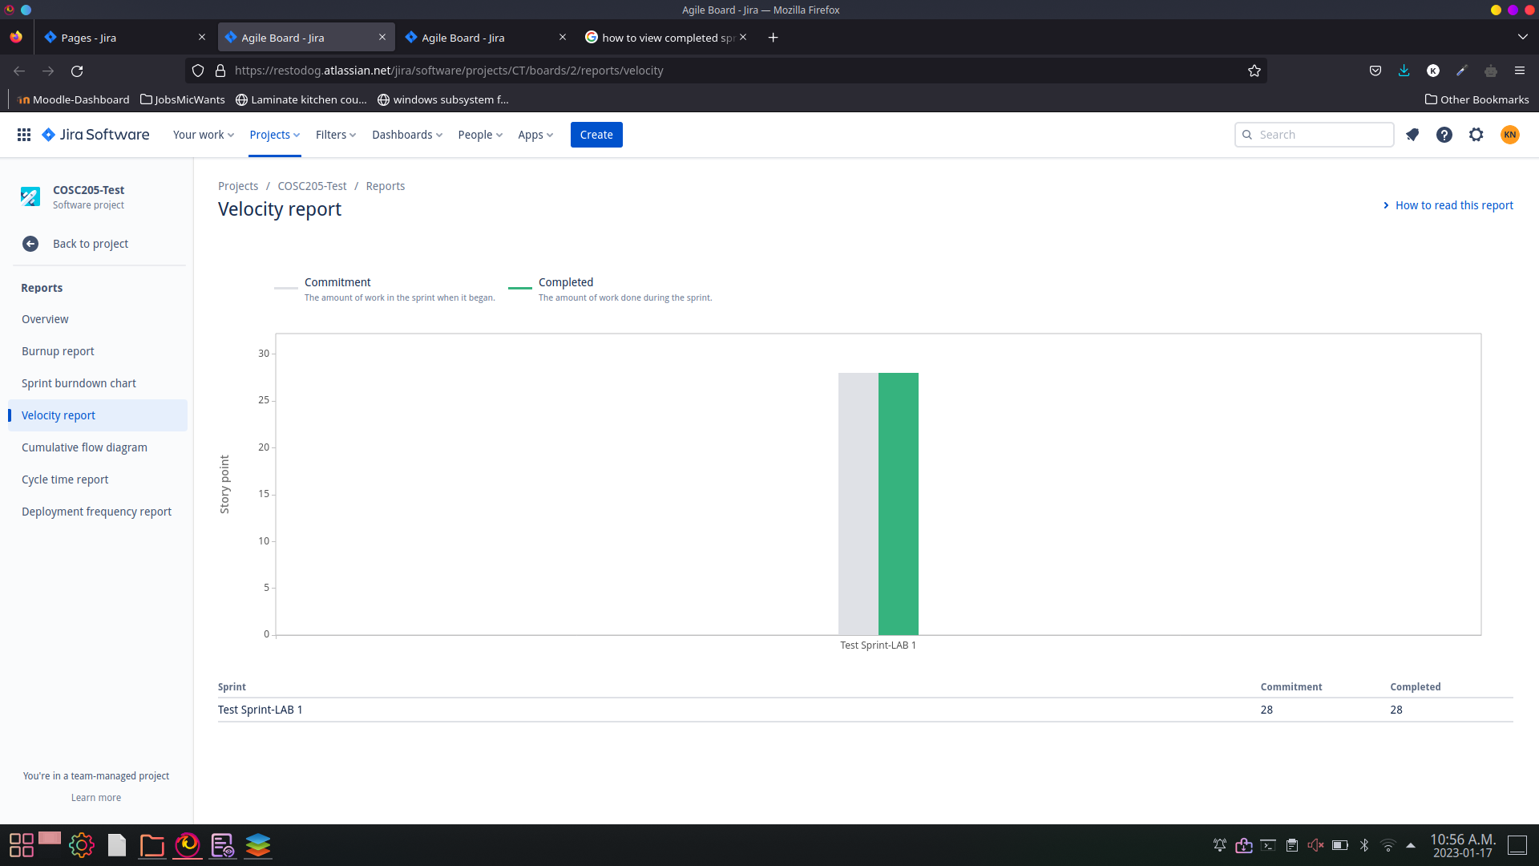

The two columns of the bar chart are the same height because we were able to complete all the tasks that were assigned during the sprint.

**Cumulative Chart**

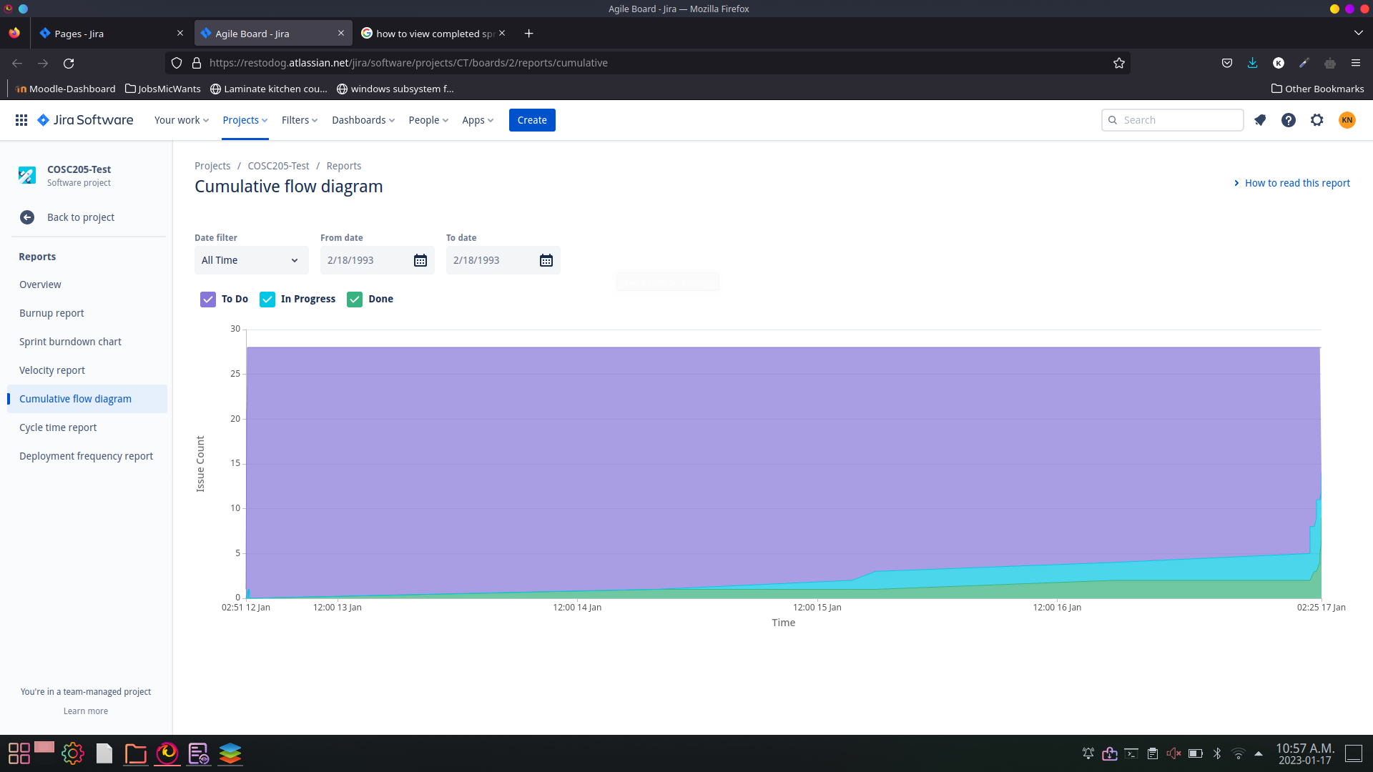

The purple (to-do) area takes up most the graph because we left most of the tasks until the very last day before we started and completed the tasks.