COSC 224 – Meeting #3

Project Title: O’Keefe Ranch Task Management System

Project Group: Arrested Developers

Project Sponsor: Carolyn

Meeting Theme: ________Meeting to discuss Sprint #1_________________________

Date & Time: February 28th 2023 11:00am

Next Meeting: March 14th 2023 11:00am

1. Link to Sprint’s output:

Project is not currently live to the internet so no link is possible as it is currently run locally on development machines

1. Completed goals from meeting 1 (Sprint 1 backlog)
   1. Task Manipulation, View, Create
   2. User Login, Logout
   3. Front End Task Dashboard
   4. Database Creation
2. Goals not completed from meeting 1 (Sprint 1 backlog)

a. User/Account Management

b. Task editing

1. Sponsors’ comments/questions:
   * Carolyn was very impressed with amount completed during sprint.
   * Enjoys simplicity of the system for ease of use.
   * Would like user management entirely done by admin I.e password management
2. What will you have done before the next meeting?
   1. User management
   2. Edit tasks
3. Group collaboration: discuss among yourselves.

As a group we were very happy with the progress we were able to make during the first sprint, despite not completing all of the backlog. A lot of the sprint was spent learning the django Framework but once we had a better understanding, the system began to fall into place.

**Cumulative Flow Diagram**

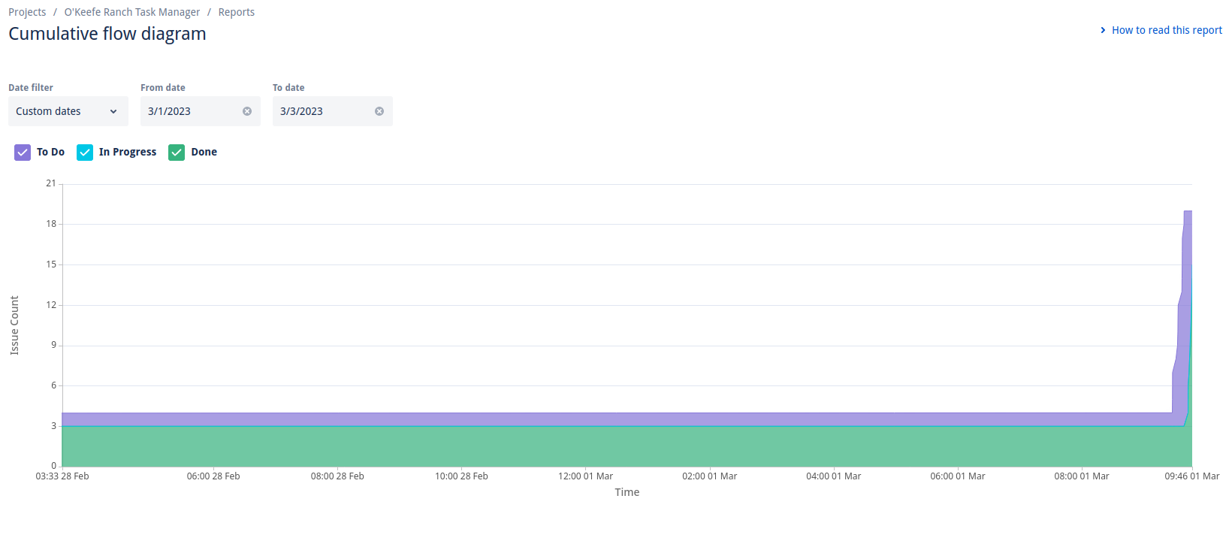

**Velocity Report**

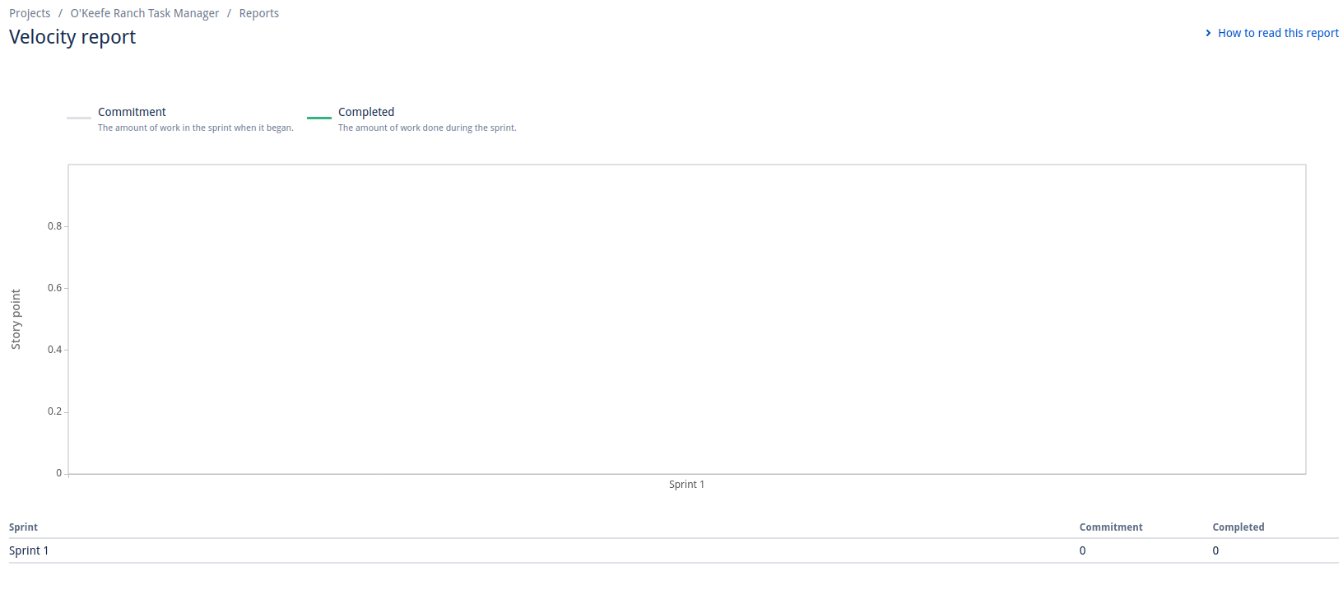

We don’t really know why the velocity report shows as empty

**Sprint Burndown Chart**

