**BMI548 Term Project Report**

**Description**

The application we are trying to develop looks at MyChart and its lack of a referral option in its menu offerings. Especially as many people who use the MyChart system may receive referrals from their physicians to see a specialist, in many instances, these referrals are left ignored or forgotten. Patients usually have to call into the physician’s office in order to get an update on their referral but by implementing this system into MyChart directly, it takes away the hassle of a patient not knowing where their referral is. This application would allow patients to understand and see what step of a process their referral is such as “just sent out”, “being reviewed by specialist physician”, “approved”, etc. In this case, it would be easier for the patients to know what their referral status is.

**User Persona and Use Case**

User Persona:

Emily Turner

Demographics

Age: 36

Occupation: Marketing Manager

Location: Suburban Area

Tech Savviness: Moderate

Health Status: Recently diagnosed with a chronic condition requiring specialist care

Goals

Stay informed about her referral status without needing to call multiple offices.

Understand what each status means and what she needs to do next.

Quickly access contact information for the clinic or specialist when issues arise.

Frustrations

Has previously experienced confusion with lost or delayed referrals.

Finds it time-consuming to repeatedly call her primary care provider or the specialist’s office for updates.

Wishes MyChart was more transparent about referral details.

Needs

Clear, up-to-date referral information with status updates and explanations.

Notifications about changes or actions needed.

Contact information to resolve issues directly, without being redirected multiple times.

Use Case:

Display each referral with the following information:

1. Referral details
2. Current status and estimated time to completion
3. Remaining steps
4. Referral completed (post-visit) and info sent to referring MD

Update in real time to reflect changes or actions on the referral and timeline

Provide appropriate contact info to referring or receiving office based on stage

1. Display insurance contact info if pending insurance authorization

Report referral issues

Indicate any required patient actions

**Current Implementation**

* MyChart does not currently have a referral tracking interface.
* Patients must rely on phone calls to clinics for updates, causing frustration and inefficiency.
* No centralized location for referral status updates, historical actions, or estimated completion times.

Shortcomings

* Lack of Transparency: Patients are unaware of referral progress, leading to unnecessary inquiries.
* Increased Administrative Burden: Clinics receive frequent calls from patients seeking referral updates.
* Confusion and Delays: No system for tracking lost referrals or providing reasons for delays.
* No Direct Communication Links: Patients lack an easy way to reach referring and receiving providers.

**Storyboard**

**Prototype Overview**

With the created prototype, patients are able to navigate to the MyChart menu or click on the “View referral” button on the home page to navigate to the referral page. On this page, the users are able to click on the individual referrals to open up some more information about the referral such as status details and referral/physician contact information. The users are able to also sort the referrals by referral status, date ordered, ordering clinician last name, and receiving clinician last name.

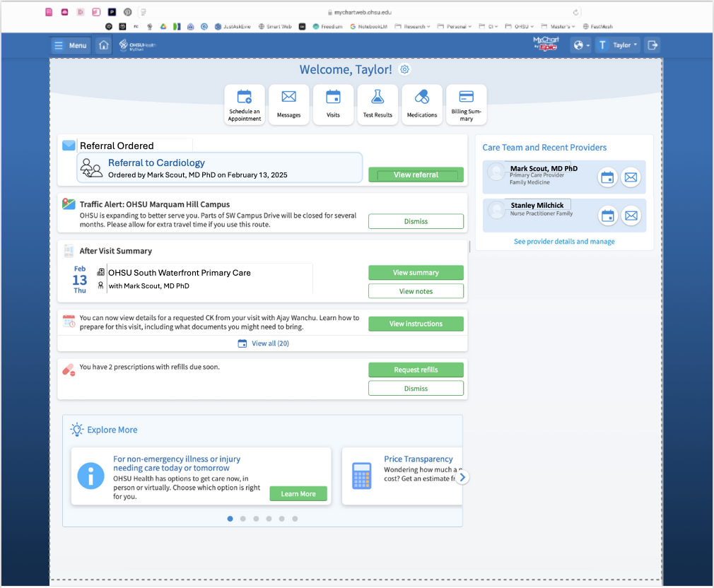

The **Referral Navigator** is a MyChart-integrated feature that allows patients to:

* View new referrals directly from the homepage.
* Access referral details including status updates.
* Sort and filter referrals based on status, date, and provider.

#### **Prototype Evolution**

* The **initial storyboard** proposed a simplified tracking system, but the prototype evolved to include:
  + **Sorting options** for better organization.
  + **Clickable expanded views** for in-depth referral details.
  + **Direct contact links** for improved communication.
* Changes were based on feedback emphasizing usability and clarity.

#### **Design Decisions**

* **Integration with MyChart**: Ensures seamless adoption.
* **Expandable Referral Cards:** Balances simplicity and detail.
* **Sorting and Filtering Options:** Enhances usability for users with multiple referrals.

#### **Influencing Design Principles**

* **Consistency**: Mirrors existing MyChart functionalities.
* **User Control & Freedom**: Provides navigation flexibility.
* **Minimalist Design**: Ensures clarity for tech-limited users.
* **Accessibility**: Supports high contrast, large fonts, and language options for diverse users​

**Evaluation Process**

The prototype was evaluated by another team for usability and heuristic violations. Three members from a different team went through the prototype and tried to use it as through they were a patient using the Referral navigator on MyChart themselves. Some feedback from the evaluations that changed the prototype including adjusting the modify/cancel referral button to one that says “request to modify/cancel referral” so that the individual could get in contact with the prescribing physician to discuss their concerns. Another example of a feedback that changed the prototype included specifying who the “Request a phone call” button was referring to and keeping the referral statuses consistent when collapsing and expanding a referral (error on our end). Some other feedback were out of scope and were not implemented into the updated prototype.

**Uncertainty in Design**

#### **Potential Issues**

* **Sorting Options Complexity**: Users may struggle with filtering choices.
* **Referral Status Descriptions**: Some terminology may still be unclear.
* **Adoption by Older Users**: Low-tech patients may need guidance.

#### **Addressing Uncertainties**

* **Additional user testing** to refine unclear areas.
* **Incorporating tooltips** for status descriptions.
* **Offering training materials** for less tech-savvy users​

**Evaluation Plan**

* Goal:
  + Assess usability, clarity, and effectiveness of the Referral Navigator.
* Evaluation Type:
  + Usability testing and surveys to gather user experience insights.
* Target Users:
  + Patients with recent referrals.
  + Caregivers managing multiple referrals.
  + Healthcare providers interacting with the system.
* Limitations:
  + Limited sample size.
  + Feedback may be subjective.
  + Need for additional iterations based on real-world use.
* Analysis and Usage:
  + Collect quantitative and qualitative feedback.
  + Identify common pain points and refine interface elements

**Future Directions and Conclusion**

Future Enhancements

* AI-based referral prediction for estimated completion times.
* Integration with insurance for real-time coverage status.
* Mobile app notifications for real-time updates.

Conclusion

The Referral Navigator addresses a critical gap in MyChart, improving transparency, efficiency, and user experience. While refinements are ongoing, early feedback suggests a strong potential for reducing patient frustration and clinic workload​.