# NAMES;

Kwizera josias 26135

Niyomugabo Nice Kevin 26708

KHADIJA ADAM 28041

# Simple Report – Database Project

## 1. Tables Created

• Students: Contains student details with constraints:  
 - student_id → Primary Key  
 - name → Not Null  
 - email → Unique & Not Null

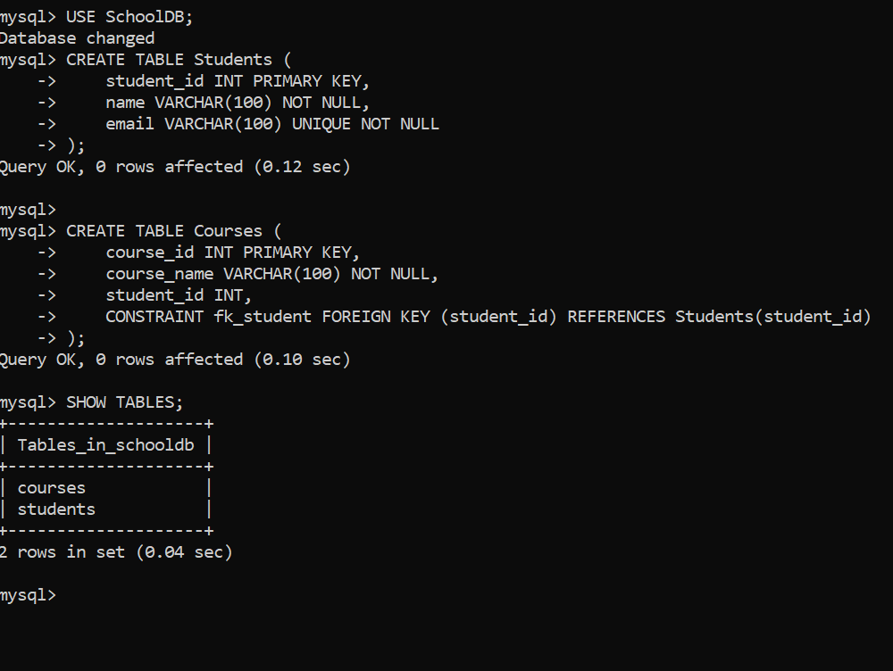

## 2. Joins Performed

• INNER JOIN: Displays only students enrolled in courses.  
• LEFT JOIN: Displays all students, even if they have not enrolled in any course.  
• RIGHT JOIN: Displays all courses, even if no student is enrolled.  
• FULL OUTER JOIN (via UNION in MySQL): Displays all students and all courses, whether or not they match.

## ASSSSSS3. Index

• idx_student_email created on the email column of Students.  
• This index improves performance when searching for students by email (faster queries).

## ASSLLLLL

## 4. View

• StudentCourseView created as a simplified way to view combined student and course data.  
• Instead of writing joins repeatedly, users can just query the view:

SELECT * FROM StudentCourseView;

## 5. Results

• The database shows relationships between students and their enrolled courses.  
• Joins demonstrate different perspectives of combining data.  
• The index improves query efficiency.  
• The view simplifies data access for users.  
  
In summary:  
We successfully created tables with constraints, performed multiple joins, added an index, created a view, and validated results through queries. This demonstrates how relational databases ensure consistency, efficiency, and ease of access.