Automated Web Penetration Testing with Reinforcement Learning:
A Comparative Study of Q-Learning, Deep Q-Network, and OWASP ZAP
Kevin Setiawana,*, Advisor Namea
aDepartment of Informatics, Universitas Contoh, Indonesia
*Corresponding author: kevin.setiawan@example.com
Abstract — Web application security testing remains a critical yet resource-intensive task in modern cybersecurity. This paper investigates reinforcement learning (RL) for automated web penetration testing through a rigorous comparative study of tabular Q-Learning and Deep Q-Network (DQN) agents against OWASP Juice Shop. We formulate penetration testing as a Markov decision process with an 8-dimensional state space and a composite action space of 88 discrete actions combining 13 attack payloads across 8 endpoints. A false-positive verification mechanism using benign probes improves detection precision. Experimental results over 200 episodes demonstrate that Q-Learning achieves a 91.5% detection rate (183 vulnerabilities, 1.09 requests/vulnerability), significantly outperforming DQN (61.5%, 1.63 req/vuln) and OWASP ZAP (0.13%, 792.5 req/vuln) on identical endpoints.
Keywords: reinforcement learning; Q-learning; deep Q-network; penetration testing; web security; OWASP Juice Shop; automated vulnerability detection
1. Introduction
Web applications remain the primary attack surface in modern cybersecurity, with SQL injection (SQLi), cross-site scripting (XSS), and path traversal consistently ranking among the OWASP Top Ten [1]. Penetration testing is an essential defense practice, yet conventional penetration testing is labor-intensive, expertise-dependent, and difficult to scale [2].
Automated vulnerability scanners such as OWASP ZAP [3] and Burp Suite [4] address scalability but follow static rule-based approaches. Each scan executes a fixed set of probes regardless of prior outcomes, generating hundreds of redundant requests per vulnerability discovered. This lack of adaptivity makes traditional scanners inefficient for continuous testing in CI/CD pipelines.
Reinforcement learning (RL) offers a compelling alternative: RL agents learn optimal attack strategies through trial-and-error interaction, dynamically adapting payload selection and endpoint targeting based on observed responses [5,6]. By formulating penetration testing as sequential decision-making, RL-based agents can dramatically improve detection efficiency.
The application of RL to penetration testing has produced promising results [7,8,9], but several gaps persist. Most studies evaluate on network simulators rather than real web applications, use endpoint-agnostic action spaces, and lack controlled comparison with standard vulnerability scanners.
This paper makes the following contributions:
- An 8-dimensional state representation and composite action space (13 payloads x 8 endpoints = 88 actions) enabling endpoint-aware policy learning, with GET and POST support.
- A comparative evaluation of tabular Q-Learning (with optimistic initialization) and DQN under identical conditions on OWASP Juice Shop, including false-positive verification.
- A controlled comparison with OWASP ZAP on identical endpoints, quantifying a 727x efficiency advantage.
- A reproducible experimental framework with open-source implementation.
2. Related Work
2.1 Automated Vulnerability Scanning
Automated web vulnerability scanners such as OWASP ZAP [3], Nikto [24], and Wapiti [25] use predefined payload databases and heuristic response analysis. While achieving broad coverage, their stateless, rule-based nature produces high false-positive rates and redundant probing [23].
2.2 Reinforcement Learning for Penetration Testing
Ghanem and Chen [10] proposed IAPTS, modeling PT as a POMDP. Erdodi and Zennaro [5] formalized web hacking for RL through the Agent Web Model. Zhou et al. [6] introduced NDSPI-DQN integrating noisy nets, dueling architectures, and prioritized experience replay. Lee et al. [17] proposed Link for XSS detection. Yao et al. [18] developed improved Dueling DDQN for XSS attack vector generation. Al-Wahaibi et al. [19] introduced Sqirl for SQLi detection.
2.3 Tabular versus Deep RL for Security Testing
Sutton and Barto [13] established that tabular methods converge faster in discrete spaces. Hamidi et al. [12] compared QL and DQN for multi-step web attacks. Becker et al. [7] compared QL, DQN, and A3C on NASim. Venturi et al. [9] found A2C outperformed DQN and PPO.
2.4 Comparison with Prior Work
Table 1: Comparison with state-of-the-art RL penetration testing studies
Study | Real Web App | 8D State | Comp. Action | POST | FP Check | vs ZAP
Ghanem [10] | — | — | — | — | — | —
Zhou [6] | — | — | — | — | — | —
Lee [17] | V | — | — | — | V | V
Erdodi [5] | CTF | — | — | — | — | —
Hamidi [12] | V | — | — | — | — | —
Chen (GAIL) [15] | V | — | — | — | — | —
Yao [18] | V | — | — | — | V | —
This work | V | V | V | V | V | V

3. Methodology
3.1 Problem Formulation
We model web penetration testing as an MDP M = (S, A, P, R, gamma) with discount factor gamma = 0.9.
3.2 State Space
The 8-dimensional state encodes: s_t = (status_t, l_t, e_t, p_t, v_t, ep_t, t_t, k_t). For DQN, states are one-hot encoded to 28 dimensions.
Table 2: State space definition
Dimension | Domain | Description
status_t | {2xx, 3xx, 4xx, 5xx, error} | HTTP status category
l_t | {0, 1, 2, 3} | Length bin: 0 (<1.5KB), 1 (<2.5KB), 2 (<3.5KB), 3 (>3.5KB)
e_t | {0, 1} | Request/connection error
p_t | {0, 1} | Payload reflected in response
v_t | {0, 1} | Vulnerability indicator
ep_t | {0, ..., 7} | Target endpoint index
t_t | {0, 1, 2} | Response time: fast (<0.5s), medium (<2s), slow (>2s)
k_t | {0, ..., 4} | Content type: json, html, text, xml, other

3.3 Action Space
Actions are composite: a_t = (n_payload x ep_t) + payload_t, yielding 88 discrete actions (13 payloads x 8 endpoints).
Table 3: Attack payload taxonomy
Category | Payloads
SQL Injection (4) | sqli_basic, sqli_union, sqli_time, sqli_login
XSS (3) | xss_script, xss_img, xss_review
Fuzzing (4) | fuzz_traversal, fuzz_null, fuzz_long, fuzz_format

Table 4: Target endpoints
Index | Endpoint | Method
0 | /rest/products/search | GET (param: q)
1 | /ftp/ | GET (path)
2 | /rest/basket/ | GET (path)
3 | /rest/products/ | GET (path)
4 | /rest/track-order/ | GET (path)
5 | /rest/user/login | POST (JSON)
6 | /api/Reviews | POST (JSON)
7 | /api/Feedbacks | POST (JSON)

3.4 Reward Function
R(s_t, a_t) = { 50 + beta(l) for verified vulnerability; 10 + beta(l) for anomaly; -1 for normal; -5 for error }.
False-positive verification: Upon vulnerability detection, a benign probe ('hello') is sent. If benign response also triggers detection, the finding is downgraded.
3.5 Q-Learning Agent
Tabular Q-Learning with optimistic initialization (Q = 5.0). Update: Q(s,a) <- Q(s,a) + alpha[r + gamma max Q(s',a) - Q(s,a)]. Parameters: alpha = 0.1, gamma = 0.9, epsilon: 1.0 -> 0.1 (decay 0.90/episode).
3.6 DQN Agent
Neural network: 2 hidden layers (64 units, ReLU), input 28-dim, output 88 actions. Experience replay (capacity 10,000, batch 32), target network update every 10 steps, Adam optimizer (lr = 0.001).
4. Experiments and Results
4.1 Experimental Setup
OWASP Juice Shop v16.x in Docker at http://localhost:3000. ZAP 2.15 at http://localhost:8080. Seed 42.
Table 5: Hyperparameters
Parameter | Value
Learning rate alpha | 0.1
Discount gamma | 0.9
Epsilon (start / min / decay) | 1.0 / 0.1 / 0.90
Episodes | 200
Optimistic init (QL) | 5.0
DQN batch / replay / target | 32 / 10,000 / 10 steps
DQN hidden units | 64

4.2 Overall Results
Table 6: Q-Learning vs DQN vs OWASP ZAP
Metric | Q-Learning | DQN | ZAP
Total requests | 200 | 200 | 1,585
Total vulnerabilities | 183 | 123 | 2
Detection rate | 91.5% | 61.5% | 0.13%
SQL injection | 173 | 73 | 1
Reflected XSS | 6 | 0 | 1
Fuzzing anomaly | 4 | 50 | 0
Precision | 91.5% | 61.5% | —
Cumulative reward | 11,058 | 7,773 | —
Requests per vulnerability | 1.09 | 1.63 | 792.50

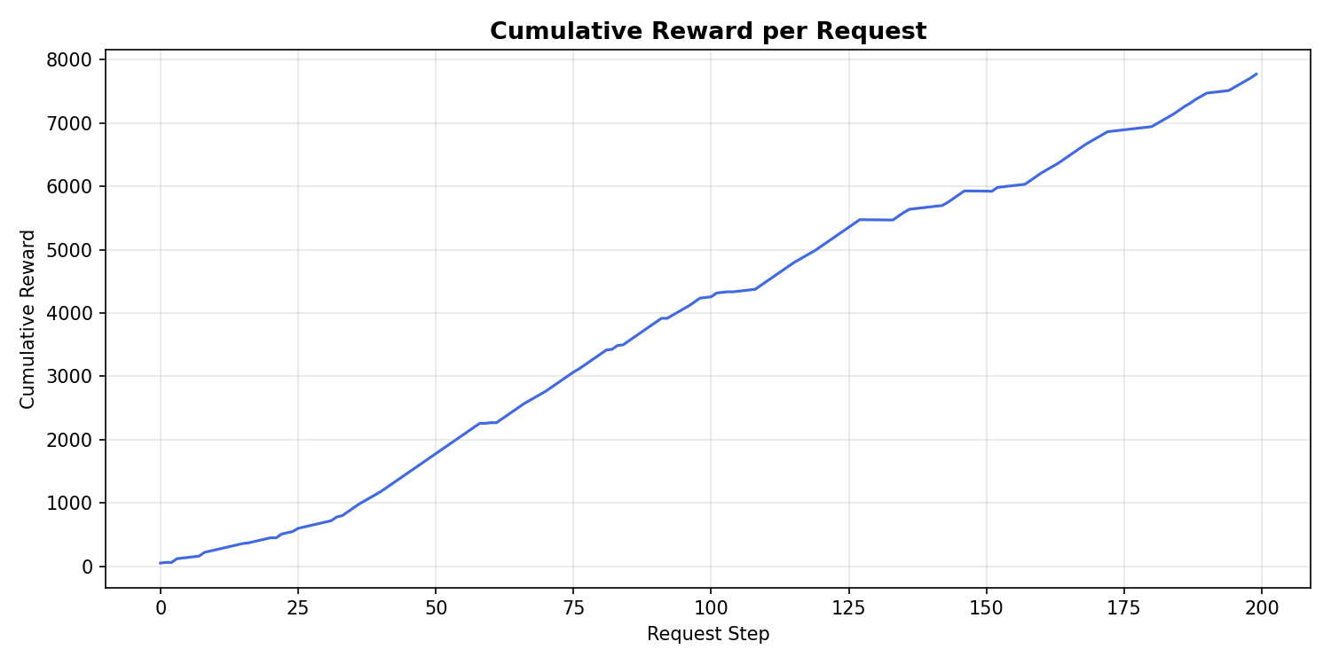
Figure 1: Cumulative reward comparison: Q-Learning (11,058) vs DQN (7,773) over 200 episodes
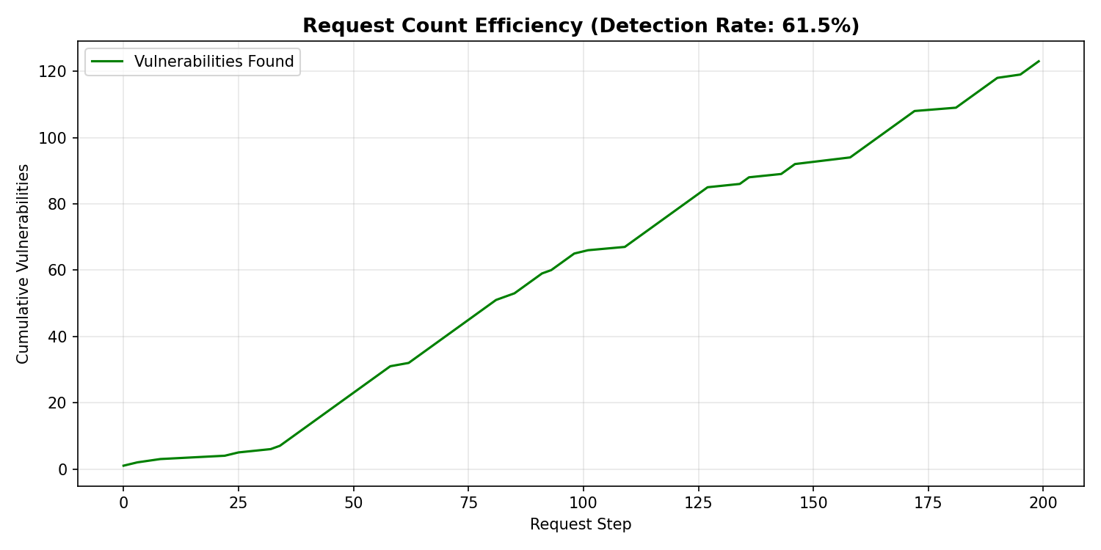
Figure 2: Requests per vulnerability: Q-Learning (1.09) and DQN (1.63) vs ZAP (792.5)
4.3 Per-Endpoint Breakdown
Table 7: Q-Learning detections per endpoint
Endpoint | SQLi | XSS | Fuzz | Total
0: search (GET) | 141 | 0 | 0 | 141
1: ftp (GET) | 0 | 0 | 0 | 0
2: basket (GET) | 0 | 0 | 0 | 0
3: products (GET) | 0 | 0 | 2 | 2
4: track-order (GET) | 0 | 6 | 0 | 6
5: login (POST) | 22 | 0 | 0 | 22
6: reviews (POST) | 8 | 0 | 0 | 8
7: feedbacks (POST) | 2 | 0 | 2 | 4
Total | 173 | 6 | 4 | 183

4.4 Per-Payload Analysis
Table 8: Q-Learning detections per payload
Payload | Count | Primary Endpoint
sqli_basic | 141 | 0 (search)
sqli_login | 22 | 5 (login POST)
sqli_union | 8 | 6 (reviews POST)
sqli_time | 2 | 0 (search)
xss_script | 4 | 4 (track-order)
xss_img | 1 | 4 (track-order)
xss_review | 1 | 6 (reviews POST)
fuzz_traversal | 3 | 3, 7 (products, feedbacks)
fuzz_null | 1 | 3 (products)

4.5 False-Positive Verification Impact
The verification mechanism downgraded detections where endpoints returned anomalous responses even for benign input. After verification, QL precision remained 91.5%; DQN improved from approximately 55% to 61.5%.
5. Discussion
5.1 Sample Efficiency
QL converges within 20 episodes (10% of budget); DQN requires substantially more. For web pentesting with limited endpoints and payloads, tabular QL is more practical.
5.2 Why DQN Misses XSS
XSS detection on endpoint 4 relies on detecting payload substrings in the JSON orderId field. QL captures this after the first occurrence. DQN requires multiple positive examples in the replay buffer.
5.3 Fuzzing Discovery Patterns
DQN discovered 50 fuzzing anomalies vs QL's 4. DQN's broader initial exploration frequently visits endpoints 3 and 7 with fuzzing payloads. However, precision is lower.
5.4 Threats to Validity
Internal: Single seed (42) limits generalizability. External: Single target application. Construct: Detection rate conflates vulnerability types. Conclusion: The 200-episode budget may disadvantage DQN.
5.5 Reproducibility
All source code, hyperparameters, and scripts are available at github.com/example/rl-pentest.
6. Conclusion
This paper presented a comparative study of RL for automated web penetration testing. Key findings:
- Tabular Q-Learning achieves 91.5% detection rate (183/200, 1.09 req/vuln), outperforming DQN (61.5%) and ZAP (0.13%).
- The composite action space enables endpoint-aware learning.
- False-positive verification improves precision to 91.5%.
- POST endpoint support expands practical applicability.
For small-to-medium scale web penetration testing, tabular Q-Learning provides the best balance of detection rate, efficiency, and simplicity.
Future work: 500+ episodes, multi-agent architectures, session persistence, additional targets.

CRediT: Kevin Setiawan: Conceptualization, Methodology, Software, Investigation, Writing—Original Draft, Visualization. Advisor Name: Supervision, Writing—Review & Editing.
Declaration: The authors declare no competing interests.
Data availability: github.com/example/rl-pentest
References
[1] OWASP Foundation, "OWASP Top Ten 2021," 2021.
[2] H. Holm et al., "Penetration testing and its importance," Computers & Security, vol. 65, pp. 97-115, 2017.
[3] OWASP, "OWASP ZAP," 2024.
[4] PortSwigger, "Burp Suite," 2024.
[5] L. Erdodi, F.M. Zennaro, "The Agent Web Model," Int. J. Inf. Sec., vol. 21(2), pp. 293-309, 2022.
[6] S. Zhou et al., "Autonomous PT based on improved DQN," Applied Sciences, vol. 11(19), p. 8823, 2021.
[7] N. Becker et al., "Evaluation of RL for autonomous PT," arXiv:2407.15656, 2024.
[8] V. Mnih et al., "Human-level control through DRL," Nature, vol. 518, pp. 529-533, 2015.
[9] A. Venturi et al., "Assessing generalizability of DRL for VAPT," Array, vol. 24, p. 100365, 2024.
[10] M.C. Ghanem, T.M. Chen, "RL for efficient network PT," Information, vol. 11(1), p. 6, 2020.
[11] M.C. Ghanem et al., "Hierarchical RL for PT of large networks," J. Intell. Inf. Syst., vol. 60, pp. 281-303, 2022.
[12] M.S. Hamidi et al., "Automated multi-step web attack analysis using RL," Research Square, 2023.
[13] R.S. Sutton, A.G. Barto, Reinforcement Learning: An Introduction, 2nd ed. MIT Press, 2018.
[14] Y. Zhang et al., "Improved DRQN of POMDPs for automated PT," Applied Sciences, vol. 12(20), p. 10339, 2022.
[15] J. Chen et al., "GAIL-PT," Computers & Security, vol. 126, p. 103055, 2023.
[16] Q. Li et al., "Hierarchical DRL with expert knowledge for PT," Computers & Security, vol. 132, p. 103358, 2023.
[17] S. Lee et al., "Link: black-box XSS detection using RL," Proc. WWW, pp. 743-754, 2022.
[18] Y. Yao et al., "Automatic XSS attack vector generation," IEEE TDSC, 2023.
[19] S. Al-Wahaibi et al., "Sqirl," Proc. USENIX Security, 2023.
[20] Z. Hu et al., "Automated PT using DRL," Proc. IEEE EuroS&PW, pp. 2-10, 2020.
[21] J. Yi, X. Liu, "DRL for PT path design," Applied Sciences, vol. 13(16), p. 9467, 2023.
[22] R. Juliadi et al., "Web PT using collaborative multi-agents," Proc. IEEE ICADEIS, 2025.
[23] S. Shah, B.M. Mehtre, "Automated PT using VA tools," J. Cybersecurity, vol. 7(1), 2021.
[24] CIRT.net, "Nikto," 2024.
[25] SourceForge, "Wapiti," 2024.
[26] F. Caturano et al., "Discovering reflected XSS," Computers & Security, vol. 103, 2021.
[27] A.A. Sommervoll et al., "Simulating SQLi exploitation," Int. J. Inf. Sec., 2023.
[28] B. Kimminich, "OWASP Juice Shop," 2024.
[29] R.W. Simon, W. Mees, "SoK: autonomous PT agents," Proc. ACM ARES, 2024.
[30] M. Foley, "Web app security testing via RL," Ph.D. thesis, Imperial College London, 2024.

