This is Heading1 Text
This is a regular paragraph with the default style of Normal. This is a regular paragraph with the default style of Normal. This is a regular paragraph with the default style of Normal. This is a regular paragraph with the default style of Normal. This is a regular paragraph with the default style of Normal.
This is a Defined Block Style Called BlockStyleTest
This is more Normal text.

This is Heading 2 text
This is more Normal text. This is bold, this is italic, and this is bold italic. This is normal. This is in a defined inline style called InlineStyle. This is normal. This is red text. This is normal.
This block is centered.
This is left-aligned.

- First item of bulleted list.
- Second item of bulleted list.
Second paragraph of second item of bulleted list.
- Third item of bulleted list.
  - First item of third item’s nested list
  - Second item of third item’s nested list
- Fourth and final item of main bulleted list.

This is Normal text.

- First item of numbered list.
- Second item of numbered list.
Second paragraph of second item of numbered list.
- Third item of numbered list.

Here is a BMP picture:

Here is a table:
 | New York |  | Boston | Detroit
Baseball | Mets | Yankees | Red Sox | Tigers
Hockey | Rangers | Islanders | Bruins | Red Wings
Football | Giants | Jets ads ads asd asdads as | Patriots | Lions

Here is an embedded Excel spreadsheet:

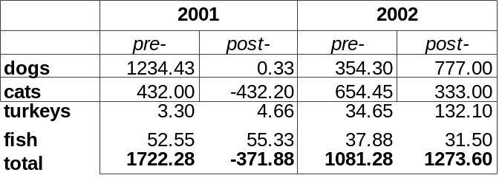

This concludes our test.

