

**PPC Management Proposal for Lords Cars**

25th February 2011

Private and Confidential

Prepared for **Ryan Galloway**

Lord Cars Ltd

121 Dixons Hill Road

Welham Green

Hatfield

Herts.

AL9 7DW



by Protea Digital

106 Todd St, Suite A,

Carrboro, N.C. 27510

[www.proteadigital.com](http://www.proteadigital.com)

Thank you for inviting Protea Digital to submit a Pay-Per-Click Management proposal.

**Background**

Lord Cards is seeking to grow and expand, with PPC providing an effective opportunity to grow leads and new business.

**Scope**

Protea proposes a targeted, smart pay-per-click campaign for getting more leads, web traffic and enquires.

**Pay-Per-Click Search Advertising**

Pay-per-click (PPC) advertising allows a site to get traffic based on keywords very quickly and precisely control the advertisements which are shown. A well-run campaign can deliver qualified traffic, and when linked to a well targeted site, becomes a strong sales tool. And as you only pay for clicks, this is an efficient way to get exposure.

A good PPC campaign allows the site to access potential customers who self-qualify by searching for the relevant keywords.

**The Protea Digital PPC Plan includes**:

* End-to-end campaign management, development, writing, set-up
* Active daily management of ads and campaigns.
* Developing a smart PPC strategy to help meet Lord Cars business goals
* On-going testing, refinement and improvements
* Geographic targeting to appropriate areas

**Also incorporates:**

* Monthly progress reports and updates
* Ongoing communication as needed
* Email responsiveness and personal availability via phone when needed (same day responsiveness)

Bottom line

A well-run campaign takes time and skill, but delivers highly targeted traffic has been shown time and time again to be an excellent revenue builder. We believe Lord Cars will benefit from a focused and targeted PPC campaign.

**Investment**

|  |  |
| --- | --- |
| Setup Fee: | Waived |
| Management Fee: | $399 per month (Approximately 247 GBP) |

*Please note that keyword spend costs are for the client’s account.*

Payment to be made via credit card, and are made on a monthly basis.

**Anticipated Return on Investment**

* More Leads
* More conversions
* Greater website traffic
* Brand awareness and visibility
* Improved customer focus

**About Protea Digital**

Protea is focused on: 1) Quality 2) Ethics 3) Communication.

We are based near the Research Triangle area of North Carolina, close to great technology companies, leading universities and not far from the mountains and beach.

**Staffing**

All work on this project will be led by Steven Kent. You’ll be able to contact Steven at anytime via phone or email to discuss any aspect of your account.

|  |  |
| --- | --- |
| C:\Users\SPK\Desktop\1Protea Digital Folder\4. Logos and Images\spk4 - Copy.png | Steven is the CEO of Protea Digital. He has over six years experience in web marketing and enterprise IT software. Steven holds Masters degrees from Duke University, Durham, N.C. as well as the University of Cape Town, SA. |

**Client results**

* **Tripled online revenue** for luxury sheet manufacturer, while reducing cost of customer acquisition by 66%
* **Managed 351 keywords** for a NASDAQ-listed, $318 million in revenue furniture manufacturer with 84 first place rankings in Google, and 185 top five rankings in Google. Corporate database driven website with ten thousand pages,
* **Grew traffic** to client in competitive permission-based email marketing industry by 4x, outperforming better-funded competitors by 60%
* **Increased Click-Through-Rate** for corporate sales training e-commerce store by 110%, decreased Cost-Per-Click by 12% and increased conversion rate by 250%
* **Managed end-to-end** $375k dollar annual PPC spend campaign for sector-leading employment industry client, including strategy and implementation

**Relevant certifications**

|  |  |
| --- | --- |
| |  | | --- | | Google Adwords Certified Professional ID 883-883-7576 | |
|  |
|  |
|  |
|  |
|  |
|  |



**Client Testimonials**

“Steven Kent has been managing our PPC campaigns for several years. We employed Contactology about three years ago where Steven worked and was assigned our account. Steven recently left Contactology to start his own business. We kept our account with Steven as he has proven to be quite adept in managing our business. Our revenue has consistently grown with Steven's guidance. Steven suggested we begin a social networking marketing strategy which was initiated about three weeks ago. This effort, which Steven manages, has generated a significant amount of incremental sales since inception.

In short we are very satisfied with Steven. He is professional, easy to communicate with, responsive, creative, and attentive to our needs. I recommend Steven with no hesitation.”

*-Tom Muscalino, CEO Thomas Lee Ltd, Former President of WestPoint Pepperell*

“Steven managed our social media, paid search. He was a member of our staff.  We were very disappointed to lose him, but excited that he's launched his own firm.  He's still consulting on Contactology PPC.  He's done an excellent job.  He understands the importance of measuring ROI and did an excellent job of demonstrating it with his projects.”

*-Winston Bowden, VP Marketing, Contactology*

“Again, thank you for all your hard work and fast response on our requests and fixes. You are great at what you do and have accomplished for Laser Image.”

*-Cynthia Luks, Laser Image Printing and Marketing*

**Some Clients**  
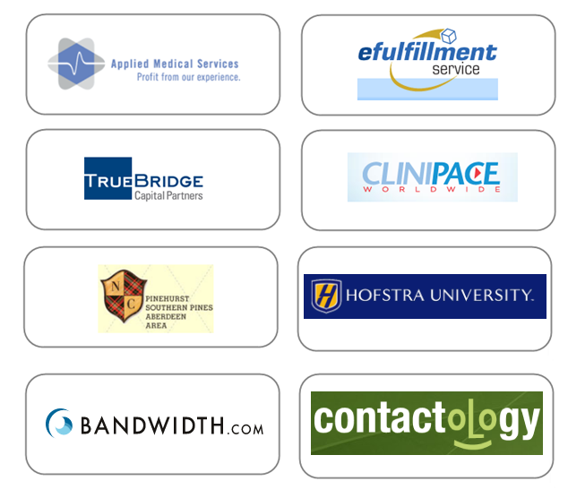

**Next steps**

Feel free to contact Steve at [spkent@proteadigital.com](mailto:spkent@proteadigital.com) for any more information.

Please let me know if you would like to move forward and I can email you an electronic contract for your review.

Thanks Ryan,

Steve Kent

Protea Digital