Power Consumption Analysis - Hypothesis Testing
Prepared by: Kevin Tushar Pandya
Master of Professional Studies in Analytics
Northeastern University

Introduction
Using Tetuan city Power consumption Dataset, this report investigates the factors determining power consumption in different zones of the city. A particular focus is given to the months of Winter (November - February). Hypothesis testing was done on different questions, utilizing both one - sampled and two - sampled tests and tried to analyse linear regression to support the hypotheses.

Main Section
- About Dataset: The dataset named Tetuan contains information about power consumption in three different zones in the city. It also contains several natural factors such as temperature, humidity, and wind speed. The dataset contains timestamps of year 2017. The data is updated every 10 minutes and has around 57000 rows with 9 columns. The dataset consists of 8 continuous variables which are humidity, wind speed, temperature, power consumption based on different zones.

- Original Questions Explored
- Is the average temperature significantly different in Winter months when compared to other months?
- This test will help to understand if there is a difference of average temperature in Winter months when compared to non - winter months.
- Is the average Humidity significantly different in Winter months when compared to other months?
- This test will help to understand if there is a difference of average Humidity in Winter months when compared to non - winter months.
- Power consumption before and after winter months.
- This test will reveal the power consumption patterns in the winter months and compare it with non- winter months.
- Dependence of Power Consumption on Humidity, Temperature and Wind Speed.
- This test can reveal the if power consumption is related to natural factors such as temperature, wind speed and humidity.

- Exploratory Data Analysis
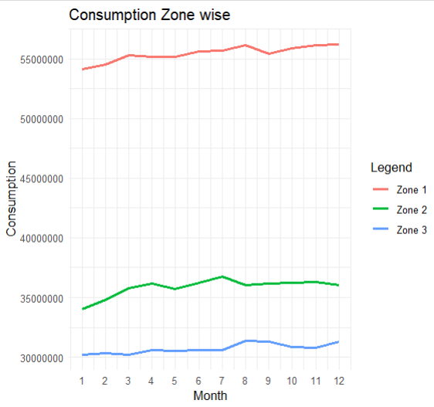
Fig1: Power Consumption based on Months.

The above graph shows power consumption in different zones of Tetuan city. It is visible that power consumption in Months of Winter (November - January) is slightly less when compared to other months. The graph follows an upward trend after January and goes slightly down after October Month.

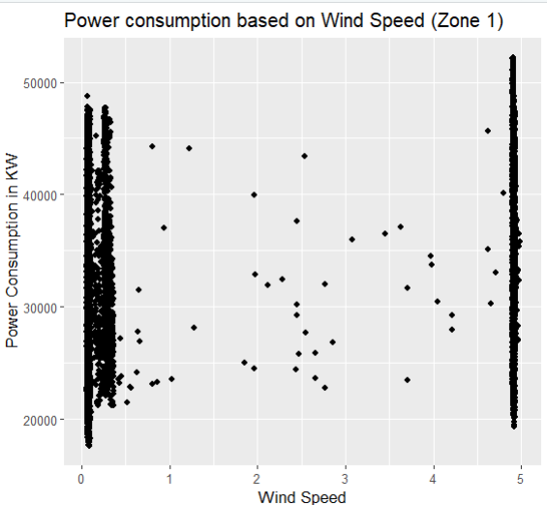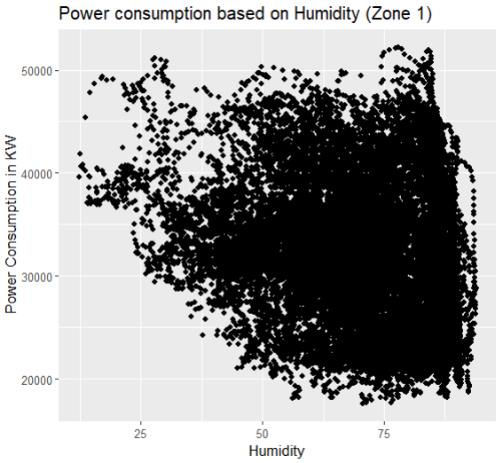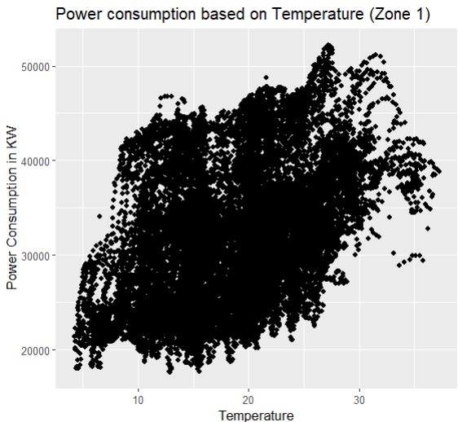
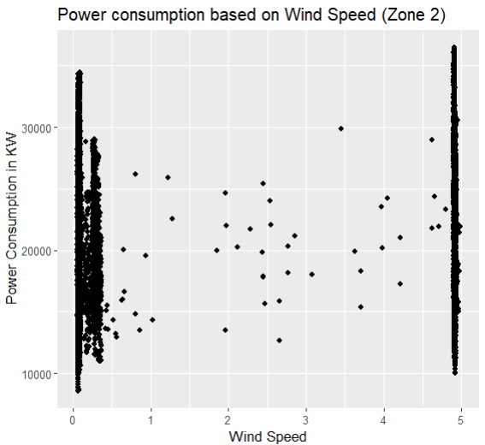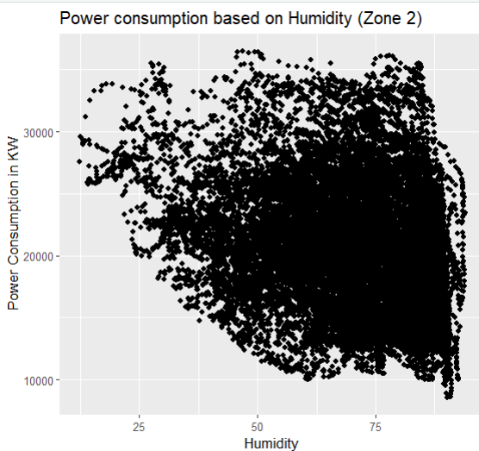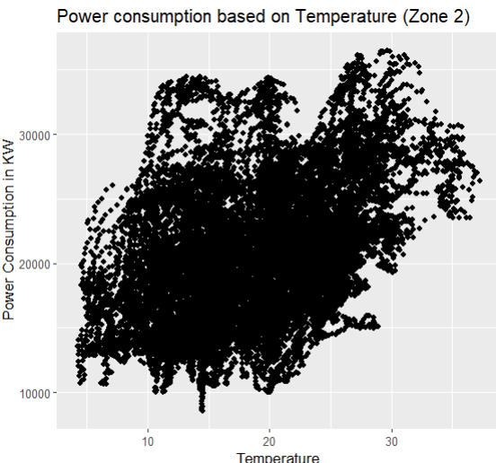
Fig2: Correlation Plots between Natural Factors and Power consumption.

The Correlation plots show relationship between Natural Factors (Temperature, Wind Speed and Humidity) and Power consumption. It is evident that there is a positive correlation between power consumption and temperature. It is also observed that there is no correlation between wind speed and power consumption.

- Hypotheses Statements and Tests
- Analysis of Average temperature in Winters to other seasons.
- H₀: The mean difference of temperature in Winter and without Winter is 0.
- H₁: The mean difference of temperature in Winter and without Winter is not 0.
- Choice of Test: One Sampled T – Test
A One Sampled T – Test is appropriate here because we are comparing the mean temperature from a single sample against global temperature of the same sample.
- Test Result: The t – test yielded a p – value less than significant value (0.05), leading to statistically rejecting null hypothesis and accepting alternate hypothesis.

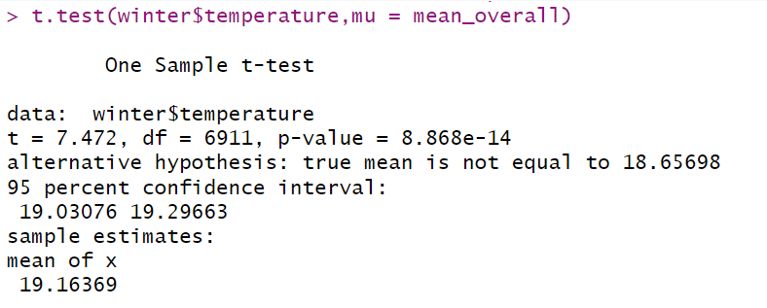
Fig3: Test Result for temperature

- Analysis of Average Humidity in Winters to other seasons.
- H₀: The mean difference of Humidity in Winter and without Winter is 0.
- H₁: The mean difference of Humidity in Winter and without Winter is not 0.
- Choice of Test: One Sampled T – Test
A one sampled t – test is appropriate for comparing mean difference of Humidity as both global and mean temperature values are taken from same sample.
- Test Result: The result portrays that p value is less than significance value of 0.05, therefore the null hypothesis should be rejected statistically.

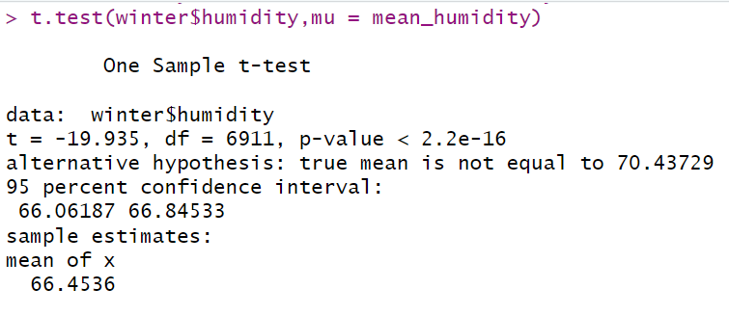
Fig4: Test result for Humidity

- Analysis of Power consumption in winter months compared to non-winter months.
- H₀: Power Consumption is similar in all three zones.
- H₁: Power Consumption is not similar in all three zones.
- Choice of test: Two sampled T – Test (Welch – T – Test)
A two sampled t – test is suitable because we are comparing means between two independent groups having unequal variance and different sample sizes.

To conduct a two-sample t – test, some assumptions are made.
  - Data values should be independent.
  - Data is assumed to be normally distributed.
  - Data should be obtained via random sampling.
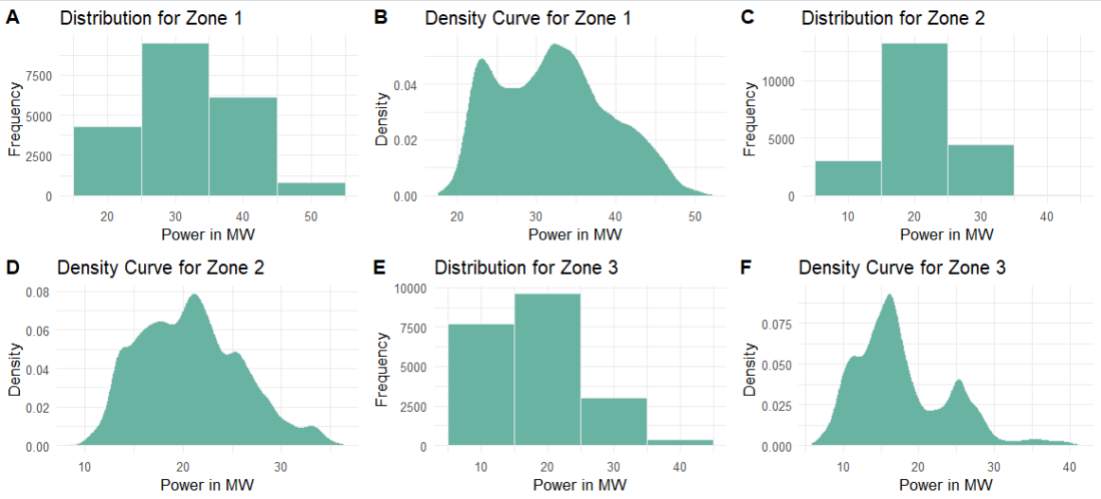
Fig5: Distribution of Power Consumption in different zones.

The data is not normally distributed but it is near to resemblance of normal distribution. Hence, we consider it to be normally distributed.

- Test Results:
For Zone 1: The welch test determines a negative t value which indicates that sample mean of first group is lower than second group. Its significance is given by p – value which is greater than significance value of 0.05 suggesting strong evidence to statistically accept null hypothesis.
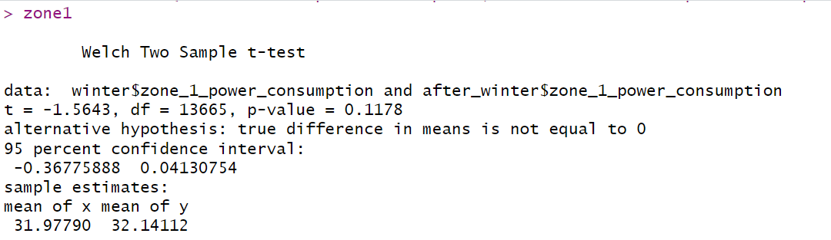
Fig6.1: Two Sample T – Test (Zone 1)

For Zone 2: Two sampled t – test for zone 2 also determines negative t – value which indicates that sample mean of first group is less than sample mean of second group. However, the p – value is significantly smaller than alpha value i.e. 0.05, suggesting strong evidence to reject null hypothesis.

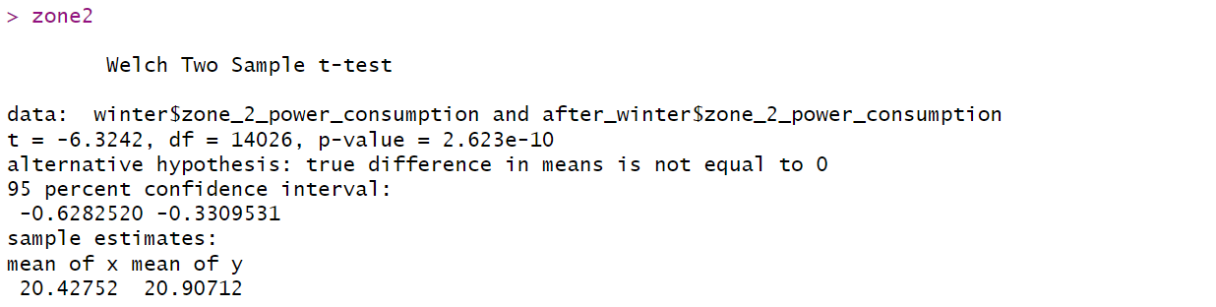
Fig6.2: Two Sample T – Test (Zone 2)

For Zone 3: Based on p – value determined by Welch t – test, which is significantly larger than alpha i.e. 0.05 (confidence level), it statistically suggests strong evidence to accept null hypothesis.

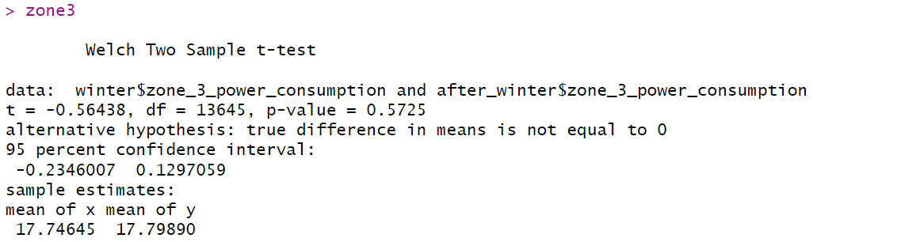
Fig6.3: Two Sample T – Test (Zone 3)

- Dependence of Power Consumption on Humidity, Temperature and Wind Speed.
Part 1: Correlation Analysis of Power Consumption with Humidity, Temperature and Wind Speed.
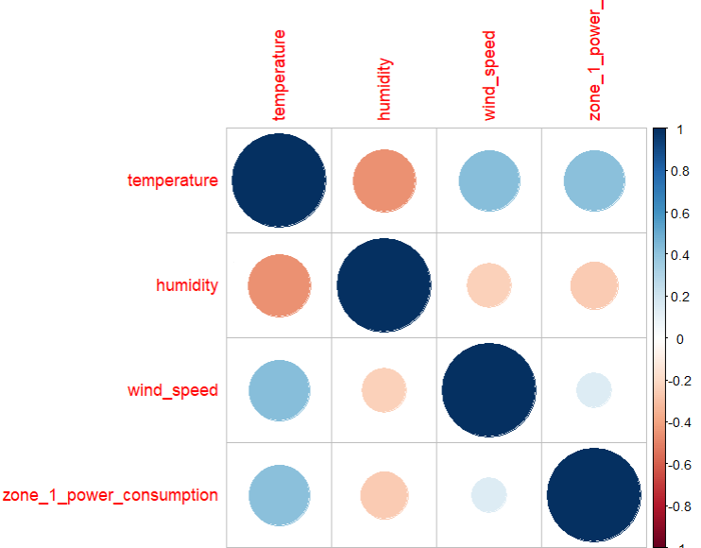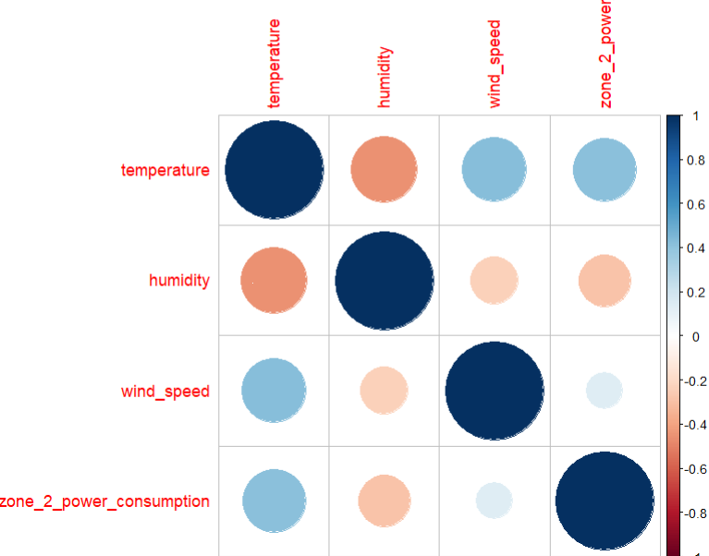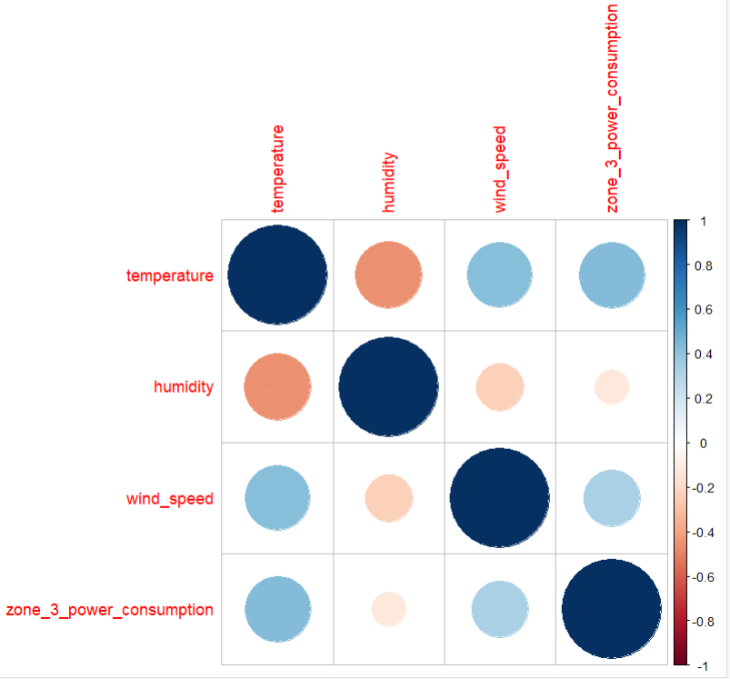
Fig7: Correlation Plot for Power consumpion v/s natural factors

Due to more number of columns, entire correlation plot is divided into three parts to make it easy to understand and be visually appealing.
The correlation plot suggests that there is a significant positive correlation between power consumption in all zones with Temperature (represented by light blue circle in 1st column and last row). However, there is negative correlation with Humidity (represented by light orange circles in 2nd column last row). Furthermore, it provides very less positive correlation with wind speed (represented by small light blue circles in 3rd column last row).

Part 2: Regression Analysis of Power Consumption with Humidity, Temperature and Wind Speed.
- H₀: Power consumption in zones depend on Wind_speed, Temperature and Humidity.
- H₁: Power consumption in zones does not depend on Wind_speed, Temperature and Humidity.
- Choice of Test: Linear regression.
Linear regression is chosen to analyse the trend of power consumption based on Humidity, Temperature and Wind speed.
- Test Results:
For Zone 1: The p – value from regression analysis provides significant evidence to reject null hypothesis as the p – value is less than 0.05 (alpha value). The plot also suggests that it is deflecting from regression line denoting the false predicted values at both the tails signifying outliers.
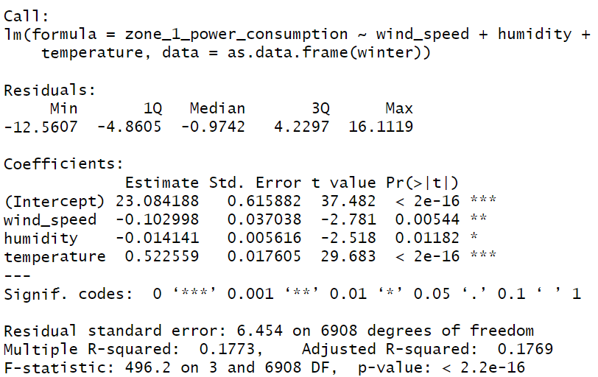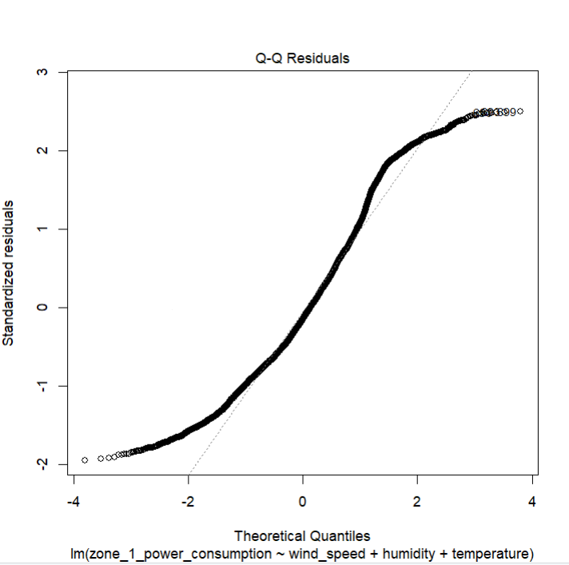
Fig8.1: Regression for Zone 1.

For Zone 2: It is significant from p – value which is very less when compared to significance level (alpha = 0.05) that it is statistically evident to reject null Hypothesis. The plot represents the deflected line from normal distribution line also known as outliers at both the tails.
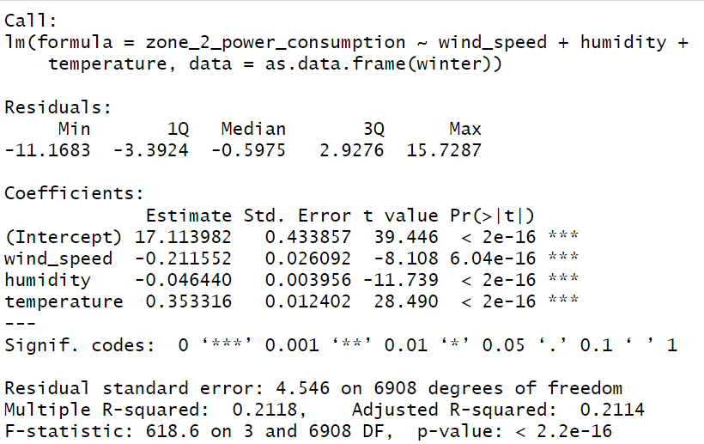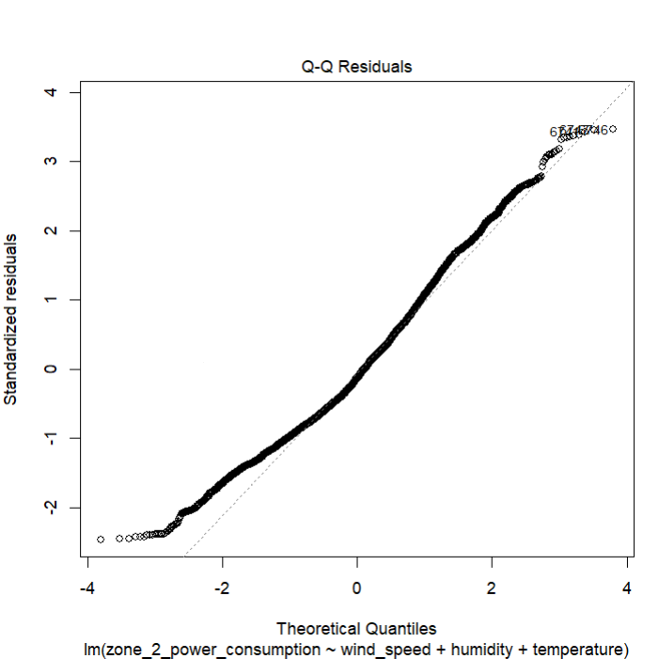
Fig8.2: Regression for Zone 2.

For Zone 3: The regression analysis clearly determines with the help of p – value which is way less than alpha = 0.05 (significance level) making a strong evident to reject null hypothesis. The plot provides outliers on both ends and a clear deflection from normal distribution plot.
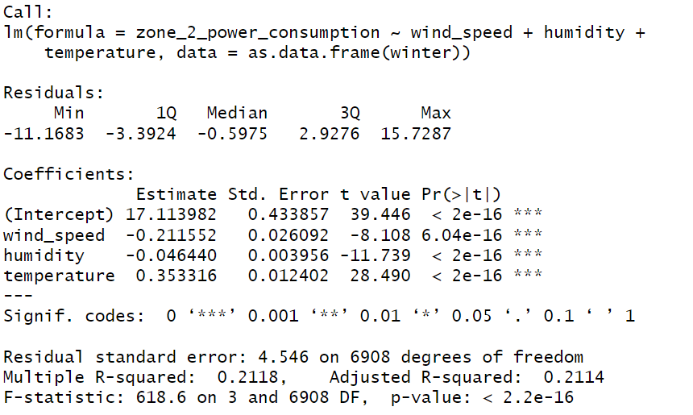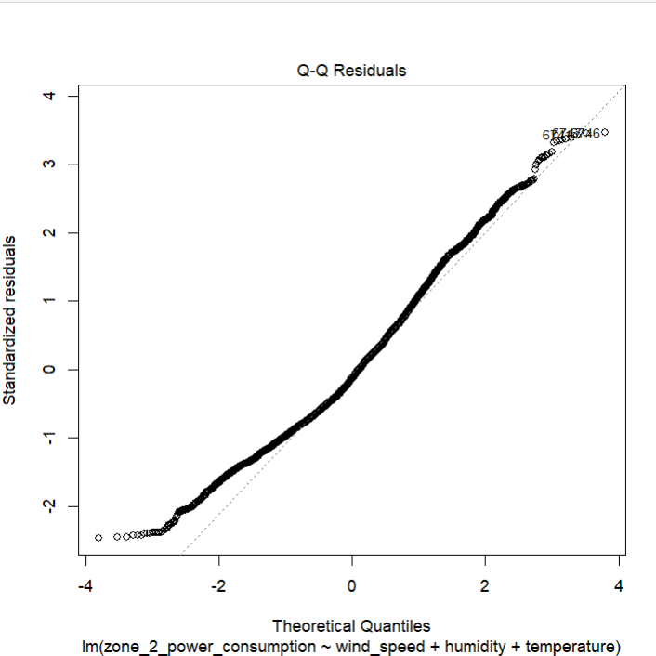
Fig8.3: Regression for Zone 3.

Conclusion
The analysis suggests statistically that there is no relationship between Power Consumption between different Zones of Tetuan City. However, when analysed based on Correlation plot, there was significant correlation between temperature, humidity, and power consumption. However, correlation analysis does not guarantee causation of any event. Thus, Hypothesis testing was utilized in analysis which concluded that there is no evidence to support that power consumption is influenced by Temperature, Wind Speed and Humidity.

References
- UCI Machine Learning Repository (Dataset)
https://archive.ics.uci.edu/dataset/849/power+consumption+of+tetouan+city
- Interpretation of Q-Q Plots
https://www.statology.org/diagnostic-plots-in-r/
- Interpretation of T- Test
https://www.investopedia.com/terms/t/t-test.asp

