Project Profile

[1] PROJECT PROFILE

- Project Title: Doctor Appointment Management System (CareSlot)

- Project Domain: Web Application Development

- Project Duration: Forth Semester

- Technologies Used:
- Frontend: HTML, CSS, Tailwind, JavaScript, React
- Backend: Node.js / Express.js
- Database: MySQL / MongoDB
- Payment: RazorPay
- Analytics & Dashboard: Chart.js / React Chart / Custom Dashboard

- Project Description:
This project is a complete Full Stack Doctor Appointment Management System developed using the MERN Stack. The system allows patients to search for doctors, check available appointment slots, and book appointments online through a simple and user-friendly interface. Doctors can manage their schedules, handle patient appointments, and track their earnings using a dedicated dashboard.
The system also includes an Admin panel that provides full control over doctors, patients, and appointments across the platform. A modern analytics dashboard is implemented to visualize important system data such as appointment statistics, doctor performance, and earnings using graphical charts.
Additionally, the platform supports Excel report download functionality, allowing administrators and doctors to export appointment and earnings data for reporting and record-keeping purposes. The system also integrates secure authentication, role-based access control, and online payment processing using Razorpay, making the platform efficient, secure, and suitable for modern healthcare appointment management.

- Key Features:
    - User Registration and Secure Login (JWT Authentication)
    - Doctor Listing with Search and Specialization Filtering
    - Appointment Management System
    - Doctor Dashboard for Managing Slots, Appointments, and Earnings
    - Admin Panel for Managing Doctors, Patients, and Appointments
    - Online Payment Integration using Razorpay
    - Modern Analytics Dashboard with Graphical Reports
    - Excel Report Download for Admin and Doctors
    - Email Notification System for Appointment Booking and Doctor Credential Delivery (when Admin creates a doctor account)

INTRODUCTION TO TOOLS

[2] INTRODUCTION TO TOOLS
- Introduction:
The Doctor Appointment Management System (CareSlot) is developed using modern web development tools and technologies that support efficient application development, scalability, and performance. These tools are used for designing the user interface, building the server-side logic, managing the database, and integrating additional services such as payments, analytics, and email notifications.
Frontend Tools
- HTML (HyperText Markup Language)
HTML is used to create the basic structure of web pages. It defines elements such as forms, buttons, headings, and layouts that build the foundation of the user interface.
- Tailwind CSS
Tailwind CSS is a utility-first CSS framework used to design modern and responsive user interfaces. It provides ready-to-use classes that help developers quickly build clean and consistent UI components.
- JavaScript
JavaScript is used to add interactivity and dynamic behavior to web pages. It enables features such as form validation, API communication, and real-time updates in the application.
- React.js
React.js is a JavaScript library used for building fast and interactive user interfaces. It allows developers to create reusable components and develop single-page applications efficiently.
- Redux
Redux is a state management library used with React to manage application data across multiple components. It helps maintain a predictable and centralized data flow in the application.
- Chart.js
Chart.js is a JavaScript library used to create graphical charts and data visualizations. It is used in the dashboard to display analytics such as appointment statistics and earnings.

Backend Tools
- Node.js
Node.js is a server-side runtime environment that allows JavaScript to run on the backend. It is used to build scalable and high-performance server applications.
- Express.js
Express.js is a lightweight web framework for Node.js used to build REST APIs. It simplifies routing, request handling, and middleware integration in backend development.
- CORS (Cross-Origin Resource Sharing)
CORS is a middleware that allows secure communication between the frontend and backend servers. It enables controlled access to resources from different domains.
- Cookie Parser
Cookie-parser is a middleware used to read and manage cookies in HTTP requests. It helps handle authentication tokens and user session data stored in cookies.
- Cloudinary
Cloudinary is a cloud-based service used for storing and managing images. It is used in the system to upload and store user profile images securely.

Database
- MongoDB
MongoDB is a NoSQL database that stores data in flexible JSON-like documents. It allows scalable and efficient storage of application data.
- Mongoose
Mongoose is an Object Data Modeling (ODM) library used to interact with MongoDB. It provides schema-based structure and data validation for database collections.

Authentication & Security
- Express Rate Limit
Express-rate-limit is a middleware used to limit repeated API requests from users. It helps protect the system from spam requests and brute-force attacks.
- JSON Web Token (JWT)
JWT is used for secure user authentication. It allows the server to verify users through tokens without storing session data on the server.

Payment Integration
- Razorpay
Razorpay is an online payment gateway integrated into the system to allow patients to pay consultation fees securely through digital transactions.

Email Notification
- Nodemailer
Nodemailer is used to send automated emails from the server. It sends notifications such as appointment confirmations and doctor account credentials when created by the admin.

Excel File Export
- ExcelJS
ExcelJS is a library used to generate and download Excel files from the application. It allows admins and doctors to export appointment and earnings data for reporting and analysis.

SYSTEM STUDY

[3] SYSTEM STUDY

  - Existing System

In many healthcare facilities, appointment scheduling is still handled manually through phone calls, physical visits, or basic record-keeping systems. Patients usually need to visit the clinic or call the hospital to check doctor availability and book appointments. This process often leads to several issues such as long waiting times, scheduling conflicts, and lack of proper record management.

The manual system also makes it difficult for doctors to manage their schedules efficiently and for administrators to monitor appointments and patient records. In addition, there is no centralized platform to track appointment status, doctor availability, or payment information. These limitations reduce overall efficiency and may cause inconvenience for both patients and healthcare providers.

  - Proposed System:
The proposed system, Doctor Appointment Management System (CareSlot), is a web-based platform designed to automate and simplify the appointment management process. The system allows patients to search for doctors, check available time slots, and book appointments online.
Doctors can manage their schedules, view appointments, and track their earnings through a personalized dashboard. Administrators have full control over the system, including managing doctors, patients, and appointments. The platform also provides analytics dashboards, secure authentication, online payment integration, email notifications, and Excel report downloads.
This digital solution improves efficiency, reduces manual work, and provides better communication between patients and doctors.

  - Scope Of the Proposed System:
The scope of the proposed system includes developing a web-based platform that supports appointment booking and management for healthcare services. The system will allow patients to book appointments with doctors based on available time slots and manage their appointment history.
Doctors will be able to manage their availability, view patient details, and monitor their appointments and earnings. Administrators will manage system users, monitor appointments, and analyze system performance through dashboards and reports.
The system can also be expanded in the future with additional features such as mobile applications, video consultation, and automated appointment reminders.

  - Aims and Objectives:
The main aim of the Doctor Appointment Management System is to develop a digital platform that simplifies the process of scheduling and managing doctor appointments.
Objectives of the system include:
- To provide an easy and efficient online appointment booking system for patients.
- To allow doctors to manage their schedules and appointments effectively.
- To enable administrators to manage doctors, patients, and appointments from a centralized platform.
- To reduce manual errors and improve scheduling efficiency.
- To provide data visualization and analytics through modern dashboards.
- To integrate secure online payment and email notification systems.
- To allow data export through Excel reports for better record management.

3.5 Feasibility Study
A feasibility study evaluates whether the proposed system is practical and beneficial for implementation. It analyzes different aspects such as operational feasibility, technical feasibility, and economic feasibility to determine whether the system can be successfully developed and deployed.

3.5.1 Operational Feasibility
Operational feasibility refers to how well the proposed system will work within the organization and whether users will be able to operate it effectively. The Doctor Appointment Management System is designed with a simple and user-friendly interface so that patients, doctors, and administrators can easily use the platform.
The system reduces manual workload, improves appointment management, and enhances communication between patients and doctors. Therefore, it is highly practical and beneficial for healthcare service management.

3.5.2 Technical Feasibility
Technical feasibility evaluates whether the required technology and resources are available to develop and maintain the system. The CareSlot system uses widely adopted technologies such as React.js, Node.js, Express.js, and MongoDB, which are reliable and suitable for building scalable web applications.
These technologies support fast development, efficient data handling, and secure authentication. Since these tools are well-supported and commonly used in modern web development, the system is technically feasible.

3.5.3 Economic Feasibility
Economic feasibility analyzes the cost involved in developing and maintaining the system compared to the benefits it provides. The proposed system is developed using open-source technologies such as React, Node.js, and MongoDB, which significantly reduce development costs.
The system helps reduce manual work, improves efficiency, and provides better management of appointments and records. Therefore, the benefits of the system outweigh the development and maintenance costs, making it economically feasible.

SYSTEM ANALYSIS

[4] SYSTEM ANALYSIS
System analysis is the process of studying the system requirements and identifying how the system should function to meet user needs. It helps in understanding the functionalities, system behavior, and interactions between different components.
In the Doctor Appointment Management System (CareSlot), the analysis focuses on defining the requirements for patients, doctors, and administrators so that the platform can efficiently manage appointment scheduling, user management, and system monitoring.

4.1 Requirements Specification (With System Modules)
The system is designed with multiple modules that define the functionality available for different types of users. Each module performs specific tasks that contribute to the overall working of the application.

1. Patient Module
The Patient Module allows users to search for doctors, book appointments, and manage their appointment history.
Main Functions:
- User registration and secure login
- View and search doctors by specialization
- View doctor profile and available time slots
- Book appointment with selected doctor
- Online payment using Razorpay
- Receive email confirmation after booking
- View appointment history and status (Pending, Confirmed, Completed, Cancelled)
- Manage personal profile information

2. Doctor Module
The Doctor Module allows doctors to manage their schedules, appointments, and patient information.
Main Functions:
- Secure login for doctors
- View dashboard with appointment statistics and earnings
- Manage available appointment slots (add / delete)
- View upcoming appointments
- Confirm, cancel, or mark appointments as completed
- View patient details for appointments
- Download Excel report for appointment data
- Update doctor profile information

3. Admin Module
The Admin Module provides full control over the system and manages all users and system data.
Main Functions:
- Secure admin authentication
- Add new doctors to the system
- Automatically send doctor login credentials via email
- View and manage all doctors
- Activate or deactivate doctor accounts
- View and manage patient records
- Monitor all appointments in the system
- View commission details from appointments
- Download Excel reports for system data
- View analytics dashboard with graphical reports

4. Appointment Management Module
This module manages the entire appointment scheduling process.
Main Functions:
- Create appointments based on available slots
- Track appointment status (Pending, Confirmed, Completed, Cancelled)
- Manage doctor availability and time slots
- Store appointment details including doctor, patient, date, and time
- Provide centralized management of appointment records

5. Notification and Communication Module
This module handles communication between the system and users.
Main Functions:
- Send email notifications for appointment booking
- Send doctor account credentials when admin creates a doctor profile

6. Analytics and Reporting Module
This module provides system insights and data visualization.
Main Functions:
- Display graphical analytics using charts
- Show appointment statistics and doctor earnings
- Display top-performing doctors
- Export reports in Excel format for record management

Use Case Diagram

4.2 Use Case Diagram
Admin :
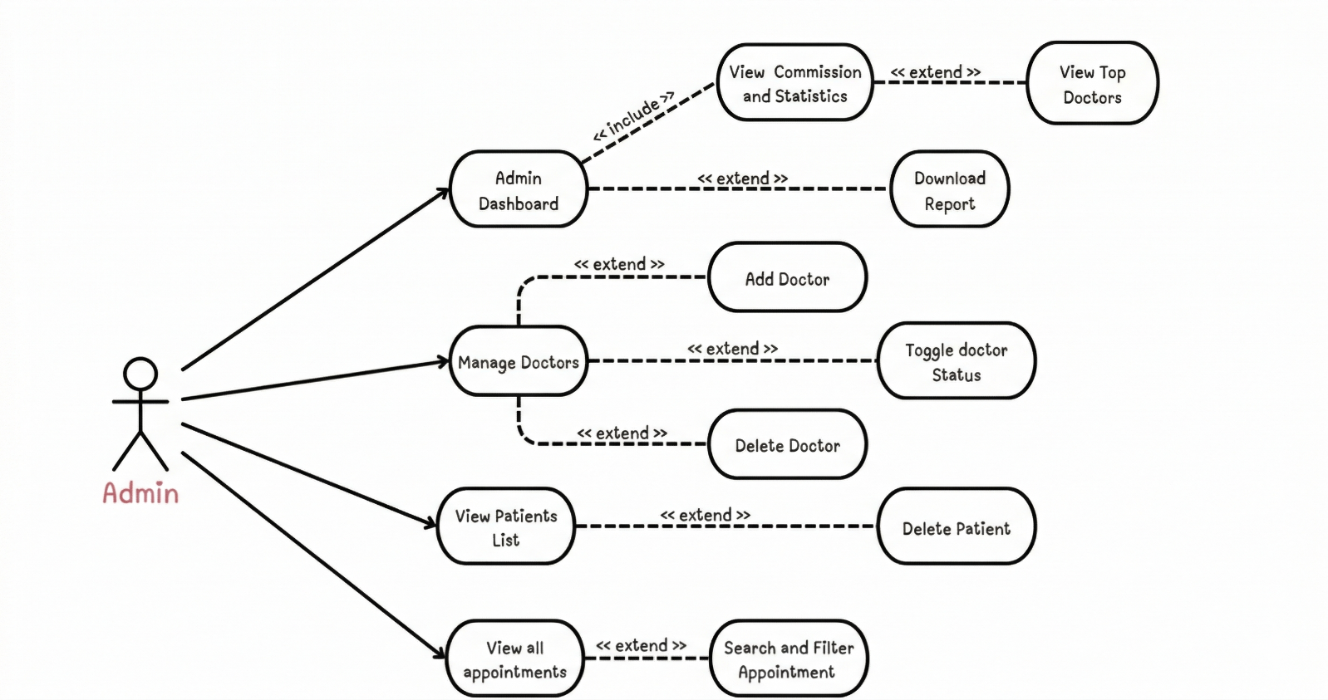

Doctor :
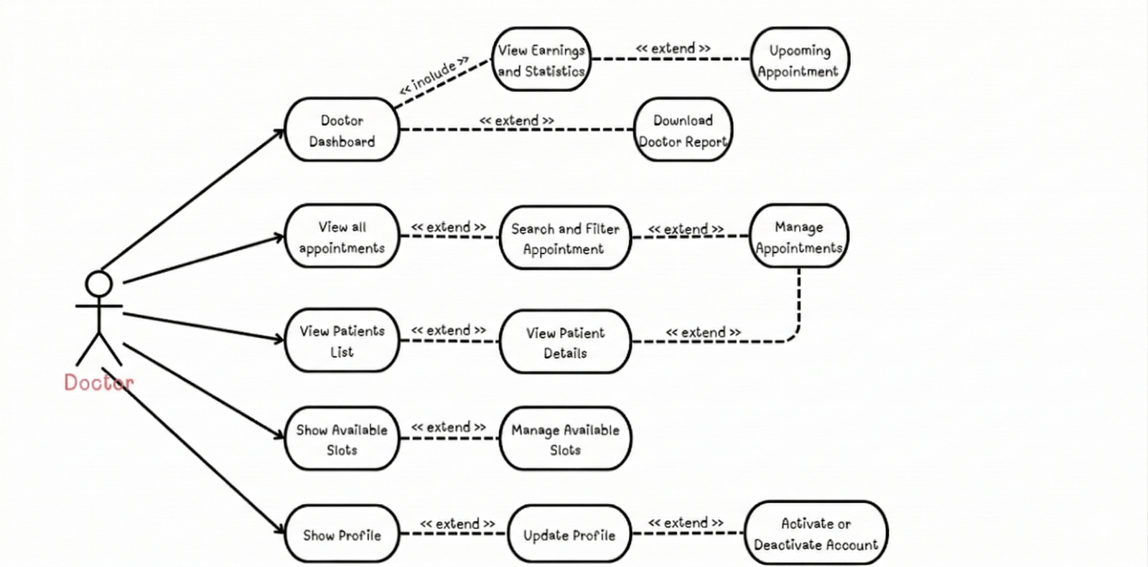

Patient :
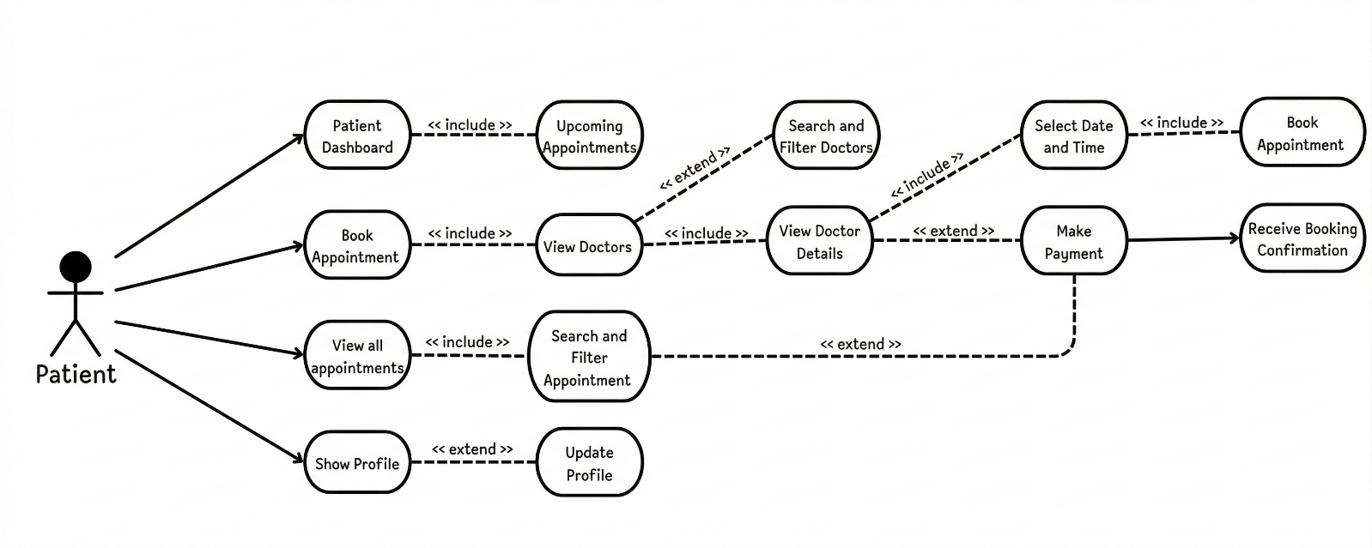

Activity Diagram

4.3 Activity Diagram
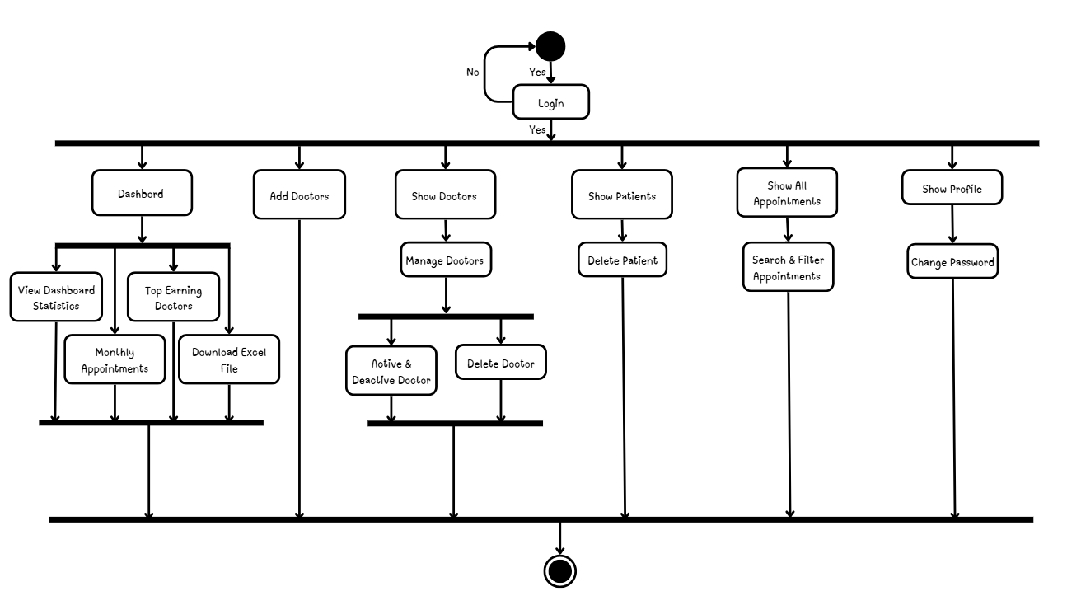
- Admin :

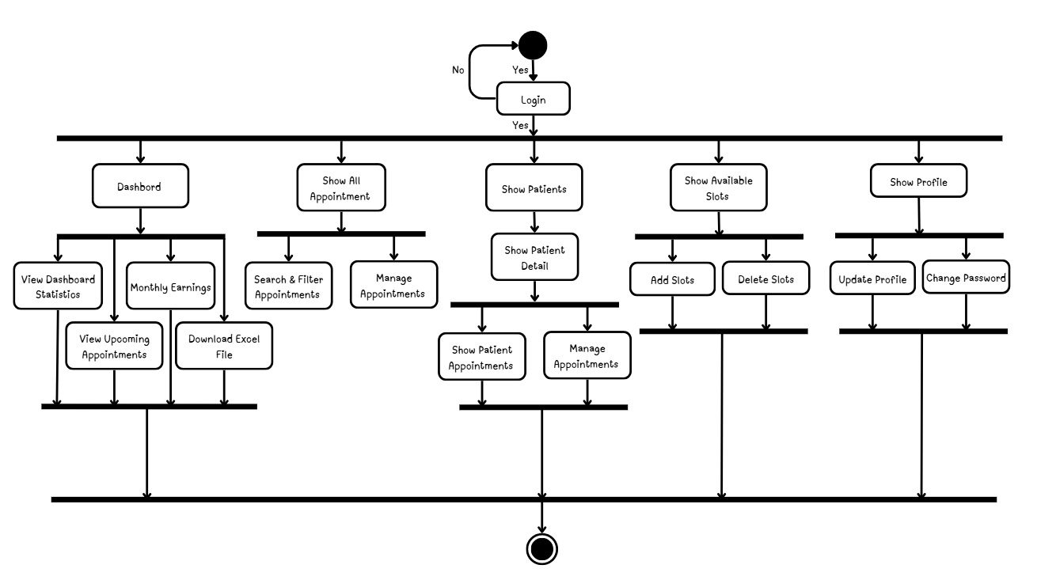
- Doctor :

- Patient :
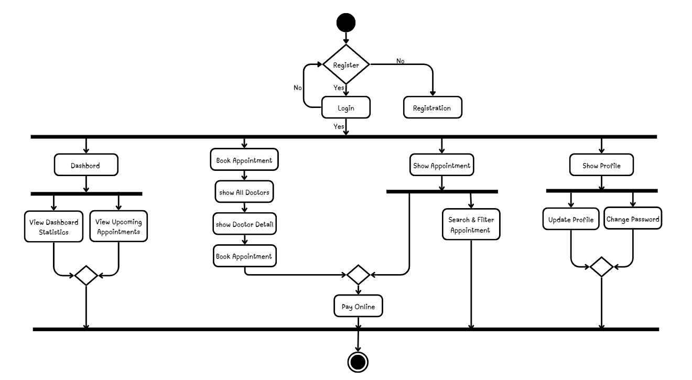

Data Flow Diagram

4.5 Data Flow Diagram
4.5.1 Context Level DFD

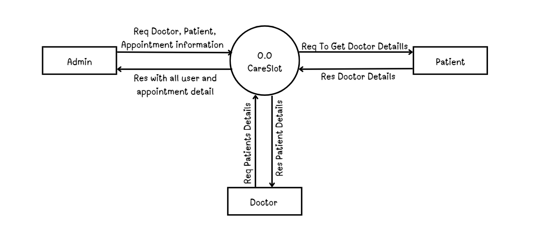
4.5.2 First Level DFD
- Admin :-
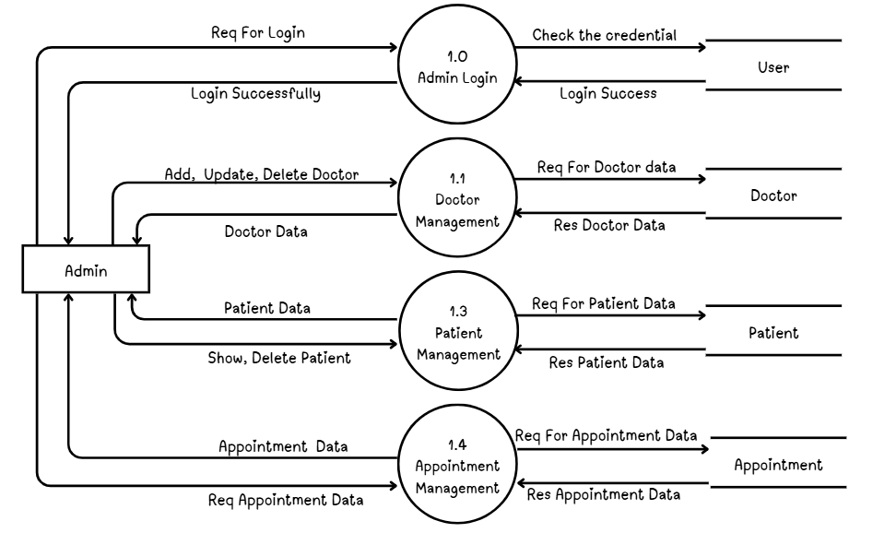

- Doctor :-
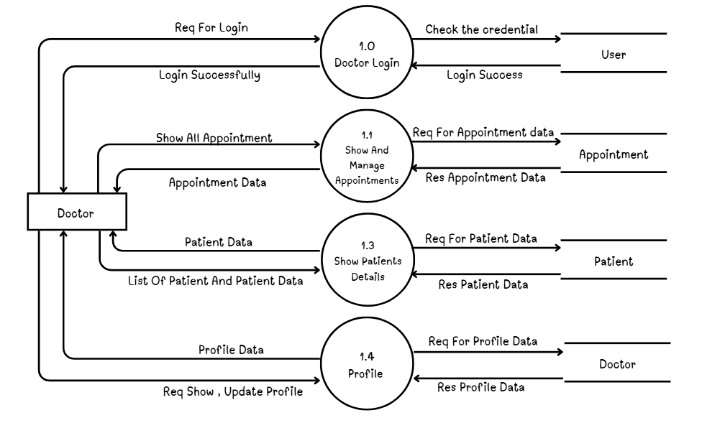
- Patient :-
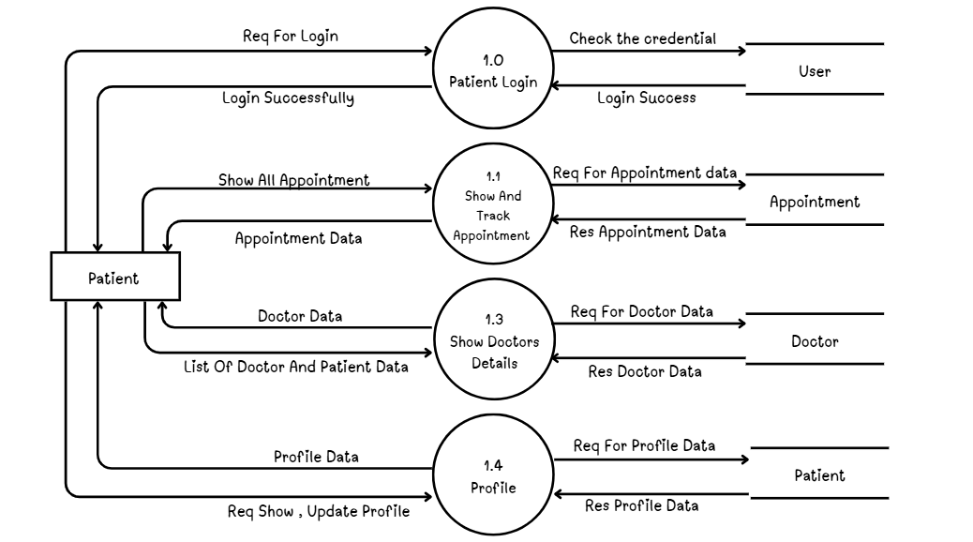
4.6 ER Diagram

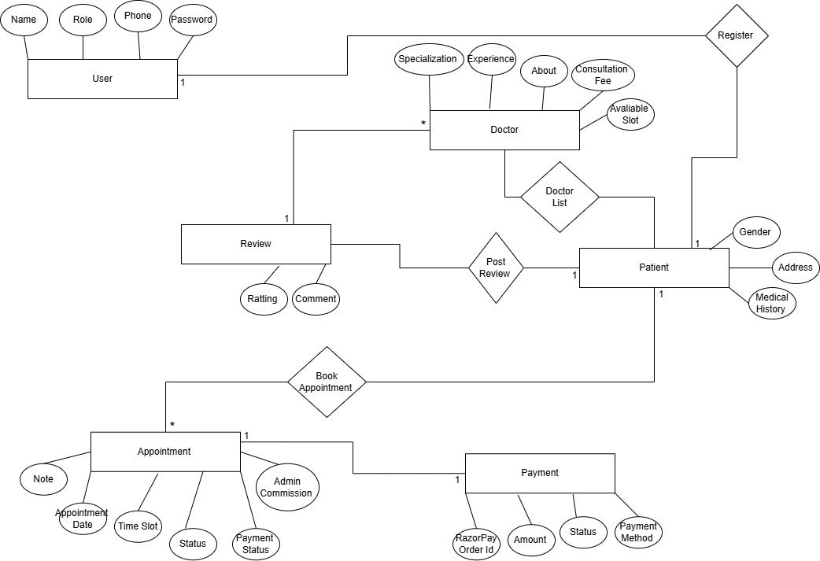

System Design

5.1 Data Dictionary
- Database Name: CareSlot

- User Collection:

No. | Field Name | Data Type | Constraint | Description
1 | _id | ObjectId | Primary Key | Unique identifier automatically generated by MongoDB
2 | name | String | Required | Name of the user
3 | email | String | Required, Unique | Email address used for login and communication
4 | password | String | Required, Min Length: 6 | Encrypted password used for authentication
5 | phone | String | Optional | Contact number of the user
6 | image | String | Default Value | URL of the user profile image
7 | role | String | Required, Enum (admin, doctor, patient) | Defines the role and permissions of the user
8 | isActive | Boolean | Default: true | Indicates whether the user account is active
9 | isDeleted | Boolean | Default: false | Indicates whether the user account is soft deleted
10 | createdAt | Date | Auto-generated | Timestamp when the user account is created
11 | updatedAt | Date | Auto-generated | Timestamp when the user information is last updated

- Patient Collection:

No. | Field Name | Data Type | Constraint | Description
1 | _id | ObjectId | Primary Key | Unique identifier automatically generated by MongoDB
2 | userId | ObjectId | Required, Unique, Reference (User) | References the associated user account from the Users collection
3 | dateOfBirth | Date | Optional | Date of birth of the patient
4 | gender | String | Enum (male, female, other) | Specifies the gender of the patient
5 | address | String | Optional, Max Length: 500 | Residential address of the patient
6 | medicalHistory | String | Optional, Max Length: 2000 | Stores patient medical history or important health information
7 | isDeleted | Boolean | Default: false | Indicates whether the patient record is soft deleted
8 | createdAt | Date | Auto-generated | Timestamp when the patient record is created
9 | updatedAt | Date | Auto-generated | Timestamp when the patient record is last updated

- Doctor Collection:
No. | Field Name | Data Type | Constraint | Description
1 | _id | ObjectId | Primary Key | Unique identifier automatically generated by MongoDB
2 | userId | ObjectId | Required, Unique, Reference (User) | References the associated user account from the Users collection
3 | specialization | String | Required | Medical specialization of the doctor (e.g., Cardiologist, Dentist)
4 | experience | Number | Default: 0 | Total years of professional experience
5 | about | String | Optional, Max Length: 1000 | Description or profile information about the doctor
6 | consultationFee | Number | Required | Consultation fee charged by the doctor per appointment
7 | availableSlots | Array (Object) | Required (Nested Structure) | Stores available appointment slots with date and time
8 | availableSlots.date | Date | Required | Date on which the doctor is available
9 | availableSlots.times | Array (String) | Required | List of available time slots for appointments
10 | isApproved | Boolean | Default: false | Indicates whether the doctor account is approved by admin
11 | averageRating | Number | Default: 0 | Average rating given by patients
12 | totalReviews | Number | Default: 0 | Total number of reviews received from patients
13 | isDeleted | Boolean | Default: false | Indicates whether the doctor record is soft deleted
14 | createdAt | Date | Auto-generated | Timestamp when the doctor profile is created
15 | updatedAt | Date | Auto-generated | Timestamp when the doctor information is last updated

- Appointment Collection:
No. | Field Name | Data Type | Constraint | Description
1 | _id | ObjectId | Primary Key | Unique identifier automatically generated by MongoDB
2 | doctorId | ObjectId | Required, Reference (Doctor) | References the doctor associated with the appointment
3 | patientId | ObjectId | Required, Reference (Patient) | References the patient who booked the appointment
4 | appointmentDate | Date | Required | Date of the scheduled appointment
5 | timeSlot | String | Required | Time slot selected for the appointment
6 | status | String | Enum (pending, confirmed, completed, cancelled), Default: pending | Indicates the current status of the appointment
7 | paymentStatus | String | Enum (pending, paid, failed), Default: pending | Shows whether the payment for the appointment is completed
8 | paymentMethod | String | Enum (cash, razorpay) | Specifies the payment method used by the patient
9 | consultationFee | Number | Required | Consultation fee charged by the doctor for the appointment
10 | adminCommission | Number | Default: 0 | Commission amount received by the admin from the appointment
11 | notes | String | Optional, Max Length: 1000 | Additional notes related to the appointment
12 | isDeleted | Boolean | Default: false | Indicates whether the appointment record is soft deleted
13 | createdAt | Date | Auto-generated | Timestamp when the appointment is created
14 | updatedAt | Date | Auto-generated | Timestamp when the appointment record is last updated

- Review Collection
No. | Field Name | Data Type | Constraint | Description
1 | _id | ObjectId | Primary Key | Unique identifier automatically generated by MongoDB
2 | doctorId | ObjectId | Required, Reference (Doctor) | References the doctor who received the review
3 | patientId | ObjectId | Required, Reference (Patient) | References the patient who submitted the review
4 | rating | Number | Required, Min: 1, Max: 5 | Rating score given by the patient to the doctor
5 | comment | String | Optional, Max Length: 1000 | Feedback or comments provided by the patient
6 | createdAt | Date | Auto-generated | Timestamp when the review is created
7 | updatedAt | Date | Auto-generated | Timestamp when the review is last updated

Screen Layouts / UI Design

  - Reports :
Reports play an important role in the Doctor Appointment Management System (CareSlot) by providing organized and structured information about appointments, doctors, patients, and earnings. The system generates reports that help administrators and doctors monitor activities, analyze performance, and maintain proper records.
The platform includes a modern analytics dashboard and Excel report download functionality, allowing users to view data in both graphical and tabular formats.

5.3.1 Appointment Reports
The system provides detailed reports of all appointments booked through the platform. These reports help administrators and doctors track appointment activities and monitor the status of each booking.
Information included in appointment reports:
- Patient Name
- Doctor Name
- Appointment Date
- Time Slot
- Appointment Status (Pending, Confirmed, Completed, Cancelled)
- Payment Method (Cash / Razorpay)
- Payment Status
These reports help monitor appointment trends and ensure smooth scheduling.

5.3.2 Doctor Performance Reports
Doctor performance reports provide insights into the activity and performance of doctors on the platform.
Information included in doctor reports:
- Total number of appointments handled
- Total earnings generated
- Average rating given by patients
- Number of completed appointments
- Patient feedback and reviews
These reports help administrators evaluate doctor performance and service quality.

5.3.3 Patient Activity Reports
Patient activity reports provide information about patient interactions within the system.
Information included in patient reports:
- Total appointments booked by the patient
- Appointment history
- Appointment status details
- Payment details
These reports help administrators understand patient engagement with the platform.

5.3.4 Financial and Commission Reports
The system also provides financial reports that help track payments and earnings.
Information included in financial reports:
- Total payments received
- Payment method distribution (Cash / Razorpay)
- Doctor consultation fees
- Admin commission from appointments
These reports help administrators monitor financial transactions and revenue generated through the platform.

5.3.5 Excel Report Download
The system includes an Excel report export feature that allows administrators and doctors to download important data for external use and record keeping.
Using the ExcelJS library, users can download structured reports containing:
- Appointment details
- Doctor earnings
- Payment information
- Patient records
This feature makes it easier to analyze data, generate summaries, and maintain system records outside the application.

SYSTEM IMPLEMENTATION

System implementation is the phase where the designed system is converted into a working application. In this stage, the system modules are developed using the selected technologies and integrated to form a complete working system.
The Doctor Appointment Management System (CareSlot) is implemented using the MERN Stack, which includes React.js for the frontend, Node.js with Express.js for the backend, and MongoDB for the database. The system follows a modular architecture where different functionalities are developed as separate modules for better maintainability and scalability.
The implementation also includes secure authentication, online payment integration, email notifications, analytics dashboards, and Excel report generation. Each module interacts with the backend APIs to fetch and manage data stored in the database.

6.1 Module Implementation
The system is divided into multiple modules based on user roles and functionalities. Each module is responsible for performing specific operations within the application.

1. Authentication Module
The authentication module handles user registration, login, and secure access to the system.
Functions implemented:
- User registration for patients
- Secure login using JWT authentication
- Password hashing using bcrypt
- Role-based access control for Admin, Doctor, and Patient
- Protected API routes
- Logout functionality
This module ensures that only authorized users can access system features.

2. Patient Module
The patient module allows users to search doctors, book appointments, and manage their profiles.
Functions implemented:
- View list of doctors
- Search and filter doctors by specialization
- View doctor details and available slots
- Book appointments with selected doctors
- Make payments through Razorpay
- View appointment history and status
- Receive email confirmation after appointment booking
- Update personal profile information
This module provides a simple and convenient way for patients to interact with healthcare services.

3. Doctor Module
The doctor module allows doctors to manage their schedules, appointments, and earnings.
Functions implemented:
- View dashboard with appointment statistics
- Manage available time slots
- View upcoming appointments
- Confirm or cancel appointments
- Mark appointments as completed
- View patient details for appointments
- Track total earnings
- Download Excel reports of appointment data
- Update doctor profile
This module helps doctors efficiently manage their appointments and schedules.

4. Admin Module
The admin module provides full control over the system and manages all users and data.
Functions implemented:
- Add new doctors to the system
- Automatically send doctor login credentials via email
- View and manage doctors
- Activate or deactivate doctor accounts
- View and manage patient records
- Monitor all appointments
- View commission details
- Download Excel reports for system data
- View analytics dashboards
This module helps administrators maintain control and monitor system activities.

5. Appointment Management Module
This module handles the scheduling and management of appointments between patients and doctors.
Functions implemented:
- Create appointments based on doctor availability
- Manage appointment status (Pending, Confirmed, Completed, Cancelled)
- Store appointment details in the database
- Track payment status for each appointment
This module ensures smooth scheduling and management of medical appointments.

6. Notification and Reporting Module
This module manages communication and report generation within the system.
Functions implemented:
- Send email notifications for appointment booking
- Send doctor login credentials when admin creates a doctor account
- Generate Excel reports using ExcelJS
- Display graphical analytics dashboards using Chart.js
This module improves communication and provides valuable insights through reports and analytics.

System Testing

Future Enhancement

8 Future Enhancement
- SMS Reminder: The system can send automatic SMS reminders to patients and doctors before scheduled appointments to reduce missed visits and improve time management.
- Video Consultation Integration: Future versions can include a video consultation feature that allows doctors and patients to connect online for remote medical consultations.
- Prescription Upload System: Doctors will be able to upload digital prescriptions to the system so that patients can easily download and view them after the consultation.
- Multi-Language Support: The platform can support multiple languages to make the system accessible to users from different regions.
- Mobile App Version: A dedicated mobile application for Android and iOS can be developed to provide easier access and better user experience.
- AI-Based Doctor Recommendation: Artificial intelligence can be implemented to recommend suitable doctors to patients based on specialization, availability, ratings, and previous patient reviews.

Bibliography/References

9 Bibliography / References
- Redux Official Documentation. Available at: https://redux.js.org
- Express.js Official Documentation. Available at: https://expressjs.com
- Mongoose Official Documentation. Available at: https://mongoosejs.com/docs
- Razorpay Documentation. Available at: https://razorpay.com/docs
- Lucide React Documentation. Available at: https://lucide.dev
- Node.js Official Documentation. Available at: https://nodejs.org
- Nodemailer Documentation. Available at: https://nodemailer.com

Reporting Report

