Set 1 :

- Find the maximum and minimum numbers from a given array without using the array function
Input: [100, 4, 9, 25, 36]
Output: Max => 100, Min => 4
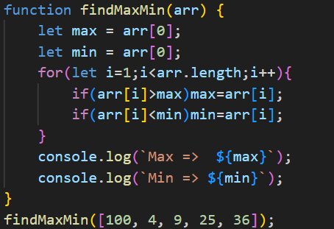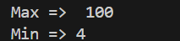

- Print Series 1, 3, 5, 7, 9, 11, 13, 15, 17, 19 up to value is less than 50
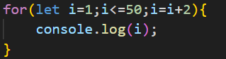

- Find the match square root value.
array1 = [1, 2, 3, 4, 5];
array2 = [1, 4, 9, 25, 36];
output: [1, 2, 3, 5]
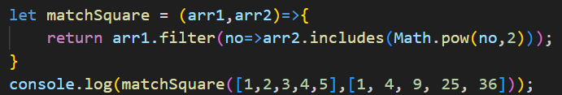

Set 2 :

- Make all vowels uppercase and consonants lowercase for a given string
Ex: Websoptimization
Output: vowels => EOIIAIO, consonant => wbsptmztn
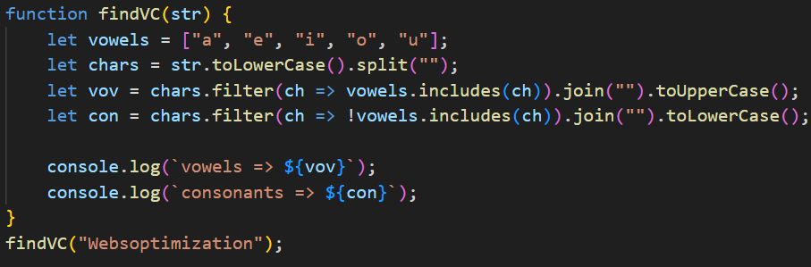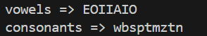

- Pattern logic
*
* * *
* * * * *
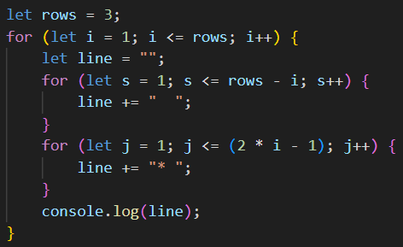

- Print Series 3, 6, 12, 24, 48, 96 up to a value is less than 500
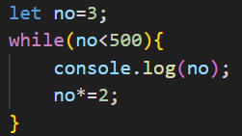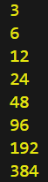

- Print the last 10 even numbers that are divisible by 3 between 10 to 100
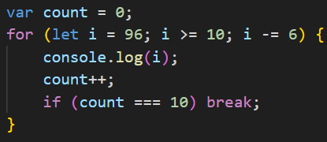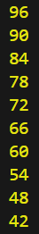

- Print 10 even numbers that are divisible by 3 between 10 to 50
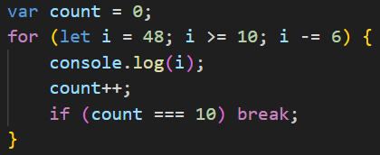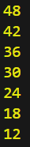

Set 3 :

- Find duplicate numbers from the given array.
Ex : [12, 45, 12, 23, 64, 23]
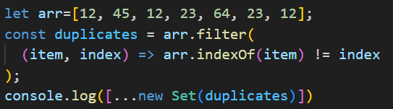

- Find the second largest element from an array.
Ex : [12, 45, 100, 23, 64, 76]

- Fibonacci Series (The Fibonacci sequence is a series where the next term is the sum of the previous two terms)
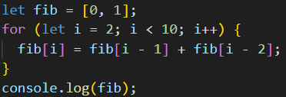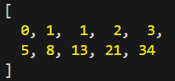

Set 4 :

- Find unique numbers from the given array without using the array function.
Ex : [100, 32, 15, 76, 12, 34, 32]
Output : [100, 32, 15, 76, 12, 34]
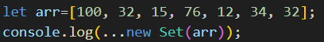

- Calculate String character count.
Ex : "mississippi";
Output: m = 1, i = 4, s = 4, p = 2
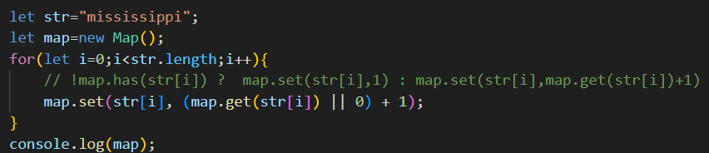

- Program to check for Anagram (Anagram:- a word or phrase that is made by arranging the letters of another word or phrase in a different order)
Ex :1. Listen, 2. Silent
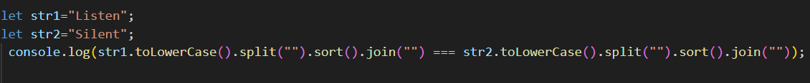

Set 5 :

- List Prime Numbers between 1 to 100.
Output : 2, 3, 5, 7, 11, 13, 17, 19, 23, 29, 31, 37, 41, 43, 47, 53, 59, 61, 67, 71, 73, 79, 83, 89, 97.
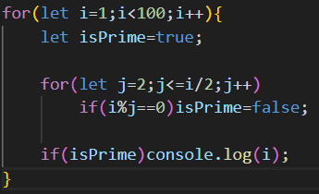

- Pattern Logic
2.1
1
2 3
4 5 6
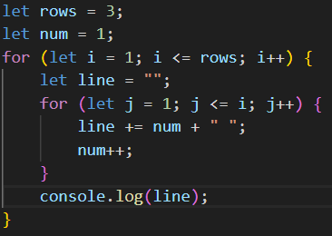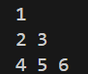

2.2
*
* *
* * *
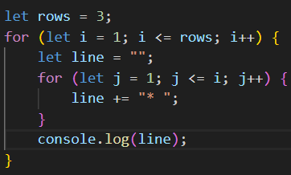
- Factorial using recursion
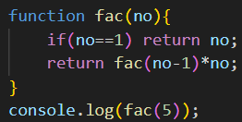

Set 6 :

- Swap two variables without using the third variable
Input -> a = 10; b = 13;
Output -> a = 13; b = 10;
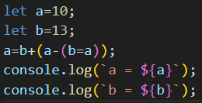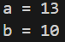

- Pattern Logic

1
2 3
4 5 6
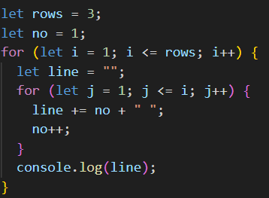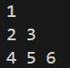

1
1 1
1 1 1
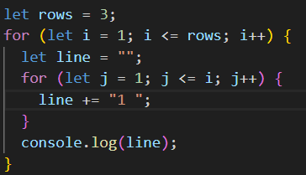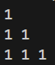
- Get the revert array without using any array function
Input: [12, 43, 23, 67, 34, 87]
Output: [87, 34, 67, 23, 43, 12]
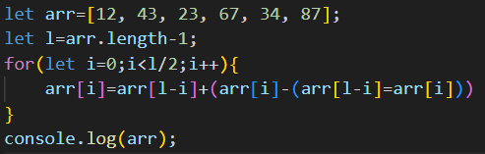

Set 7 :
- The logic for Leap Year tc
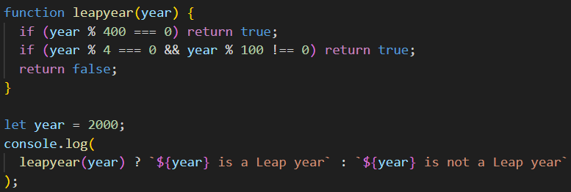

- Count special characters and remove duplicate special characters by sorting the string.
Input: @@@O$$$$$K###
- Count Special characters
- Order by lower case,
- Should not repeat any special characters
Output:
- Count Special -> 11
- Final String -> #$@ko
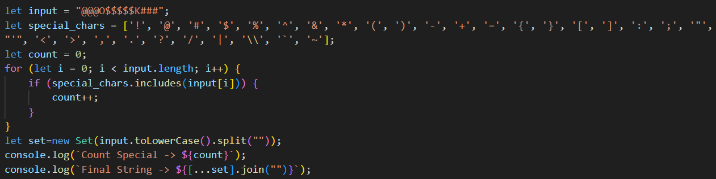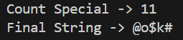

- Check Armstrong Number logic (An Armstrong number is the one whose value is equal to the sum of the cubes of its digits.)
Ex: 303(Non-Armstrong), 407 (Armstrong)

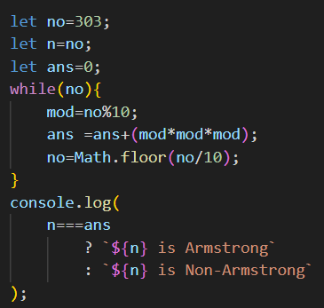

Set 8 :
- Palindrome string.
Input: "MALAYALAM"
Output: Palindrome
Code 1 :-
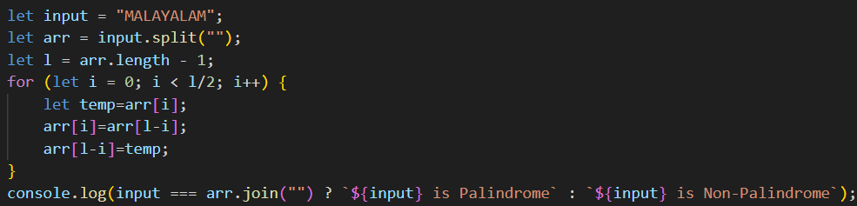
Code 2 :-
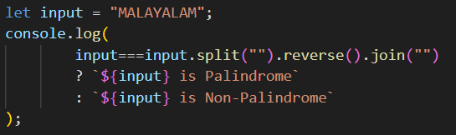

- Give date for today:
Format the date properly
25th October 2021, 12H 5M 30S

- Remove adjacent duplicate characters from a string
Ex :
Input: AAABBCDDDAAD
Output: ABCDAD
