Topic 1 JavaScript, ES6 and vanilla JavaScript

JavaScript is the core programming language. ES6 is a major version (edition) of the JavaScript standard. Vanilla JavaScript is the practice of using core JavaScript features without extra libraries or frameworks.
JavaScript
JavaScript is a versatile, light-weight, interpreted programming language primarily used for web development to create dynamic and interactive experiences in web browsers. It's the only language natively supported by all browsers.
The language is governed by the ECMAScript (ES) standard, established by Ecma International to ensure consistency across different implementations.

ES6 (ECMAScript 6 or ES2015)
ES6 is the sixth edition of the ECMAScript standard, released in 2015 (hence its alternative name, ES2015). It was a significant update that introduced numerous features to make the language more efficient, readable, and capable of handling complex applications.
Key ES6 features include:
- let and const for block-scoped variable declarations.
- Arrow functions (=>) for a more concise function syntax.
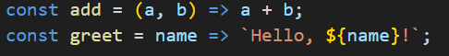

- Template literals (backticks `) for multi-line strings and string interpolation.
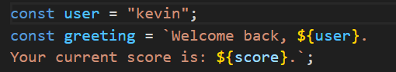
- Classes for object-oriented programming patterns.
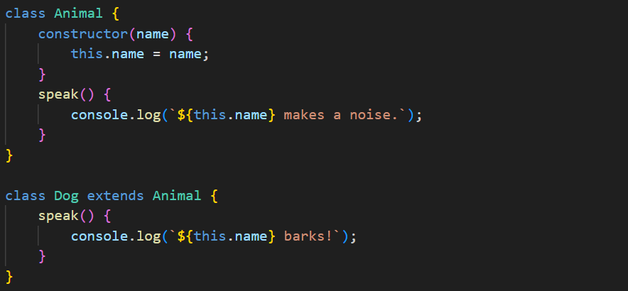

- Destructuring assignments for easily extracting values from arrays or objects.

- Default, rest, and spread operators for more flexible function parameters and array/object manipulation.

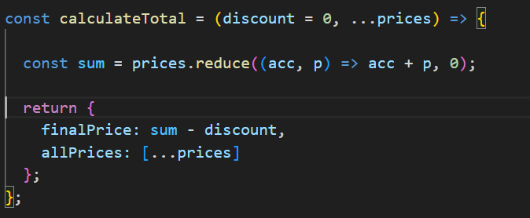
- Modules using import and export statements for organizing code across multiple files.

- A Promise is a placeholder for a value that is not yet known but will be resolved in the future

A Promise is always in one of these three states:
Pending: Initial state, neither fulfilled nor rejected.
Fulfilled (Resolved): The operation completed successfully. We use .then() to handle this.
Rejected: The operation failed. We use .catch() to handle this.

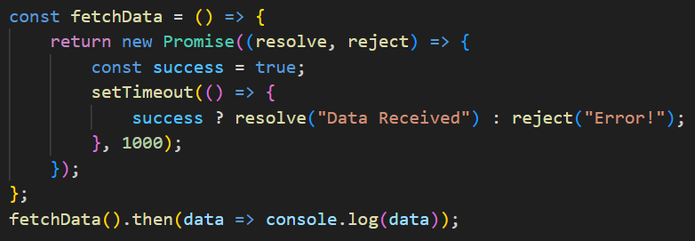.

Vanilla JavaScript
"Vanilla JavaScript" is a term used to refer to using plain, core JavaScript capabilities and native browser APIs (like the DOM) without relying on external libraries (like jQuery) or frameworks (like React, Angular, or Vue).
It is extremely fast because there is no overhead to download, and it helps you understand how the web actually works under the hood.

Code :-
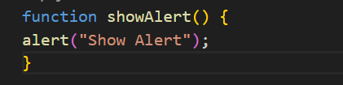

Output :-
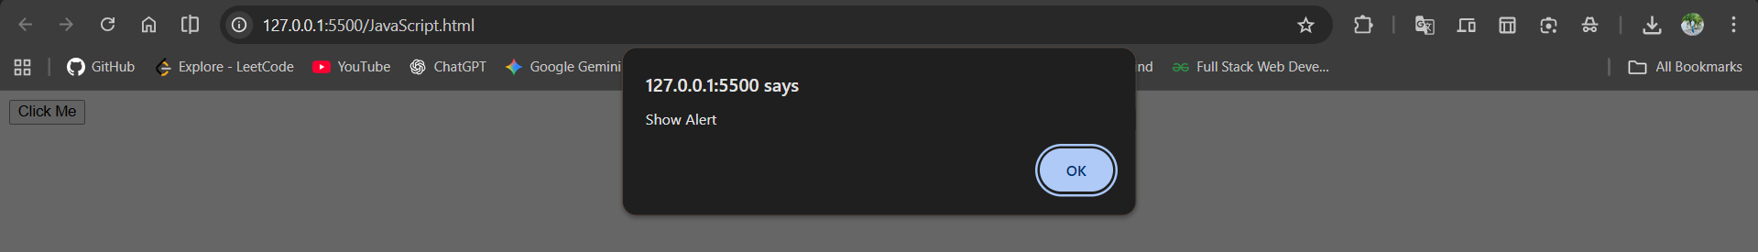

Topic 2 If condition, switch, for loop, break, continue

the if and switch statements are used for conditional execution, while the for loop is for iteration. The break and continue keywords provide granular control over the flow of loops and switch statements.
Conditional Execution
- if condition: Executes code if a condition is true, with optional else or else if for false or alternative conditions.
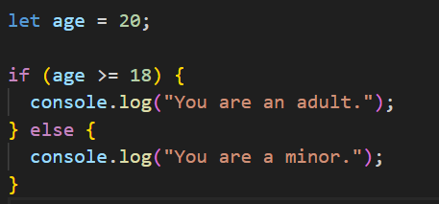
- switch statement: Selects a code block to execute based on a value. Use break to avoid "fall-through".
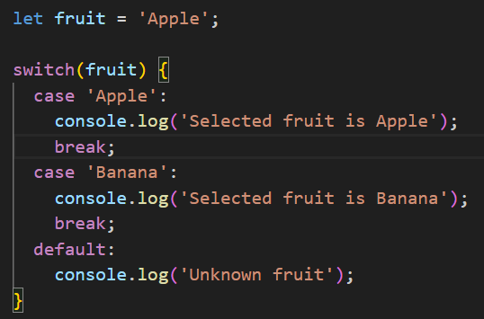

Loops and Flow Control
- for loop: Repeats code based on initialization, a condition, and an increment/decrement.
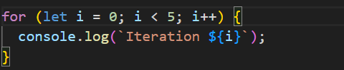
- break statement: Exits the current loop or switch.
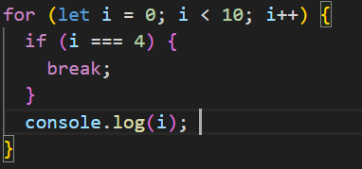
- continue statement: Skips the current loop iteration and moves to the next.
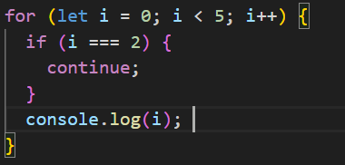
Topic 3 JavaScript Statements

a Statement is an instruction that tells the browser (the interpreter) exactly what to do. Think of a statement as a complete sentence in a language, while variables and operators are just the words within that sentence.
A JavaScript program is essentially a long list of these statements, which are executed one by one in the order they are written.

1. Declaration Statements: These statements are used to create (declare) variables and functions. They reserve space in the computer's memory for data.
- var / let / const: Used to declare variables.
- function: Used to declare a block of reusable
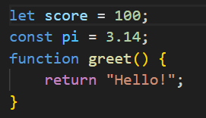

2. Expression Statements: An expression statement is any statement that evaluates to a value. The most common type is an Assignment Statement, which uses the = operator to give a value to a variable.
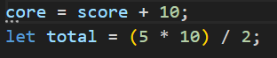

3. Conditional (Flow Control) Statements: These statements control when or if a block of code should run based on a condition. They allow the program to "makedecisions."
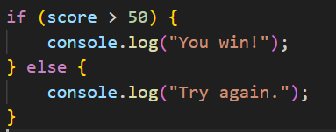

4. Loop Statements: These statements repeat a block of code multiple times as long as a specific condition is met.
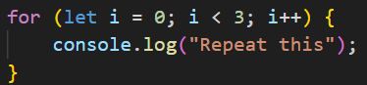

5. Jump Statements: These statements allow the program to "jump" to a different part of the code. They are used to exit loops or functions early.
- break: Exits a loop or switch.
- continue: Skips the current loop iteration.
- return: Exits a function and specifies a value to send back.
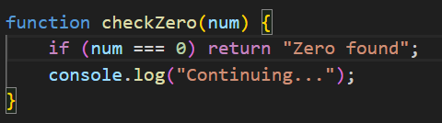

Feature | Description
Semicolons ( ; ) | Used to separate statements. While optional in some cases in JS, they are best practice to prevent bugs.
White Space | JavaScript ignores multiple spaces; you can use them to make code more readable.
Blocks { } | Statements can be grouped together inside curly braces to form a "Block Statement."

Topic 4 JavaScript Comments

Comments are non-executable lines of code. They are used to explain what the code is doing, making it easier for you (or other developers) to understand the logic later.
The JavaScript engine completely ignores comments when running the script, so they have zero impact on performance.

1. Single-Line Comments
Used for short explanations or notes on a single line. They begin with two forward slashes //. Anything after // on that line will not be executed.

2. Multi-Line Comments
Used for longer descriptions, documentation, or to temporarily disable large blocks of code. They start with /* and end with */.

3. JSDoc (Professional Documentation)
Professional developers often use a special type of multi-line comment to document functions, showing what inputs they expect.
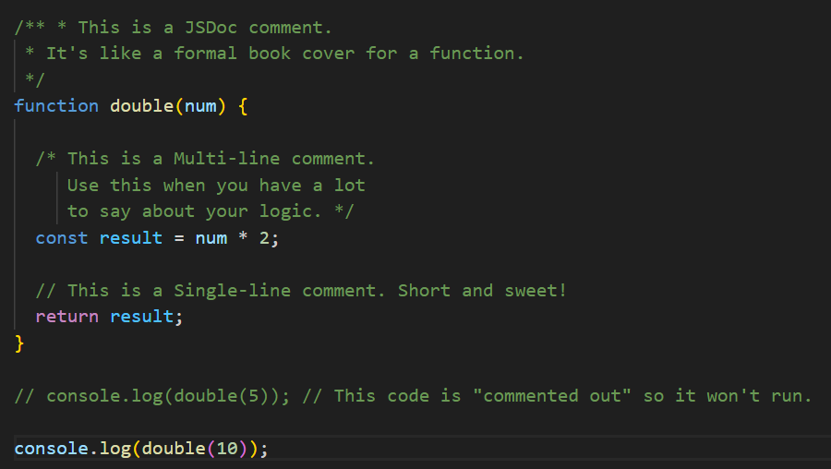
Comparison Table
Type | Syntax | Best Used For
Single-Line | // | Quick notes, labeling variables, or small fixes.
Multi-Line | /* ... */ | Detailed explanations or disabling blocks of code.
JSDoc | /** ... */ | Formal documentation for functions and classes.
Topic 5 JavaScript Variables, JavaScript Let, JavaScript Const (Imp)

JavaScript variables are containers for storing data values. Think of them as labeled boxes where you can keep information to use later.
Since ES6 (2015), we have three ways to declare these boxes: var, let, and const.

1. JavaScript var (The Old Way)
Before 2015, var was the only way to declare variables. However, it has some "quirks" that can cause bugs, so it is rarely used in modern coding.
- Scope: Function-scoped (not block-scoped).
- Redeclaration: You can redeclare the same variable name without an error.
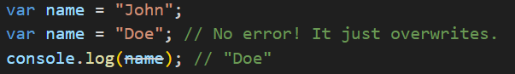
2. JavaScript let (The Modern Standard)
let was introduced in ES6 to fix the issues with var. It is the preferred way to declare variables that might change later.
- Scope: Block-scoped (it only exists inside the { } where it was created).
- Redeclaration: You cannot redeclare it in the same scope.
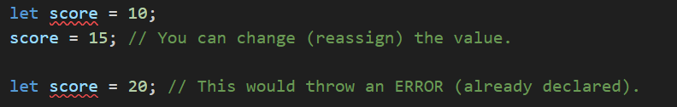
3. JavaScript const (The Fixed Value)
const stands for constant. Use this for values that should never change. It makes your code safer because it prevents accidental changes.
- Scope: Block-scoped.
- Assignment: You must give it a value immediately, and you can never change it.

Comparison
Feature | var | let (ES6) | const (ES6)
Scope | Function Scope | Block Scope {} | Block Scope {}
Can Reassign? | Yes | Yes | No
Can Redeclare? | Yes | No | No
Hoisting | Yes (initialized as undefined) | Yes (but uninitialized) | Yes (but uninitialized)

- Always use const by default. It is the safest.
- Use let only if you know the value will change (like a counter in a loop).
- Avoid var entirely in modern JavaScript.

Topic 6 JavaScript Assignment

Assignment Operators are used to assign values to variables. While the most common one is the equal sign (=), there are several "shorthand" operators that perform a mathematical operation and an assignment at the same time.

1. The Basic Assignment (=)
This operator assigns the value on the right to the variable on the left.

2. Combined (Compound) Assignment
These operators are shortcuts for performing an operation on a variable and then saving the result back into that same variable.
Operator | Name | Example | Equivalent to
+= | Addition Assignment | x += 5 | x = x + 5
-= | Subtraction Assignment | x -= 2 | x = x - 2
*= | Multiplication Assignment | x *= 3 | x = x * 3
/= | Division Assignment | x /= 2 | x = x / 2
%= | Remainder Assignment | x %= 3 | x = x % 3

Code :-
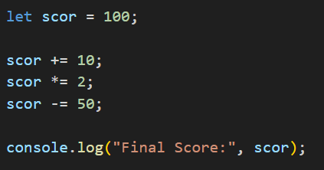

4. Modern ES6+ Assignment Features
ES6 and later versions introduced even more powerful ways to assign values.

A. Destructuring Assignment
This allows you to "unpack" values from arrays or objects into distinct variables in one line.
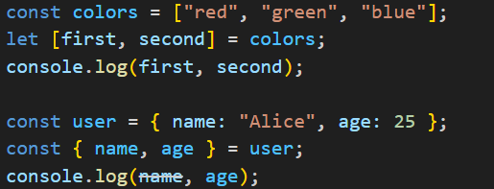
B. Logical Assignment (ES2021)
These only assign a value if a certain condition is met.
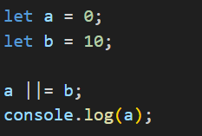

Topic 7 JavaScript Data Types

Data Types define the kind of value a variable can hold. Understanding this is crucial because JavaScript is a "dynamically typed" language, meaning a variable can change from a number to a string easily.
JavaScript data types are divided into two main categories: Primitives and Objects.

1. Primitive Data Types
Primitives are the simplest forms of data. They are immutable (cannot be changed) and represent a single value.
Type | Description | Example
String | Textual data wrapped in quotes. | "Hello", 'World', `Hi`
Number | Integers and floating-point numbers. | 25, 3.14
BigInt | For numbers larger than the standard limit. | 9007199254740991n
Boolean | Logical values: true or false. | true, false
Undefined | A variable that has been declared but not assigned a value. | let x;
Null | Represents an intentional "empty" or "nothing" value. | let x = null;

2. Non-Primitive: Object Data Type
Objects are complex and can store collections of data. Unlike primitives, objects are mutable (can be changed).
- Object: A collection of key-value pairs.
- Array: A special type of object used to store ordered lists.
- Date: For handling dates and times.
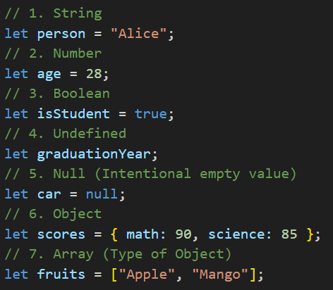
How to Check the Data Type
You can use the typeof operator to find out what type of data is stored in a variable.
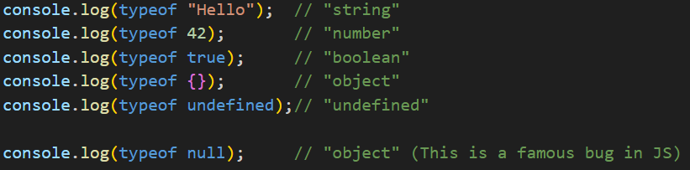

Key Difference: Primitive vs. Reference
- Primitives are stored by Value. When you copy a primitive, you make a real copy of the data.
- Objects are stored by Reference. When you copy an object, you are actually just copying the "address" to where that object lives in memory.

Topic 8 JavaScript Functions

a Function is a reusable block of code designed to perform a particular task. You define the code once, and then you can "call" (execute) it as many times as you need.
Functions are the building blocks of any JavaScript application because they prevent you from writing the same code over and over again.

1. Function Declaration (The Traditional Way)
This is the most common way to define a function. It uses the function keyword, a name, and a block of code.
Key terms:
- Parameters: The variables listed in the function definition (name).
- Arguments: The real values passed to the function when calling it ("Alice").
- Return: The statement that stops the function and sends a value back to the caller.
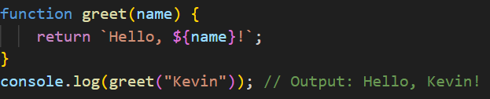
2. Function Expressions
A function can also be stored inside a variable. This is called a function expression.
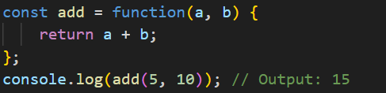
3. Arrow Functions (ES6+)
Introduced in 2015, arrow functions provide a shorter syntax. They are very popular in modern Vanilla JavaScript.
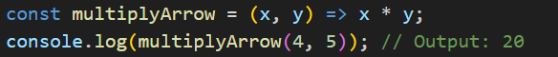
Note: If the function has only one line of code, you can omit the {} and the return keyword.

4. Function Scope
Variables defined inside a function cannot be accessed from outside the function. This is called Local Scope.
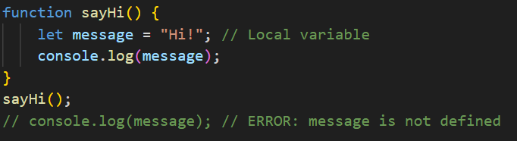

Comparison
Feature | Declaration | Expression | Arrow Function
Syntax | function name() {} | const x = function() {} | const x = () => {}
Hoisting | Yes (can call before it's defined) | No | No
this context | Its own this | Its own this | Inherits this from parent

Topic 9 JavaScript Objects (Imp)

While a variable stores a single value, an Object is a standalone entity that can store a collection of related data and functionality in the form of Properties and Methods.
Think of an object as a "container" for related variables.

1. Object Literal Syntax
The most common way to create an object is using curly braces {}. Data is stored in key: value pairs.
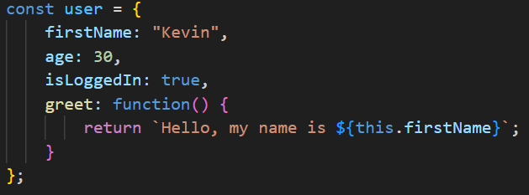
2. Accessing Object Data
There are two ways to get data out of an object:
- Dot Notation: user.firstName (Most common and easiest to read).
- Bracket Notation: user["firstName"] (Useful if the key name is stored in a variable).
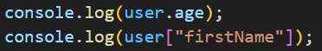
3. Important Object Operations
Objects are mutable, meaning you can add, change, or delete properties after the object is created.
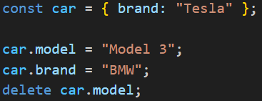

4. Modern ES6 Object Features
ES6 introduced powerful ways to work with objects that you will see in every modern JavaScript project.
A. Object Destructuring
This allows you to extract properties into variables instantly.
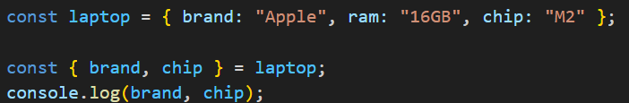
B. Property Shorthand
If your variable name matches the object key name, you only have to write it once.
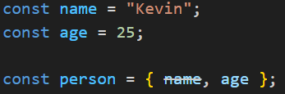
C. The Spread Operator (...)
Used to clone objects or merge them together.
5. Object Methods: The this Keyword
Inside an object method, the keyword this refers to the owner of the function (the object itself).
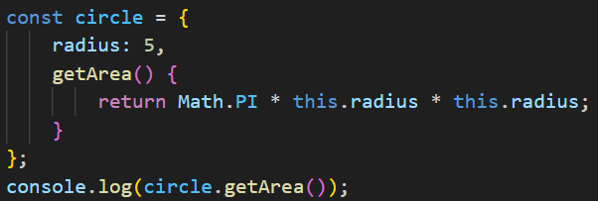
Reference vs Value
When you copy an object (e.g., const obj2 = obj1), you are not making a new box; you are making a second key to the same box. If you change obj2, obj1 will also change! Use the Spread Operator ({...obj}) to make a real, separate copy.

Topic 10 JavaScript Events

Events are the way the browser signals that something has happened. Interactions like clicking a button, typing in a box, or scrolling the page are all "Events."
JavaScript allows you to "listen" for these events and execute code in response.

1. How Events Work (The 3 Parts)
To make an event work, you generally need three things:
- The Event Target: The HTML element (e.g., a <button>).
- The Event Type: What happened? (e.g., "click").
- The Event Listener (Handler): The function that runs when the event occurs.

2. The Modern Way: addEventListener()
This is the standard and most flexible way to handle events in Vanilla JS. It allows you to attach multiple functions to a single event without overwriting them.
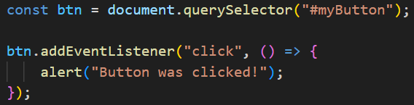
3. Common Event Types
You can listen for almost anything a user does:
- Mouse Events: click, dblclick, mouseenter, mouseleave.
- Keyboard Events: keydown, keyup, keypress.
- Form Events: submit, change, input, focus.
- Window Events: load, resize, scroll.

4. The Event Object (e)
When an event occurs, JavaScript automatically passes an Event Object to your function. This object contains useful information, such as which key was pressed or the coordinates of a mouse click.
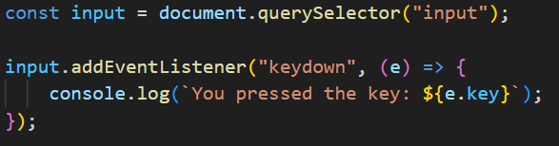
5. Event Bubbling and Delegation
When you click an element, the event doesn't just happen there—it "bubbles" up to its parents like a bubble in water.
Event Delegation is a clever technique where you put a listener on a parent element to manage events for all of its children. This is great for performance.
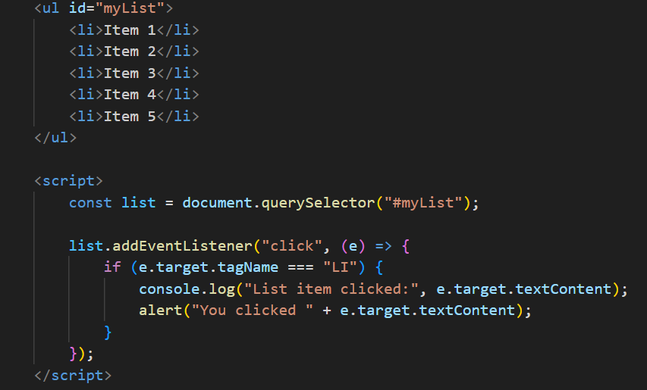

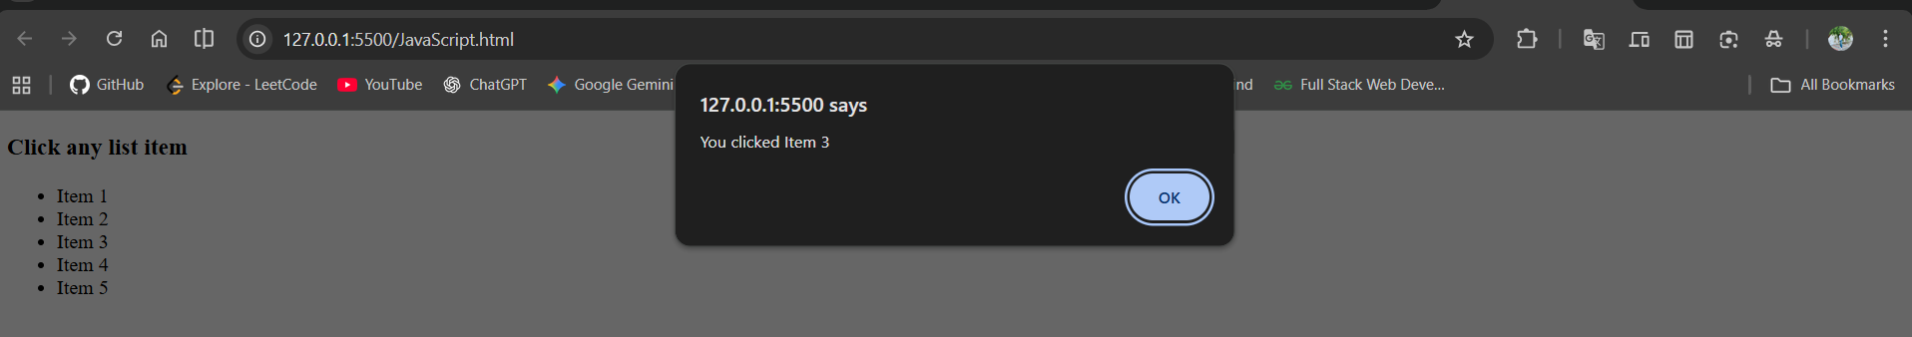

Topic 11 JavaScript String and its methods, JavaScript Template Literals

a String is a sequence of characters used to represent text. In modern Vanilla JS, strings have become significantly more powerful thanks to Template Literals (introduced in ES6).

1. JavaScript Strings
You can create a string using single quotes ('), double quotes ("), or backticks (`).
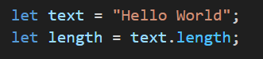
2. Common String Methods
Strings are immutable, meaning these methods do not change the original string; they return a new one.
Method | Description | Example
toUpperCase() | Converts to all caps | "hi".toUpperCase() → "HI"
toLowerCase() | Converts to all lowercase | "HI".toLowerCase() → "hi"
trim() | Removes whitespace from both ends | " hey ".trim() → "hey"
slice(start, end) | Extracts a part of the string | "Apple".slice(0, 2) → "Ap"
replace() | Replaces a value with another | "Red".replace("Red", "Blue")
includes() | Checks if a string contains a word | "Hello".includes("H") → true
split() | Converts string into an array | "a,b".split(",") → ["a", "b"]

3. JavaScript Template Literals (ES6)
Template Literals are strings that use backticks (`) instead of quotes. They are the "Modern Way" to handle text because they solve two major problems:
A. String Interpolation (Variables in Strings)
Before ES6, you had to use the + sign to join strings and variables. Now, you use ${variable}.

Old Way:
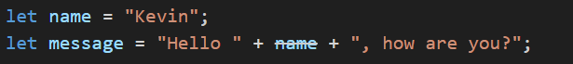
ES6 (Template Literals):
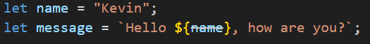
B. Multi-line Strings
Before ES6, you had to use \n to create a new line. With template literals, you simply press "Enter."
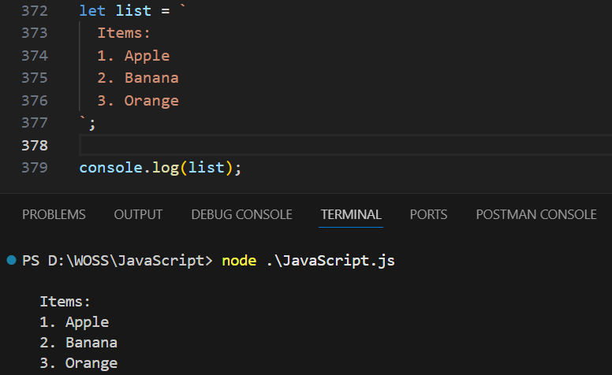

Feature | Standard String (' or ") | Template Literal (`)
Variable Injection | Requires + (Concatenation) | Use ${variable} (Interpolation)
Multi-line | Requires \n | Just press Enter
Expressions | Not possible inside quotes | Can do math/logic: ${2 + 2}

Topic 12 JavaScript Numbers and its Methods

the Number type handles both integers (like 10) and decimals (like 10.5). Unlike other languages, JavaScript doesn't have different types for "int" or "float"—everything is just a Number.

1. Basic Characteristics
JavaScript numbers are stored as 64-bit floating-point values. This sometimes leads to small precision issues (e.g., $0.1 + 0.2$ results in $0.30000000000000004$).

2. Common Number Methods
Methods help you format numbers, convert types, or check if a value is valid.
Method | Description | Example
toString() | Converts a number to a string. | (123).toString() → "123"
toFixed(x) | Rounds to $x$ decimal places (returns string). | (9.656).toFixed(2) → "9.66"
toPrecision(x) | Rounds to a total length of $x$. | (9.656).toPrecision(2) → "9.7"
Number() | Converts a variable to a number. | Number("10") → 10
parseInt() | Parses a string and returns a whole number. | parseInt("10.5") → 10
parseFloat() | Parses a string and returns a decimal. | parseFloat("10.5") → 10.5

3. The Number Object Properties
JavaScript also provides built-in constants for number limits.
- Number.MAX_VALUE: The largest possible number in JS.
- Number.MIN_VALUE: The smallest possible number in JS.
- Number.NaN: "Not a Number" (result of invalid math, like "Hello" / 2).
- Number.isInteger(): Checks if a value is a whole number.

4. The Math Object (Essential for Numbers)
While not "Number methods," the Math object is almost always used alongside numbers for advanced calculations.
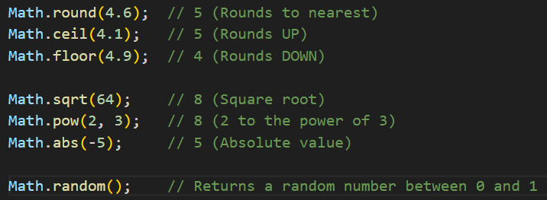
Example :-
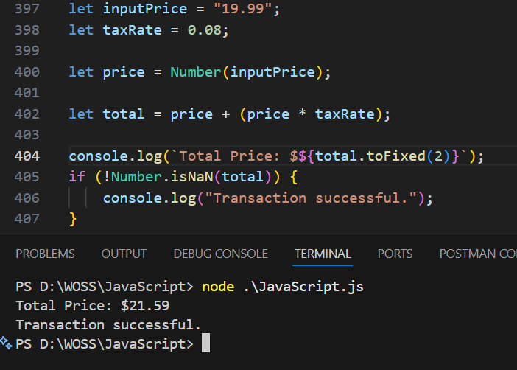

Number() vs parseInt()
- Number("10.5") → 10.5 (Converts the whole thing).
- parseInt("10.5") → 10 (Stops at the decimal).
- parseInt("10px") → 10 (Extracts number from start of string).
- Number("10px") → NaN (Fails if any character is non-numeric).
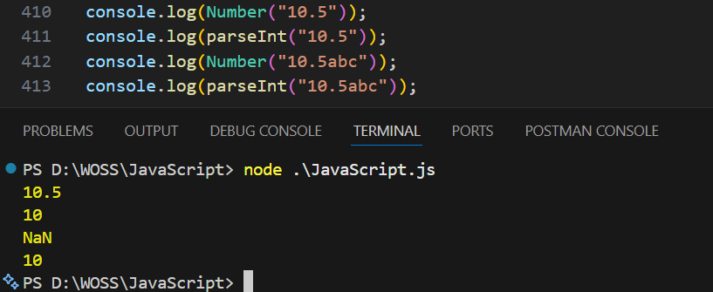

Topic 13 JavaScript Arrays & all method (Most Imp)

1. Array Basics & Creation
An array is a special type of object used for storing multiple values in a single variable.
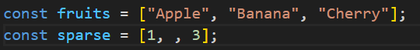

2. Transformation Methods (The Most Used)
These methods are used to change data or iterate through it.
- map(): Creates a new array by applying a function to every element.
- filter(): Creates a new array containing only elements that pass a test.
- forEach(): Executes a function for each element (returns nothing).
- reduce(): Reduces the array to a single value (e.g., a sum).
- flatMap(): Maps each element, then flattens the result into a new array.
Empty Slot Behavior: All of these skip empty slots.
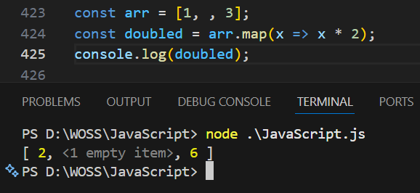
3. Search & Verification Methods
These methods find specific items or check if they exist.
- find(): Returns the value of the first element that satisfies a condition.
- findIndex(): Returns the index of the first element that satisfies a condition.
- includes(): Returns true if an array contains a specific value.
- indexOf(): Returns the first index at which a given element can be found.
- every(): Checks if all elements pass a test.
- some(): Checks if at least one element passes a test.
Empty Slot Behavior: Newer methods like find and includes treat holes as undefined. Older ones like indexOf skip them.
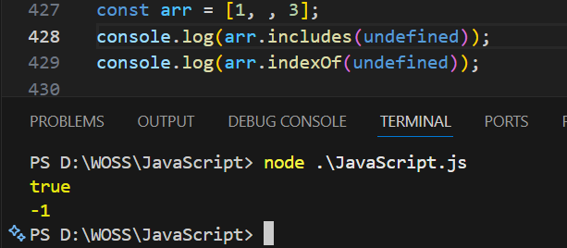

4. Structural & Modification Methods
Methods that add, remove, or rearrange items.
- push() / pop(): Add/Remove from the end.
- unshift() / shift(): Add/Remove from the start.
- splice(): Adds or removes elements at any position (Mutates original).
- slice(): Copies a portion of the array into a new array.
- concat(): Merges two or more arrays.
- copyWithin(): Copies array elements to another position in the same array.
Empty Slot Behavior: These preserve empty slots.
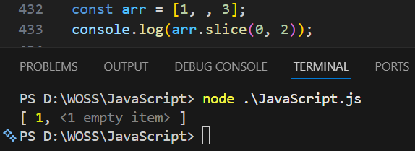
5. Summary: Handling Empty Slots
The "Old Guard" (ES5 and older)
These methods were designed to be efficient by ignoring non-existent data.
Methods: forEach, map, filter, every, some, reduce, indexOf, concat, slice, splice.
- Behavior: They either skip the hole (don't run the function) or preserve it (keep the hole as is).
The "New Guard" (ES6+)
These methods were designed for consistency, treating a "hole" as if you explicitly wrote undefined.
Methods: find, findIndex, includes, join, fill, keys, values, entries, toSorted, toReversed.
- Behavior: They conflate holes with undefined.

Example :-
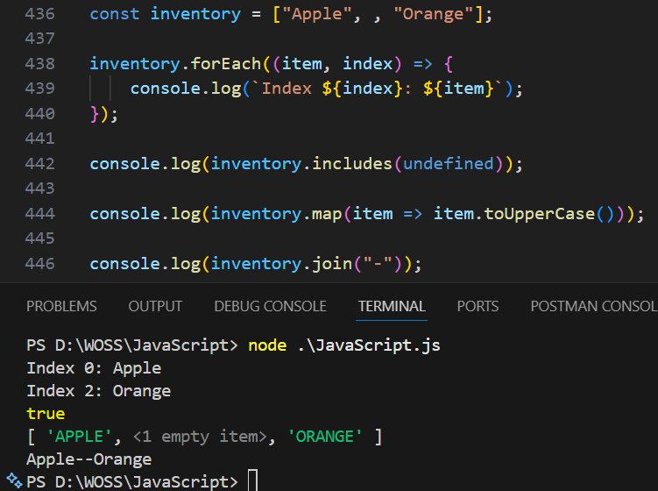

Why does this matter?
If you are processing data from an API and there are missing indices, using forEach might cause you to miss logic that should have run for "missing" data. Using a modern for...of loop is safer, as it also treats empty slots as undefined.
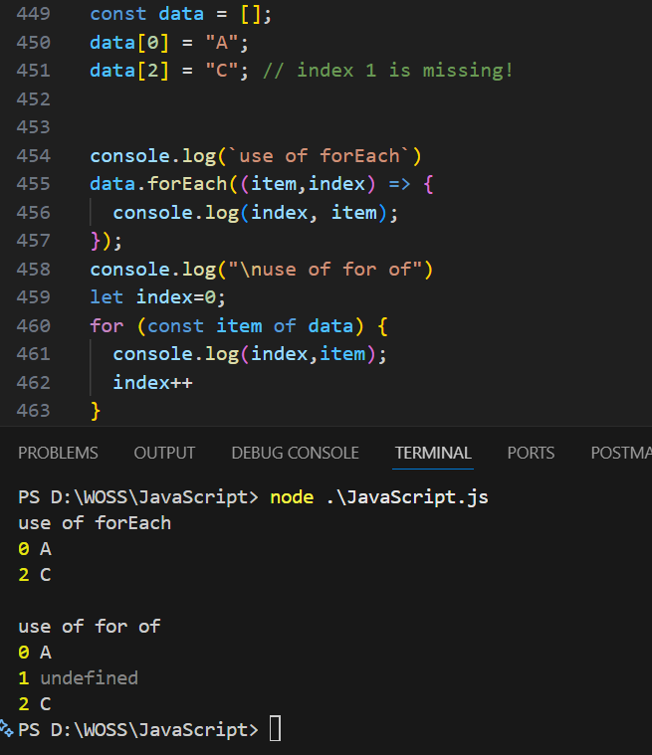

Topic 14 JavaScript Date

the Date object is used to work with dates and times. Dates are stored as the number of milliseconds since January 1, 1970 (Unix Epoch).

1. Creating a Date
Method | One-Line Definition | Example
new Date() | Creates a new date object with the current date and time. | const now = new Date();
new Date(value) | Creates a date from a timestamp (milliseconds). | new Date(1000000000000);
new Date(string) | Parses a date string into a date object. | new Date("2026-01-01");
Date.now() | Returns the current timestamp in milliseconds. | const ms = Date.now();

2. Get Methods (Pulling Data Out)
These methods extract specific parts of a date.
Method | One-Line Definition | Example
getFullYear() | Returns the 4-digit year. | date.getFullYear(); // 2026
getMonth() | Returns the month (0-11; 0 is Jan). | date.getMonth(); // 0
getDate() | Returns the day of the month (1-31). | date.getDate(); // 6
getDay() | Returns the day of the week (0-6; 0 is Sunday). | date.getDay(); // 2
getHours() | Returns the hour (0-23). | date.getHours(); // 12
getMinutes() | Returns the minutes (0-59). | date.getMinutes(); // 30
getSeconds() | Returns the seconds (0-59). | date.getSeconds(); // 45
getTime() | Returns milliseconds since Jan 1, 1970. | date.getTime();

3. Set Methods (Changing Data)
These methods allow you to modify specific parts of a date object.
Method | One-Line Definition | Example
setFullYear() | Sets the year (and optionally month/day). | date.setFullYear(2030);
setMonth() | Sets the month (0-11). | date.setMonth(5); // June
setDate() | Sets the day of the month (1-31). | date.setDate(15);
setHours() | Sets the hour (0-23). | date.setHours(10);
setTime() | Sets the date using a millisecond timestamp. | date.setTime(0); // Back to 1970

4. Formatting Methods (Converting to String)
These help you display the date in a readable format.
Method | One-Line Definition | Example
toDateString() | Returns a readable date (e.g., "Tue Jan 06 2026"). | date.toDateString();
toTimeString() | Returns a readable time string. | date.toTimeString();
toISOString() | Returns date in ISO standard (YYYY-MM-DDTHH:mm). | date.toISOString();
toLocaleDateString() | Returns date formatted to the user's locale/language. | date.toLocaleDateString('en-US');
toJSON() | Formats the date for use in a JSON string. | date.toJSON();

Example
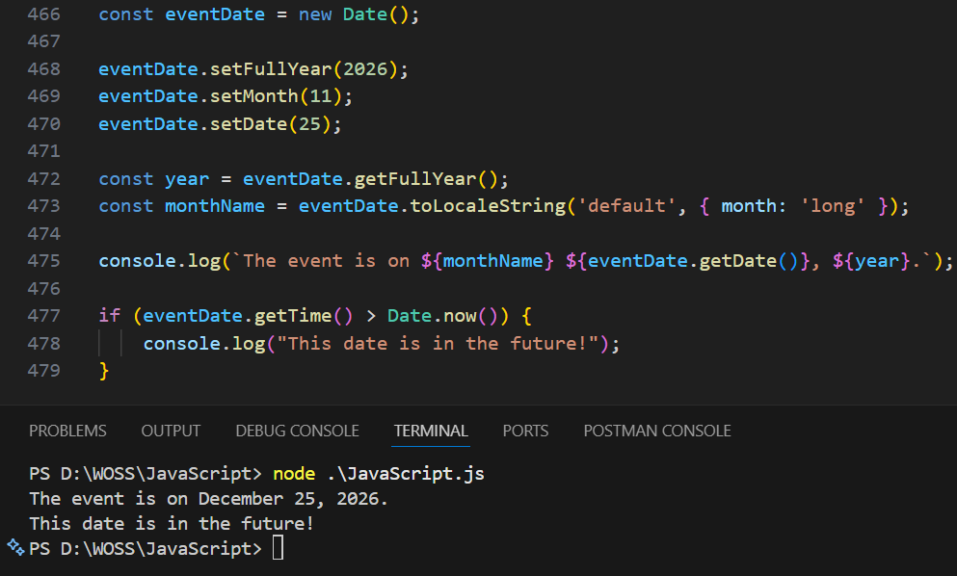

Topic 15 JavaScript Comparison

Comparison Operators are used in logical statements to determine equality or difference between variables or values. They always return a Boolean value: true or false.¹
1. Equality Operators
The most important distinction in JavaScript is between "Double Equals" and "Triple Equals."
Operator | Name | One-Line Definition | Example
== | Abstract Equality | Compares values after converting them to a common type (Coercion). | 5 == "5" → true
=== | Strict Equality | Compares both value and type without conversion. | 5 === "5" → false
!= | Abstract Inequality | Returns true if values are not equal (after type conversion). | 5 != "6" → true
!== | Strict Inequality | Returns true if either value or type are not equal. | 5 !== "5" → true
2. Relational Operators
These are used to compare the relative size or order of values.
Operator | Name | One-Line Definition | Example
> | Greater than | Returns true if the left value is larger than the right. | 10 > 5 → true
< | Less than | Returns true if the left value is smaller than the right. | 3 < 2 → false
>= | Greater than or equal | Returns true if the left is larger than or equal to the right. | 10 >= 10 → true
<= | Less than or equal | Returns true if the left is smaller than or equal to the right. | 5 <= 10 → true
3. Logical Operators
These are used to combine multiple comparisons.
Operator | Name | One-Line Definition | Example
&& | Logical AND | Returns true only if both sides are true. | (5 > 2 && 10 > 5) → true
|| | Logical OR | Returns true if at least one side is true. | (5 > 10 || 10 > 5) → true
! | Logical NOT | Reverses the boolean result (true becomes false). | !(5 > 2) → false

4. The Ternary Operator (Conditional)
The only JavaScript operator that takes three operands. It is a shorthand for an if...else statement.
Syntax: condition ? valueIfTrue : valueIfFalse
Example:
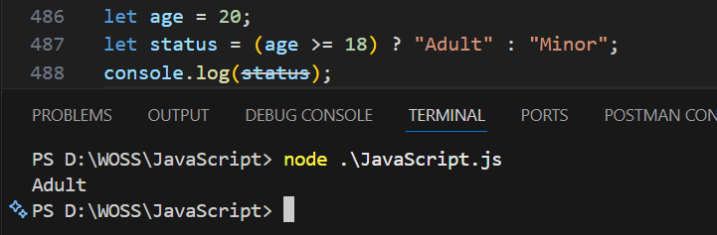
Example :-
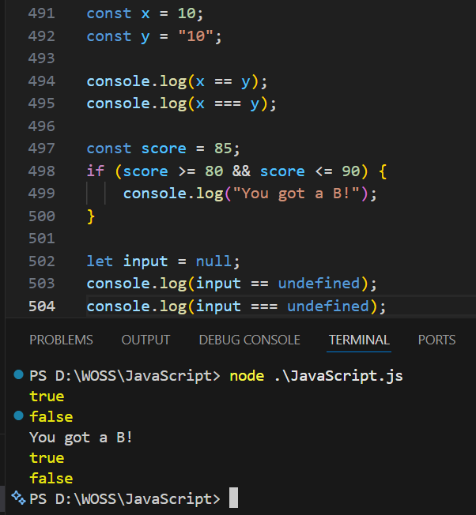
The "Golden Rule"
Always use === (Strict Equality). Using == can lead to strange bugs because of type coercion (for example, 0 == "" is true in JavaScript, which is rarely what you want!).

Topic 16 JavaScript Classes

Classes are a blueprint for creating objects. Introduced in ES6, they provide a much cleaner and more "Object-Oriented" way to handle inheritance and object creation compared to the old prototype-based method.
Even though they look like classes in Java or C++, they are technically "syntactic sugar" over JavaScript's existing prototype system.

1. The Basic Structure
A class consists of a constructor (to initialize properties) and methods (to define behavior).
Component | One-Line Definition | Example
class | The keyword used to declare a class. | class Car { ... }
constructor() | A special method for creating and initializing an object instance. | constructor(brand) { this.brand = brand; }
this | Refers to the specific instance of the object being created. | this.name = name;
new | The keyword used to "instantiate" (create) an object from a class. | const myCar = new Car("Tesla");

2. Class Methods
Methods are functions that belong to the class. Unlike regular functions, you don't use the function keyword inside a class.
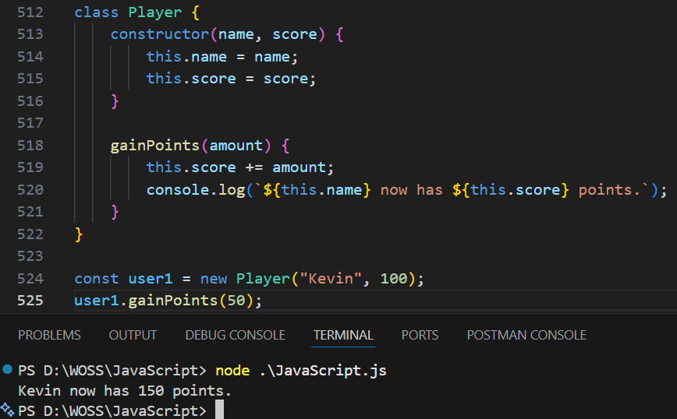
3. Inheritance (extends and super)
Inheritance allows a class to "absorb" the properties and methods of another class. This is perfect for creating specialized versions of a general concept.
- extends: Used to create a child class.
- super(): Used inside the child constructor to call the parent's constructor.
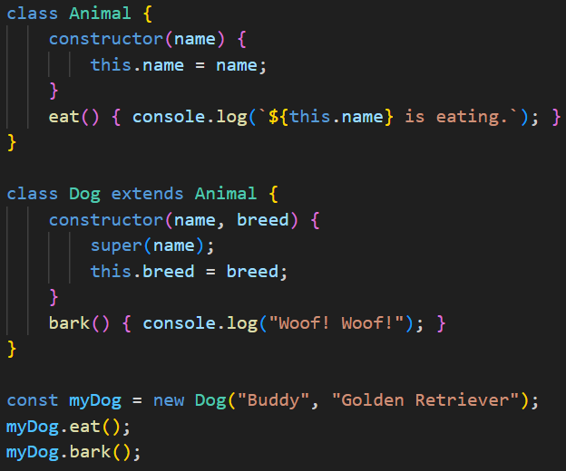
4. Getters and Setters
Getters and setters allow you to define methods that look like properties. This is useful for validating data before saving it.
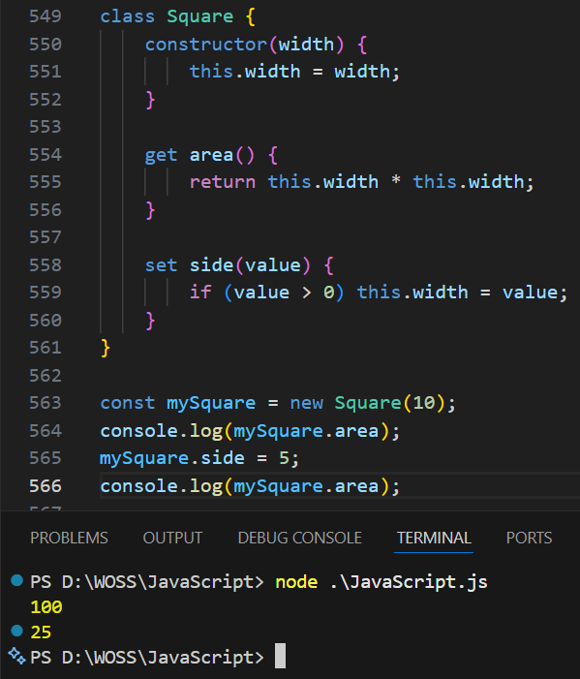

5. Static Methods
Static methods belong to the class itself, not to the objects created by the class. You call them using the class name.
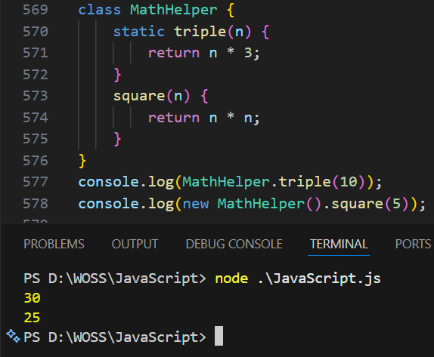

Topic 17 JavaScript all Arrow Functions

Arrow Functions are a compact way to write function expressions. They use the "fat arrow" => syntax and have two major advantages over traditional functions:
- Shorter Syntax: You can omit the function keyword and even the return keyword in some cases.
- Lexical this: They do not have their own this context. They "inherit" this from the surrounding code, which solves many bugs in event listeners and timers.

1. Basic Arrow Function
The most common form, replacing a standard function expression.
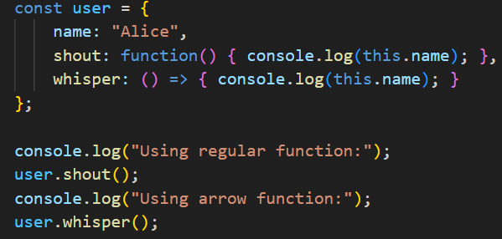
2. One-Line "Implicit Return"
If the function only has one statement that returns a value, you can remove the curly braces {} and the return keyword. This is called an implicit return.
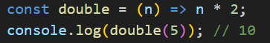
3. Single Parameter (No Parentheses)
If your function takes exactly one parameter, you can omit the parentheses () around it.
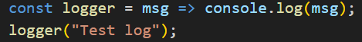
Note: If there are zero parameters or more than one, parentheses are required.

  - .Returning an Object
Because curly braces are used for the function body, if you want to implicitly return an object literal, you must wrap the object in parentheses ().

5. Lexical this (The "Killer Feature")
In regular functions, the this keyword refers to the object that called the function. In arrow functions, this refers to the scope where the function was defined.

6. Async Arrow Functions
You can make arrow functions asynchronous by placing the async keyword before the parameters.
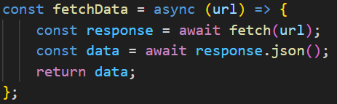

Topic 18 JSON

JSON stands for JavaScript Object Notation. Despite the name, it is a language-independent data format used to exchange information between a server and a web application (or between different parts of a system).
Think of JSON as the universal language of the internet. It allows a Python server to talk to a JavaScript browser or an Android app to talk to a database.

JSON Syntax Rules
JSON is essentially a string that looks like a JavaScript object, but it has stricter rules:
- Data is in name/value pairs (e.g., "name": "John").
- Keys must be in double quotes ("key").
- Strings must be in double quotes ("value").
- Data is separated by commas.
- Curly braces {} hold objects.
- Square brackets [] hold arrays.

Supported Data Types
JSON supports a limited set of data types:
- String: "Hello"
- Number: 25 or 3.14
- Object: {"city": "New York"}
- Array: ["Red", "Green"]
- Boolean: true or false
- Null: null
(Note: JSON cannot store functions, dates, or undefined values.)

The Two Essential Methods
In Vanilla JavaScript, we use the global JSON object to convert data back and forth.
A. JSON.stringify()
Converts a JavaScript object into a JSON string. Use this when sending data to a server.
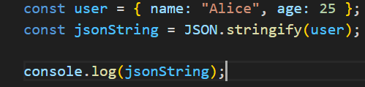
B. JSON.parse()
Converts a JSON string into a JavaScript object. Use this when you receive data from a server.
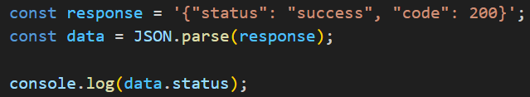
Why is JSON better than XML?
Before JSON, everyone used XML. JSON won because:
- It is shorter: Less text to download.
- It is faster: Browsers can turn JSON into objects instantly.
- It is readable: It looks like standard code.

Example :-
This is how you typically interact with JSON in a real project using the fetch API:
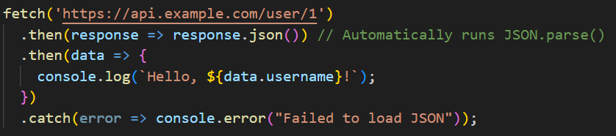

Topic 19 JS Async - async/await, promises, callbacks (Most IMP)

Asynchrony allows the browser to perform long-running tasks (like fetching data or reading a file) in the background without freezing the user interface.
Think of it like a restaurant: The waiter takes your order (starts a task) and moves to the next table while the kitchen cooks (background task), instead of standing still until your food is ready.

1. Callbacks (The Old Way)
A callback is a function passed as an argument to another function, to be "called back" once a task is finished.
Callback hell happens when many callbacks are nested inside each other, making the code hard to read, understand, and maintain.
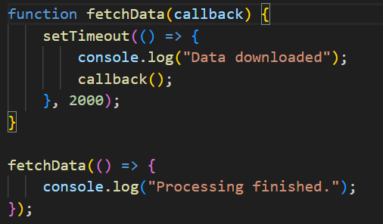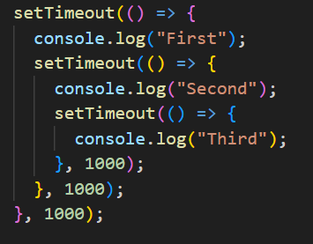
- The Problem: If you have many steps, you end up with "Callback Hell" (nested code that looks like a pyramid), making it very hard to read and debug.
Solution of Callbacj hell :-
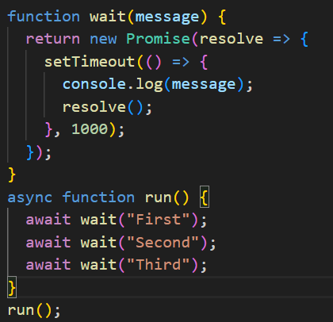

2. Promises (The ES6 Standard)
A Promise is an object representing the eventual success or failure of an asynchronous operation. It acts as a placeholder for a future value.
A Promise has 3 states:
- Pending: Still working.
- Fulfilled (Resolved): Success!
- Rejected: Something went wrong.
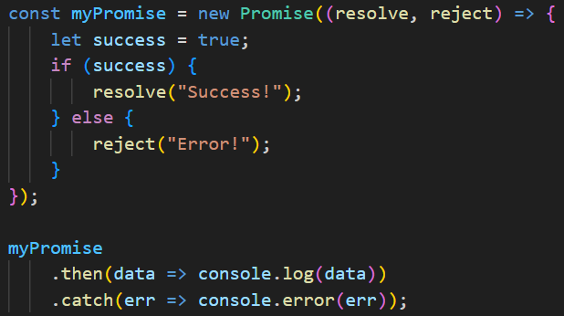

Promise.all(iterable)
Waits for all promises to resolve. If even one fails, the whole thing fails immediately.
- Best for: When you need multiple pieces of data to load before the page can work (e.g., User Profile + User Posts + User Friends).
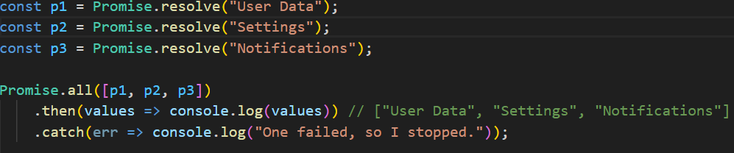
2. Promise.allSettled(iterable)
Waits for all promises to finish, regardless of whether they succeeded or failed. It returns an array of objects describing the outcome of each.
- Best for: When you want to attempt several tasks and show the results for the ones that worked, while ignoring the ones that didn't.
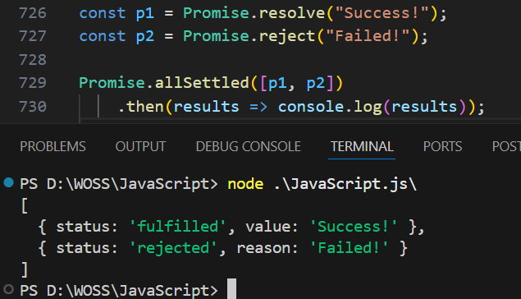
3. Promise.race(iterable)
Returns a promise that resolves or rejects as soon as one of the promises in the iterable resolves or rejects. It’s a "race" to see who finishes first.
- Best for: Setting a timeout for a network request. If the request takes too long, the timeout "wins" the race.
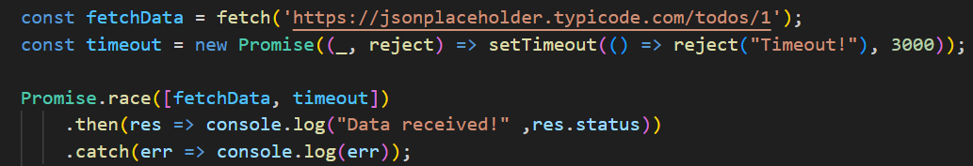
4. Promise.any(iterable)
Returns the first promise that succeeds. It ignores rejections unless all of them fail.
- Best for: When you have multiple servers (mirrors) and you just want the data from whichever one responds successfully first.
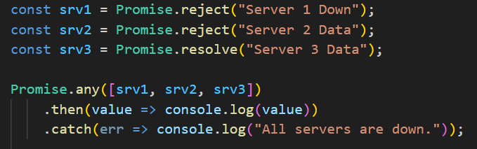

5. Promise.resolve(value) & 6. Promise.reject(reason)
These are "quick start" methods to create a promise that is already resolved or already rejected.
- Best for: Mocking data in tests or ensuring a function returns a promise even if the data is already available.
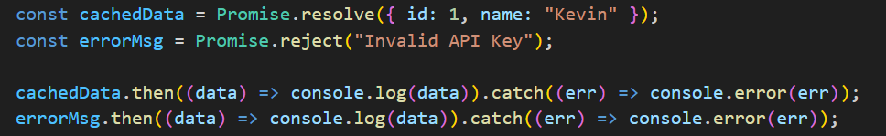

3. Async / Await (The Modern Standard)
Introduced in ES2017, async and await are "syntactic sugar" built on top of Promises. They allow you to write asynchronous code that looks and behaves like synchronous (top-to-bottom) code.
- async: Placed before a function to make it return a promise.
- await: Pauses the execution of the function until the promise resolves.
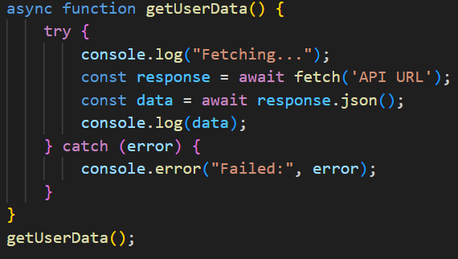

Topic 20 JS Objects

Objects are the foundation of the language. While a variable stores a single piece of data, an object is a collection of related data and functionality, stored as Properties (variables) and Methods (functions).

1. Object Anatomy
An object is made of Keys and Values.
- Key (Property Name): The identifier (e.g., brand).
- Value: The data assigned to that key (e.g., "Toyota").
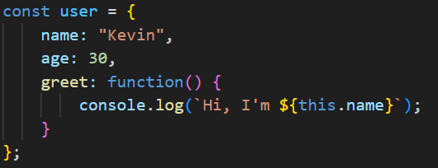
2. Accessing and Modifying Data
You can interact with objects using two types of notation.
Method | Syntax | Best Use Case
Dot Notation | user.name | The standard, most readable way.
Bracket Notation | user["name"] | Used when the key name is dynamic or contains spaces.

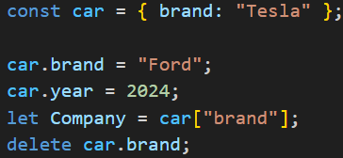

3. Important Object Methods (Built-in)
Vanilla JavaScript provides a global Object constructor with powerful methods to manipulate data.

- Object.keys() :- Returns an array of all property names (keys).
- Object.values() :- Returns an array of all property values.
- Object.entries() :- Returns an array of [key, value] pairs.
- Object.assign() :- Copies properties from one object to another.
- Object.freeze() :- Prevents any changes to the object.
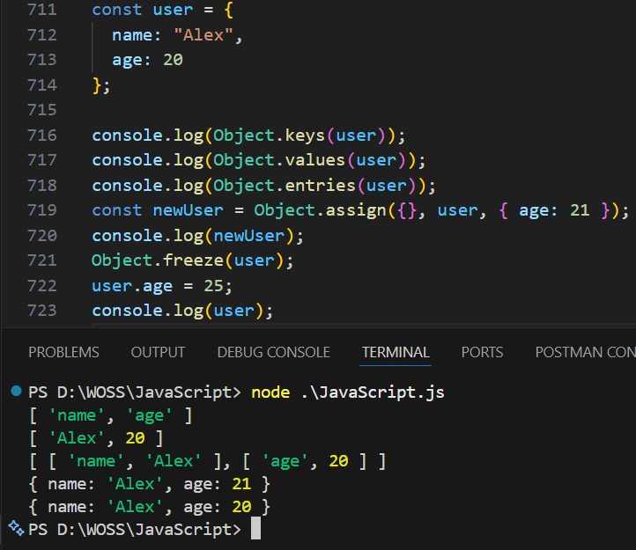

5. Object Reference vs. Value
This is a critical concept. Primitives (like numbers) are copied by value, but objects are copied by reference.
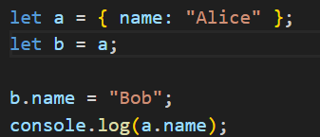

6. Create a Empty Object
there are several ways to create an empty object. While the Object Literal is the most common, others are used for specific technical reasons like inheritance or performance.

1. Object Literal (The Recommended Way)
This is the simplest and most readable method. It is the "industry standard" for 99% of use cases.
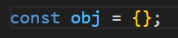
2. Object Constructor
This uses the built-in Object function. It does exactly the same thing as the literal method but is more "wordy."
3. Object.create(null) (The "Pure" Object)
Normally, even an "empty" object inherits properties from the global Object.prototype (like .toString()). Using null creates an object with no prototype at all.
- Best for: Creating "Dictionaries" or "Maps" where you don't want any hidden default properties.
4. Using a Class (Blueprint)
If you intend to create many objects of the same type later, you can define an empty class and instantiate it.
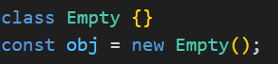
Topic 21 Function properties Text processing

1. Function Properties
In JavaScript, functions are "First-Class Objects." This means they can have properties and methods, just like any other object.
A. The length Property
Returns the number of formal parameters defined in the function (excluding rest parameters).
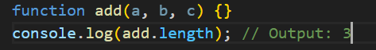
B. The name Property
Returns the name of the function as a string. Useful for debugging.
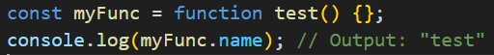
C. Function Methods: call(), apply(), and bind()
These are built-in methods that allow you to control the value of this.
Method | One-Line Definition | Example
call() | Calls a function with a specific this and arguments passed individually. | func.call(obj, arg1, arg2)
apply() | Same as call, but arguments are passed as an array. | func.apply(obj, [args])
bind() | Does not call the function; it returns a new function with this permanently set. | const newFunc = func.bind(obj)

2. Text Processing (Strings)
Text processing involves manipulating strings to clean, format, or extract data.
A. Basic Search & Extraction
Method | Definition | Example
indexOf() | Returns the index of the first occurrence of text. | "Hello".indexOf("l") → 2
slice() | Extracts a section of a string and returns it. | "Apple".slice(0, 3) → "App"
substring() | Similar to slice, but handles negative indexes differently. | "Apple".substring(1, 4) → "ppl"

B. Cleaning & Formatting
Method | Definition | Example
trim() | Removes whitespace from both ends. | " hi ".trim() → "hi"
replace() | Replaces a specific value with another. | "cat".replace("c", "b") → "bat"
split() | Splits a string into an array based on a character. | "a-b-c".split("-") → ["a", "b", "c"]

C. Advanced ES6+ Features
Modern JavaScript introduced methods that make text checking much more readable.
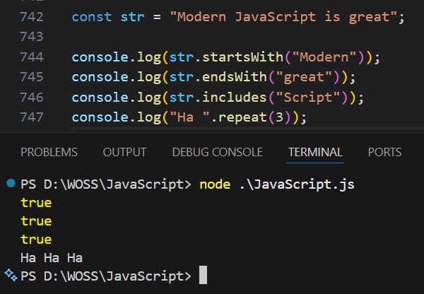

Example : 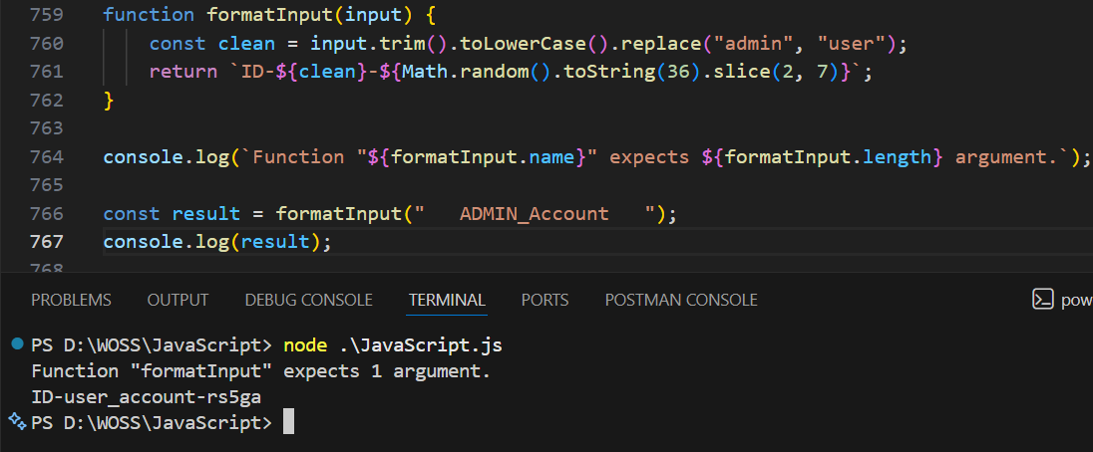
Topic 22 map

In JavaScript, the word Map refers to two distinct but equally important things: the .map() array method and the Map object.

1. The .map() Array Method
This is a transformation tool. It creates a new array by calling a function on every element in the original array. It does not change the original array.
Key Rule: The new array will always have the same length as the original.
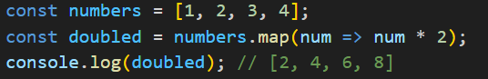
2. The Map Object (Key-Value Collection)
A Map is a collection of keyed data items, similar to an Object. However, Map allows keys of any type (objects, functions, or primitives), whereas Object keys must be Strings or Symbols.
Essential Map Methods
Method | One-Line Definition | Example
set(key, val) | Adds or updates an element with a specified key/value. | myMap.set('id', 1);
get(key) | Returns the value associated with the key. | myMap.get('id');
has(key) | Returns a boolean indicating if the key exists. | myMap.has('id');
delete(key) | Removes the element with the specified key. | myMap.delete('id');
clear() | Removes all elements from the Map. | myMap.clear();
size | (Property) Returns the number of elements. | myMap.size;

3. Map vs. Object: Which one to use?
Feature | Object | Map
Key Types | Strings and Symbols only. | Any type (Functions, Objects, etc).
Order | Not reliably ordered. | Elements are iterated in insertion order.
Size | Must be determined manually. | Has a built-in .size property.
Performance | Better for small, static data. | Better for frequent adding/removing of pairs.

Example :-
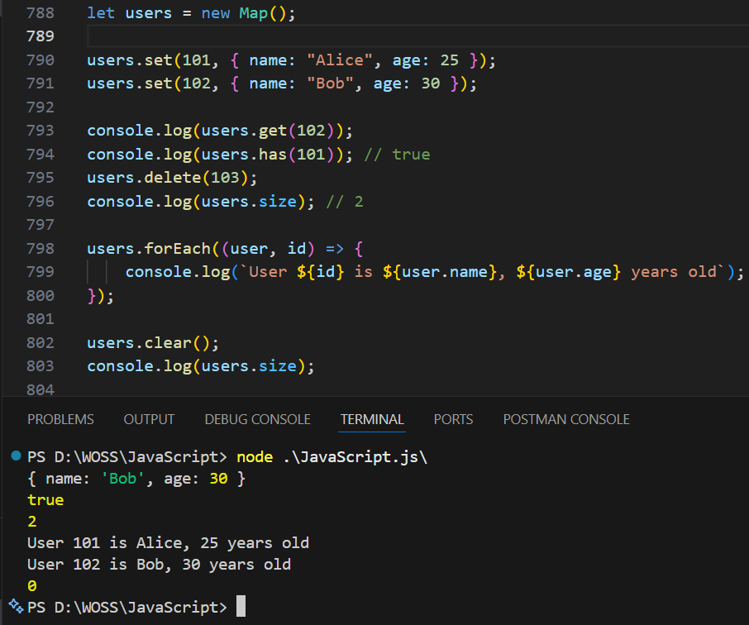

4. Map and Empty Slots (The Method)
As you noted in the Array section, the .map() method handles empty slots specifically:
- It skips empty slots in sparse arrays.
- It preserves the "hole" in the resulting new array.
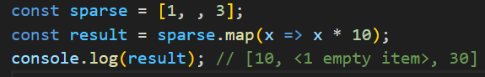

Topic 23 set

Set object, a collection of unique values. Each value can occur only once in a Set.

1. What is a Set?
A Set is like an array, but with one major rule: No duplicates allowed. If you try to add a value that already exists, the Set will simply ignore it.
Essential Set Methods & Properties
Method/Property | One-Line Definition | Example
new Set() | Creates a new Set object. | const s = new Set();
add(value) | Adds a new element to the Set. | s.add(5);
delete(value) | Removes a specific element. | s.delete(5);
has(value) | Returns true if the value exists in the Set. | s.has(5);
clear() | Removes all elements from the Set. | s.clear();
size | Returns the number of elements in the Set. | s.size;
Example :-
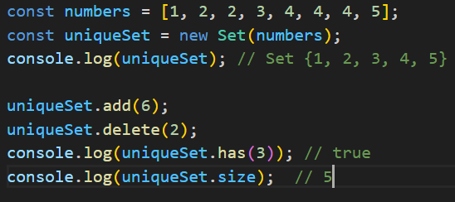
3. Iterating Over a Set
You can loop through a Set using forEach or a for...of loop. Sets maintain the insertion order of the elements.
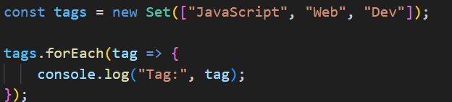
4. Set vs. Array: When to use which?
Feature | Array | Set
Duplicates | Allowed. | Not allowed.
Access | Access by index (arr[0]). | No index access. Use .has().
Performance | Slower to check if an item exists. | Very fast to check if an item exists.
Use Case | Ordered lists where order/index matters. | Collections of unique items (IDs, tags).

5. WeakSet (The "Memory Safe" version)
A WeakSet is a special version of a Set where:
- A WeakSet is a collection of objects only (primitive values like numbers or strings are not allowed).
- The objects in a WeakSet are weakly referenced, meaning if there’s no other reference to an object, it can be garbage collected.
- Cannot iterate over a WeakSet. No .size, no forEach, no for...of.
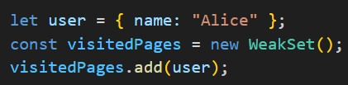

Topic 24 Prototype

In JavaScript, every object has a "hidden" property called a Prototype. Think of a prototype as a parent or a blueprint that the object can borrow properties and methods from.
If you try to access a property on an object and it’s not there, JavaScript doesn't give up immediately. It looks at the object's Prototype to see if it’s there. This is called the Prototype Chain.
Every function in JavaScript has a prototype property. When you create an object using a constructor function (or a class), that object links to the constructor's prototype.
Example
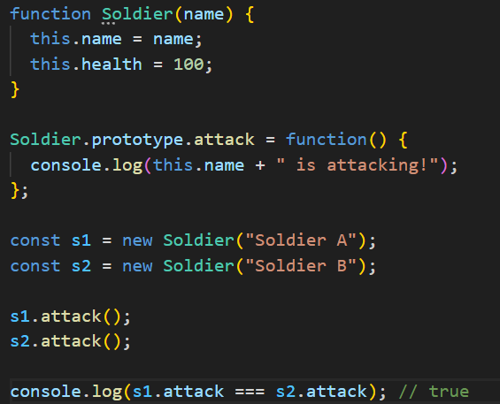
Why is this important?
- Memory Efficiency: Instead of creating a function 1,000 times for 1,000 objects, you create it once on the prototype.
- Inheritance: It allows objects to inherit features from other objects (the basis for Classes in JS).

Topic 25 Lexical Scope

Lexical Scope is like a "one-way mirror." A function defined inside another function can see "out" to the variables of its parent, but the parent cannot see "in" to the variables of the child.
The word "Lexical" means that the scope is determined by where the code is written in your file, not where or when it is called.
Lexical scope is used constantly to protect variables so they don't get accidentally changed by other parts of your program.
Example:
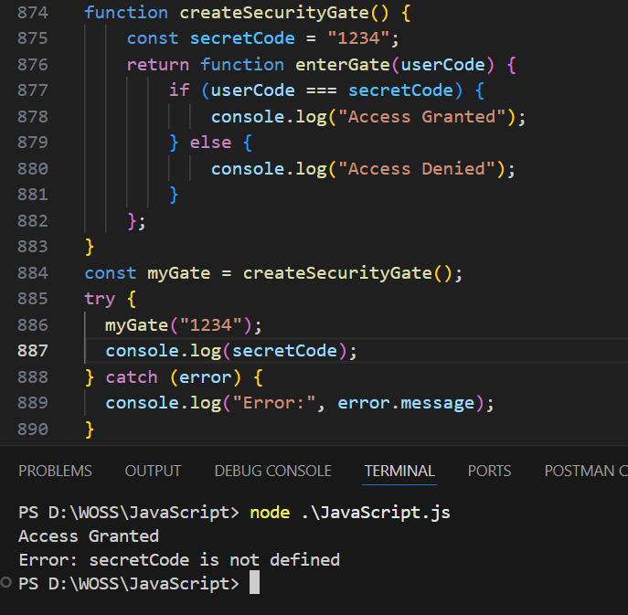

Why is this important?
- Security: It allows you to create "private" variables that can't be touched from the outside.
- Organization: It prevents "naming collisions" (where two variables have the same name but do different things).
- Closures: Lexical scope is the "engine" that makes Closures work (which is often the next topic people learn).

Topic 26 Call, Apply and Bind

In JavaScript, the this keyword normally refers to the object that "owns" the method. However, sometimes you want to borrow a method from one object and use it on another.
Call, Apply, and Bind are three methods used to manually set what this refers to.
- Call & Apply: Use these to run the function immediately.
- Bind: Use this to create a copy of the function to be used later.

What is this?
In JavaScript, the this keyword refers to an object.
The this keyword refers to different objects depending on how it is used:

- Alone, this refers to the global object.
- In a function, this refers to the global object.
- In a function, in strict mode, this is undefined.
- In an object method, this refers to the object.
- In an event, this refers to the element that received the event.
- Methods like call(), apply(), and bind() can refer this to any object.

The Difference Between call() and apply()
The call() method takes arguments separately.
The apply() method takes arguments as an array.

Bind() :-
- Sometimes the bind() method has to be used to prevent losing this.
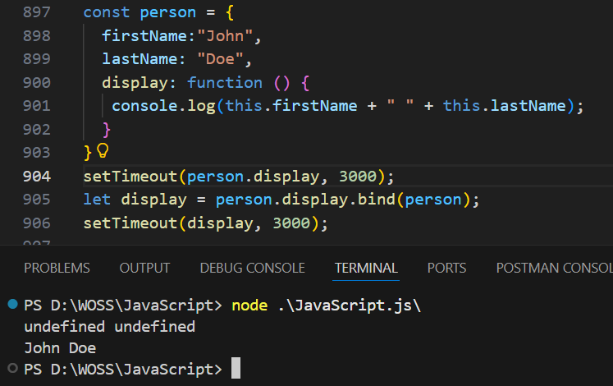
Example :-
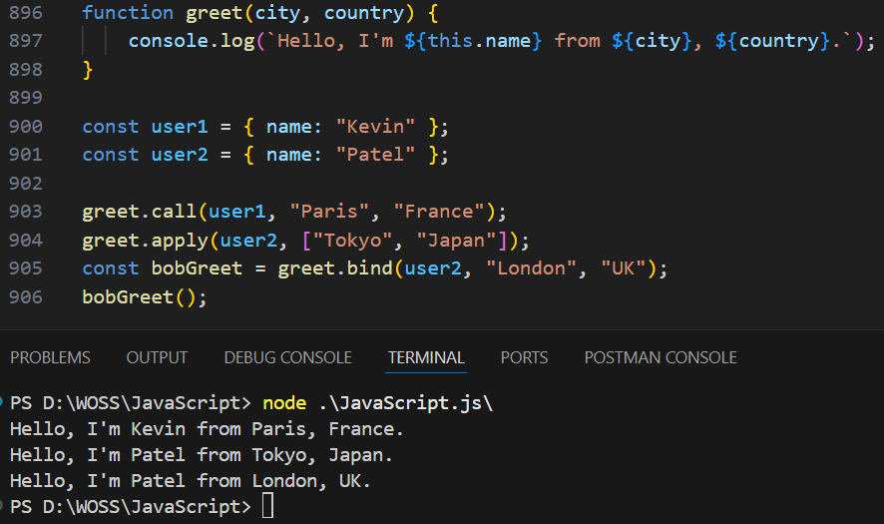

Topic 27 different between slice and splice

