**Week 5:**

File: DSC550_Paulovici_Exercise_5_2.py (.ipynb)  
Name: Kevin Paulovici  
Date: 4/12/2020  
Course: DSC 550 Data Mining (2205-1)  
Assignment: 5.2 Exercise: Graph Analysis

**Assignment Tasks**

Complete the Hypothesis Case Study Part 1 tutorial. It is not a complete case study; it is just the steps you might take to do Graph Analysis. I have provided sample code for you to use as you go through the tutorial. I recommend that you comment out the steps and run them separately so you can fully understand what you are doing for each step of the analysis. As you go through each step, take screenshots to “prove” to me that you successfully completed each step. Paste your screenshots into a Word document and submit that Word document to the Assignment submission link.  
  
Code provided by Prof. Becky Deitenbeck

**Case Study: Testing Hypothesis**

Hypothesis: Articles about Climate Change are more likely to be published by "Liberal" sources  
  
NOTE: This case study is not complete! We are only using the first part of it to practice Graphic Analytics.

In [1]:

**import** **pandas** **as** **pd**

**import** **numpy** **as** **np**

**import** **string**

**import** **re**

**import** **matplotlib.pyplot** **as** **plt**

**from** **collections** **import** Counter

**Step 1: Load data into a dataframe**

In [2]:

addr1 = "articles1.csv" *# file in same dir as .py file*

articles = pd.read_csv(addr1)

**Step 2: check the dimension of the table/look at the data**

In [3]:

*#Dimension of table*

print("The dimension of the table is: **{}**".format(articles.shape))

The dimension of the table is: (50000, 10)

In [4]:

*#Display the data*

print(articles.head(5))

Unnamed: 0 id title \

0 0 17283 House Republicans Fret About Winning Their Hea...

1 1 17284 Rift Between Officers and Residents as Killing...

2 2 17285 Tyrus Wong, ‘Bambi’ Artist Thwarted by Racial ...

3 3 17286 Among Deaths in 2016, a Heavy Toll in Pop Musi...

4 4 17287 Kim Jong-un Says North Korea Is Preparing to T...

publication author date year month \

0 New York Times Carl Hulse 2016-12-31 2016.0 12.0

1 New York Times Benjamin Mueller and Al Baker 2017-06-19 2017.0 6.0

2 New York Times Margalit Fox 2017-01-06 2017.0 1.0

3 New York Times William McDonald 2017-04-10 2017.0 4.0

4 New York Times Choe Sang-Hun 2017-01-02 2017.0 1.0

url content

0 NaN WASHINGTON — Congressional Republicans have...

1 NaN After the bullet shells get counted, the blood...

2 NaN When Walt Disney’s “Bambi” opened in 1942, cri...

3 NaN Death may be the great equalizer, but it isn’t...

4 NaN SEOUL, South Korea — North Korea’s leader, ...

In [5]:

*#what type of variables are in the table*

print("Describe Data")

print(articles.describe())

print("Summarized Data")

print(articles.describe(include=['O']))

Describe Data

Unnamed: 0 id year month url

count 50000.000000 50000.000000 50000.000000 50000.000000 0.0

mean 25694.378380 44432.454800 2016.273700 5.508940 NaN

std 15350.143677 15773.615179 0.634694 3.333062 NaN

min 0.000000 17283.000000 2011.000000 1.000000 NaN

25% 12500.750000 31236.750000 2016.000000 3.000000 NaN

50% 25004.500000 43757.500000 2016.000000 5.000000 NaN

75% 38630.250000 57479.250000 2017.000000 8.000000 NaN

max 53291.000000 73469.000000 2017.000000 12.000000 NaN

Summarized Data

title publication \

count 50000 50000

unique 49920 5

top The 10 most important things in the world righ... Breitbart

freq 7 23781

author date content

count 43694 50000 50000

unique 3603 983 49888

top Breitbart News 2016-08-22 advertisement

freq 1559 221 42

In [6]:

*#display length of data*

print(len(articles))

print(len(articles.index)) *# another way*

50000

50000

In [7]:

*#display publishers (publications)*

print(articles.publication.unique())

['New York Times' 'Breitbart' 'CNN' 'Business Insider' 'Atlantic']

In [8]:

*#display min, max of years published*

print(articles['year'].min())

print(articles['year'].max())

2011.0

2017.0

In [9]:

*#display how many articles from each year*

print(articles['year'].value_counts())

2016.0 28451

2017.0 17908

2015.0 3326

2013.0 212

2014.0 76

2012.0 26

2011.0 1

Name: year, dtype: int64

**Step 3: Create some bar charts to show articles**

In [10]:

*#display bar chart of articles sorted by Publication Name*

ax = articles['publication'].value_counts().sort_index().plot(kind='bar', fontsize=14, figsize=(12,10))

ax.set_title('Article Publication**\n**', fontsize=20)

ax.set_xlabel('Publication', fontsize=18)

ax.set_ylabel('Count', fontsize=18);

plt.show()

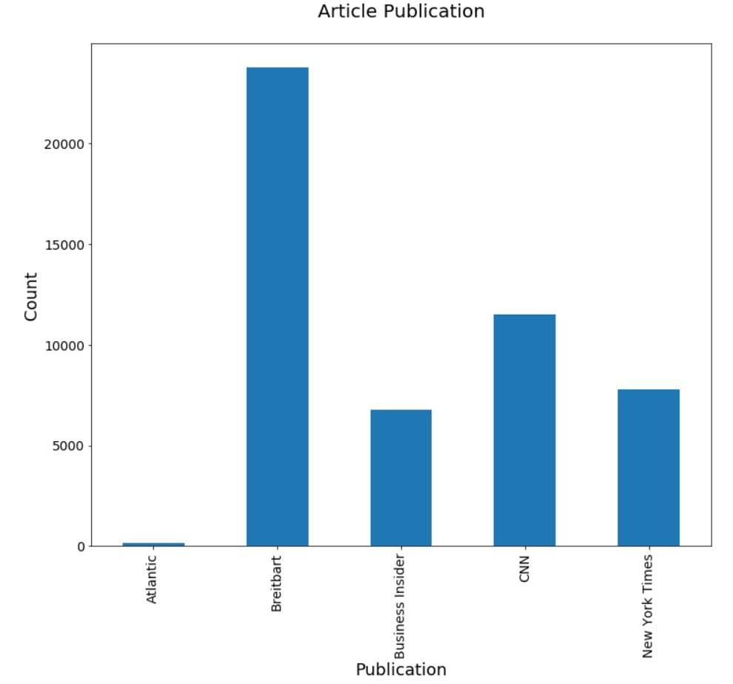

In [11]:

*#display bar chart of articles sorted by counts*

ax = articles['publication'].value_counts().plot(kind='bar', fontsize=14, figsize=(12,10))

ax.set_title('Article Count - most to least**\n**', fontsize=20)

ax.set_xlabel('Publication', fontsize=18)

ax.set_ylabel('Count', fontsize=18);

plt.show()

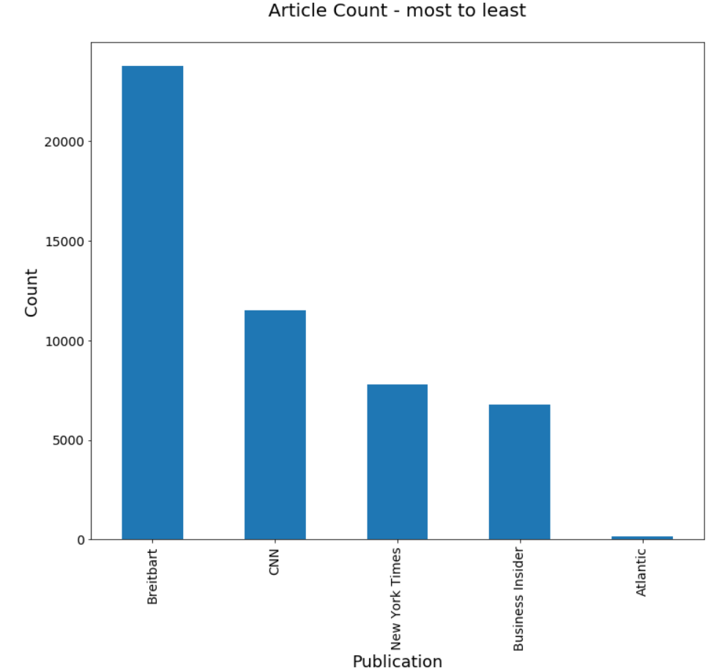

**Step 4: clean text: no punctuation/all lowercase**

In [12]:

**def** clean_text(article):

clean1 = re.sub(r'['+string.punctuation + '’—”'+']', "", article.lower())

**return** re.sub(r'\W+', ' ', clean1)

articles['tokenized'] = articles['content'].map(**lambda** x: clean_text(x))

print("clean text: **\n{}**".format(articles['tokenized'].head()))

clean text:

0 washington congressional republicans have a ne...

1 after the bullet shells get counted the blood ...

2 when walt disneys bambi opened in 1942 critics...

3 death may be the great equalizer but it isnt n...

4 seoul south korea north koreas leader kim said...

Name: tokenized, dtype: object

In [13]:

*#look at mean, min, max article lengths*

articles['num_wds'] = articles['tokenized'].apply(**lambda** x: len(x.split()))

print("Mean: **{:.2f}**".format(articles['num_wds'].mean()))

print("Min: **{:.2f}**".format(articles['num_wds'].min()))

print("Max: **{:.2f}**".format(articles['num_wds'].max()))

Mean: 636.26

Min: 0.00

Max: 24736.00

**Step 5: remove articles with no words**

In [14]:

len(articles[articles['num_wds']==0])

articles = articles[articles['num_wds']>0]

print("New Mean: **{:.2f}**".format(articles['num_wds'].mean()))

print("New Min: **{:.2f}**".format(articles['num_wds'].min()))

print("New Max: **{:.2f}**".format(articles['num_wds'].max()))

New Mean: 637.09

New Min: 1.00

New Max: 24736.00

**Step 6: Check for Outliers: show bar graph of outliers**

In [15]:

ax=articles['num_wds'].plot(kind='hist', bins=50, fontsize=14, figsize=(12,10))

ax.set_title('Article Length in Words**\n**', fontsize=20)

ax.set_ylabel('Frequency', fontsize=18)

ax.set_xlabel('Number of Words', fontsize=18);

plt.show()

