# Case Study: Analyze Stack Overflow Developer Survey Data

## Data File

Dataset contains 2019 survey results from Stack Overflow developers.

survey_results_public.csv

survey_results_schema.csv

Data location: <https://insights.stackoverflow.com/survey>

## Overview

This analysis will look at the 2019 survey results from Stack Overflow. Throughout this analysis we will be looking for what aspects developers have. We’ll try to answer some questions such as, which gender developer tend to be, do they code for fun, is there a linear trend in years of development vs. pay. Do they participate in open source projects, and how their profession is related to programming (e.g., full time, student, hobby, etc.).

## Step-by-Step Instructions

### Part 1 Includes step 1 – 12

### Part 2 Includes step 13 -14

1. Load the data from *survey_results_public.csv* and *survey_results_schema.csv* files into a DataFrame.
   1. *survey_results_schema.csv* contains the header information, so we’ll want to include this to check headers later.
2. Display the dimensions of the dataset.
   1. There are a lot of columns that are not going to be directly applicable to this analysis, we’ll remove them later in Part 2.

The dimension of the data is: (88883, 85)

1. Filter data to only include United States
   1. I’m limiting the survey results to be more applicable to me. Through this analysis, I would like to see what attributes others developers have and more directly compare them to myself.
2. Display the dimensions of the file.
   1. From the two filtering criteria we set in step 3, we were able to reduce the dataset to ~ 21,000 rows – this should help us more directly focus in features we care about.

The dimension of the data is: (20949, 85)

1. Display the first few rows of the new dataset and header schema.

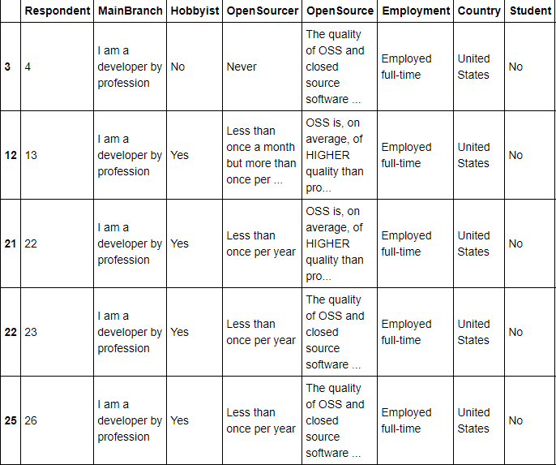

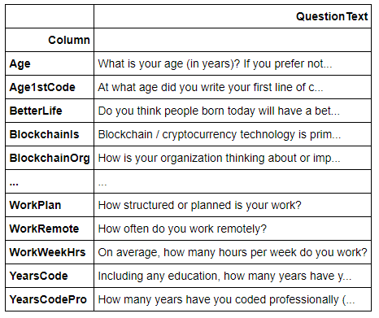

1. Replace values for select numerical features (YearsCode & YearsCodePro)
   1. Some options allow for more than 50 years or less than 1 years as an answer. For plotting, I’m lumping the less than 1 year as 0, and more than 50 with 50.
2. Convert select numerical features (YearsCode & YearsCodePro) to numerics
3. Display the summary of the data for features of interest (Age, YearsCode, YearsCodePro).
   1. Age – we can see non-realistic ages like 1 and 99, in Part 2 we’ll narrow the scope of the age.
   2. This also gives an idea of the experience level of the developers.

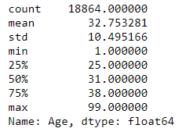

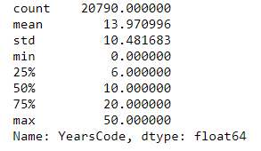

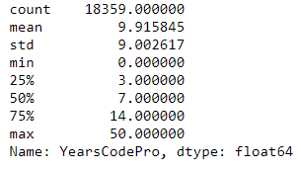

1. Plot histogram for features (Age, YearsCode & YearsCodePro).
   1. We can see by limiting the age range we will still be cover the majority of participants.

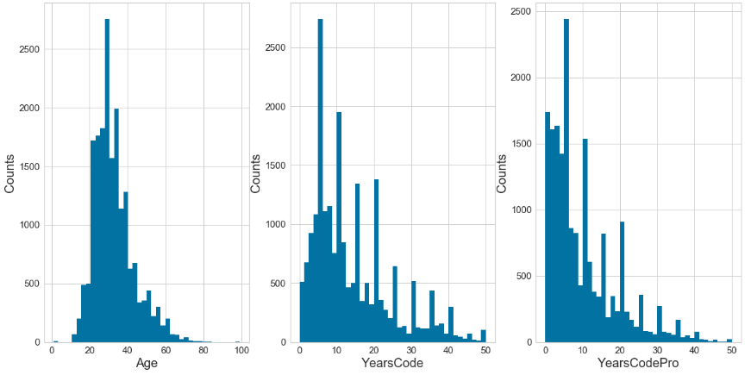

1. Replace values for OpenSourcer, the original survey has long text, to display better on the plot this should be converted to shorthand. Also replace text for Employment for similar reason.
2. Filter genders to Man & Woman; other genders are relatively small.

The dimension of the data is: (16510, 20)

1. Make bar chart for other features of interest.
   1. This data enables us to better understand the distribution of various features. We can latter use these as filters and compare to salary. Additionally, we can use them for machine learning to see which are most important when considering salary.
   2. Open Source providers – the majority of developers rarely is at contribute.
   3. Gender – Overwhelming male dominated, this was expected since STEM fields follow the same trend. It will definitely be interesting to compare salary’s here when holding older features constant.
   4. Hobbyist – the majority of developers program for fun. It is surprising so few contribute regularly to open source programs when the majority like to program for fun.
   5. Students – only a small sample are part-time or full-time students.
   6. MgrIdiot- This feature is for the confidence developers have in their managers. It looks like most have somewhat or are very confident in their managers.
   7. Employment status – most respondents are full-time employed. Unemployed respondents will be removed since they skew the data on salary. I’m curious to see how independent compares to full-time salarys.

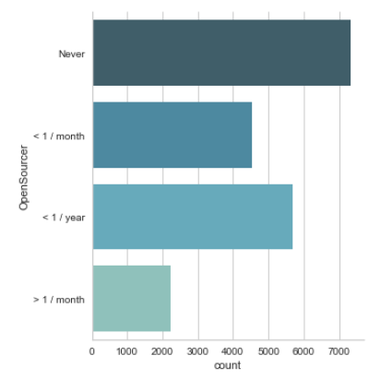

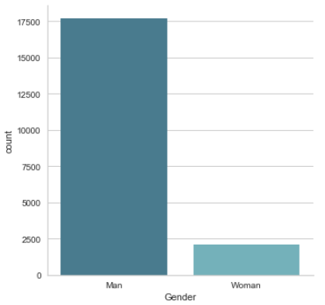

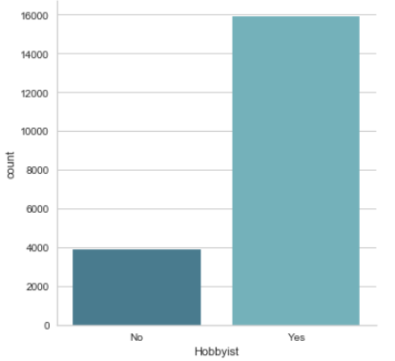

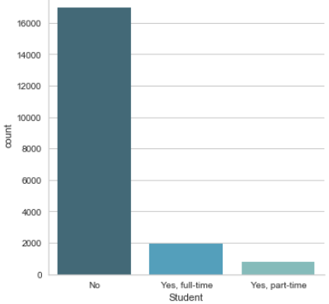

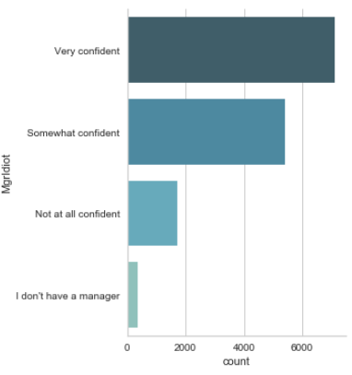

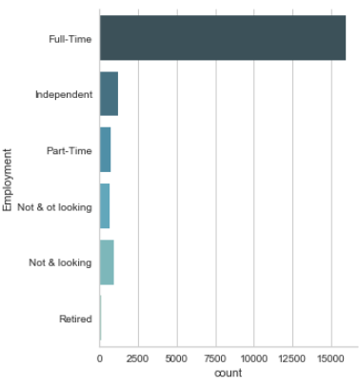

1. Filter additional data based on what we’ve seen from the graph analysis above.
   1. Step 3 removed programming languages that did not include Python and restricted the demographic to the United States.
   2. Step 11 removed any gender that was not Man or Woman.
   3. Remove anyone that is not currently employed, retired folks or people not currently working won’t provide sufficient data relative to salary.
   4. Restrict age range to 18 – 65. This is the core working demongraphic.

The dimension of the data is: (16510, 20)

1. Remove features not of interest.
   1. Since there are 85 features, it is easier to show the features that were included
   2. Features included relate to describe the type of people included and/or related to salary.
   3. Other features e.g., work location or last hire date are irrelevant to the scope of this analysis.

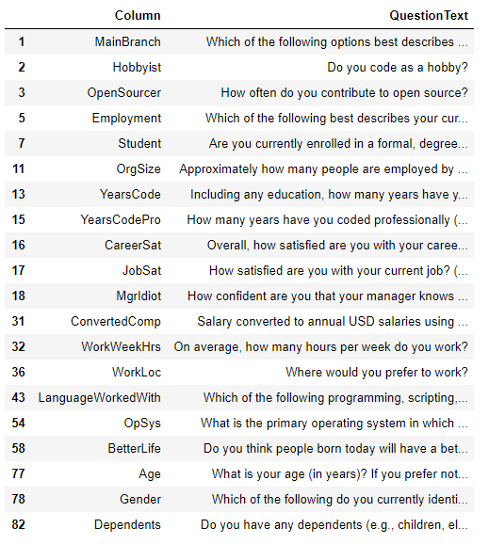

## Future Considerations

At this point in the analysis we have a decent understanding of the respondents and various feature distributions. Through feature selection we removed 65 columns that were less relevant to help up understand how the features compare to salary. Some additional features were left that could be of interest through some exploratory analysis. By selectively restricting certain feature criteria (e.g., gender, age, employment status, Country) we have developed a core dataset by removing as much noise that could skew results as possible. Going forward, we’ll have to start exploring how these features impact salary and determine what trends we see.