Assignment 1

Milestone 1

Milestone 2

Milestone 3

Milestone 4

Milestone 5

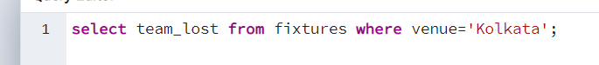

Milestone 8

Milestone 9

Milestone 10

Milestone 11

Making change for pulling and merging.