**MAJOR ASSIGNMENT**

Kevin Paul K

MileStone 1

1. ERRORS:

This is the aws error that I had got earlier.

Atom

1. OUTPUT: Snowflake

Atom.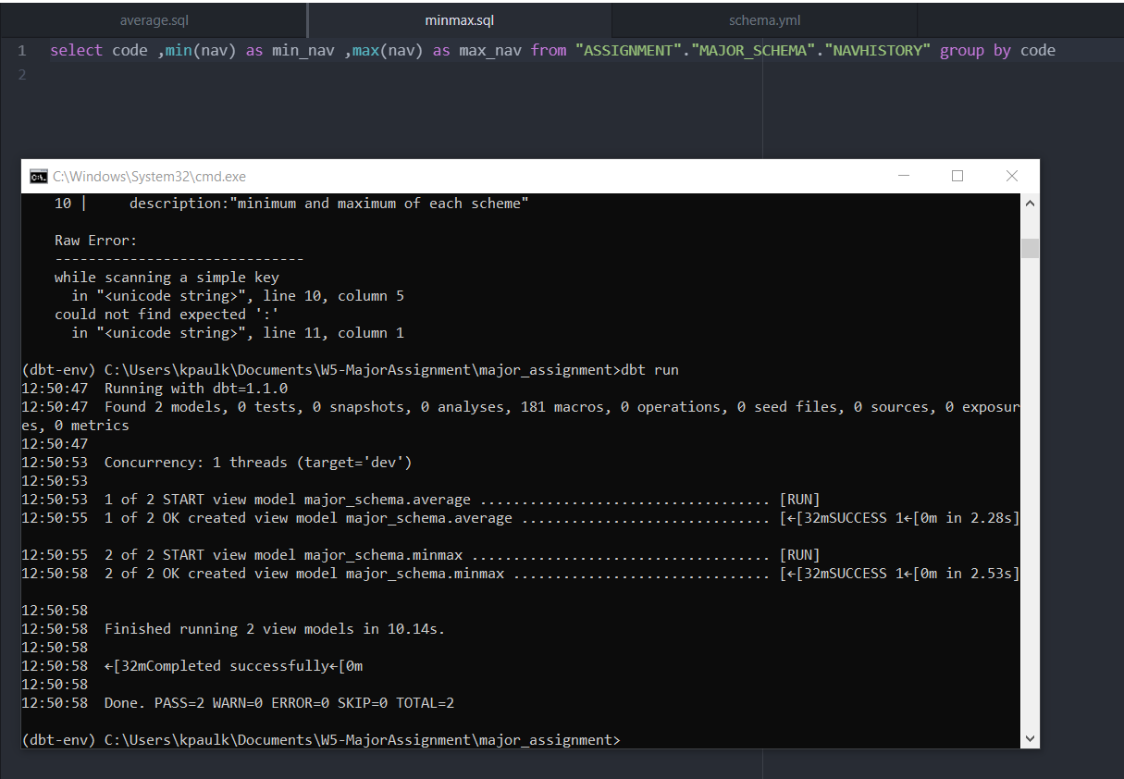

Milestone2

1.

Query:

Milestone 3

