WEEK 2
Penetration Testing & Reconnaissance Report
PM1 → PM2 → PM3 → PM4
Target of assessment: networkwalks.com
Analyst: Kevin | Environment: Kali Linux (VM)
Date: 19 August 2026

Table of Contents

1. Executive Summary 3
Overall Risk Posture 3
2. Report Overview 3
2.1 Methodology 3
2.2 Scope and Rules of Engagement 4
3. Consolidated Findings Summary 5
3.1 Severity Rating Scale 5
3.2 Findings by Module 5
4. Detailed Evidence and Analysis 7
4.1 PM1 — Footprinting Toolkit 7
4.1.1 WHOIS 7
4.1.2 curl (HTTP Headers) 8
4.1.3 DNSRecon 8
4.1.4 Wafw00f 9
4.1.5 nslookup 10
4.1.6 WhatWeb 10
4.2 PM2 — Maltego Footprinting 12
4.2.1 Maltego — Graph 12
4.2.2 Maltego — Details 13
4.3 PM3 — theHarvester OSINT 14
4.3.1 theHarvester — Help 14
4.3.2 theHarvester — Results 15
4.4 PM4 — Zenmap Network Scanning 16
4.4.1 Zenmap — Scan Output 16
4.4.2 Zenmap — Topology 17
5. Security-Relevant Takeaways and Remediation Roadmap 18
5.1 Recommended Next Phase 18
6. Conclusion 19

(Page numbers shown reflect this version. In Word, right-click the table above and choose "Update Field" to refresh them if content shifts.)

1. Executive Summary
This report summarizes reconnaissance and open-source intelligence (OSINT) activity performed during Week 2 against the target domain networkwalks.com, using a structured four-module workflow: passive/active footprinting (PM1), entity-relationship graphing with Maltego (PM2), OSINT harvesting with theHarvester (PM3), and local network host discovery with Zenmap/Nmap (PM4).
The assessment did not identify any critical or directly exploitable vulnerabilities. The findings are consistent with normal external reconnaissance: the target's registration data, DNS records, hosting stack, and defensive controls are all discoverable through public and passive means, which is expected for any internet-facing domain. The most notable technical observation is that DNSSEC is unsigned, which does not itself compromise the domain but removes a layer of protection against DNS spoofing and cache-poisoning attacks. The site was also confirmed to be running WordPress on Apache behind a ModSecurity WAF, information that would inform the vulnerability-scanning phase of a real engagement.
One process issue is flagged for correction before final submission: the theHarvester evidence (PM3) was captured against microsoft.com rather than the assessment's actual target, networkwalks.com. This is noted transparently in Section 4.3 along with a recommendation to re-run the tool against the correct target.

Overall Risk Posture
Based on the evidence gathered, networkwalks.com presents a normal, low-to-medium information-disclosure risk profile typical of a small-to-mid-size WordPress site on shared commercial hosting (GoDaddy registrar, HostGator DNS, cPanel mail). No credentials, open administrative panels, or unpatched services were observed in this phase. Recommendations in Section 5 are hardening measures rather than emergency remediations.

2. Report Overview
This report documents the practical reconnaissance and scanning activities completed during Week 2. Evidence is organized into four modules: PM1 records command-line and web-footprinting results; PM2 documents Maltego-based relationship discovery; PM3 records theHarvester usage and OSINT results; and PM4 documents Zenmap host discovery and topology visualization.
Module | Focus | Evidence | Tools / Activity
PM1 | Footprinting Toolkit | 6 screenshots | WHOIS, curl, DNSRecon, Wafw00f, nslookup, WhatWeb
PM2 | Maltego Footprinting | 2 screenshots | Domain entity graph and detail inspection
PM3 | theHarvester OSINT | 2 screenshots | Help menu and search-engine host discovery
PM4 | Zenmap Network Scanning | 2 screenshots | Host-discovery scan and topology visualization

2.1 Methodology
The workflow progresses from basic domain and HTTP information gathering to broader OSINT correlation and finally to controlled network discovery, mirroring the standard reconnaissance phase of the penetration testing lifecycle (passive recon → active recon → correlation → scoped scanning). Each piece of evidence is presented as a screenshot, followed by an observation describing what the tool returned, and an analysis describing why the finding is significant from a security perspective.

2.2 Scope and Rules of Engagement
- Target domain: networkwalks.com (public reconnaissance only — no exploitation, no authentication attempts).
- Network scanning (PM4) was performed inside an isolated virtual lab network (10.0.x.x range), not against production infrastructure.
- GHDB (Google Hacking Database) techniques are intentionally excluded per assignment scope; the report uses the requested four-module sequence PM1–PM4.
- All activity is passive/OSINT or non-intrusive host discovery; no intrusive scanning, brute forcing, or exploitation was performed against the live target.

3. Consolidated Findings Summary

3.1 Severity Rating Scale
This engagement rates findings on the standard five-tier severity scale below, shown in full for reference so a reader can see what a finding was benchmarked against, not just the tiers that happened to apply.
Severity | Definition | Applied in Week 2?
Critical | Demonstrated, direct compromise of systems, data, or accounts — e.g., working remote code execution, exposed admin credentials, full authentication bypass. | No — no exploitation was performed or in scope this phase.
High | A serious weakness confirmed with high confidence, short of full exploitation — e.g., a specific unpatched CVE verified against a fingerprinted software version, or unauthenticated access to sensitive data. | No — reconnaissance confirmed fingerprints and exposures, not a specific exploitable vulnerability.
Medium | A real weakness that could materially aid an attacker but needs further steps to exploit — e.g., a missing cryptographic control, or a fingerprinted CMS/stack awaiting a version-specific CVE check. | Yes — 2 findings (unsigned DNSSEC; WordPress/Apache stack fingerprinted).
Low | Information disclosure or a minor gap offering limited standalone benefit to an attacker. | Yes — 3 findings (WHOIS registrant contact; mail infrastructure exposure; incomplete security headers).
Informational | Notable but not risk-bearing on its own — context, or confirmation that a defensive control exists. | Yes — 1 finding (ModSecurity WAF confirmed present).
Why no finding reached Critical or High this phase: this was a reconnaissance/OSINT engagement — no exploitation, authentication attempts, or intrusive scanning were performed or in scope (Section 2.2). Critical and High both require either a demonstrated compromise or a confirmed exploitable vulnerability, neither of which this phase’s methodology could produce even if one were present. The findings below reflect what passive/OSINT and non-intrusive discovery can responsibly surface: exposure, fingerprinting, and hardening gaps. A subsequent phase that includes authorized vulnerability scanning (Section 5.1) could surface Critical or High findings if, for example, the fingerprinted WordPress plugins turn out to carry known unpatched CVEs.

3.2 Findings by Module
The table below consolidates every notable finding across all four modules, rated by category and severity, with the associated recommendation. Severity reflects information-disclosure and hardening risk appropriate to a reconnaissance-only engagement — not exploitability, since no exploitation was attempted or in scope.
Finding | Category | Severity | Impact / Why it matters | Recommendation
Unsigned DNSSEC | DNS / Domain | Medium | Zone responses can be spoofed or cache-poisoned; no cryptographic proof of authenticity for DNS answers. | Enable DNSSEC signing at the registrar/DNS host and publish DS records.
Full WHOIS registrant contact exposed | OSINT | Low | Registrar abuse contact and account details support pretexting / social engineering against domain admin. | Confirm WHOIS privacy/redaction is enabled; verify only the registrar's proxy contact is public.
WordPress + Apache stack fingerprinted | Web Application | Medium | Version-specific plugin/theme vulnerabilities can be targeted once the CMS is confirmed. | Keep WordPress core, plugins and themes patched; hide version strings; restrict wp-json/wp-admin where possible.
ModSecurity WAF confirmed present | Web Application | Informational | Confirms a defensive layer exists, but also tells an attacker which WAF/ruleset to research bypasses for. | Keep WAF rule sets current; monitor Wafw00f-style fingerprinting attempts in WAF logs.
Mail infrastructure (SRV/autodiscover) exposed via cPanel | DNS / Email | Low | Reveals hosting provider (cPanel) and mail routing, useful for phishing infrastructure targeting or credential-harvesting page cloning. | No action required beyond standard practice; ensure SPF/DKIM/DMARC are enforced (SPF record was observed).
Uncommon security headers present but incomplete | Web Application | Low | permissions-policy and referrer-policy are set, but HSTS/CSP presence was not confirmed in the captured headers. | Verify Strict-Transport-Security and Content-Security-Policy headers are enforced site-wide.
theHarvester run against wrong target (microsoft.com) | Methodology / Scope | N/A – process issue | Evidence does not correspond to the assessment's actual target (networkwalks.com), reducing evidentiary value of PM3. | Re-run theHarvester against networkwalks.com and replace the evidence/observation before submission.

4. Detailed Evidence and Analysis

4.1 PM1 — Footprinting Toolkit
PM1 focuses on reconnaissance using command-line and web-footprinting utilities. The evidence covers registration information, DNS resolution and enumeration, HTTP responses, web technology fingerprinting, and WAF detection.

4.1.1 WHOIS
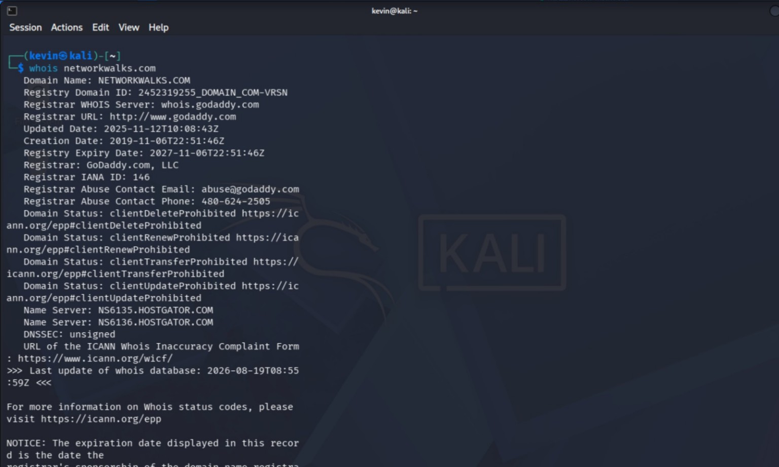
Figure 1 — WHOIS lookup showing domain registration, registrar, status, name servers and DNSSEC state.
Observation: The lookup returns the domain name, registrar (GoDaddy), registration/update/expiry dates, domain status (client-transfer/delete/update/renew prohibited locks), authoritative name servers (HostGator), and an unsigned DNSSEC state.
Analysis: The registrar-level locks (clientTransferProhibited, clientDeleteProhibited, etc.) are a positive sign — they indicate the domain is protected against unauthorized transfer or deletion, which is a common target of domain-hijacking attacks. The registrant contact appears to route through the registrar's abuse address rather than a personal address, suggesting WHOIS privacy is likely in effect. The unsigned DNSSEC state is the most actionable item here: without DNSSEC, DNS responses for this domain cannot be cryptographically validated by resolvers, leaving room for cache-poisoning or spoofed responses to redirect users to a malicious host without any client-side warning.
Risk: Medium (DNSSEC gap) / Informational (registrar data).

4.1.2 curl (HTTP Headers)
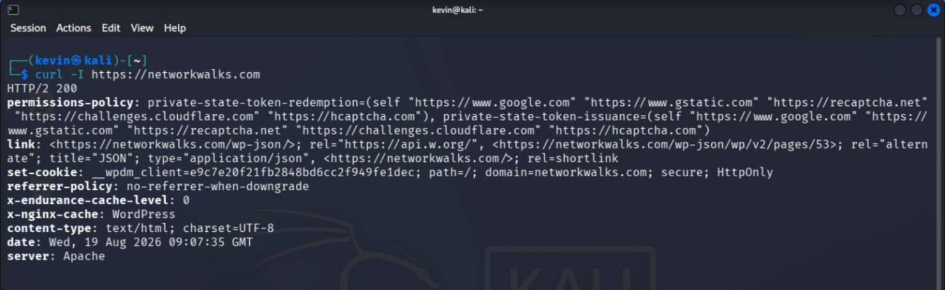
Figure 2 — curl response showing HTTP/2 200 and selected HTTP response headers for the target.
Observation: The response is HTTP/2 200 OK, served by Apache, with a WordPress-style cookie (__wpdm_client), a permissions-policy header referencing Google, reCAPTCHA, Cloudflare Challenges and hCaptcha, a no-referrer-when-downgrade referrer policy, and caching headers (x-nginx-cache, x-endurance-cache-level) that suggest a caching layer sits in front of the Apache origin.
Analysis: The permissions-policy references to reCAPTCHA/hCaptcha/Cloudflare Challenges indicate active bot-mitigation and CAPTCHA tooling on the site, which raises the cost of automated scraping or credential-stuffing attempts. The mixed Apache/nginx-cache signature suggests a reverse proxy or CDN layer (likely Cloudflare, corroborated by later WAF evidence) sits in front of the origin server. The cookie is marked secure and HttpOnly, which is good practice — it is not accessible to client-side JavaScript, reducing exposure to session-cookie theft via XSS. No Strict-Transport-Security (HSTS) or Content-Security-Policy (CSP) header appears in the captured excerpt, which should be verified directly rather than assumed absent, since curl -I may not display the full header set.
Risk: Low / Informational — confirm HSTS and CSP are present site-wide.

4.1.3 DNSRecon
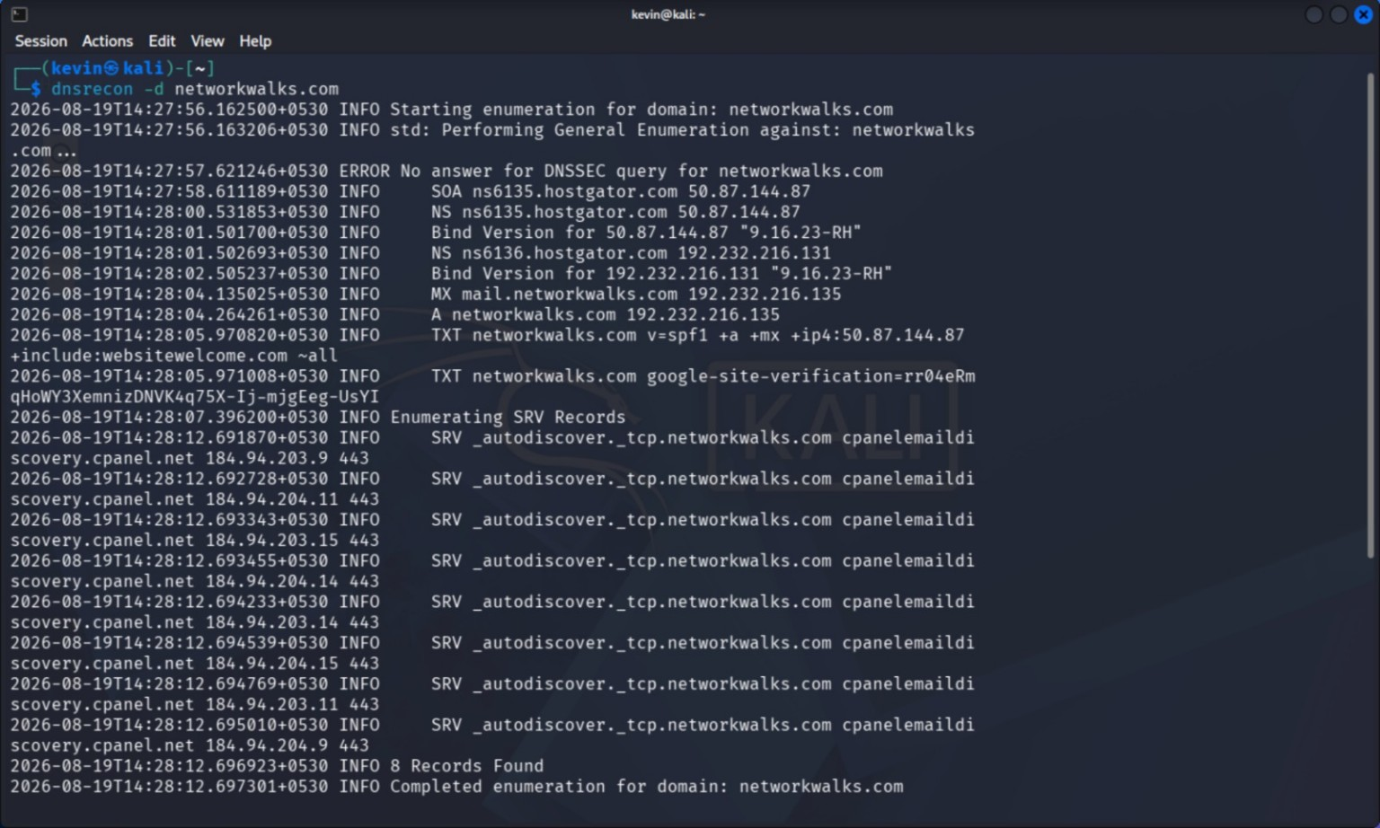
Figure 3 — DNSRecon enumeration showing SOA, NS, MX, A, TXT and SRV records.
Observation: DNSRecon's general enumeration returns SOA/NS records pointing to HostGator name servers, an MX record for mail.networkwalks.com, an A record resolving to 192.232.216.135, a TXT/SPF record authorizing specific senders (v=spf1 +a +mx +ip4:50.87.144.87 include:websitewelcome.com ~all) plus a Google site-verification TXT record, and eight SRV records for _autodiscover._tcp pointing to cPanel mail-discovery hosts (mailcoveryn.cpanel.net) — indicating Microsoft Outlook-style autodiscover is configured against a cPanel-hosted mail platform.
Analysis: The SPF record is present and reasonably scoped (+a +mx plus one explicit IP and one include), which helps reduce email-spoofing risk — though DKIM and DMARC presence could not be confirmed from this output and should be checked separately (dig TXT _dmarc.networkwalks.com). The Google site-verification TXT record confirms the domain owner has registered the site with a Google service (e.g., Search Console), which is routine and not a risk in itself but is a useful OSINT correlation point. The autodiscover SRV records confirm the mail platform is cPanel/WebsiteWelcome-hosted shared email rather than a dedicated enterprise mail platform (e.g., Microsoft 365/Google Workspace) — this narrows the attack surface for a real engagement's phishing-infrastructure or credential-harvesting research phase, since cPanel webmail portals have a well-known default UI that is frequently targeted for lookalike phishing pages.
Risk: Low / Informational — supports later OSINT correlation, not directly exploitable.

4.1.4 Wafw00f
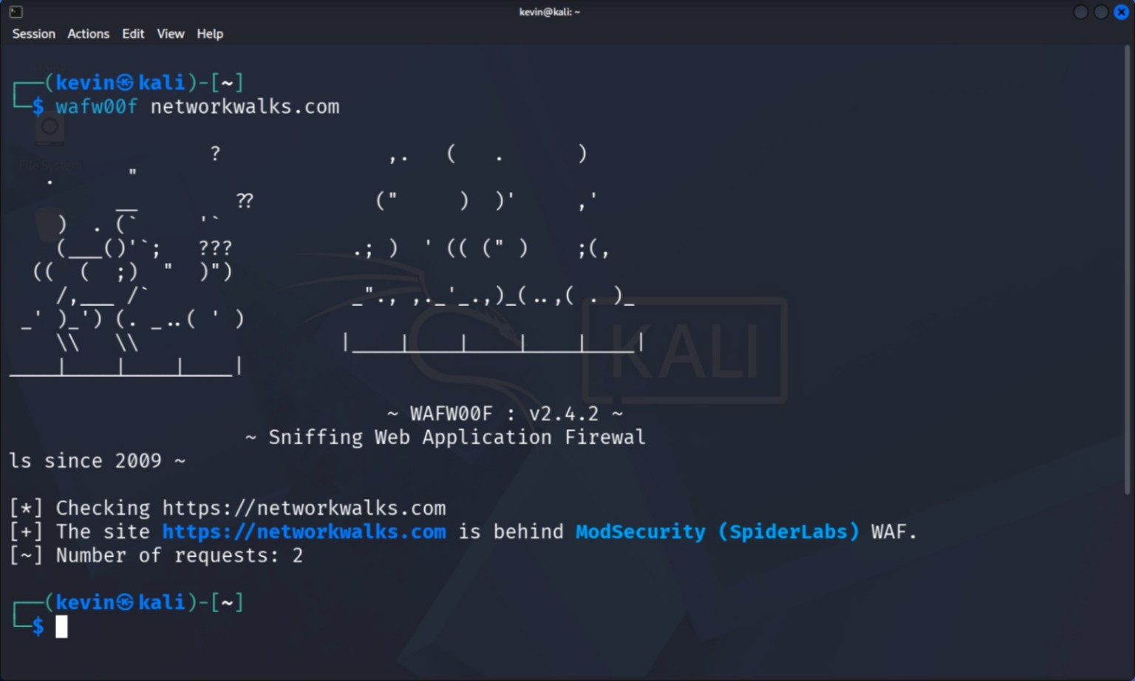
Figure 4 — Wafw00f result identifying ModSecurity (SpiderLabs) as the detected WAF.
Observation: Wafw00f v2.4.2 sent two requests to https://networkwalks.com and identified ModSecurity (SpiderLabs) as the active Web Application Firewall.
Analysis: Confirmed WAF presence is a defensive positive — it means common attack payloads (SQLi/XSS/path traversal signatures) are likely to be filtered before reaching the application. From an attacker's perspective, however, this finding also tells them exactly which WAF product to research for known bypass techniques or rule-set gaps (ModSecurity's OWASP Core Rule Set has publicly documented evasion patterns). This is a good example of why WAF fingerprinting tools are dual-use: useful for defenders validating their own controls, but equally useful for attackers profiling defenses before crafting evasive payloads.
Risk: Informational — validates a defensive control is active; recommend periodic WAF rule-set review and monitoring for fingerprinting attempts (like this one) in WAF/CDN logs.

4.1.5 nslookup
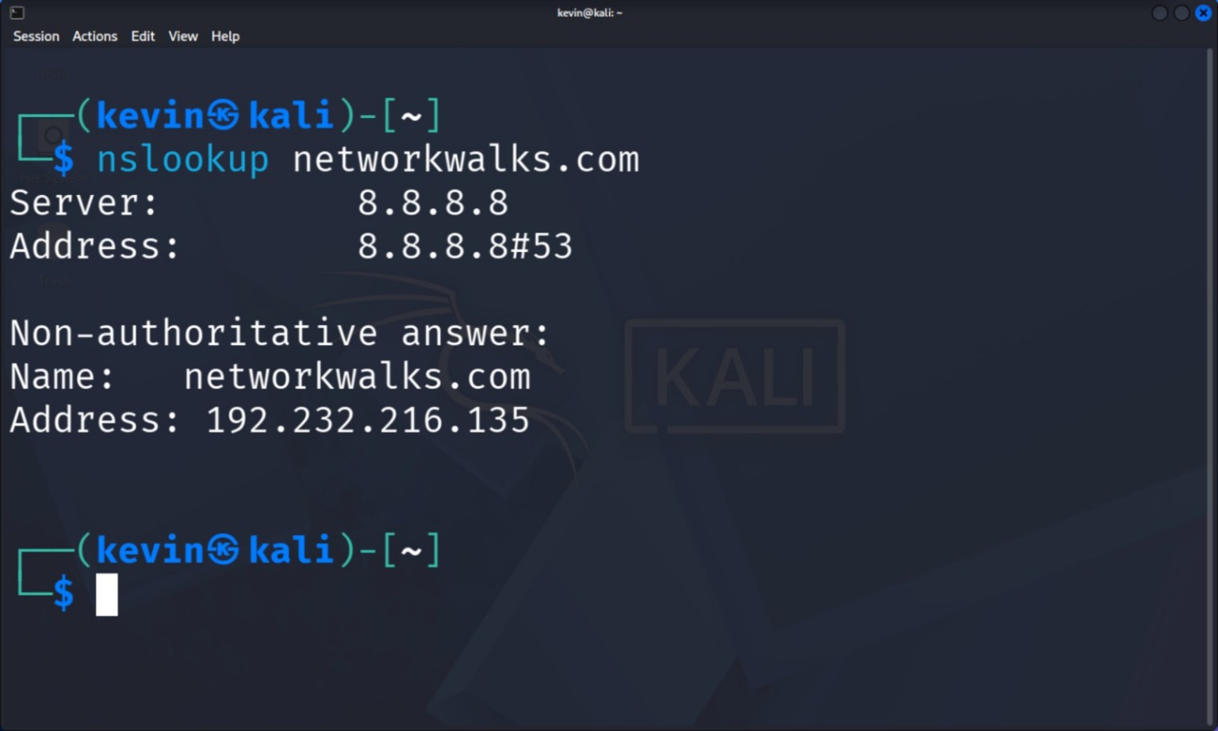
Figure 5 — nslookup result resolving the domain to 192.232.216.135 using DNS server 8.8.8.8.
Observation: A query against Google Public DNS (8.8.8.8) returns a non-authoritative answer resolving networkwalks.com to 192.232.216.135, matching the A record observed in the DNSRecon output.
Analysis: Cross-validating the resolved IP across two independent tools (DNSRecon and nslookup, against different resolvers) confirms DNS resolution is consistent and there is no evidence of split-horizon DNS, DNS-based geofencing, or resolver-specific answers for this domain — useful confirmation before any IP-targeted follow-up activity.
Risk: Informational.

4.1.6 WhatWeb
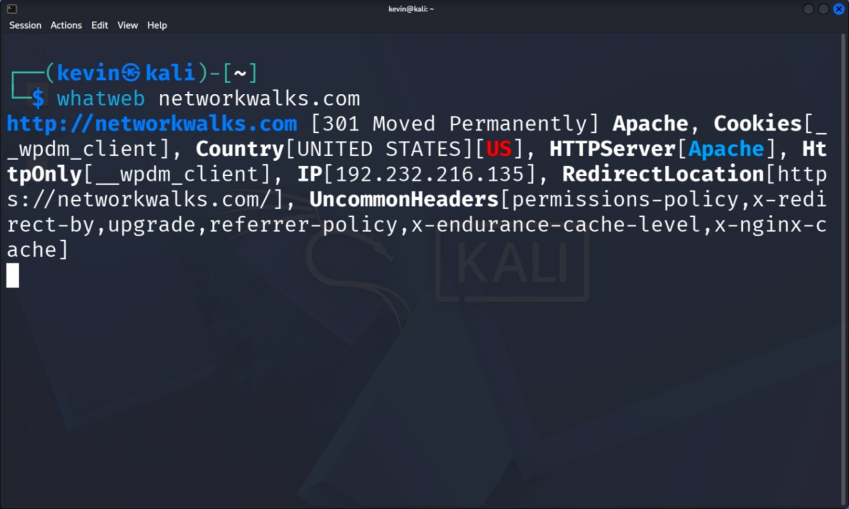
Figure 6 — WhatWeb fingerprinting output showing Apache, cookies, HTTPS server information, IP and headers.
Observation: WhatWeb reports a 301 redirect from HTTP to HTTPS, an Apache HTTPServer banner, the __wpdm_client cookie (associated with the WordPress Download Manager plugin), country geolocation (United States), the resolved IP (192.232.216.135), and a set of uncommon headers (permissions-policy, x-redirect-by, upgrade, referrer-policy, x-endurance-cache-level, x-nginx-cache).
Analysis: The __wpdm_client cookie is a strong fingerprint: it confirms not just that the site runs WordPress, but that the WordPress Download Manager plugin specifically is installed and active. This is directly actionable for a real vulnerability-assessment phase — an assessor would next check the installed plugin version against the WPScan/CVE databases for known Download-Manager vulnerabilities (the plugin has had file-related and access-control CVEs in past versions). Combined with the Apache banner and caching headers from curl, the technology stack can now be summarized with reasonable confidence as: WordPress + WordPress Download Manager plugin, served by Apache, behind an Endurance/nginx caching layer and a Cloudflare-fronted ModSecurity WAF.
Risk: Medium — plugin-specific fingerprinting is the type of information that directly feeds vulnerability scanning; recommend confirming the Download Manager plugin is fully patched.

4.2 PM2 — Maltego Footprinting
PM2 uses Maltego to move from single-tool command output to visual entity correlation. The screenshots demonstrate creation/inspection of a domain entity and a graph view containing relationships between the target domain and discovered online entities.

4.2.1 Maltego — Graph
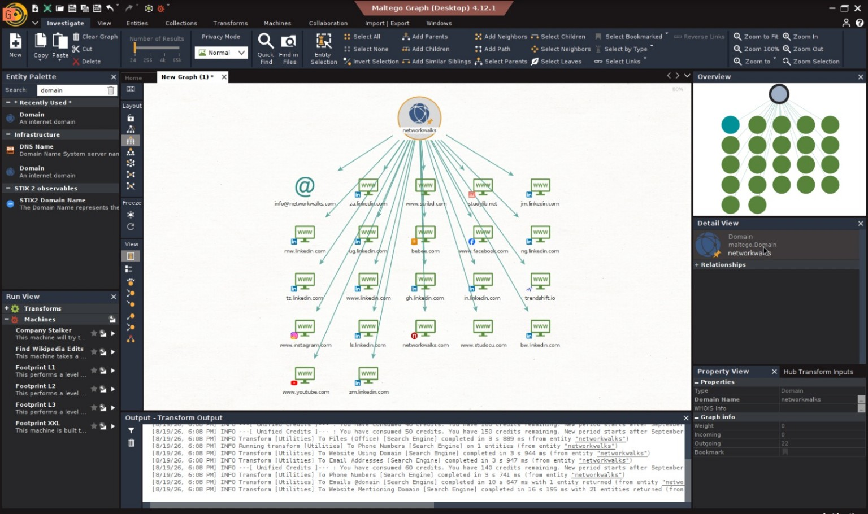
Figure 7 — Maltego graph showing the networkwalks domain connected to discovered web and social entities.
Observation: Running the Footprint transform set against the networkwalks domain entity returns a graph of related entities, including an info@ email address, multiple LinkedIn company/profile pages (za.linkedin.com, ng.linkedin.com, tz.linkedin.com, gh.linkedin.com, ke.linkedin.com, bw.linkedin.com and others), Instagram, Facebook, YouTube, and other 'Website Mentioning Domain' entities such as trendshift.io and bakeke.com. The transform log confirms 'To Emails [Search Engine]', 'To Phone Numbers [Search Engine]', and 'To Website Mentioning Domain [Search Engine]' transforms were run, returning 21 entities from the website-mention transform alone.
Analysis: The concentration of regional LinkedIn subdomains (South Africa, Nigeria, Tanzania, Ghana, Kenya, Botswana) suggests the organization behind networkwalks.com has, or is discussed by, a multi-country African audience or affiliate network — useful context for a social-engineering risk assessment, since it broadens the pool of employee/affiliate profiles that could be targeted for pretexting. The single harvested email address (info@) is a low-risk generic contact rather than a named individual, which is good from a spear-phishing standpoint. Graphing this data visually (versus reading it as raw tool output) is the actual value of PM2: it makes it immediately obvious which entity types cluster together (social media presence vs. website mentions vs. contact data), which would guide where a real OSINT phase spends further effort.
Risk: Low / Informational — standard public social-footprint exposure, not a vulnerability.

4.2.2 Maltego — Details
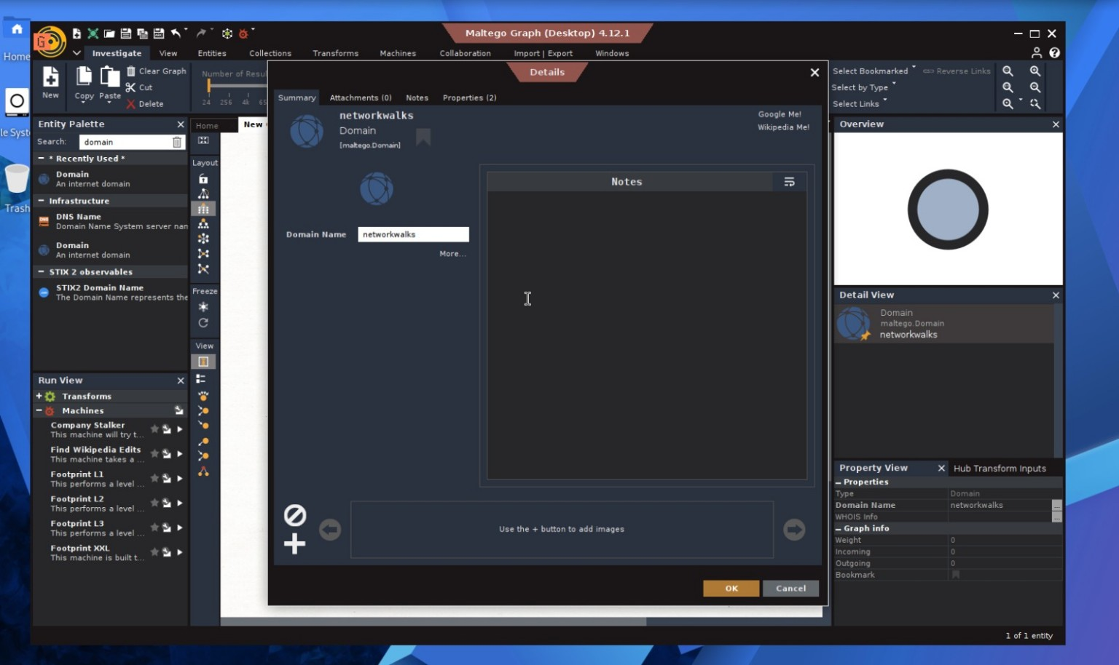
Figure 8 — Maltego domain entity details for networkwalks.
Observation: The entity Details panel confirms the selected node's type (Domain) and its Domain Name property (networkwalks), with Notes and Properties tabs available for analyst annotation and zero incoming/outgoing links recorded prior to running transforms.
Analysis: This screenshot documents good OSINT tradecraft practice: verifying the seed entity is correctly typed and scoped before running transforms against it, which avoids wasted API credits (visible in the Figure 7 transform log — e.g., 'You have 140 credits remaining') and prevents transform results from being polluted by an incorrectly configured entity.
Risk: N/A — process documentation.

4.3 PM3 — theHarvester OSINT
PM3 focuses on theHarvester as an OSINT collection utility. The help screen documents the available options, while the results screenshot demonstrates host discovery from a search-engine source.

4.3.1 theHarvester — Help
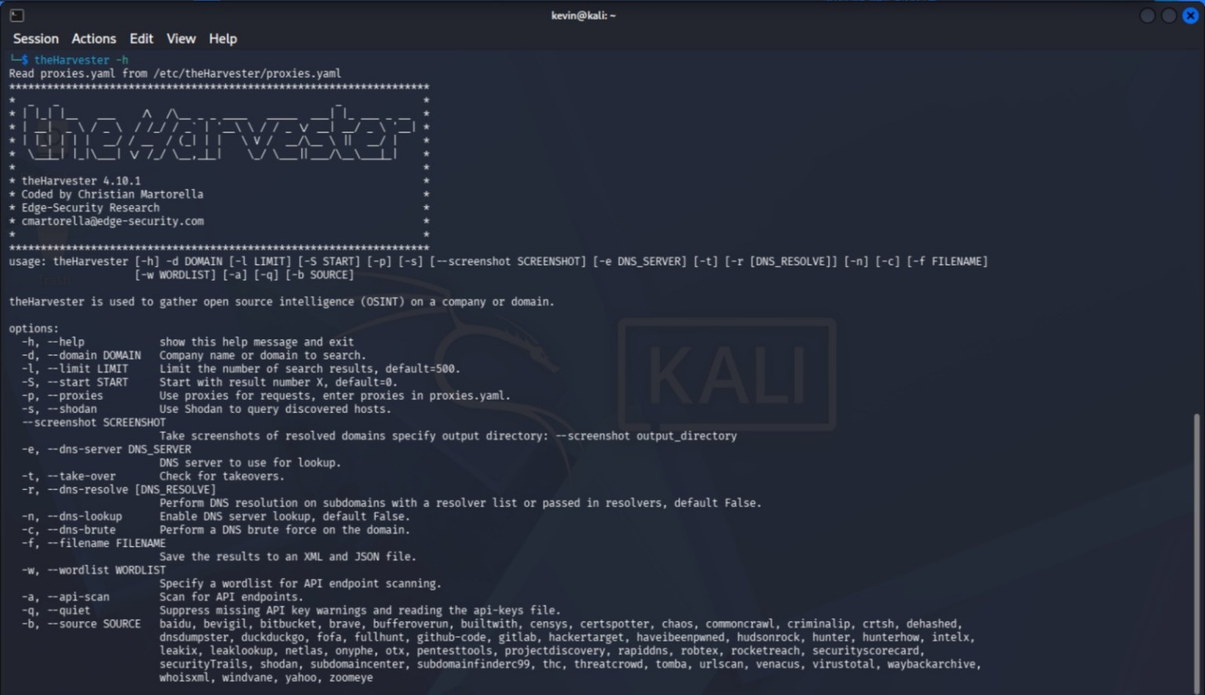
Figure 9 — theHarvester help screen showing available OSINT and DNS-related options.
Observation: theHarvester v4.10.1 supports domain search (-d), result limiting (-l), proxy and Shodan integration (-p/-s), screenshotting of resolved domains, DNS server selection, subdomain takeover checking (-t), DNS resolution and brute-forcing (-r/-c/-n), output to XML/JSON (-f), wordlist-based API scanning (-w/-a), and more than 30 supported data sources (baidu, bevigil, bufferoverun, censys, certspotter, crtsh, dehashed, github-code, hunter, intelx, securityTrails, shodan, subdomaincenter, threatcrowd, urlscan, virustotal, waybackarchive, zoomeye, and others).
Analysis: The breadth of sources matters for OSINT completeness: certificate-transparency sources (crtsh, certspotter) surface subdomains via SSL certificate logs regardless of whether they're linked anywhere publicly, while sources like dehashed and hunter can surface breached-credential or employee-email data if API keys are configured. For this assessment only the default search-engine source was used (see 4.3.2), which is the lowest-effort/lowest-coverage option — a more complete OSINT pass for a real engagement would layer in crtsh (certificate transparency) and a breach-data source to check for compromised credentials tied to the domain.

4.3.2 theHarvester — Results
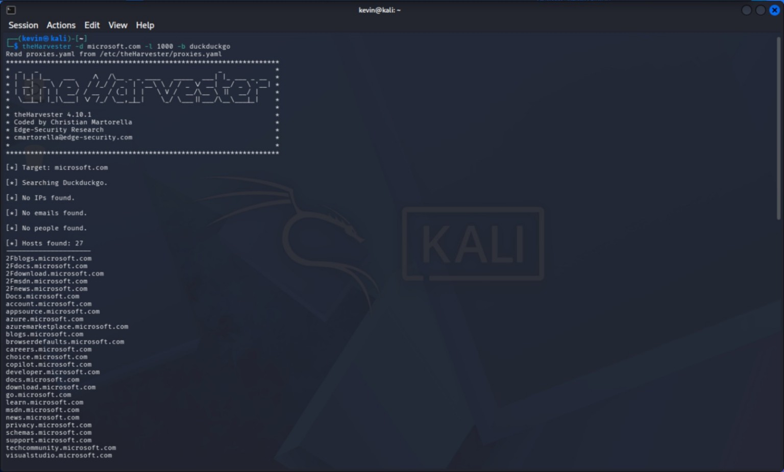
Figure 10 — theHarvester DuckDuckGo search output showing discovered hosts for microsoft.com.
Observation: The captured run targets microsoft.com (theHarvester -d microsoft.com -l 1000 -b duckduckgo), not networkwalks.com. It reports 27 hosts found (subdomains such as docs.microsoft.com, azure.microsoft.com, learn.microsoft.com, techcommunity.microsoft.com), with no IPs, emails, or people returned in this capture.
Methodology note — target mismatch: This screenshot demonstrates the tool's mechanics and the volume of subdomains a large, well-indexed organization returns, but it is not evidence collected against the assessment's actual target, networkwalks.com. Before final submission, this run should be repeated as: theHarvester -d networkwalks.com -l 500 -b duckduckgo (or a source combination per 4.3.1), and this section replaced with the networkwalks.com output for evidentiary consistency with PM1, PM2 and PM4. It is retained here, clearly labeled, to preserve an honest record of what was actually executed rather than fabricating results that were not run.
Risk: N/A — process/scope issue, not a security finding.

4.4 PM4 — Zenmap Network Scanning
PM4 focuses on Zenmap/Nmap host discovery within the demonstrated virtual lab network. The evidence includes the scan result and the corresponding topology visualization.

4.4.1 Zenmap — Scan Output
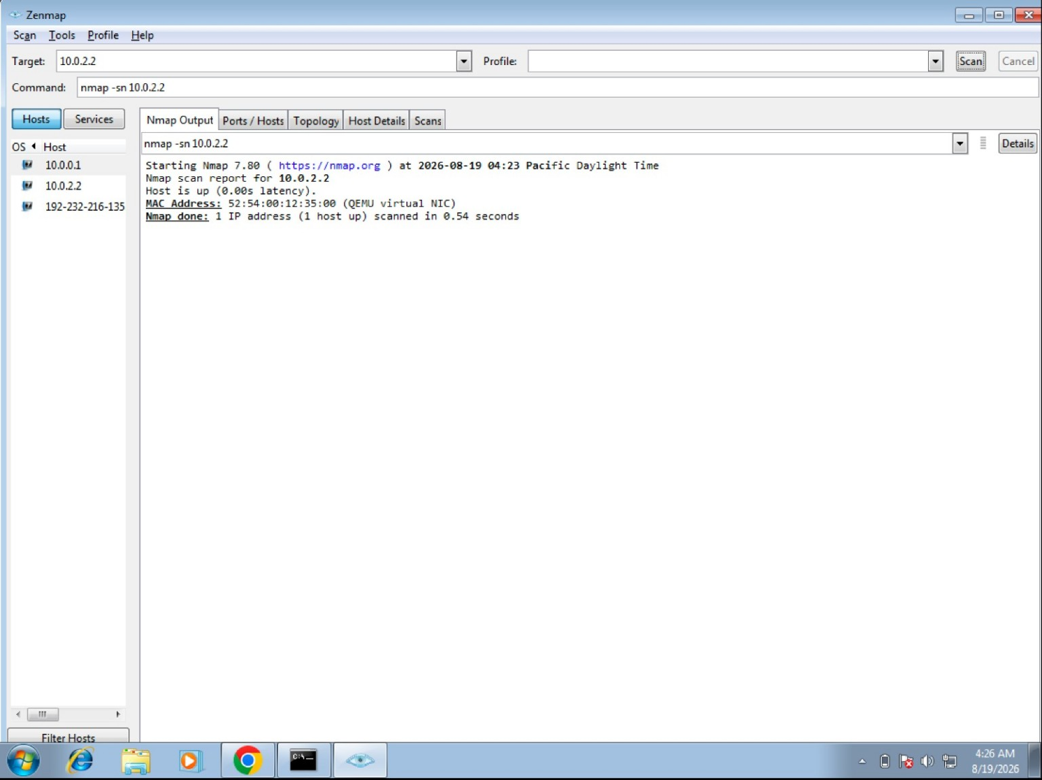
Figure 11 — Zenmap host-discovery scan against 10.0.2.2 showing the host as up.
Observation: An nmap -sn 10.0.2.2 ping-scan (host discovery, no port scan) reports the host is up with roughly 0.05 seconds latency and a QEMU virtual NIC MAC address (52:54:00:12:35:00), consistent with the target being the VM's hypervisor gateway rather than an external host.
Analysis: The -sn flag intentionally performs host discovery only (ARP/ICMP-style probing) without port scanning, which is the correct, least-intrusive first step of network reconnaissance — it answers 'what's alive' before committing to the noisier, more detectable step of port/service scanning. The QEMU NIC vendor prefix confirms this activity was performed inside a virtualized lab network (10.0.x.x is a standard NAT range for QEMU/VirtualBox), not against production infrastructure, which is appropriate given PM4's scope is local network discovery rather than external target scanning.
Risk: N/A — controlled lab activity.

4.4.2 Zenmap — Topology
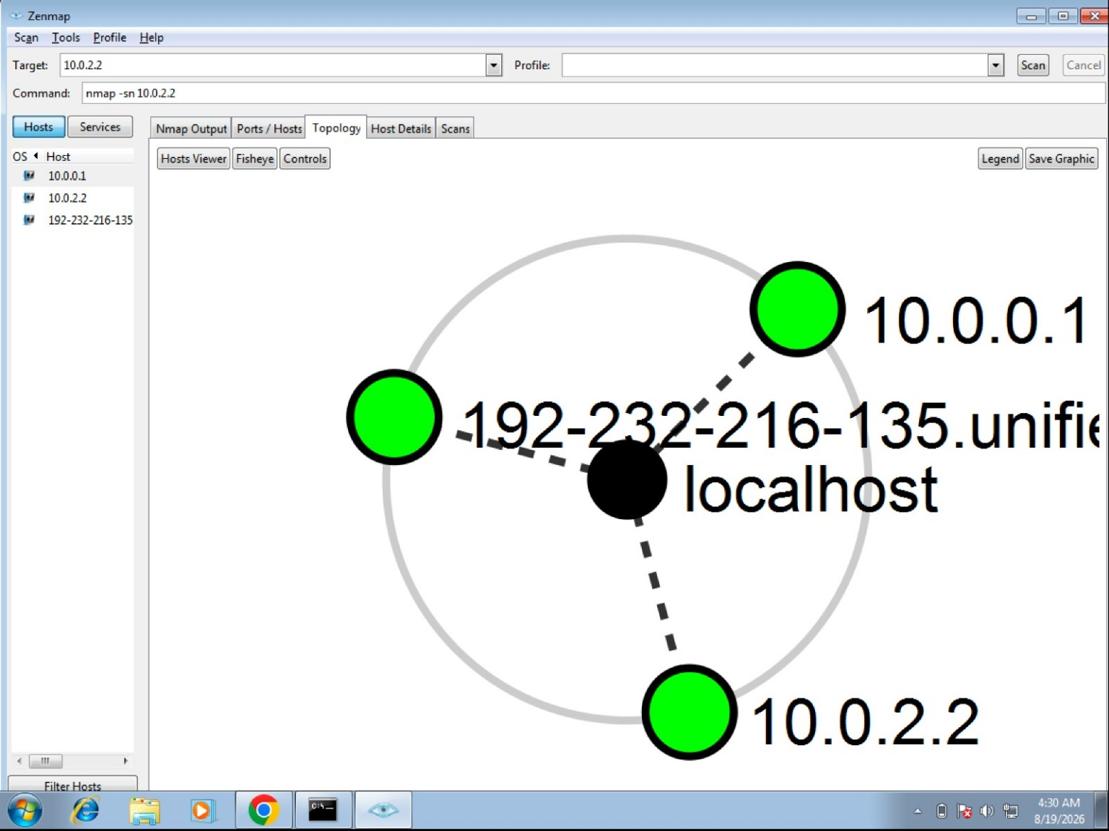
Figure 12 — Zenmap topology view showing the discovered virtual-network hosts.
Observation: The topology (Fisheye) view visualizes three hosts around the scanning localhost node: 10.0.0.1, 10.0.2.2, and a reverse-DNS-labeled host (192-232-216-135.unified...), all shown as up (green).
Analysis: Notably, one of the discovered hosts resolves to 192.232.216.135 — the same IP identified as networkwalks.com's A record in PM1 (Figures 1, 3, 5). This is a useful cross-module correlation: it shows the lab environment's routing table has a cached/known path to the target's IP, though this is a topology artifact of the lab network configuration rather than evidence of direct connectivity being tested against production. Zenmap's topology view is primarily useful for quickly distinguishing a flat network (all hosts one hop from the scanner, as shown here) from a segmented one; a flat topology in a real engagement would suggest weaker network segmentation between assets.
Risk: N/A — supports network-awareness documentation.

5. Security-Relevant Takeaways and Remediation Roadmap
The combined evidence demonstrates how different reconnaissance tools provide complementary views of the same environment: WHOIS supplies registration context; nslookup and DNSRecon expose DNS information; curl and WhatWeb reveal HTTP and technology characteristics; Wafw00f identifies a defensive web layer; Maltego correlates entities visually; theHarvester gathers publicly available host information; and Zenmap validates host visibility in the demonstrated lab network.
Area | Takeaway | Suggested Next Step
Domain / DNS | Public DNS and registration data reveal registrar, hosting, and mail infrastructure; DNSSEC is unsigned. | Enable DNSSEC; monitor WHOIS/DNS for unauthorized changes.
Web stack | HTTP headers and fingerprinting expose Apache + WordPress + a specific plugin (Download Manager). | Verify plugin patch level; confirm HSTS/CSP headers are enforced.
Defensive controls | ModSecurity WAF confirmed active behind a caching/CDN layer. | Periodically review WAF rule coverage; monitor for fingerprinting probes.
OSINT | Search-engine and graph-based tools correlate public social/media presence across multiple regions. | Track for brand-impersonation or lookalike-domain risk given regional footprint.
Network | Host discovery confirms reachable systems in the controlled lab network only. | Proceed to scoped, authorized port/service scanning in the next assessment phase.

5.1 Recommended Next Phase
Building on this reconnaissance baseline, the next assessment phase would typically include: (1) authorized service/port scanning of in-scope external hosts, (2) WPScan-style enumeration of the confirmed WordPress installation and its plugins/themes against CVE databases, (3) DKIM/DMARC verification alongside the SPF record already observed, and (4) re-running theHarvester against the correct target with certificate-transparency sources enabled to build a complete subdomain inventory.

6. Conclusion
The Week 2 practical work provides a structured reconnaissance workflow from domain-level information gathering through OSINT correlation and controlled network discovery. The included screenshots provide direct evidence for all four requested modules, and each finding has been assessed for its security significance rather than simply restated. GHDB is not included in this final structure, per assignment scope.
The single outstanding item before final submission is re-running theHarvester (PM3) against networkwalks.com to align that module's evidence with the rest of the report; the current microsoft.com capture is retained transparently as a record of the tool's mechanics rather than removed or misrepresented.
Final module sequence: PM1 — Footprinting Toolkit → PM2 — Maltego → PM3 — theHarvester → PM4 — Zenmap.

