1. Using OpenCV: OpenCV (Open Source Computer Vision) is an image and video processing library in Python. OpenCV is used for image and video analysis, such as image processing, AI image recognition, etc.,
2. This example Python program illustrates how the program read and display an image.

Explanation:

* Line 1: import the “cv2” (OpenCV library).
* Line 3: Define “img” to be cv2.read(‘image.jpg’, IMREAD_GREYSCALE) . The default is “IMREAD_COLOR”. Rather than using IMREAD_COLOR etc., simple numbers can be used -1 for original, 0 for greyscale, or 1 for color. For greyscale,

“img = cv2.imread(‘image.jpg’, 0)” can be used instead.

* Line 4: Once the image is loaded, “cv2.imshow(title,image)” is used to show the image.
* Line 5: “cv2.waitKey(0)” is to wait until any key is pressed.
* Line 6: Once any key is pressed, using “cv2.destroyAllWindows()” close the image window on the screen.

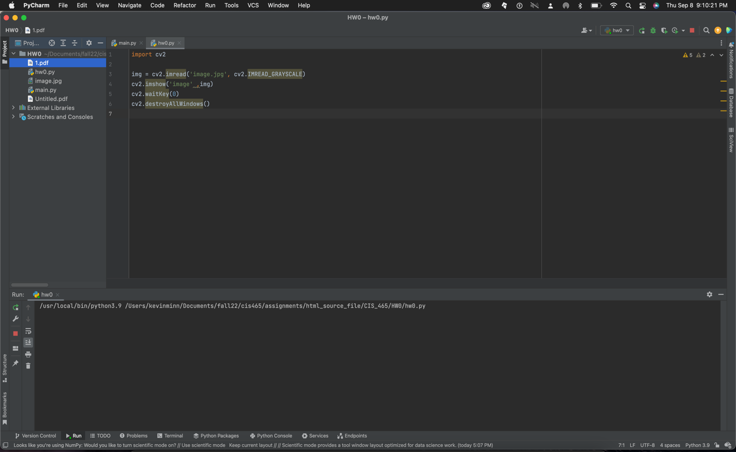

Output:

Before running the program.

After Running the program:

