REPORT WEEK 1

The uart rate is 115200. the uart packet is 1 start bit 8 data bit and 1 stop bit. So there are 10 bits. Thus the data we receive is 8 data bits at rate of 11520. so we can take that as a sampling rate. The cutoff freq should be less than half of sampling rate considering nyquist rate. So we can consider here about 2khz as cutoff freq. We need to normalise it to create the filter it is fc/(fs/2) which is .347.

since data bit is of 8 bit lets say the first bit is sign bit thus we can represent it from -128 to +127.
the window funciton of the fir filter here considered is rectangular. And also considered q1.7 quantization because the coefficients lies in the range of that. Here 1 is sign bit and the other 7 is fractional part. -1 to 0.9921875. 10000000 2’s complement is -1.

so while desinging a filter we will multiply our 8 bit data with this coefficients which will cause it to be 16 bits and because we are having tap16 then there would be additions too. So we can make a head room of 4 bits and make the bits as 20 bits. We then need to quantise it back to q1.7 format to sent it back.
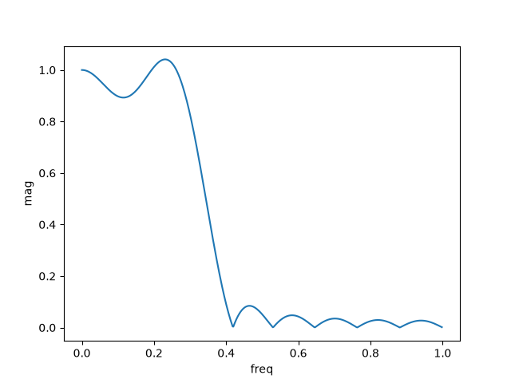

Chosen coeff from python code is
[ 0.0381763 0.03360314 -0.01538393 -0.06590199 -0.05407423 0.04871123 0.20114767 0.31372181 0.31372181 0.20114767 0.04871123 -0.05407423 -0.06590199 -0.01538393 0.03360314 0.0381763 ]

Rectangular
taps 16
ORDER N=15

