Numpy model values
import numpy as np
from quantise_fun import quantise
from scipy.signal import firwin, lfilter
import matplotlib.pyplot as plt

numtaps =16

cutoff_freq = 2000
fs=10000
cutoff=cutoff_freq/(fs/2)

coefficients = firwin(numtaps, cutoff,window='rectangular',pass_zero=True)
# what firwin is doing is that it is first calculate the ideal impulse reponce of what we nee
# then it woudl shift it to make it causal and then to truncate the sinc fucntion it multiply it with the window
# and then give the coefficients of the discreate signal created that are its values

print(coefficients)

quantise_value=[quantise(i) for i in coefficients]
print("quantised value",quantise_value)

x = np.array([1,2,3,4,5])
y_numpy = np.convolve(x, quantise_value)

print("numpy model values",y_numpy)
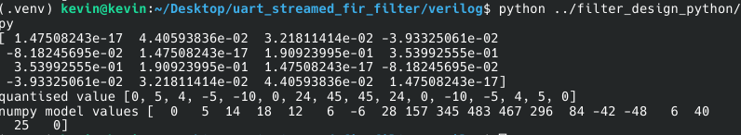
Verilog Code
index.v
//taps = 16
//order =15

module filter (
input wire clk,
input wire rstn,
input wire signed [7:0] sig,
output wire signed [19:0] samp_op,
output wire signed [7:0] trunc_op
);

//assume the sig is q1.7

wire signed [7:0] coeff [0:15];
reg signed [7:0] signal[0:15];
wire signed [15:0] res[0:15];

assign coeff[0] = 8'sd0;
assign coeff[1] = 8'sd5;
assign coeff[2] = 8'sd4;
assign coeff[3] = -8'sd5;
assign coeff[4] = -8'sd10;
assign coeff[5] = 8'sd0;
assign coeff[6] = 8'sd24;
assign coeff[7] = 8'sd45;
assign coeff[8] = 8'sd45;
assign coeff[9] = 8'sd24;
assign coeff[10] = 8'sd0;
assign coeff[11] = -8'sd10;
assign coeff[12] = -8'sd5;
assign coeff[13] = 8'sd4;
assign coeff[14] = 8'sd5;
assign coeff[15] = 8'sd0;

integer i;
always @(posedge clk or negedge rstn) begin

if(!rstn) begin
for(i=0;i<16;i=i+1)begin
signal[i]<=8'sd0;
end
end else begin
for(i=15;i>0;i=i-1) begin
signal[i]<=signal[i-1];
end
signal[0]<=sig;
end

end

genvar k;
generate

for(k=0;k<16;k=k+1) begin: gen
mul ml(

.delsig(signal[k]),
.coeff(coeff[k]),
.res(res[k])

);

end

endgenerate
wire signed [19:0] sum;

assign sum = res[0] + res[1] + res[2] + res[3] +
res[4] + res[5] + res[6] + res[7] +
res[8] + res[9] + res[10] + res[11] +
res[12] + res[13] + res[14] + res[15];

wire signed [19:0] rounded_sum;
assign rounded_sum = sum + 20'sd64;

wire signed [12:0] scaled_sum;
assign scaled_sum = rounded_sum >>> 7;

reg signed [7:0] final_trunc;

always @(*) begin

if (scaled_sum > 13'sd127) begin
final_trunc = 8'sd127;

end else if (scaled_sum < -13'sd128) begin
final_trunc = -8'sd128;

end else begin
final_trunc = scaled_sum[7:0];
end
end

assign samp_op = sum;
assign trunc_op = final_trunc;
endmodule

module mul(

input signed [7:0] delsig,
input signed [7:0] coeff,
output signed [15:0] res

);

assign res=coeff*delsig;

endmodule

TESTBENCH CODE
`timescale 1ns / 1ps

module tb_index;

reg clk;
always #(5.0) clk = ~clk;

reg rst_n = 1'b0;

// ---- Shared DUT input signals (reg) ----
reg rstn;
reg [7:0] sig;

// ---- Shared DUT output signals (wire) ----
wire [19:0] samp_op;
wire [7:0] trunc_op;
reg signed [7:0] x_input [0:4];
// ---- DUT: filter (u_filter) ----
filter u_filter (
.clk ( clk ),
.rstn ( rstn ),
.sig ( sig ),
.samp_op ( samp_op ),
.trunc_op ( trunc_op ));

initial begin
$dumpfile("tb_index.vcd");
$dumpvars(0, tb_index);
end
integer i;
initial begin

clk=0;
rstn=0;
sig=8'sd0;

x_input[0] = 8'sd1;
x_input[1] = 8'sd2;
x_input[2] = 8'sd3;
x_input[3] = 8'sd4;
x_input[4] = 8'sd5;

#15 rstn=1;

for (i = 0; i < 21; i = i + 1) begin
@(posedge clk);
if (i < 5)
sig <= x_input[i];
else
sig <= 8'sd0;

#1;
$display("cycle = %d sig = %d samp_op = %d trunc_op = %d", i + 1, sig, $signed(samp_op), $signed(trunc_op));
end
#20;
$finish;
end

endmodule

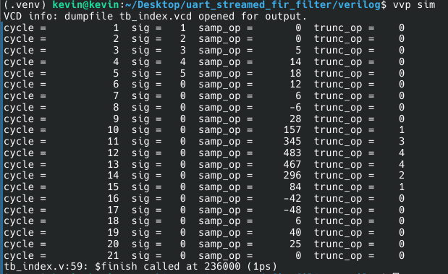
the numpy model and the created rtl code filter output matches

IMPULSE RESPONCE OP OF PYTHON AND VERILOG IMPLEMENTATION

