REPORT WEEK 3

In the week 2 I created the fir filter and verified it using verilog testbench.
The target of this week is to code and simulate uart rx and tx modules and integrate rx to fir to tx with proper handshaking.

So first i planned to create the uart implementation.
For that i decieded to create 3 modules
- baud rate generator
- rx
- tx
- uart top module

Baud Rate Generator

The fpga i am having have a internal clock signal of 12mhz. I need to create a uart communication of baud rate 115200. so that is it would send 115200 bits per second. Since while recieving a bit we must sample it multiple times in order to verify if it is a glitch or is it actually a bit. For that i decided to use take 5 samples and check for the majority vote case. Since the 5 samples i should take should be on the center of the bits recievign i planned to sample the bits 16 times and take the center 5 samples and check for majority votes.

Since i need 16 samples per bit i need to generate another clock of 115200*16. so i can sample every bit 16 times.
What i did is that we know number of cycles=freq x time. I have a clock freq 12mhz and i need another clock of 115200x16. So t=1/f. 12mhz/(115200x16) give number of clock cycles. Which is 6.5.

So i 6.5 clock cycles to generate that freq. But 6.5 is not possible i need a integer. So i created a accumulator register and on every posedge of clk it would add 115200x16 to it and then if the accumulator value is greater than 12000000-115200x16 that is it would overflow if another posedge occurs then i would assign accumulator register to be the current value + 115200x16 -12000000. that is essentially like taking the overflow value and resetting the overflow value to a new reg. And producing a tick when the overflow occuring. This would maintain the shift occuring by making it 6 clock cycle some time and 7 clock cycle some time maintiainging the baudratex16 pulses.

Verilog code

module baud_generator(
input clk,
input rstn,
output reg tick
);
localparam system_clk=12_000_000;
localparam baud_rate=115200;
localparam rx_needed=(baud_rate*16);
reg [23:0] acc_rx=24'd0;
always @(posedge clk) begin
if (!rstn) begin
tick <= 1'b0;
acc_rx <= 24'd0;
end
else begin
tick <= 1'b0;
if(acc_rx>=system_clk-rx_needed) begin
tick<=1'b1;
acc_rx<=acc_rx+rx_needed-system_clk;
end
else begin
acc_rx<=acc_rx+rx_needed;
end
end
end
endmodule

I decided to verify it using python cocotb verification test bench
The plan was that to see if the tick is occuing for 6 cycles and 7 cyles

import cocotb
from cocotb.clock import Clock
from cocotb.triggers import RisingEdge, ReadOnly

@cocotb.test()
async def test_baud_generator(dut):
cocotb.start_soon(Clock(dut.clk, 83.33, units="ns").start())
dut.rstn.value=0
await RisingEdge(dut.clk)
dut.rstn.value=1
for i in range(3):
count=0
while True:
await RisingEdge(dut.clk)
await ReadOnly()
count=count+1
if(dut.tick.value==1):
break

dut._log.info(f"tick {i} fired with count {count}")
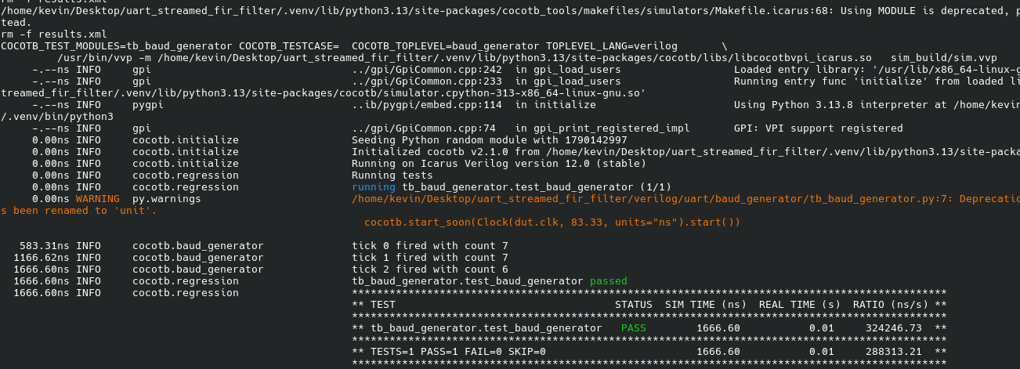

RX module

the rx module have basically 5 stages
- IDLE stage
it waits for the rx signal to go low. When the rx signal goes low the data transfer actualy begins. So the state will goes to START stage when the rx goes low
- START stage
in this stage since we have the tick pulse 16 times per bit. I looked at the 7th bit if that is actually 1 or 0. then if it is 0 go to the data stage or else go to the idle state since it might be a glitch. Only transition to the next state once the rx_tick_cnt=15 since we are generating tick 16 times right
- DATA stage
in this stage create a counter to count for 8 data bits and for each data bits we sample when tick is from 6 to 10 and count for the majority vote. If majority value is 1 that is known by adding a vairable by 1 everytime the value is 1. thus if vairable is = or greater than 3 the data is 1 or else it is 0. then shift the data to a data reg.
- STOP stage
after the data is recieved it moves to stop stage in that we smaple the 7th bit if it is still low then it is error and moves to error stage else moves to idle stage making the ready_signal 1. that is bit recieved successfully for 1 cycle.
- ERROR stage.
We move to the idle stage only when the rx goes to high and tick cnt counts till 15

Verilog Code

module rx (
input clk,
input rstn,
input rx_tick,
input read_clear,
input rx,
output ready,
output [7:0] data_out
);

localparam [2:0]
RX_IDLE = 3'd0,
RX_START = 3'd1,
RX_DATA = 3'd2,
RX_STOP = 3'd3,
RX_ERROR = 3'd4;

reg start_valid = 1'b0;
reg stop_valid = 1'b0;
reg [2:0] rx_state = RX_IDLE;
reg [3:0] rx_tick_cnt = 4'd0;
reg rx_sync_1 = 1'b1;
reg rx_sync_2 = 1'b1;

reg [2:0] sampling = 3'd0;
reg [3:0] data_cnt = 4'd0;
reg [7:0] data = 8'd0;
reg ready_reg = 1'b0;

assign ready = ready_reg;
assign data_out = data;

//to prevent metastability
always @(posedge clk) begin
rx_sync_1 <= rx;
rx_sync_2 <= rx_sync_1;
end

// Main FSM
always @(posedge clk) begin
if (!rstn) begin
rx_state <= RX_IDLE;
rx_tick_cnt <= 4'd0;
data_cnt <= 4'd0;
sampling <= 3'd0;
start_valid <= 1'b0;
stop_valid <= 1'b0;
ready_reg <= 1'b0;
end else begin

if (read_clear) begin
ready_reg <= 1'b0;
end

case (rx_state)

RX_IDLE: begin
start_valid <= 1'b0;
stop_valid <= 1'b0;
rx_tick_cnt <= 4'd0;
data_cnt <= 4'd0;
if (!rx_sync_2) begin
rx_state <= RX_START;
end
end

RX_START: begin
if (rx_tick) begin
rx_tick_cnt <= rx_tick_cnt + 4'd1;

if (rx_tick_cnt == 4'd7) begin
if (!rx_sync_2) begin
start_valid <= 1'b1;
end
end

if (rx_tick_cnt == 4'd15) begin
if (start_valid) begin
rx_state <= RX_DATA;
sampling <= 3'd0;
data_cnt <= 4'd0;
rx_tick_cnt <= 4'd0;
end else begin
rx_state <= RX_IDLE;
end
end
end
end

RX_DATA: begin
if (rx_tick) begin
rx_tick_cnt <= rx_tick_cnt + 4'd1;
if (rx_tick_cnt <= 4'd5) sampling <= 3'd0;

if (rx_tick_cnt == 4'd6) sampling <= sampling + rx_sync_2;
if (rx_tick_cnt == 4'd7) sampling <= sampling + rx_sync_2;
if (rx_tick_cnt == 4'd8) sampling <= sampling + rx_sync_2;
if (rx_tick_cnt == 4'd9) sampling <= sampling + rx_sync_2;
if (rx_tick_cnt == 4'd10) sampling <= sampling + rx_sync_2;

if (rx_tick_cnt == 4'd15) begin

if (sampling >= 3'd3) begin
data <= {1'b1, data[7:1]};
end else begin
data <= {1'b0, data[7:1]};
end

data_cnt <= data_cnt + 4'd1;
sampling <= 3'd0;

if (data_cnt == 4'd7) begin
rx_state <= RX_STOP;
end
end
end
end

RX_STOP: begin
if (rx_tick) begin
rx_tick_cnt <= rx_tick_cnt + 4'd1;

if (rx_tick_cnt == 4'd7) begin
if (rx_sync_2) begin
stop_valid <= 1'b1;
end
end

if (rx_tick_cnt == 4'd15) begin
if (stop_valid) begin
rx_state <= RX_IDLE;
ready_reg <= 1'b1;
end else begin
rx_state <= RX_ERROR;
end
end
end
end

RX_ERROR: begin
if (rx_tick) begin
rx_tick_cnt <= rx_tick_cnt + 4'd1;

if (rx_tick_cnt == 4'd15 && rx_sync_2) begin
rx_state <= RX_IDLE;
end
end
end

default: rx_state <= RX_IDLE;

endcase
end
end

endmodule

TX Module
it consist of 4 stages IDLE,START,DATA,STOP
- IDLE
it is sending the tx high pulse. Stay at this stage till the enable pulse comes.
- START
start sending the start pulse. Count for 16 pulses and send the low state for that. That is the start stage
- DATA state
for each data bit count till 15 and using shift register shift the data to send and using a ocunter send the 8 bit data one by one.
- STOP state
this state is the high state for 15 ticks.

module tx (
input clk,
input rstn,
input tx_tick,
input enable,
input [7:0] data,
output tx,
output busy
);

reg tx_reg = 1'b1;
assign tx = tx_reg;
assign busy = (tx_state != TX_IDLE);

localparam [1:0]
TX_IDLE = 2'd0,
TX_START = 2'd1,
TX_DATA = 2'd2,
TX_STOP = 2'd3;

reg [1:0] tx_state = TX_IDLE;
reg [7:0] tx_data_reg = 8'd0;
reg [2:0] bit_cnt = 3'd0;
reg [3:0] tick_cnt = 4'd0;

reg tx_sync_1 = 1'b0;
reg tx_sync_2 = 1'b0;

always @(posedge clk) begin
tx_sync_1 <= enable;
tx_sync_2 <= tx_sync_1;
end

always @(posedge clk) begin
if (!rstn) begin
tx_state <= TX_IDLE;
tx_reg <= 1'b1;
tx_data_reg <= 8'd0;
bit_cnt <= 3'd0;
tick_cnt <= 4'd0;
end else begin
case (tx_state)

TX_IDLE: begin
tx_reg <= 1'b1;
tick_cnt <= 4'd0;
bit_cnt <= 3'd0;
if (tx_sync_2) begin
tx_state <= TX_START;
tx_data_reg <= data;
end
end

TX_START: begin
tx_reg <= 1'b0;
if (tx_tick) begin
if (tick_cnt == 4'd15) begin
tick_cnt <= 4'd0;
tx_state <= TX_DATA;
end else begin
tick_cnt <= tick_cnt + 4'd1;
end
end
end

TX_DATA: begin
tx_reg <= tx_data_reg[0];
if (tx_tick) begin
if (tick_cnt == 4'd15) begin
tick_cnt <= 4'd0;
tx_data_reg <= tx_data_reg >> 1;
if (bit_cnt == 3'd7) begin
bit_cnt <= 3'd0;
tx_state <= TX_STOP;
end else begin
bit_cnt <= bit_cnt + 3'd1;
end
end else begin
tick_cnt <= tick_cnt + 4'b1;
end
end
end

TX_STOP: begin
tx_reg <= 1'b1;
if (tx_tick) begin
if (tick_cnt == 4'd15) begin
tick_cnt <= 4'd0;
tx_state <= TX_IDLE;
end else begin
tick_cnt <= tick_cnt + 4'd1;
end
end
end

default: tx_state <= TX_IDLE;

endcase
end
end

endmodule

UART TOP MODULE

created by just connecting those pins of each moduel
module uart(

input clk,
input rstn,

input tx_enable,
input [7:0] data,
output tx,
output busy,

input read_clear,
input rx,
output ready,
output [7:0] data_out

);

wire tick;

baud_generator bg(

.clk(clk),
.rstn(rstn),
.tick(tick)

);

tx tx1(

.clk(clk),
.rstn(rstn),
.tx_tick(tick),
.enable(tx_enable),
.data(data),
.tx(tx),
.busy(busy)

);

rx rx1(

.clk(clk),
.rstn(rstn),
.rx_tick(tick),
.read_clear(read_clear),
.rx(rx),
.ready(ready),
.data_out(data_out)

);

endmodule

TESTED the uart moduel by connecting the tx pin to rx pin and verify if the transmitteed byte is displaying or not.
import cocotb
from cocotb.clock import Clock
from cocotb.triggers import RisingEdge, ClockCycles

@cocotb.test()
async def test_uart_loopback(dut):

cocotb.start_soon(Clock(dut.clk, 83.33, unit="ns").start())

dut.rstn.value=0
dut.tx_enable.value=0
dut.data.value=0
dut.read_clear.value=0
dut.rx.value=1

await ClockCycles(dut.clk,5)
dut.rstn.value=1
await ClockCycles(dut.clk,5)

byte=0x10
dut.data.value=byte
dut.tx_enable.value=1

await RisingEdge(dut.clk)
dut.tx_enable.value=0
dut._log.info(f"tx byte {byte}")
timeout_counter=0
max_cnt=2000

while int(dut.ready.value)==0:
await RisingEdge(dut.clk)

dut.rx.value = int(dut.tx.value)
timeout_counter+=1
assert timeout_counter<max_cnt, "timeout occured"

recieved_data=int(dut.data_out.value)
dut._log.info(f"recieved {recieved_data}")
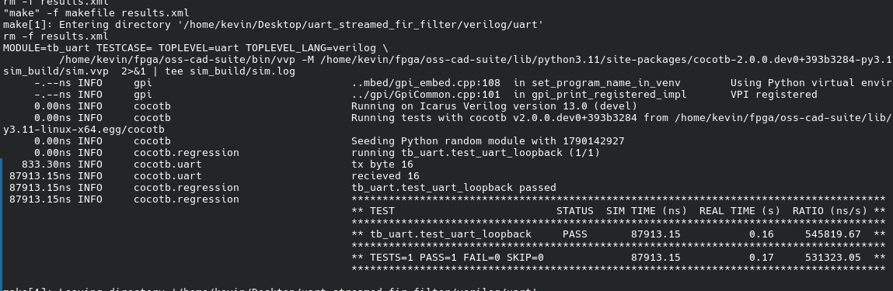
here verified send 16 and recieved bit 16 too.

FILTER TOP MODULE
before that i added a enable in filter module. Because i need to make the filter process only when i needed not like on a clock edge.
module uart_with_filter (
input wire clk,
input wire rx,
output wire tx,
input wire btn1_n
);

wire rx_ready;
wire [7:0] rx_byte;
wire [7:0] filtered_byte;
wire tx_busy;

reg tx_enable = 1'b0;
reg read_clear = 1'b0;
reg [7:0] tx_byte = 8'd0;

reg filter_en = 1'b0;
reg pending_tx = 1'b0;

reg rst_n_sync1, rst_n;
always @(posedge clk) begin
rst_n_sync1 <= btn1_n;
rst_n <= rst_n_sync1;
end

uart uart0 (
.clk (clk),
.rstn(rst_n),
.tx_enable (tx_enable),
.data(tx_byte),
.tx (tx),
.busy(tx_busy),
.read_clear (read_clear),
.rx (rx),
.ready(rx_ready),
.data_out (rx_byte)
);

filter filter0 (
.clk(clk),
.rstn(rst_n),
.en(filter_en),
.sig(rx_byte),
.samp_op(),
.trunc_op (filtered_byte)
);

always @(posedge clk)
if (!rst_n) begin
tx_enable <= 1'b0;
read_clear <= 1'b0;
filter_en <= 1'b0;
pending_tx <= 1'b0;
tx_byte <= 8'd0;
end else
begin
tx_enable <= 1'b0;
read_clear <= 1'b0;
filter_en <= 1'b0;

if (rx_ready && !tx_busy && !pending_tx) begin
filter_en <= 1'b1;
read_clear <= 1'b1;
pending_tx <= 1'b1;
end

else if (pending_tx) begin
tx_byte <= filtered_byte;
tx_enable <= 1'b1;
pending_tx <= 1'b0;
end
end

endmodule

i programmed the board with that and send the data and revied using python serial communication

import serial
import time
ser = serial.Serial('/dev/ttyUSB1', 115200, timeout=1)
time.sleep(0.1)

X = [60,70,80,90,100]
ser.write(bytes(X))
response = ser.read(len(X))
received_dec = [b for b in response]
print(f"Sent: {X}")
print(f"Received : {received_dec}")

print(len(received_dec))
print(len(X))

here timeout means it would wait atmost 1sec for data
programed the baord using apio build and upload then the output of the python is

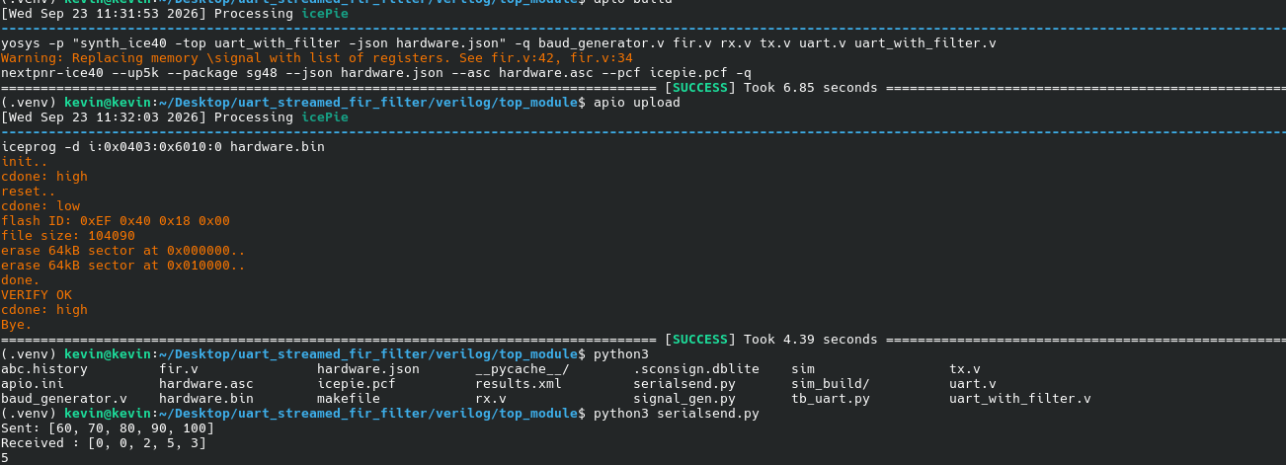
which is verified using python convolution function and trucating
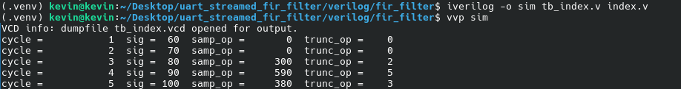
this is output from the fir filter last week.

