CSS: Frameworks: Bootstrap Introduction

Last updated: 10/19/2016

Introduction

Bootstrap is a CSS framework. The Bootstrap download (like most CSS frameworks) includes:

* Pre-defined styles for:
  + Typography
  + Forms
  + Navigation
  + And more
* Pre-built UI components
  + Navigation bars
  + Buttons
  + Dialog boxes
  + Much more
* Framework
  + Grid system

The minimal Bootstrap download will include the following directories:

* CSS
  + Contains the predefined styles
  + Minified version of the Bootstap CSS file
* JavaScript
  + Contains the files required for UI component support
* Fonts
  + Contains the glyphicons

Bootstrap summary

* Open-source with an MIT license
* Responsive by design
* Created by Twitter and first released in August 2011
* At version 3.3.6 as of this publication date (4.0.0 alpha 2)
* Contains source code in SASS (some versions use both LESS and SASS)

There are several advantages to adopting a known CSS framework. First of all, the CSS styles required for implementing responsive features including layout, tables, images, etc. are provided in the framework. Therefore, the developer is not starting from ground zero, but is, instead, applying pre-built styles to achieve the sites inherit responsiveness. In addition, depending on the framework chosen, a certain amount of cross-platform, cross-browser and even cross-device testing devices may already have taken place. Thus the developer can build with confidence knowing that the framework has been tested on a range of browsers and devices. Other advantageous features of a CSS framework are the extra styles that come with the framework. Mobile optimized buttons and form controls are often built into the framework. These styles can be used “as is” or they can be modified to comply with the enterprise branding rules for colors, fonts, etc. Many developers choose to implement frameworks for professional looking “out-of-the-box” prototypes and then modify the CSS after the prototype or mockup has been approved.

The usual vetting process should take place when selecting a responsive framework. This process typically involves selecting a short list of frameworks based on the frameworks feature set and your site objectives. Another step might be analyzing the Github traffic on the framework itself. For example, how many times has it been forked? When was it most recent contribution made? How many developers contribute? Etc. In addition, the vetting process should include checking out the frameworks home page (if there is one). Have other large enterprises (e.g. Linked In, Yahoo, other Fortune 500 type companies) implemented the framework. Doe is include any endorsements.

Some popular CSS responsive frameworks include:

* Bootstrap
* Foundation
* Fluid 960
* Blueprint

This section will provide an overview of the popular Bootstrap framework (formerly Twitter Bootstrap). This overview will include downloading the framework, the steps required to use the framework and an examination of some of the included example files as well as a review of the fundamental CSS principles at work in the framework and its provided styles.

Download the framework is as simple as visiting http://getbootstrap.com or at Github at https://github.com/twbs/bootstrap. You can place the download anywhere you wish, but will need to put the necessary files in your sites root folder. For example, you will need to move the .css files from the downloaded framework into your website or applications CSS folder.

Using the framework involves a few steps which are outlined below.

Build or open your starter template for a standard HTML page skeleton

In the <head> section, add a link to the bootstrap CSS files you downloaded

<link href=”css/bootstrap.css” rel=”stylesheet” media=”screen”>

<link href=”css/bootstrap-responsive.css” rel=”stylesheet” media=”screen”>

Use the frameworks’ provided styles to achieved the desired layout

In the <head> section, insert a link to the jQuery library

<script src=”http://code.jquery.com/jquery-latest.min.js” ></script>

Below the closing </body> element in the HTML, add a link to the bootstrap.js file

<script src=”js/bootstrap.js”></script>

You will need to understand some of the basic CSS principles at work in the frameworks provided styles. These include the CSS box model that was introduced in the section “Responsive Design Fundamentals”, the CSS reset that was introduced in the same section and the CSS properties known as “clear” and “float” which will be addressed in the next set of demonstrations and exercises.

Guided Exercise: Acquiring the Bootstrap framework

There are several ways to install Bootstrap and begin a project.

From the command line, you can use a package manager like npm.

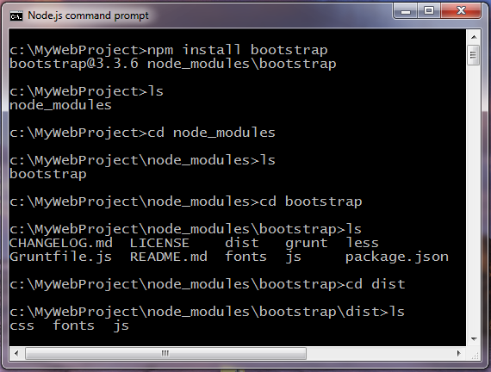

Command to install Bootstrap with the node package manager.

From an IDE, like WebStorm you can create a new project.

The WebStorm New Project dialog box.

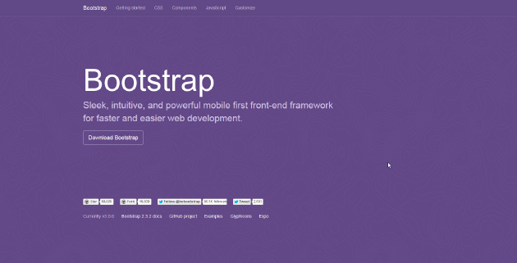Download from the framework from the getbootstrap.com website

The Bootstrap website at <http://getbootstrap.com>

Step 1 Open a web browser and visit http://getbootstrap.com/.

Note At publication time the latest version was Bootstrap 3.3.6. You may download it if you wish, but this file has already been downloaded and can be found in your data files in the “bootstrap-3.3.6-dist” folder.

Step 2 If you do not wish to use the supplied library from the “bootstrap-3.3.6-dist” folder in the data files you may click the “Download Bootstrap” button and continue the download process.

Practice Exercise: Install Bootstrap from nodejs

Setup

Nodejs and npm are installed (see <https://nodejs.org/en/> to install both nodejs and npm)

Nodejs command prompt is open.

Step 1 Use the nodejs command prompt to create a directory on your root drive and name it bootstrap-test.

Step 2 Install Bootstrap from nodejs

Practice Exercise: Download Bootstrap from the website

Step 1 Create a directory on your root drive and name it bootstrap-download-test.

Step 2 Download Bootstrap into the new directory using the website <http://getbootstrap.com>

Resources

http://getbootstrap.com