**Stok Barang**

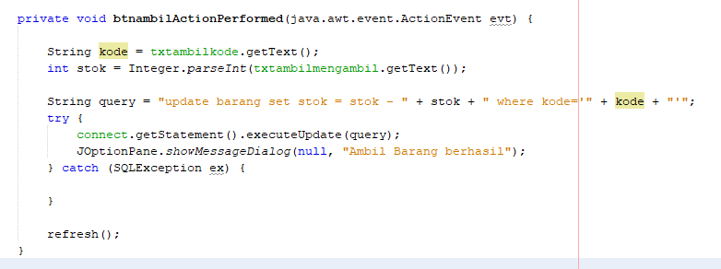

**Audio Player**

**HTTP Get**

**HTTP Post**

**Aplikasi Chatting**

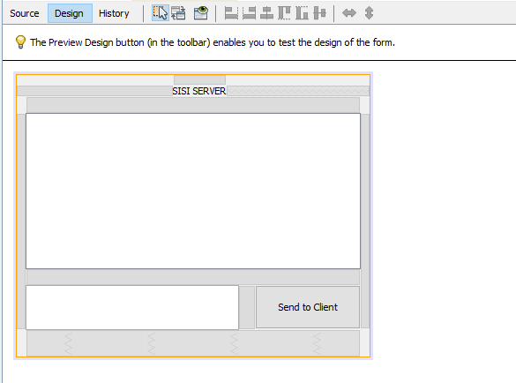

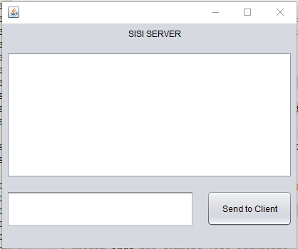

**Pertanyaan 1**

**Pertanyaan 2**

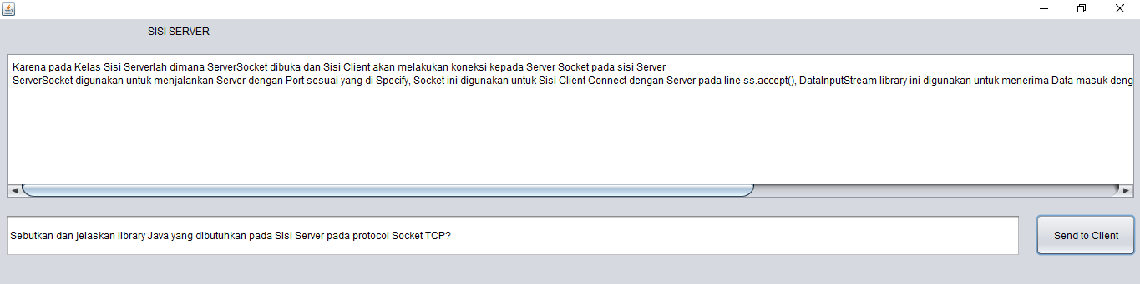

**Pertanyaan 3**

