First user: current Berkeley student majored in Economics

He complained about YouTube mobile app in several aspects.

First is there is no loop play option for videos. He likes to listening to music on YouTube while doing homework but he has to click replay every time when the video ends if he wants to listen to it again.

Second is he cannot continue watching a video easily. He has to search it again or find it in his history. He does not want to add a lot of videos in his playlist too. Thus he wants to find a way to continue watching a particular video easily.

Second user: current Berkeley student majored in Art

She sometimes wants to fix the typos and other mistakes in her tweets but she has to delete the tweets and then retweets.

When she looks for place for meal on Yelp, the ratings can be misleading. Some restaurants are bad at first but improves a lot since then. But the ratings can only reflect how good the restaurant is during the entire time. She has to read the latest reviews or click to see the details of the change of the ratings to get an idea of the rating of the restaurants now.

Another misleading aspect of ratings is that some restaurants have very high ratings but small number of reviews which means not a lot of people went there and thus the ratings cannot reflect how most people judge the restaurant.

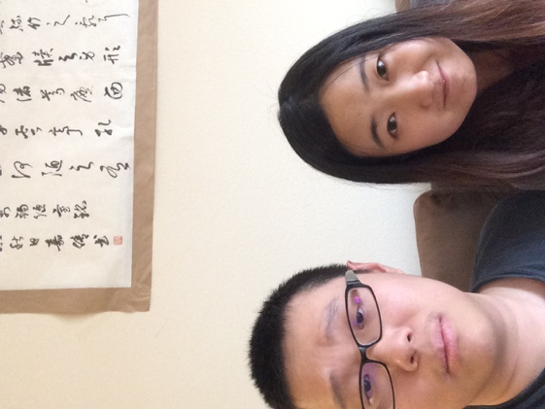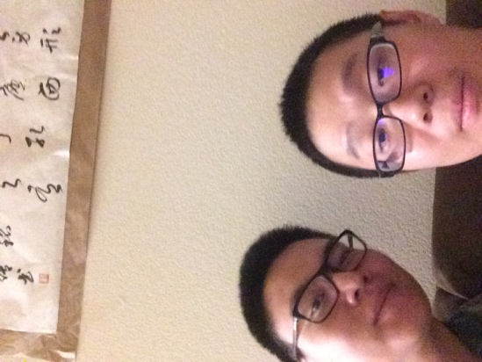

Brainstorming

For YouTube loop play mode option:

I can add loop play mode option in the settings of YouTube app to allow user to change the play mode based on their preferences.

I can add loop play mode option in the right bottom corner of the video together with other already existing options so that users can change the play mode quickly.

I can include more play modes such as random play to give users more choice, just like most music apps.

For YouTube continue watching problems:

I can put a continue watching button in the bottom menu.

I can move the bottom menu to the left side to allow more space for different features including continue watching feature.

I can add a continue watching section in the homepage together with other videos.

I can simply put the last video that the user watch at the top of the homepage.

For twitter:

Add spell checking and auto correction when people write tweets.

Allow tweet editing after people tweeted so that they do not have to delete and retweet.

Allow tweet editing for only 10 minutes after people tweeted so that they can correct obvious mistakes.

For Yelp reviews:

Alongside with the overall ratings, add recent ratings that reflect how people think about the restaurant recently.

Allow the search results to be sorted by number of reviews and then ratings.

I choose the third idea of YouTube continue watching problems: add a continue watching section in the homepage.

Prototype:

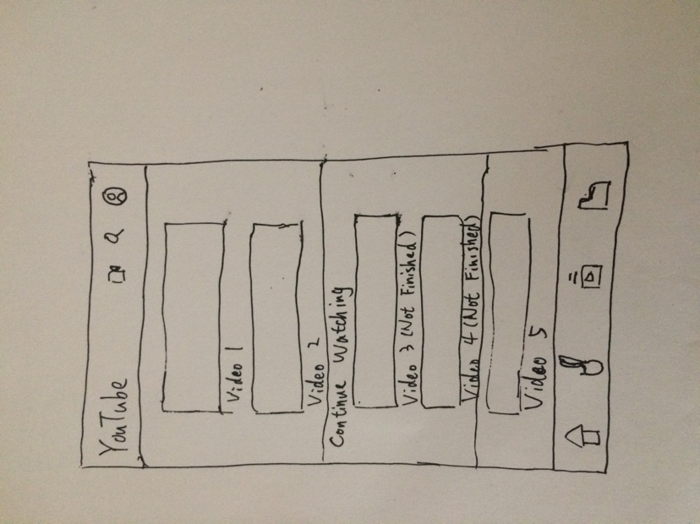

On the homepage, most videos are presented in the same way as the original YouTube app. But a continue watching section is inserted into theses videos. It contains two last videos that the user does not finish watching. I do not want to put too many videos in this sections because of space limit. Most time user is watching new videos on YouTube after all. The menus at the top and bottom remains the same.

Feedback:

I test the prototype with the user. User thinks this prototype can solve his problem. But he thinks it can still be improved further. Some advice are listed below:

Continue watching section can be changed into a horizontal list. User can scroll from left to right to view videos that he does not finish watching. This will allow more videos in the section and more space for other videos in the homepage.

Another advice is that continue watching section can be put at the top of the page so that users can access these videos faster.

Also there should be an option in the settings to enable or disable this section.