Design 02

Evaluating the Duolingo App on IPhone, which is a mobile App for people to learn new languages.

1. H-3: User control and freedom.

Users can add courses in the top menu and switch between them. But if they make a mistake when adding courses or they just don’t want to learn that language anymore, there is no option to remove that course.

S-2: minor.

It can be quite annoying when there is a course in the top menu that the user doesn’t want to learn. But this issue doesn’t affect the utilities of the App.

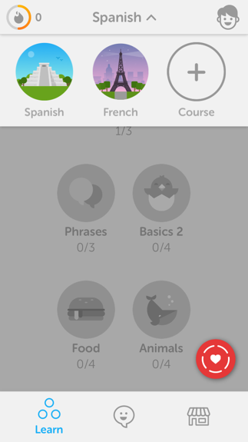

2. H-3: User control and freedom.

Users cannot save their progress during a lesson. When they quit, they will lose all the progress in this lesson.

S-3: major.

Users have to learn the lesson from the start if they have to leave to do something else during the lesson. This issue will cause users to learn the same thing for several times. An option to save progress is necessary.

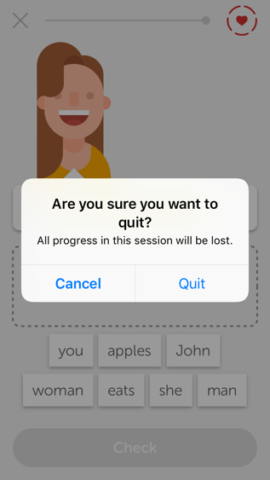

3. H-8:Aesthetic and minimalist design.

Users can customize their avatar in this App and they need to buy items to do this. However, this utility is a little bit irrelevant and distracting here since this is a language learning App instead of a social network App.

S-1: Not a big issue. Customization although not necessary and can cause distraction, is still a utility that can add more flavor to this App.



4. H-7: Flexibility and efficiency of use

Users have to complete all the lessons one by one. They cannot skip lessons even if they are already familiar with the materials in that lesson.

S-2: minor.

This issue makes the learning progress inflexible. A possible improvement is to test the users if they want to skip lessons. If they pass the test, they can skip the lesson. But considering most users are learning new languages and will not skip lessons, the impact of this issue is not too big.

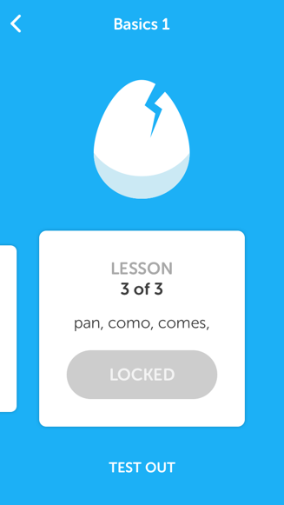

5. H-4: Consistency and standards.

In the settings screen, there are two options: “progress sharing” and “send feedback” which usually don’t appear in the settings.

S-2: minor.

These two options should be put into some other section instead of settings. But considering these options are not accessed often, the impact is not too big.

