Don't Crash!! — Development Report
Unit: 6G4Z0020 Programming | Assessment 2 (Cwk 70%) | Target: 80%+
Game theme: Star Wars / asteroid field (player fixed at centre)
Student name: ________________ JEI number: ________________

1. How the solution was developed
I developed Don't Crash!! in Processing one feature at a time, testing after each step.
I started with DontCrash.pde: a window, starfield, and three states (start, playing, game over). Next I added Player, always drawn at the screen centre, and a basic Obstacle alien drawn with shapes.
I then implemented the required control model. Arrow keys do not move the ship; applyArrowPush() shifts every world object and the starfield in the opposite direction using moveBy(). Hold flags in keyPressed/keyReleased keep steering responsive, and the ship faces the last arrow pressed.
Collision came next. Player.checkCollision(Obstacle) returns a boolean using dist(). A hit loses a life, flashes the screen, starts invulnerability frames, and spawns an explosion. At zero lives the run ends and the high score is saved.
I replaced fixed aliens with ArrayList<Obstacle> aliens. spawnAlienAtEdge() creates enemies over time; objects are marked finished first and removed once at the end of the frame. Obstacles use PImage sprites. FastObstacle and MovingObstacle extend Obstacle and override update/display, so the list holds mixed types. HealthPack pickups restore lives up to three. SPACE fires Bullet lasers along the facing direction.
For higher bands I added PImage animation sequences (thruster flames, alien frames, explosion frames), ScoreManager file I/O with loadStrings/saveStrings on data/highscore.txt, and score-based levels. Finally I introduced the GameEntity interface and abstract WorldObject so most entities share update/display/moveBy, and Explosion plays while gameplay continues. I also refactored into helper methods and private fields for maintainability.

2. Where marking features appear in the code
Band | Feature | Location (tab / method)
40% | Player stays centred; opposite arrow shift | Player constructor; DontCrash.applyArrowPush()
40–50% | 2 classes; boolean collision; ≥2 obstacles | Player.pde / Obstacle.pde; Player.checkCollision(Obstacle); restartGame()
50–60% | Own movement; PImage; ArrayList; spawn/remove | Obstacle.update(); loadImage; aliens ArrayList; spawnAlienAtEdge(); removeDeadAliens()
60–70% | 2nd obstacle type + inheritance; facing art | FastObstacle.pde, MovingObstacle.pde; Player.currentSprite()
70–80% | PImage sequences; polymorphism; file high score; refactor | flame_/alien_anim_/explosion_ frames; ArrayList polymorphism; ScoreManager.loadHighScore()/saveHighScore(); drawPlaying helpers
80%+ | Entity polymorphism; interface/abstract; collision animation while playing | GameEntity.pde; WorldObject.pde; Explosion.pde + effects ArrayList

3. Code snippet screenshots from development stages
Fig.1 — Boolean collision method (Player.pde)
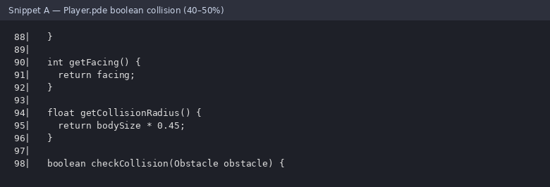
Fig.2 — Opposite world push (DontCrash.applyArrowPush)
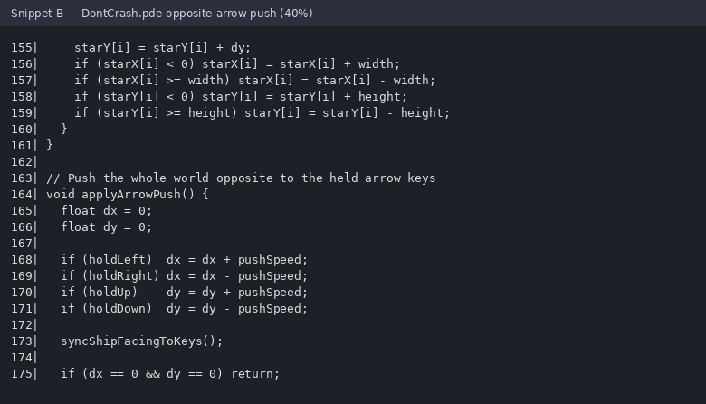
Fig.3 — ArrayList and spawning
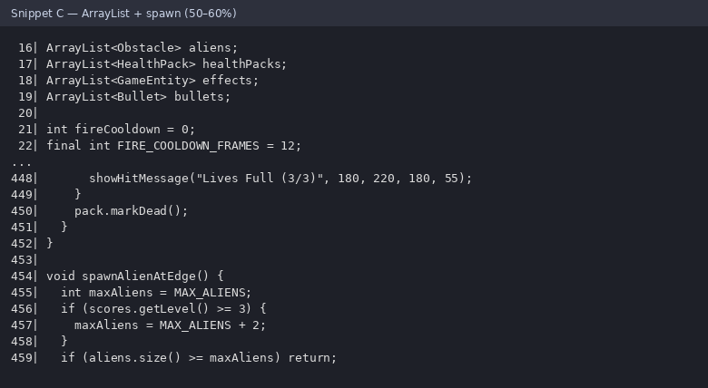
Fig.4 — Inheritance (FastObstacle)
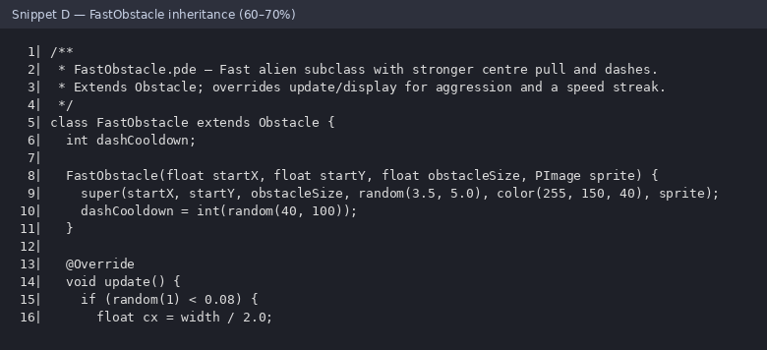
Fig.5 — High-score file handling (ScoreManager)
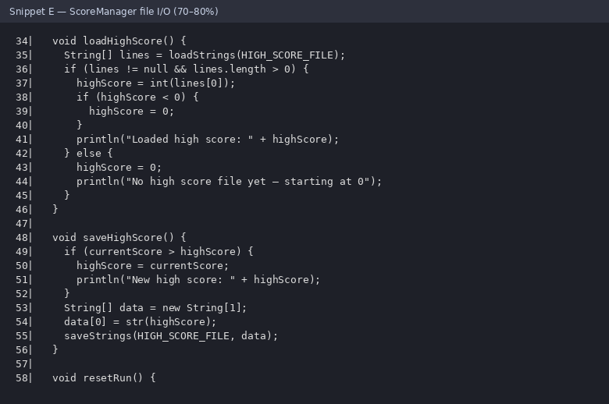
Fig.6 — Interface and abstract class
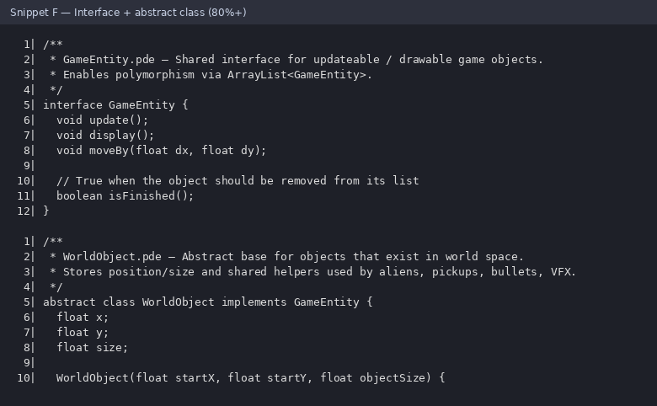
Fig.7 — Explosion animation sequence
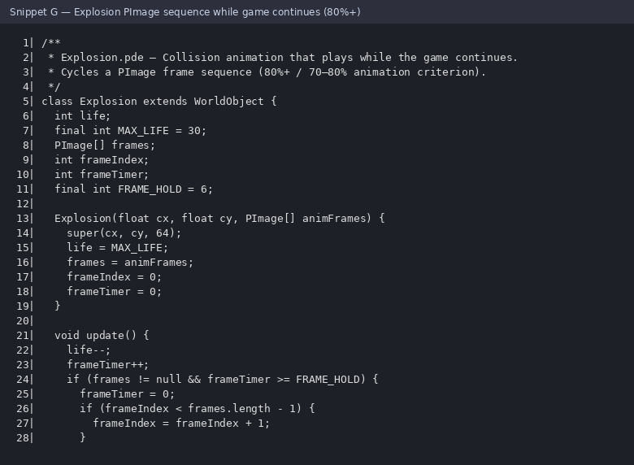
Development narrative word count: 240 (limit 500). Replace the name/JEI fields before Moodle submission.
Note: Review this report so you can explain every step in a viva. Add any personal debugging stories if asked.

