Jacob Kilver

CS7637: KBAI

Assignment 3

19 June 2016

# Introduction

The automobile industry is hotly pursuing autonomous vehicle technology. Planning – choosing a sequence of actions to accomplish a goal – is a major part in creating useful autonomous vehicles. This paper explores the details and difficulties of creating a planning algorithm for such vehicles.

# Problem Description

The first (and probably simplest) part of creating a planning algorithm is setting a goal. For an autonomous vehicle this will be a set of latitude and longitude coordinates and potentially a directional heading. The second input to the planning algorithm is the initial state. This will be a tuple like the goal state with latitude and longitude coordinates, but the directional heading is required. Since the vehicle does not operate in isolation, the initial state must also contain information about the world such as the obstacles in the vicinity of the vehicle, the speed of these nearby obstacles, and the current road conditions. This presents a difficult not only because this is a large amount of data, but also because sensors can be unreliable. In lecture it was implicitly assumed that the current state of the environment could be known completely and reliable. In practice this is rarely if ever the case. The planning algorithm must be able to account for data that can be inaccurate or missing at times.

The next input to the planning algorithm is set of actions that are allowed when transitioning between states. In lecture these were called operators. For the purposes of this discussion the operators for an autonomous vehicle will be restricted to the following: forward, back, left, and right. This obviously does not cover all the actions that vehicle can take, but it should be adequate for the discussions here. Just as with the uncertainty in sensors, there is uncertainty when taking actions. For instance, the vehicle might predict that it has travelled so far in a certain period of time when in reality it has travelled more or less than that amount. This was also not covered in lecture; when a block was commanded to be moved it was assumed that the block was moved to the specified location. A planning algorithm for an autonomous vehicle cannot make such assumptions and must be able to handle uncertainty in the execution of its operations.

Finally, the vehicle has to have some background knowledge in order to connect the initial state to the goal state using the allowed operators. For a vehicle this would simply be a map. This map adds some additional constraints to the problem like traffic flow and location of roads.

With these pieces in place the vehicle must then decide on the sequence of actions that best achieve its goal of reaching the destination location. Take Figure 1 as an example. The goal is to navigate from the initial state of Home to the goals state of Restaurant. How can the vehicle choose a route so that the time it takes to reach the goal is minimized?

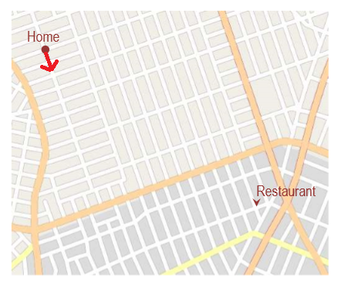

Figure : Example of route planning problem

# Approach

The goal state will be input by the passenger(s), most likely as a street address. It is assumed that a separate system will be able to translate the street address into the goal coordinates that the vehicle can understand. There are numerous techniques to handle uncertainty in both measurements and movements including Kalman and particle filters. These techniques will not be addressed here but they do allow for the assumption that the vehicle can with a great deal of certainty know about its location and the location of objects surrounding it.

Take the example in Figure 1 again and let us add to the goal state that the vehicle should be on the same side of the street as the restaurant. In terms of propositional logic discussed in lecture the goal state becomes

.

Meanwhile the initial state is

.

To expand on the operators,

Through means-end analysis the planning algorithm is presented with the paths given in Figure 2.

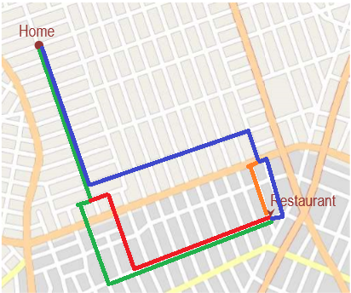

Figure : Examples of paths

# Conclusion

* Robot has to know state of the world before it can plan
* Share thoughts from RL
  + Planning in the purest sense of the word cannot handle uncertainty in movement
  + I think the assumption can be made here that the robot can plan, but if it finds itself deviating from the plan it can correct itself