DNS-Architektur – tsbe.int – Lösungsvorschlag

/etc/bind/named.conf.options
options {
directory "/var/cache/bind";
forwarders {8.8.8.8; 10.5.11.12;};
allow-query {192.168.0.0/16;};
dnssec-validation no;
dnssec-enable no;
auth-nxdomain no;
};

/etc/bind/named.conf.local
zone "tsbe.int" in {
type master;
file "/etc/bind/db.tsbe.int";
};

zone "210.168.192.in-addr.arpa" in {
type master;
file "/etc/bind/db.192.168.210";
};

/etc/bind/db.tsbe.int
$TTL 604800
@ IN SOA jupiter.tsbe.int. root.tsbe.int. (
2016091601 ; Serial
604800 ; Refresh
86400 ; Retry
2419200 ; Expire
604800 ) ; Negative Cache TTL
;
@ IN NS jupiter.tsbe.int.
@ IN A 192.168.210.102

jupiter IN A 192.168.210.60
www IN A 192.168.210.102

/etc/bind/db.192.168.210
$TTL 604800
@ IN SOA jupiter.tsbe.int. root.tsbe.int. (
2016091601 ; Serial
604800 ; Refresh
86400 ; Retry
2419200 ; Expire
604800 ) ; Negative Cache TTL
;
@ IN NS jupiter.tsbe.int.

60 IN PTR jupiter.tsbe.int.
103 IN PTR SAP.tsbe.int.
102 IN PTR www.tsbe.int.

/etc/network/interfaces
auto lo
iface lo inet loopback

auto eth0
iface eth0 inet static
address 192.168.210.60
network 192.168.210.0
netmask 255.255.255.0
broadcast 192.168.210.255
gateway 192.168.210.1
#
dns-nameservers 192.168.210.60
dns-search tsbe.int

ifdown eth0

ifup eth0

service bind9 restart
tail /var/log/syslog

nslookup jupiter.tsbe.int
nslookup www.tsbe.int
nslookup www.google.ch
nslookup 192.168.210.102

vmWP1:
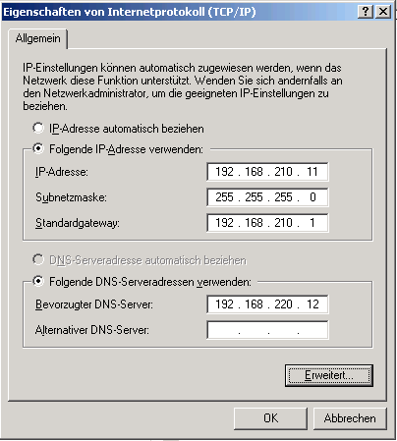 | 