**Final Project How-To Guide**

CSC 460/660

Assignment 3

Kevin Stanley

Carson Mullins

Zach Fondal

**Table of Contents**

1. Overview
2. GitHub Repository Link
3. App In Action
4. Team Roles
5. Testing
6. **Overview**

This assignment was to create a fully functional Blackjack application with the ability for the player to do the following actions:

* Play against dealer
* Hit
* Stay
* Double Down
* Split
* Bet
* Persistent Bank storage

This application was written in C# using WPF. Our team setup a JIRA instance to keep track and divide work. Our JIRA instance can be accessed here:

<https://csc660.atlassian.net/secure/Dashboard.jspa>.

We communicated through Slack and used GitHub for our Source Control repository. All of our documents can be found in the Documents folder of our GIT repository.

1. **GitHub Repository Link**

<https://github.com/kevinstanley8/Blackjack>

1. **App In Action**
   1. Click on Blackjack.exe to launch the application. This will launch the application and bring up the landing page:

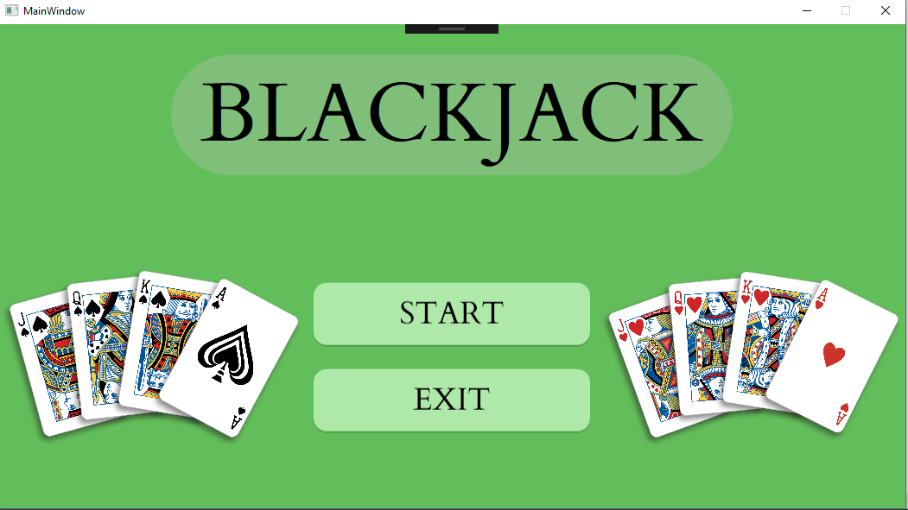

* 1. Press the START button to bring you to the Blackjack table:

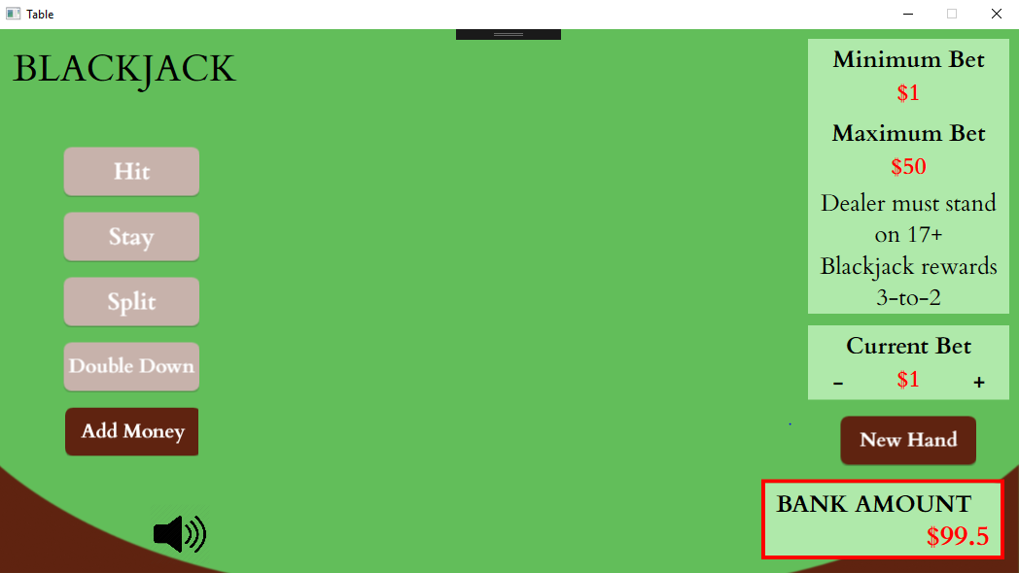

* 1. Add available action like Hit, Stay, Split, Double Down, and Add Money are presented on the left-hand side of the table. Instructions, current bet, new hand button, and bank amount are presented on the right-hand side of the table.
  2. To get started press the New Hand button. This will begin a new hand and you can play Blackjack:

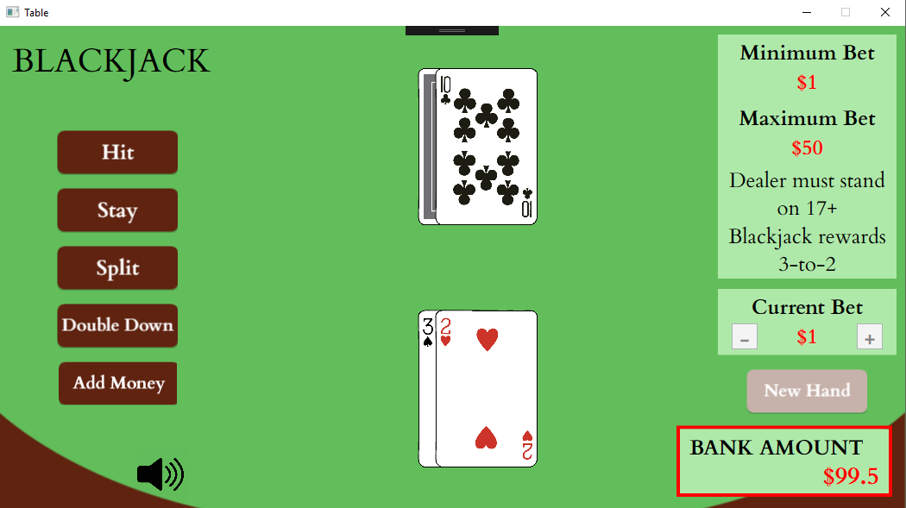

* 1. To Hit press the hit button to get another card:

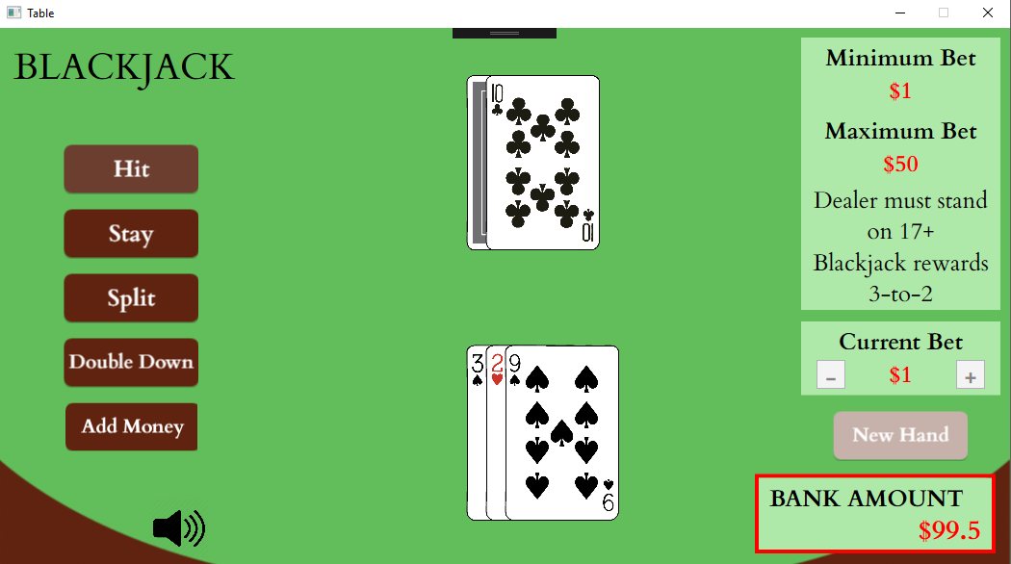

* 1. Once you are satisfied with your hand press the Stay button and the dealer will begin taking cards. Once the dealer busts or wins you will be given a prompt telling you the result of the hand:

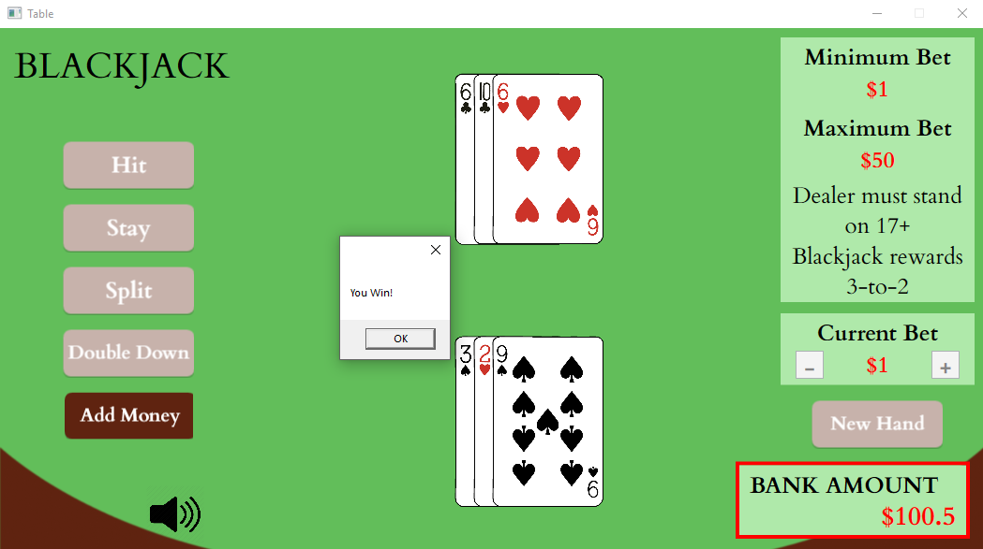

* 1. Double Down – to double down press the New Hand button and then press the Double Down button. Your current bet will be doubled and you will receive exactly 1 more card to improve your hand.

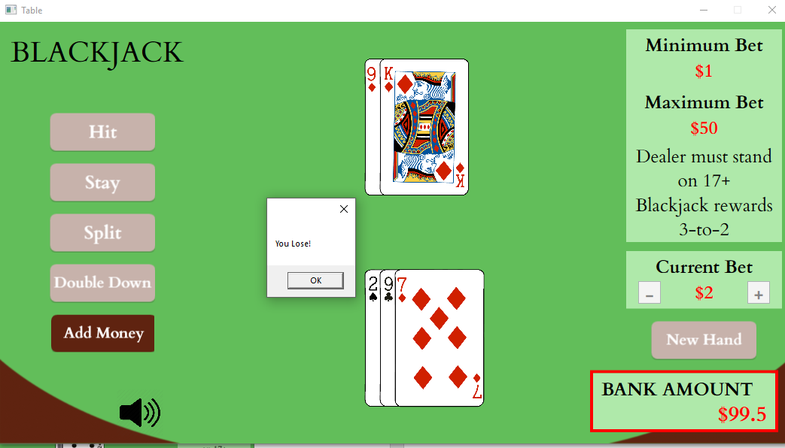

* 1. Split – If you get dealt 2 of the same value cards you will be able to Split your hand. Press the Split button and then you can play each hand individually. You can Hit and Stay just like a single hand.

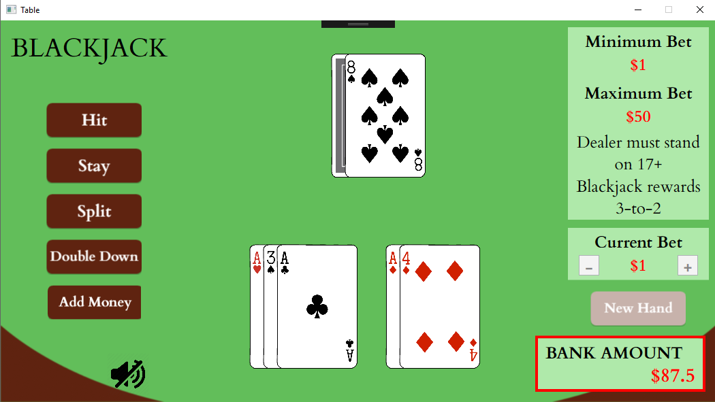

* 1. Blackjack – If you or the dealer get dealt Blackjack you will win/lose:

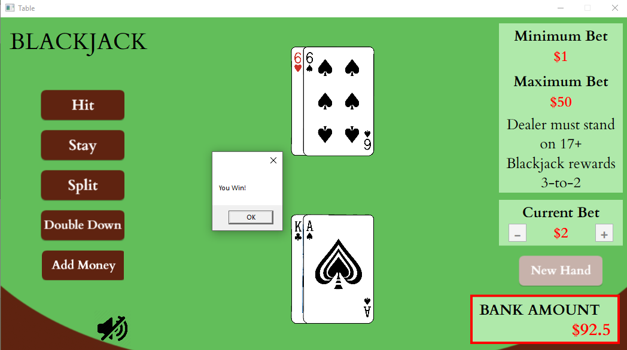

1. Team Roles
   1. Kevin Stanley
      1. Developer
      2. Scrum Master
      3. Create initial seed application for GIT repository including Card, Player, Hand, Suit, Value classes.
      4. Implemented Split, Double Down, Blackjack check and Add Money functionality
      5. Implemented JSON storage/retrieval of Bank amount.
      6. Added application audio.
      7. How to Document
   2. Carson Mullins
      1. Developer
      2. Found images for cards
      3. UI
      4. Implemented Hit, Stay functionality.
      5. Implemented hand value (to determine if win or bust).
   3. Zach Fondal
      1. Developer
      2. Created Bank class
      3. Architecture Diagram
2. Testing

All testing for the application was done manually. We played the game just as we were playing Blackjack for real. We tested all the different options such as Double Down and Split to make sure they behaved the way we expected.